JIMMA UNIVERSITY
JIMMA. ETHIOPIOA
Online Teaching Course Material
for
BSc -STATISTICS
3rd Year Students -2020
Subject Course : BIOSTATISTICS AND EPIDEMIOLOGY STAT 3101
Instructor : Dr. Adiveppa . S. Kadi,
Professor
Department of Statistics
Jimma University
JIMMA, ETHIOPIA

Chapter 1
BIOSTATISTCS
THE SCIENTIFIC METHOD
* Science is built up with facts, as a house is with stones. But a collection of facts
is no more a science than a heap of stones is a house (Jules Henri , 1908)
*The Logic of Scientific Reasoning
*The whole point of science is to uncover the “truth.”
* How do we go about deciding something is true?
We have two tools at our disposal to pursue scientific inquiry:
- We have our senses, through which we experience the world and make observations.
- We have the ability to reason, which enables us to make logical inferences.
In science we impose logic on those observations.
Clearly, we need both tools.
- All the logic in the world is not going to create an observation, and
- All the individual observations in the world won't in themselves create a theory.
- There are two kinds of relation-ships between the scientific mind and the world, and We impose two kinds of logic :
- Deductive and (b) inductive
For illustration See Figure 1.1.
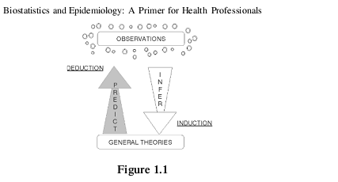
Deductive Inference
- In deductive inference, we hold a theory and based on it we make a prediction of its consequences.
- That is, we predict what the observations should be.
For example, we may hold a theory of learning that says that positive reinforcement results in better learning than does punishment,
That is, “rewards work better than punishments “.
- From this theory we predict that math’s and statistics students who are praised for their right answers during the year
- They will do better on their final exam than those who are punished for their wrong answers.
- We go from the general—the theory—to the specific—the observations. This is known a the hypothetical-deductive method.
Inductive Inference
In inductive inference, we go from the specific to the general.
We make many observations, discern a pattern, make a generalization, and draw infer an explanation.
For example:
It was observed in the Vienna General Hospital in the 1840s that women giving birth were dying at a high rate of puerperal fever.

A generalization that provoked terror in prospective mothers.
- It was a young doctor named Ignaz Phillip Semmelweis who connected the observation that medical students performing vaginal examinations did so directly after coming from the dissecting room, rarely washing their hands in between.
- The explanation that the cause of death was the introduction of cadaverous (Cadaverous means looking corpse-like, from being sick or too skinny, like an aging rock star or a Halloween ghoul or looking very thin and pale ) material into a wound. L
- The practical consequence of that creative leap of the imagination was the elimination of puerperal fever as a scourge of childbirth by requiring that physicians wash their hands before doing a delivery.
The ability to make such creative leaps from generalizations is the product of creative scientific minds.
Epidemiologists have generally been thought to use inductive inference.
For example :
- Several decades ago it was noted that women seemed to get heart attacks about 10 years later than men did.
A creative leap of the imagination led to the inference that it was women’s hormones that protected them until menopause. EUREKA!
- They deduced that if estrogen was good for women, it must be good for men and predicted that the observations would corroborate that deduction.
- A clinical trial was undertaken which gave men at high risk of heart attack estrogen in rather large doses, 2.5 mg per day or about four times the dosage currently used in post-menopausal women. Unsurprisingly , the men did not appreciate the side effects, but surprisingly to the investigators, the men in the estrogen group had higher coronary heart disease rates and mortality .
- What was good for the goose might not be so good for the gander.
The trial was discontinued and estrogen as a preventive measure was abandoned for several decades.
(Estrogen, or oestrogen, is the primary female sex hormone. It is responsible for the development and regulation of the female reproductive system and secondary sex characteristics. There are three major endogenous estrogens in females that have estrogenic hormonal activity: estrone, estradiol, and estrio)

CH-2 Biostatistics and Epidemiology
- Epidemiologists have generally been thought to use inductive inference. For example , several decades ago it was noted that women seemed to attacks about 10 years later than men did a creative leap of the imagination led to the inference that:
- it was women’s hormones that protected them until menopause. EUREKA! They deduced that if estrogen was goodfor women, it must be good for men and predicted that the observations would corroborate that deduction.
- A clinical trial was undertaken which gave men at high risk of heart attack estrogen in rather large doses, 2.5 mg per day or about four times the dosage currently used in post-menopausal women.
- Unsurprisingly , the men did not appreciate the side effects, but surprisingly to the investigators, the men in the estrogen group had higher coronary heart disease rates and mortality than those on placebo.
“What was good for the goose might not be so good for the gander”.
- The trial was discontinued and estrogen as a preventive measure was abandoned for several decades.
- During that course of time, many prospective observational studies indicated that estrogen replacement given to post-menopausal women reduced the risk of heart disease by 30-50% .
- These observations led to the inductive inference that post-menopausal hormone replacement is protective, i.e. observations led to theory. However, that theory must be tested in clinical trials.
- The first such trial of hormone replacement in women who already had heart disease, the Heart and Estrogen/progestin Replacement Study (HERS)found no difference in heart disease rates between the active treatment group and the placebo group, but did find an early increase in heart disease events in the first year of the study and a later benefit of hormones after about 2 years. Since this
- was a study in women with established heart disease, it was a secondary prevention trial and does not answer the question of whether two-men without known heart disease would benefit from long-term hormone replacement. That question has been addressed by the Women’s Health Initiative (WHI), which is described in a later section.
- The point of the example is to illustrate how observations (that women get heart disease later than men) lead to theory (that hormones are protective), which predicts new observations (that there will be fewer attacks and deaths among those on hormones), which may strengthen the theory, until it is tested in a clinical trial which can either corroborate it or overthrow it and lead to a new theory, which then must be further tested to see if it better predicts new observations. So
Biostatistics and Epidemiology:
- A Primer for Health Professionals there is a constant interplay between inductive inference (based on observations) and deductive inference (based on theory), until we get closer and closer to the “truth. ”
- However, there is another point to this story.
- Theories don't just leap out of facts. There must be some substrate out of which the theory leaps.
- Perhaps that substrate is another preceding theory that was found to be inadequate to explain these new observations and that theory, in turn, had replaced some previous theory. In any case, one a specs of the “substrate” is the “prepared mind” of the investigator.
- If the investigator is a cardiologist, for instance, he or she is trained to look at medical phenomena from a cardiology perspective and is knowledge -able about preceding theories and the ir strengths and flaws.
- If the cardiologist hadn't had such training, he or she might not have see n the connection. Or, with different training, the investigator might lead to a different inference altogether.

- The epidemiologist must work in an inter-disciplinary team to bring to bear various perspectives on a problem and to enlist minds “prepared” in different ways. The question is, how well does a theory hold up in the face of new observations?
When many studies provide affirmative evidence in favor of a theory, does that increase our belief in it?
- Affirmative evidence means more examples that are consistent with the theory. But to what degree does supportive evidence strengthen an assertion?
- Those who believe induction is the appropriate logic of science hold the view that affirmative evidence is what strengthens a theory.
- Another approach is that of Karl Popper, perhaps one of the fore most theoreticians of science. Popper claims that induction arising from accumulation of affirmative evidence doesn't strengthen a theory.
Induction
- After all, is based on our belief that the things unobserved will be like those observed or that the future will be like the past.
For example, “we see a lot of white swans and we make the assertion that all
swans are white”.
- This assertion is supported by many observations.
- Each time we see another white swan we have more supportive evidence.
But we cannot prove that all swans are white no matter how many white swans we see.
- On the other hand, this assertion can be knocked down by the sighting of a single black swan.
- Now we would have to change our assertion to say that most swans are white and that there are some black swans.
- This assertion presumably is closer to the truth.

In other words, we can refute the assertion with on e example, but we can't prove
it with many.
The assertion that all swans are white is a descriptive generalization rather than a theory.
- A theory has a richer meaning that incorporates causal explanations and underlying mechanisms.
Assertions, like those relating to the color of swans, may be components of a theory.
According to Popper- the proper methodology is to posit a theory, or a conjecture, as he calls it, and try to demonstrate that it is false.
- The more such attempts at destruction it survives, the stronger is the evidence for it.
- The object is to devise ever more aggressive attempts to knock down the assertion and see if it still survives.
- If it does not survive an attempt at falsification, then the theory is discarded and replaced by another.
He calls this as the method of conjectures and refutations.
- The advance of science toward the “truth” comes about by discarding theories whose predictions are not confirmed by observations, or theories that are not testable altogether, rather than by shoring up theories with more examples of where they work.
- Useful scientific theories are potentially falsifiable. Un-testable theories are those where a variety of contradictory observations could each be consistent with the theory.
- For example: The Oedipus complex theory says that a child is in love with the parent of the opposite sex. A boy desires his mother and wants to destroy his father. If we observe a man to say he loves his mother that fits in with the theory.
- If we observe a man to say he hates his mother that also fits in with the theory, which would say that it is “reaction formation” that leads him to deny his true feelings.
- In other words, no matter what the man says, it could not falsify the theory because it could be explained by it.
- Since no observation could potentially falsify the Oedipus theory, its position as a scientific theory could be questioned.
- A third, and most reasonable, view is that the progress of science requires both inductive and deductive inference.
- A particular point of view provides a framework for observations, which lead to a theory that predicts new observations that modify the theory, which then leads to new, predicted observations, and so on toward the elusive “truth,” which we generally never reach.
Asking which comes first, theory or observation, is like asking which comes first, the chicken or the egg.
- In general then, advances in knowledge in the health field come about through constructing, testing, and modifying theories.
- Epidemiologists make inductive inferences to generalize from many observations, make creative leaps of the imagination to infer explanations and construct theories, and use deductive inferences to test those theories.
- Theories, then, can be used to predict observations. But these observations will not always be exactly as we predict them, due to error and the inherent variability of natural phenomena.
- If the observations are widely different from our predictions we will have to abandon or Modify the theory.
How do we test the extent of the discordance of our predictions based on theory from the reality of our observations? The test is a statistical or probabilistic test. It is the test of the null hypothesis, which is the cornerstone of statistical inference and will be discussed later.
CH-3 PROBABILITY
- The theory of probability is at bottom nothing but common sense reduced to calculus.
3.1 What Is Probability?
* The probability of the occurrence of an event is indicated by a number ranging from 0 to 1.
+* An event whose probability of occurrence is 0 is certain not to occur,
- Where as an event whose probability is 1 is certain to occur.
The classical definition of probability is as follows:
“if an event can occur in N mutually exclusive, equally likely ways and if n of these outcomes have attribute A, then the probability of A, written as P(A),equals n/N. “
This is an a priori definition of probability, that is, one
determines the probability of an event before it has happened.
- Example: Assume one were to toss a die and wanted to know the probability of obtaining a number divisible by three on the toss of a die.
- Here there are six possible ways that the die can land.
- Of these, there are two ways in which the number on the face of the die is divisible by three, are 3 and 6.
- Thus,the probability of obtaining a number divisible by three on the toss of a die is 2/6 or 1/3.
- In many cases, however, we are not able to enumerate all the possible ways in which an event can occur, and, therefore, we use relative frequency definition of probability.
- This is defined as the number of times that the event of interest has occurred divided by the total number of trials (or opportunities for the event to occur).
- Since it is based on previous data, “it is called the a posteriori definition of probability”.
- For instance, if you select at random a whit American female, the probability of her dying of heart disease is .00287.

“This is based on the finding that per 100,000 white American females 287 died of coronary heart disease “(estimates are for 2001,National Center for Health Statistics).
- When you consider the probability of a white American female who is between ages 45 and 64, the figure drops to .00088 (or 88 women in that age group out of 100,000), and when you consider women 65 years and older, the figure rises to .01672 (or 1672 per 100,000).
- For white men 65 or older it is .0919 (or 9190per 100,000).
Here two important points are
- to determine a probability, you must specify the population to which you refer.
For example, all white females, white males between 65 and 74, nonwhite females between 65 and 74, and so on; and
(2) the probability figures are constantly revised as new data become available.
* This brings us to the notion of “Expected Frequency”.
* If the probability of an event is P and there are N trials (or opportunities for the event to occur), then we can expect that the event will occur N×P times.
* It is necessary to remember that probability “works” for large numbers.
* When in tossing a coin we say the probability of it landing on heads is 0.50, we mean that in many tosses half the time the coin will land heads.
* If we toss the coin ten times, we may get three heads (30%) or six heads(60%), which are a considerable departure from the 50% we expect.
* But if we toss the coin 200,000 times, we are very likely to be close to getting exactly 100,000 heads or 50%.
* Expected frequency is really the way in which probability “works.”
* It is difficult to conceptualize applying probability to an individual.

3.2 Probabilities Laws
* There are two laws for combining probabilities that are important.
* First, if there are mutually exclusive events(i.e., if one occurs, the other cannot), the probability of either one or the other occurring is the sum of their individual probabilities.
Symbolically,
P(AorB) =P(A) +P(B)
An example of this is as follows:
The probability of getting either a 3 or a 4 on the toss of a die is 1/6 + 1/6 = 2/6.Ā
“A useful thing to know is that the sum of the individual probabilities of all possible mutually exclusive events must equal 1”.
For example,
If A is the event of winning a lottery, and not A(written as Ā ), is the event of not winning t he lottery, then
P(A) + P(Ā) = 1.0 and
P(A) = 1–P(Ā).
- Second, if there are two independent events (i.e., the occurrence of one is not related to the occurrence of the other), then the joint probability of their occurring together (jointly) is the product of the individual probabilities. Symbolically,
P(A and B) = P(A)x P(B)

- An example of this is the probability that on the toss of a die
- You will get a number that is both even and odd(1,2,3,4,5,6) divisible by 3.
- This probability is equal to 1/2×1/3 = 1/6. (The only number both even and divisible by 3 is the number 6.)
( Even 2,4,6=3: odd 1,3,5=3)
- The joint probability law is used to test whether events are independent or not.
- If they are independent, the product of their individual probabilities should equal the joint probability.
- If it does not, then they are not independent.
- It is the basis of the chi-square test of significance, which we will consider in the next section.
- Let us apply these concepts to a medical example.
- The mortality rate for those with a heart attack in a special coronary care unit in a certain hospital is 15%.
Thus, the probability that a patient with a heart attack admitted to this coronary care unit will die is .15 and that he will survive is .85.
- If two men are admitted to the coronary care unit on a
Particular day,
- let A be the event that the first man dies and let B be the event that the second man dies.
The probability that both will die is
- P(A and B)= P(A) P(B) = 15/100x 15/100 =0.15x0.15= 0225
We assume these events are independent of each other so we can multiply their probabilities.
Note, however, that the probability that either one or the other will die from the heart attack is not the sum of their probabilities because these two events are not mutually exclusive.
- It is possible that both will die (i.e., both A and B can occur).
To make this clearer, a good way to approach probability is
through the use of Venn diagrams, as shown in Figure 2.1.
- Venn diagrams consist of squares that represent the universe of possibilities and circles that d efine the events of interest.
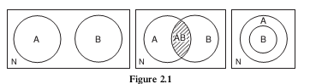

In diagrams 1, 2, and 3, the space inside the square represents all N possible outcomes.
- The circle marked A represents all the outcomes that constitute event A;
- The circle marked B represents all the outcomes that constitute event B.
- Diagram 1 illustrates two mutually exclusive events; an outcome in circle A cannot also be in circle B.
- Diagram 2 illustrates two events that can occur jointly: an outcome in circle A can also be an outcome belonging to circle B. The shaded area marked AB represents out comes that are the occurrence of both A and B.
- The diagram 3 represents two events where one (B) is a subset of the other(A); an outcome in circle B must also be an outcome constituting event A, but the reverse is not necessarily true.
3.3 Conditional Probability
* Now let us consider the case where the chance that a particular event happens is dependent on the outcome of another event.
* Then the probability of A, given that B has occurred, is called the conditional probability of A given B, and is written symbolically as P(A|B).
- An illustration of this is provided by Venn diagram 2.
- When we speak of conditional probability, the denominator becomes all the outcomes in circle B (instead of all N possible outcomes) and the numerator consists of those out-comes that are in that part of A which also contains outcomes belonging to B.
- This is the shaded area in the diagram labeled AB.
- If were turn to our original definition of probability, we see that

(the number of outcomes in bothA and B, divided by the total number of outcomes in B).
- If we divide both numerator and denominator by N, the total number of all possible outcomes, we obtain
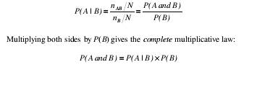

3.4
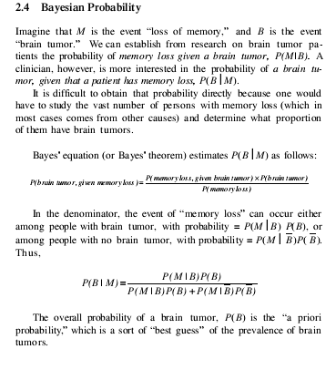
3.5 Odds and Probability
* When the odds of a particular horse losing a race are said to be 4 to 1,
* Then probability of losing a race = 4/5 = 0 .80
To convert an odds statement to probability
- Add 4 + 1 to get our denominator of 5.
- The odds of the horse winning are 1 to 4,which means that the probability of winning a race =1/5 = .20.

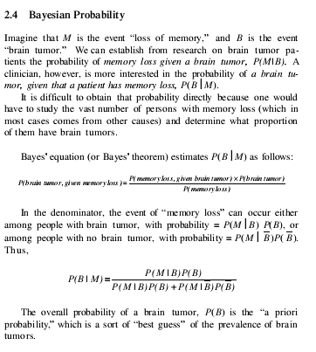

CHAPTER - 4
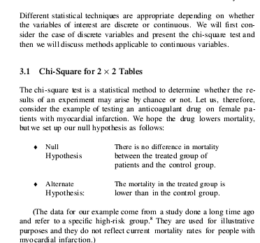

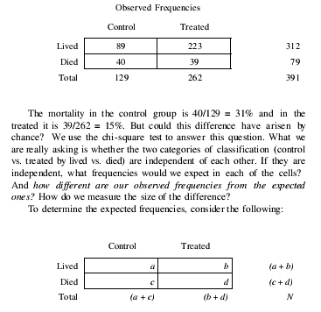
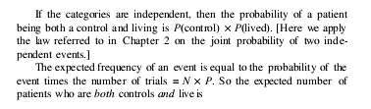
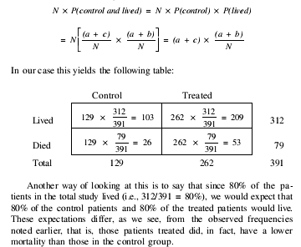
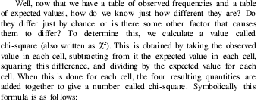
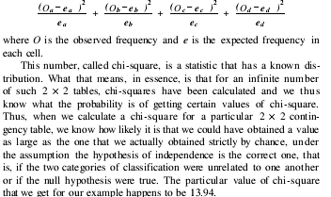
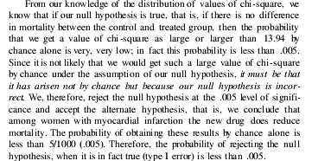

CH-5
BASIC EPIDEMIOLOGY
1 Introduction
- Before the turn of the 19th century the world has witnessed severe pains and agony due to sequence of epidemics.
- Now we are facing CARONA Pandemic throughout the world
- Several thousands of death tools of human lives occurred because of dreadful infectious diseases.
- The ravages of the Black Death, a plague in the 14th century are well known.
- In Europe alone, about 25 million deaths occurred in a population of around 100 million.
- Similarly reports came from China,UK, France , Spain ect., now in USA and other parts of the world where millions of many local populations were said to have died in widely scattered areas due to Corona Virus .
Perhaps even more worrying is the occurrence of new challenges on a wide scale. One of the greatest challenges faced by the present day world is the pandemic of AIDS and CARONA which are likely to take serious dimensions in the present century.
Since the first case of AIDS was reported among homosexual men in the USA in 1981.
Similary the first case of Corona found in Wuhan city of Chaina , now it has reached pandemic proportions, as no country in the world is free from HIV/AIDS and Corona
AIDS and its related syndromes have changed virtually every aspect of medicine and society at large. whereas no medicine is not yet found for Corona
AIDS is a condition in which the inbuilt immune mechanism of the human body breaks down completely. The process is gradual but ultimately suppresses the immunity of the individuals. Similar situation we are observing now with Corona
The process is gradual but ultimately suppresses the immunity of the individuals.
Now at present the most pandemic disease which spread throughout the world is Covind -19(Corona), which is killing many lives every day and we are unable to find a medicine or vaccine for this
It ranks as one of the most destructive microbial scourges in human history and poses a formidable challenge to the biomedical research and public health communities of the world.
Following these, serious investigations have been carried out by medical, biological and mathematical scientists to find clinical, biological, ideological reasons and also to formulate a mathematical theory to describe the phenomenon of spread of disease as well.
The clinical questions of diagnosis, prognosis and efficiency of treatment often depend on the statistical interpretation of appropriate data.
Again we are interested in developing mathematical or statistical models because of the light they throw on some aspects of the biological mechanism at work, such as the life-cycle of the parasite involved.
- Alternatively, we can use these models to study the large-scale population phenomena of immediate relevance to any social and public health measures that might be advocated or undertaken.
- In particular, we want to know more about the transmission and spread of infectious disease, about trying to predict the course of an epidemic and about the recognition of threshold densities of population which must be surpassed before a flare-up is likely.
Objectives:
After reading this chapter you should understand:

◆ that the prime focus of epidemiology is on the pattern of disease and ill-health in the population;
◆ that epidemiology combines elements of clinical, biological, social and ecological sciences;
◆ that epidemiology is dependent on clinical practice and the clinical sciences to make a diagnosis, the starting point of epidemiological work;
◆ that the central goal of epidemiology as a science is to understand the causes of disease variation and use this knowledge to better the health of populations and individuals;
◆ that the central goal of epidemiology as a practice is preventing and controlling disease in populations, guiding health and healthcare policy and planning, and improving health care in individuals;
◆ that good epidemiological variables should meet the purposes of epidemiology;
◆ that epidemiology is based on theories though these may not be made explicit.
Definition of epidemiology:
- The identity of the person who coined the term epidemiology is unknown but it is derived from the Greek words meaning study upon populations (epi =upon, demos = people, ology =study).
- This derivation does not convey what is studied or the nature of that study.
- “Epidemiology is concerned primarily with disease, and how disease detracts from health.
- A more descriptive word would be epidemiopathology (pathos is the Greek word for suffering and disease) but it is too clumsy to recommend.

- The word epidemic was used by Hippocrates, but his writings were mainly compilations of the case histories of affected people and not a study of the causes or descriptions of the pattern of the epidemic in the population.

- The early applications of epidemiology were in the study of infectious disease epidemics, environmental hazards and nutritional problems.

- The examination of social inequalities in mortality patterns was also an early focus of epidemiology.

- Most epidemiology is on human populations but veterinary epidemiology is important both in its own right and in the interaction of humans and animals, causing the diseases known as the Zoo- noses.

Last’s (2001) dictionary gives a detailed definition of epidemiology that includes these words
“The study of the distribution and determinants of health-related states or events in specified populations, and the application of this study to control of health problems”.
*Based on what it has done in the last 150 years, epidemiology is the science and practice which describes and explains disease patterns in populations, and puts this knowledge to use to prevent and control disease and improve health.
*Epidemiology is to seek out the differences and similarities (‘compare and contrast’) in the disease patterns of populations to gain new knowledge.
* Most epidemiologists are interested in health but study it indirectly through disease, partly because of the difficulty of measuring health.

Uses or Scope of Epidemiology:
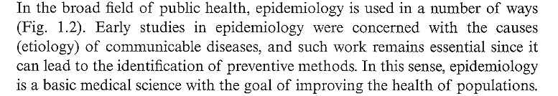

Ex: Lung Diseases, Diabetics, Heart Diseases, Blindness
.
*
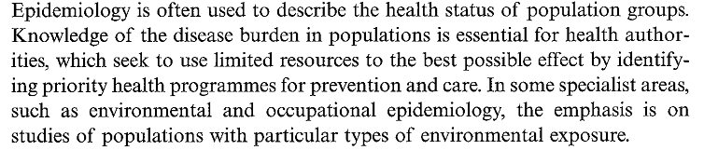

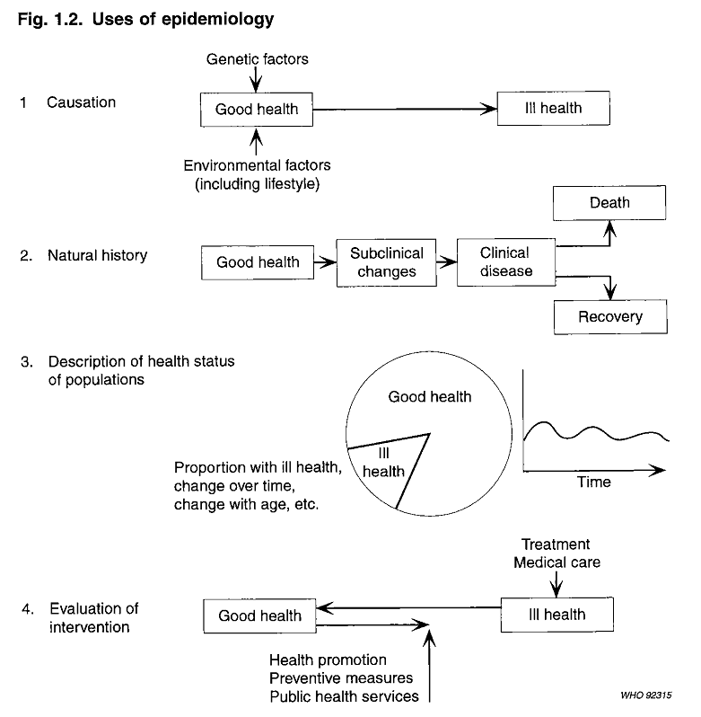

Subclinical disease: An illness that is staying below the surface of clinical detection. A subclinical disease has no recognizable clinical findings. It is distinct from clinical disease, which has signs and symptoms that can be recognized.
Many diseases, including diabetes, hypothyroidism, and rheumatoid

(Clinical Change: Words used to describe the change in the health condituions due to medical treatments, appliances and medicines)

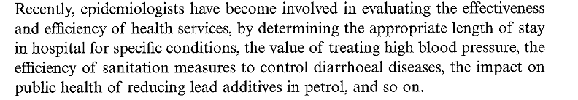

CH-6
Types of Epidemiology
Descriptive and Analytical Epidemiology
- Descriptive epidemiology
    - Describes the occurrence of disease (cross-sectional)
- Analytical epidemiology:
    - Observational (cohort, case control, cross-sectional, ecologic study) – researcher observes association between exposure and disease, estimates and tests it
    - Experimental (RCT, quasi experiment) – researcher assigns intervention (treatment), and estimates and tests its effect on health outcome

Epidemiologic Study Designs

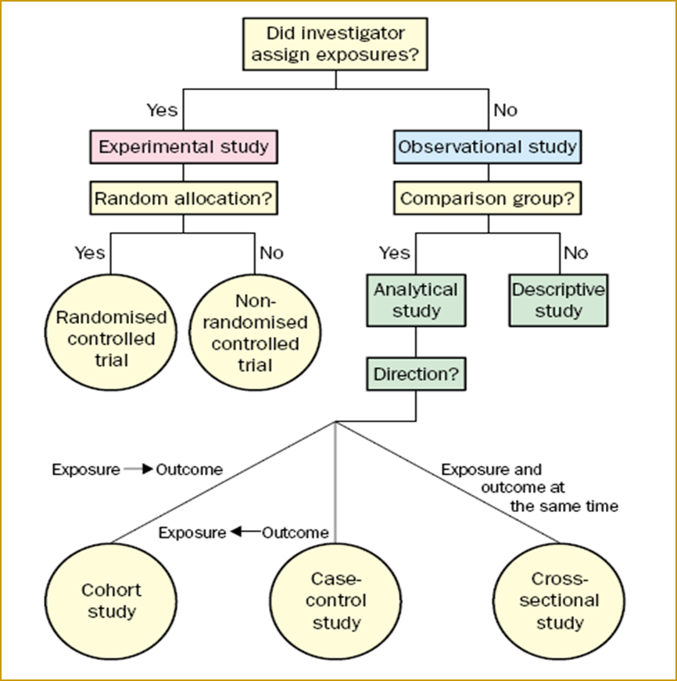

Description of Disease Distribution in the Population

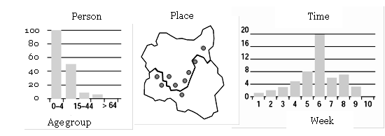
Person: Disease affects mostly people under five years of age
Place: Disease affects people living alongside the river
Time: Disease reaches its peak in frequency in Week 6

- Aims of Epidemiologic Research
- Descriptive epidemiology
- To assess the public health status of a population
- importance of diseases
B. Analytical Epidemiology
- To describe the natural history of disease,
- Explain the etiology of disease
- Predict the disease occurrence
- 6. To evaluate the prevention and control of disease
- Control the disease distribution
Etiology: the cause set of causes, or manner of causation of a disease or condition
Knowledge of how to treat and
How to prevent the disease.

* If we have sufficient knowledge about the causes of the disease and if these causes are avoidable, then we may be able to propose effective preventive programs.
* Clinical medicine may have a tendency to focus on rare but

CH-7
Measures of Disease Occurrence
* Public health priorities should be set by the combination of two aspects
1. How serious diseases are (i.e. it is a product of the number of persons suffering from a disease and its impact on those affected and society).
2. Also our ability to change their frequency or severity.
* Public health bodies may focus on the big picture by taking the frequency of disease and considers:
1. What are the best possibilities of saving many lives?
2. How to Prevent ill health and social impairments within available resources?, a
3. How do we best use these resources?

Measures of Diseases:
* We may use number of measures to describe the frequency of a disease.
But before this,
- we must count the number of people with the disease in the population (i.e. called the prevalence of the disease).

- Also must know how many new cases may appear over a given time period?

This requires either
*An estimate of the risk (the cumulative incidence ) or
* Rate of getting the disease over a given time span, giving new cases per unit time ( the incidence rate).

* Maternal, infant, and childhood mortality have been monitored in many parts of
the world and they are often considered strong indicators of general health. But similar effort was not made so far to compute other epidemiological measures.

Incidence and Prevalence Rates:
* A person may either have a disease, not have a disease, or have something in between.
* So when does a person become affected?
*While counting number of persons having a disease we have to use a set of criteria that indicates whether the person has the disease or not.
*For most diseases, we use a classification system , and we fallow International Classification of Diseases (ICD) to find people in one group or the other.
*Over a lifetime each of us will get a given disease or we will not get the disease in question,
*This probability has a time dimension.
* If you die at the age of 30, you are less likely to suffer from a heart stroke in your lifetime.
* On the other hand if you die at the age of 90 you are more likely to die because of heart stroke.
* Similarly, we may expect many more cancer cases in developing countries if life expectancy continues to increase for a population.

*The risk of getting a disease is usually a function of time and these probabilities are estimated from the observation of populations.

Also, by observing the occurrence of diseases in populations over a period of time, in such cases, we may be able to estimate incidence and prevalence of certain diseases.
*While estimating the Incidence rate and provenance rate we may consider gender, age, time, ethnic group, social conditions, place of residence, and information of other risk factors.
* Note that these measures are simply an indicator of risk, not a destiny.
* It is a prediction with uncertainty. In the end the person will either get the disease or not.
Example:
- Suppose, the person has a 25% risk of getting the disease within the next 10 years it does not mean that he/she will be 25% diseased.
It means that among, say, 1,000 people with his/her characteristics will expect about 250 persons may develop the disease.

*To estimate incidence and prevalence in a given population we need to identify the population and examine everyone in it,
Or
* a sample of them will be taken , at a given point in time to estimate prevalence, or during a follow-up time period (to estimate incidence).

- We want to estimate the prevalence of type 1 diabetes in a city with 100,000 inhabitants. We may call them all in for a medical examination or

- We may estimate based on a sample randomly selected from that population.
Thus the Prevalence Proportion (PP) is

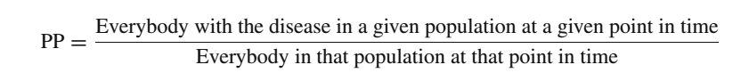
- Some Authors have defined Prevalence Proportion as Prevalence Rate as:

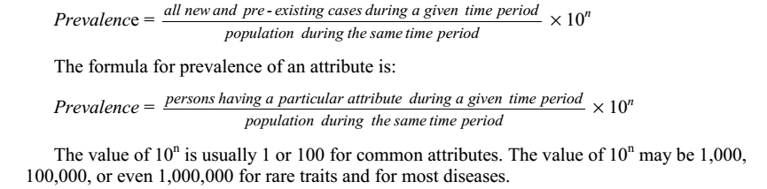
- The calculations of above rates depends on the availability of data .

Incidence Rates:
* Incidence rates are the most common measure of disease of measure of disease in a population.
It is also used to compare the frequency of disease in different populations.
*The incidence rate expresses the probability or risk of illness in a population over a period of time.
*Since incidence is a measure of risk, when one population has a higher incidence of disease than another, we say that the first population is at a higher risk of developing disease than the
second, when all other factors being equal.

* An incidence rate (sometimes referred to simply as incidence) is a measure of the frequency with which an event, such as a new case of illness, occurs in a population over a period of time.
*The formula for calculating an incidence rate follows:

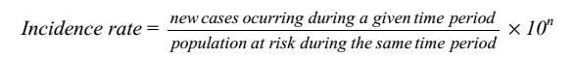
n- may be equal to 1,2,3,….
- Under steady-state conditions the prevalence is a function of the incidence (I) and the duration of the disease (D).
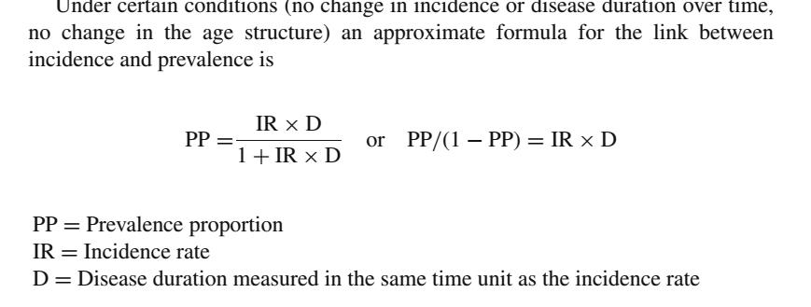
* Again there are two types of prevalence’s.
1. Point prevalence
2. Period prevalence

*The amount of disease present in a population is constantly changing over time.
* Sometimes, we want to know how much of a particular disease is present in a population at a single point in time—to get
a kind of “stop action” or “snapshot” look at the population with regard to that disease.
*This requires estimation of point prevalence for that purpose.
* The numerator in point prevalence is the number of persons with a particular disease or attribute on a particular date.
* Point prevalence is not an incidence rate, because the numerator includes pre-existing cases; it is some kind of a proportion, because the persons in the numerator are also in the denominator.
*On the other hand we want to know how much of a particular disease is present in a population over a longer period?
* Then, we use period prevalence.
*Here the numerator in period prevalence is the number of persons who had a particular disease or attribute at any time during a particular interval.
*The interval can be a week, month, year, decade, or any other specified time period.

Examples:
1. Example
In a survey of patients at a sexually transmitted disease clinic in San Francisco, 180 of 300 patients interviewed reported use of a condom at least once during the 2 months before the interview (1).
Compute period prevalence of condom use in this population over the last 2 months
Solution:
As per definition Period Prevalence Rate =
(Number of persons who had a particular disease or attribute at any time during a particular interval / Population during the same period) x 100
Denote x= No. persons used condom over the period of last 2 Months
Y= Total no of Patience during the same period
Period Prevalence Rate = (x/y) x100 = (180/300) x100= 60.0%
Thus, the prevalence of condom use in the 2 months before the study was 60% in this Population of patient.

2.Example :Two surveys were done of the same community 12 months apart. Of 5,000 people surveyed the first time, 25 had antibodies to histoplasmosis. Twelve months later, 35 had antibodies, including the original 25.Calculate the prevalence at the second survey, and compare the with the 1-year incidence.
Solution:
Two surveys conducted on the same community, the time gap between them was 2-months
By definition, we have, prevalence rate in the second survey is
Take n=3, the n
1. Prevalence at the second survey:
x= antibody positive at second survey (see numerator) = 35
y= population = 5,000
Prevalence rate = (35/ 5000) x 1000 = 7 per 1000
Similarly Incidence rate is given by
Let no. of new cases reported = x = 35-25 = 10
Population at risk at the same time period= y= 5000-25= 4750

Incidence rate = (10/4750) x 1000 = 2.10526 = 2 persons per 1000 population
CH-8
Other Measures
Attack Rate
An attack rate is a variant of an incidence rate, applied to a narrowly defined population observed for a limited time, such as during an epidemic. The attack rate is usually expressed as a percentage.
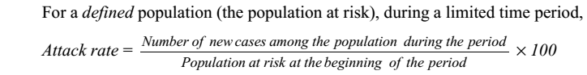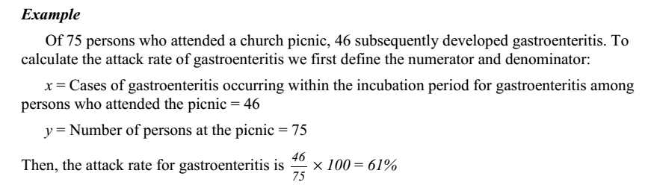
In the
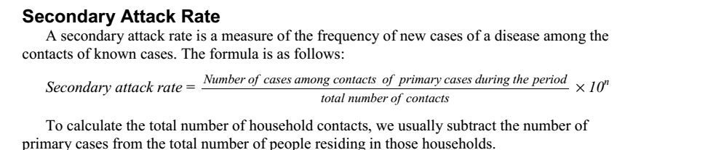

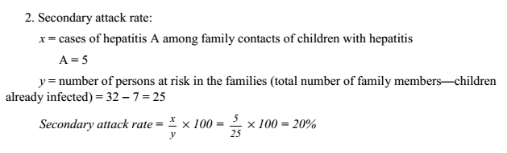
Risk Ratio :
*A risk ratio, or relative risk, compares the risk of some health-related event such as disease or death in two groups.
*The two groups are typically differentiated by demographic factors such as sex (e.g., males versus females) or by exposure to a suspected risk factor (e.g., consumption of potato salad or not).

*Among the two groups, the group of primary interest labeled the “exposed”
group, and the other comparison group labeled as “unexposed” group.
*Taking the group that we are primarily interested in the numerator; and the other group will be placed in the denominator, thus,
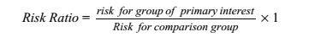
* A risk ratio of 1.0 indicates identical risk in the two groups.
* A risk ratio greater than 1.0 indicates an increased risk for the numerator group,
* While a risk ratio less than 1.0 indicates a decreased risk for the numerator group

Example:
The following data gives the classic studies of pellagra by Goldberger.
Pellagra is a disease caused by dietary deficiency
calculate the risk ratio of pellagra for females versus males. Pellagra is a disease caused by dietary deficiency of niacin and characterized by dermatitis, diarrhea, and dementia. The totals for females and males are also shown in below Table.

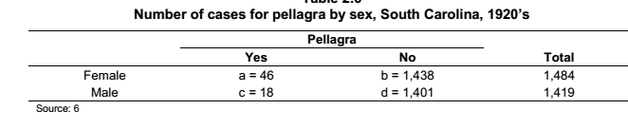
To calculate the risk ratio of pellagra for females versus males, we must first calculate the risk of illness among females and among males.

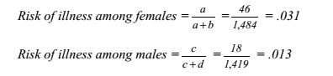

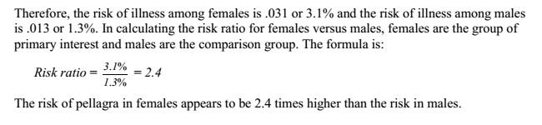
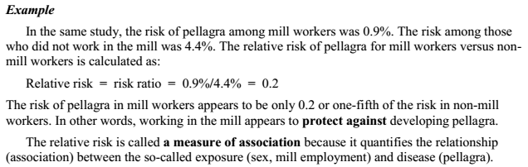
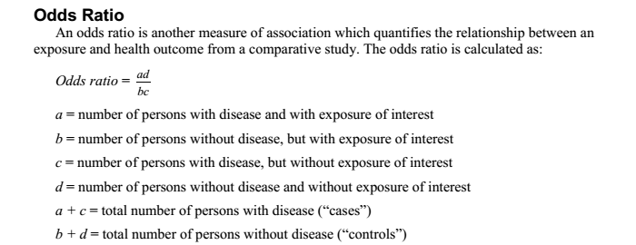

Conside the below table
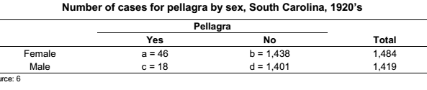
The odds ratio is sometimes called the cross-product ratio, because the numerator is the product of cell and cell d, while the denominator is the
product of cell band a and cell d. A line from cell to cell d(for the numerator) and another from cell b to cell c(for the denominator) creates an xor cross on the two-by-two table.
To quantify the relationship between pellagra and sex, the odds ratio is calculated as:
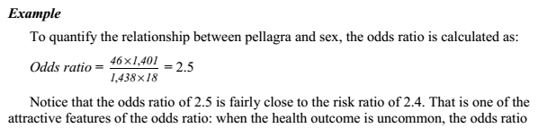

Problems

HOME ASSIGNMENT
Q.NO.1 Discuss Deductive and Inductive Inference in the context of Biostatistics
Q.NO.2. Discuss Karl Popper claims that “ induction arising from accumulation of affirmative evidence doesn't strengthen a theory”
q.No.3. Define Probability and state the additive and multiplicative theorems
Q.No.4. Define Conditional and Bayesian probability. also use of Bayesian probability
Q.No.5.Define Chi-Square Statistics and use of Contingency Tables
Q.NO.6. Define Epidemiology and explain its use and scope
Q.No.7. Define Incident Rate and Prevalence Proportion. Also define interrelationship between them
Q.No.8. Define attack rate, secondary attack rate, risk ratio and odd ratio
Q.No.9 Two surveys were done of the same community in 2 years apart. Of 8,000 people surveyed the first time, 45 had Malaria. After one year, 65 had same disease including the original .Calculate the prevalence at the first survey, and Incidence rate.
Q.No.10.In a city survey conducted in a year out of 1000, about 180 people suffering from a certain disease. Find Prevalence Proportion and what the Incidence ratio after two years using prevalence proportion
Q.No.11. In a sample of size n denoted by Xi , where i= 1234…….n, each
Xi = 1 if disease is present
Xi = 0 if disease is not present
Estimate E (Xi) , Var( Xi ), sample proportion p, Var(p) and also 95% confidence interval for p

