CHAPTER ONE
1. INTRODUCTION
1.1. HISTORY OF AGROFORESTRY
Trees have been used in cropping systems since the beginning of agriculture. Throughout the world, at one period or another in its history, it has been the practice to cultivate tree species and agricultural crops in intimate combination. In much of the tropics, human beings underwent a transition from hunting/gathering to the use of domesticated plants and livestock. Agroforestry practices are traditional, very old, and very specific to the local social, economic and agro-ecological conditions. The farmers, grazers, and forest dwellers have an intimate knowledge of these traditional practices.
History of agroforestry dates back to almost 1700 years ago in parts of China. In Europe until the middle ages, forests were clear felled and burn the slash, and cultivate food crops. This practice followed in Finland in the 18th century, and was practiced in some part of Germany until 1920s. In tropical America, multistory agroforestry system was practiced, where coconut with lower layers of papaya, banana or citrus fruits and shrub layers of coffee and maize were grown. In southern Nigeria, yam, maize, pumpkins and beans were grown under scattered trees from the beginning of human settlement. In Philippines, a complex and sophisticated systems or types of shifting cultivation were practiced. At the end of 19th century, forest plantation has been established adopting agroforestry systems, which is known as Taungya agroforestry system. This system was first started from Burma in 1850s, where teak (Tectona grandis) plantation areas were given to shifting cultivators to grow agriculture crops.
1.2. Concepts and Definitions of Agroforestry
Agroforestry is an old practice, indeed very old. Farmers of the tropical area have long tradition of growing food crops, tress and animals together as well as exploiting a multiple range of production from natural wood lots. In fact, so much has been said about trees in our ancient literature that planting tree was being done by individuals on their own along with agriculture crops.
More recently, however, the forest area has receded and resources have shrunk considerably. The people are no longer able to meet their requirements of firewood, fodder, timber, bamboo, etc. from the forest. Due to shortage of wood the prices of these commodities have, therefore, increased substantially. Many forest based industries have been facing problems in supply of raw material. Many farmers quite recently started planting trees on their farm lands to meet these shortages along with agriculture crop; thus it emerged out the concept of agroforestry.
Definitions of Agroforestry: -
Agroforestry means practice of agriculture and forest/ horticulture tree on the same piece of land. However, the agroforestry has been defined by various workers working in the field of agroforestry. Some of the definitions given by different workers are as follows:
- In simple word, agroforestry is a science that combines trees and agriculture crops (food, fruit, vegetables, fodder and forage etc) together in the same land at the same time.
- Bene et al. (1977) defined agroforestry as a sustainable management system for land that increases overall production, combines agriculture crops, forest plants and tree crop and/or animals simultaneously or sequentially and applies management practices that are compatible with the cultural patterns of a local population.
- King and Chandler (1978): “Agroforestry is a sustainable land management system which increases the overall yield of the land, combines the production of crops (including tree crops) and forest plants and/or animals simultaneously or sequentially, on the same unit of land and applies management practices that are compatible with the cultural practices of the local population.
- Nair (1979) defines agroforestry as a land use system that integrates trees, crops and animals in a way that is scientifically sound, ecologically desirable, practically feasible and socially acceptable to the farmers.
- According to Lundgren and Raintree (1982), agroforestry is a collective name for land use systems and technologies, where woody perennials (trees, shrubs, palm bamboos, etc.) are deliberately used in the same piece of land management units as agriculture crops and/or animals in some form of spatial arrangement or temporal sequence. In agroforestry systems, there are both ecological and economical interactions between the different components.
- ICRAF (1982) defined agroforestry system as a land use system that integrates trees with agriculture crops, and or animals simultaneously or sequentially to get higher productivity, more economic returns and better social and ecological benefits on a sustainable yield basis than are obtainable from mono-culture on the same unit of land, especially under conditions of low levels of technological inputs on marginal sites.
Attributes of Agroforestry
There are three attributes which, theoretically, all agroforestry system possess, these are:
✓ Productivity: Most, if not all, agroforestry systems aim to maintain or increase production (of preferred commodities as well as productivity (of the land). Agroforestry can improve productivity in many different ways. These include: increased output of tree products, improved yields of associated crops, reduction of cropping system inputs, and increased labour efficiency.
✓ Sustainability: By conserving the production potential of the resource base, mainly through the beneficial effects of woody perennials on soils, agroforestry can achieve and indefinitely maintain conservation and fertility goals
✓ Adoptability: The word “adopt” here means “accept” and it may be distinguished from another commonly used word adapt, which implies “modify” or “change.” The fact that agroforestry is a relatively new word for an old set of practices means that, in some cases, agroforestry already been accepted by the farming community. However, the implication here is that improved or new agroforestry technologies that are introduced into new area should also conform to local farming practices.
Principles of Agroforestry
- Productive- Agroforestry systems have capacity to produce food crops, fruits, leaf litter, timber, fuel wood, and fodder for livestock.
- Protective- Agroforestry helps to minimize the degradation of the farm lands and other natural resource by working as shelterbelt.
- Ameliorative- Agroforestry systems with legume trees and crops help to maintain or improve the productivity of the land.
- Livelihood improvement- Income can be generated from the sale of forest and agriculture products.
Characteristics of agroforestry systems
  - Involves two or more species of plants (plants or animals) with at least one woody perennial.
  - Always have two or more outputs.
  - Cropping cycle is always longer than one year.
  - Ecologically and economically complex system than a mono-cropping.
  - Significant interaction between woody and non-woody components of the system.
  - Efficient use of available resources.
  - Improve local environment.
  - Finally, income generation from the sale of agroforestry products

Objectives of agroforestry
- To maximize the overall production of food/fruits, woody crops and fodder and forage including livestock per unit area.
- To conserve soil, water and other resources including soil productivity.
- To improve local environment.
- To enhance the socio-economic condition of the farmers.
- Finally, to improve the livelihoods of the farmers.
1.3. The role of agroforestry
1.3.1. Economical role of agroforestry
- Produce multiple products to meet growing demand of increasing human population and livestock. These products are food/vegetables/fruits, fodder and forage needed for livestock, fuel wood, timber, leaf litter needed for organic manure production and NTFPs.
- Minimize total crop failure when farm is attacked by insects, pests and diseases.
- Sustain the crop productivity which increases the level of income of the farmers.
- Improve the nutritive value of animal and human diet.
- For soil nutrient recycling, which also helps to reduce chemical fertilizer purchase
1.3.2. Climate change and carbon trade role of agroforestry
- Stabilize shifting cultivation which leads the protection of the remaining forests.
- Improve the farm site ecology by reducing surface run off, soil erosion and nutrient loss, gully formation, landslides, and river bank erosion.
- Improve the local micro-climate and enhance the productive capacity of the farm.
- Reduce pressure of community and natural forests for fodder, fuel wood and timber
- Agroforestry helps for the beautification of the surrounding areas.
- Works as carbon sequesters, which helps to reduce the effects of climate change.
Highly productive agroforestry systems such as silvi-pastoral system can play an important role in carbon sequestration in soils and in the woody biomass. For example, traditional cattle management involves grass monocultures which degrade in about 5-7 years after establishment, releasing significant amounts of carbon to the atmosphere.
1.3.3. Livelihood and Social role of agroforestry
- Improving the living standard of the farmers through sustained agroforestry yield, income and employment.
- Access of health, education, and other social services of the farmers could be improved due to the regular income and employment opportunities.
- Increasing population requires more food, fuel wood, fodder and forage, and timber. To meet these demands, agroforestry is the only one option.
- Agroforestry farmer groups could be formed easily involving farmers practicing agroforestry practices, and their capacity can be built up easily.
Disadvantages of agroforestry
- Increase tree and agriculture crop competition for light, nutrient and space.
- Nutrient deficiency due to the over absorption.
- Amount of plant nutrient needed for crop produced increased due to the tree crop competition.
- Nutrient availability in under storey crops reduced due to the tree shade.
- Habitat to dangerous wild animals
- Trees and crops damage from wild animals.
- Allelopathy effects.
- Damage to trees and crops from cultivation and tree harvest.
- Huge possibility for soil erosion during tree harvesting in sloppy lands.
- Habitat or alternative hosts for insects, pests and diseases
- Sometimes require more labour inputs.
- Crop yield reduced due to the tree crop competition.
- Longer period may be required for trees to grow and mature.
- High possibilities for replacing food crops by trees.
- Complexity for practicing agroforestry systems to farmers compared with mono-cropping.
- More financial resource needed to follow agroforestry practice properly.
Strategy to overcome the above limitations
- Select legume trees with light crown covers to reduce tree crop competition.
- Select deep rooted trees.
- Trees should be planted in wider space.
- Select appropriate under storey crops
- Manage trees adopting following practices:
- Singling, pruning and thinning for timber species
- Lopping, pollarding and coppicing for fodder species.
1.4. Social, farm, recreation and extension forestry
1.4.1. Social Forestry:
Social forestry is the practice of forestry on lands outside the conventional forest area for the benefit of the rural and urban communities. It was first recognized as an important component of forestry for meeting rural needs in the interim report of the National Commission on Agriculture (NCA), 1976. The objectives of social forestry adopted by the NCA were to fulfill the basic and economic needs of the community. The scope of social forestry defined included farm forestry, community woodlots and reforestation in degraded lands. The concept of social forestry was firmly established as forestry, for the people, with the people and by the people‟ or forestry of the people, by the people and for the people.
1.4.2. Farm Forestry: Farm forestry is the practice of forestry on farms in the form of raising rows of tree on bunds or boundaries of field and individual trees in private agriculture land as well as creation of wind breaks, which are protective vegetal screens created round a farm or an orchard by raising one or two lines of trees fairly close with shrubs in between.
1.4.3. Recreation Forestry: is the practice of forestry with the object of raising avenue/flowering trees and shrubs mainly to serve as recreation forests for the urban and rural population. This type of forestry is also known as Aesthetic forestry which is defined as the practice of forestry with the object of developing or maintaining a forest of high scenic value
1.4.4. Extension Forestry: Extension forestry is the practice of forestry in areas devoid of tree growth and other vegetation and situated in places away from the conventional forest areas with the object of increasing the area under tree growth.
Relation of Agroforestry with other disciplines
1. Forestry
Forestry and agroforestry have close relationship because;
- Agroforestry is a branch of forestry science.
- Woody perennial trees are common in both sciences and land use system.
- Forestry has mainly monoculture of natural occurrence, whereas agroforestry is a polyculture and has been integrated with trees.
- Both practice supply similar forest products like fodder, fuel wood and timber, and other NTFPs.
- Agroforestry helps to protect forest by reducing dependency on forest for the supply of the main products.
- Knowledge of forestry and silvics of different species gained from forestry science can be applied in agroforestry system development and management.
- Knowledge and skills on tree management gained from agroforestry can be applied in forestry.
2. Agriculture
Agriculture and agroforestry have close relationship because;
- Both land use systems include agriculture crops.
- Tree products like fodder, leaf litter and poles are required for agriculture activities.
- Trees, livestock and agriculture crops have strong linkages and interrelationship.
- Tree products like fodder and leaf litter obtained from agroforestry are one of the main sources of organic manure which is fundamental components for sustaining the farming system.
- Legume trees grown in agroforestry system help to improve soil productivity by fixing atmospheric nitrogen into the soil, which provide support to increase agriculture production.
- Trees grown in agroforestry plots work as shelterbelt for agriculture crops.
- Knowledge and skills on agriculture crops gained from agriculture science can be applied in agroforestry system development and management.
- Similarly, knowledge and skills on agriculture crops gained from agroforestry science can be applied in agriculture system development and management.
3. Social forestry
Social forestry and agroforestry have close relationship because
- Both sciences have woody perennials trees.
- Both systems need trees for sustaining the farming systems.
- Both sciences have two fold relationships that are vertical and horizontal relationship because agroforestry is a part of social forestry with vertical relationship, and both social forestry and agroforestry involve farmers and have horizontal relationship.
- Social forestry passes research results to farmers and its feedback to the agroforestry scientists.

CHAPTER TWO
2. CLASSIFICATION OF AGROFORESTRY
The main purpose of agroforestry system classification is:
- To arrange agroforestry system in logical groups based on production.
- Allow agroforestry management system improvement,
- To know flexibility in regrouping the information and
- To make easy for understand and readily handled.
Principles of agroforestry system classification
The most common criteria’s for the classification of agroforestry systems are the structural basis, in which components of agroforestry (forestry, agriculture and livestock) are combined. Other criteria’s include its function, socio-economic scale and management level and ecological basis. According to Nair (1987), following are the main principles or criteria’s for agroforestry system classification.
2.1. Structural basis
It refers to the composition of components such as forestry, agriculture and livestock. This component composition can be in time (temporal or short duration and long duration) and space (dense or spatial), and other terms are used to justify the various arrangement made for system development.
- Considers the composition of components including spatial and mixture of the woody components.
- Vertical stratification of the components mix and temporal arrangement of the components.
- The spatial arrangement of trees in agroforestry system can be categorized as mix dense (like in home garden), mix sparse (like in pasture land), strip of trees, and boundary plantation.
The main agroforestry systems under components composition are as follows:

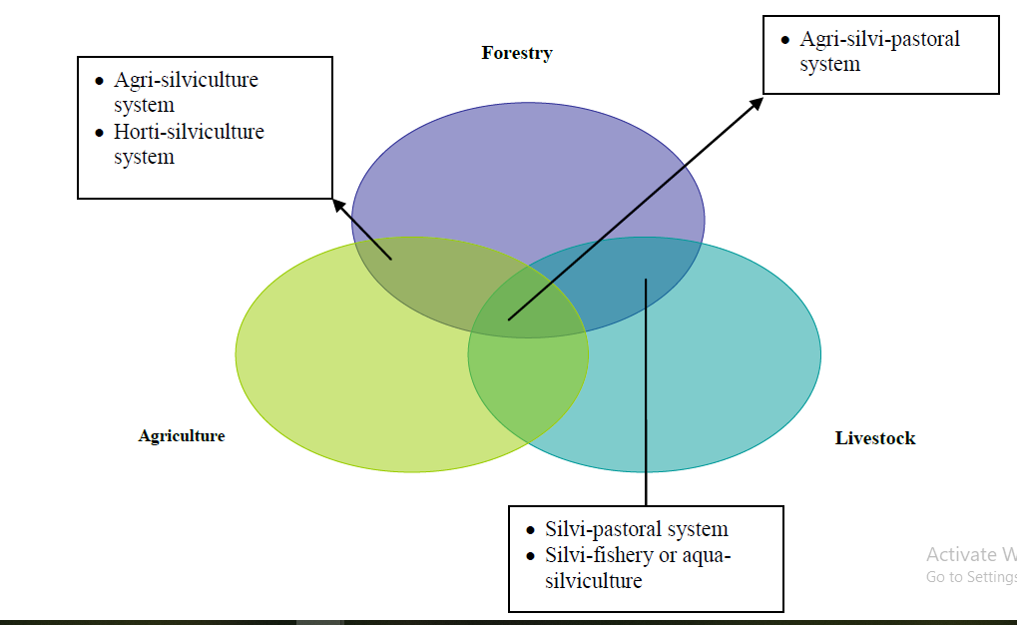

Hence on the basis of structure agroforestry system can be grouped into two broad categories such as nature and arrangement of components.
1. Nature of components: Based on nature of component agroforestry systems can be classified into following categories
  - Agrisilviculture system
  - Silvopastoral system and
  - Agrosilvopastoral system
A) Agrisilviculture system (crops + Tree)
This system involves the conscious and deliberate use of land for the concurrent production of agricultural crops including tree, crops and forest crops.
B) Silvo-Pastoral System (Trees + Pasture and/or Animals)
The production of woody plants combined with pasture is referred to as a silvi-pastoral system. The trees and shrubs may be used primarily to produce fodder for livestock or they may be grown for timber, fuel wood, and fruit or to improve the soil. A silvo-pastroal system is needed in dry areas, in order to meet out the demands of wood and fodder throughout the year. There are three main categories of silvicultural system.
C) Agro-silvopastoral System (Crops + Tree +Grasses/Animals)
Growing of trees, agriculture crops and grasses together in same lands at the same time is known as agri-silvi-pastoral system
2. Based arrangement of components
Arrangement of component refers to the plant component of the system even in agroforestry system involving animal the management of such animal according to definite plan such as rotational grazing scheme is in consideration more of the plant than animal. Such plant arrangement in multi species combination can involve dimension, space and time.
i. Spatial arrangement
– Mixed dense, e.g., homegardens
– Mixed sparse, e.g. most systems of trees in pastures
– Zonal-microzonal, macrozonal
Spatial or zonal agroforestry varies from microzonal (such as alternate rows of plant components) to macrozonal arrangements. An extreme form of the zonal arrangement is the boundary planting of trees on edges of plots for fruits, fodder, fuel wood, fencing, soil protection and windbreak.
ii. Temporal arrangement
Temporal arrangement of plant in agroforestry systems can take various forms such as;
- Coincident: When two component woody and non woody components occupy the land together as coffee under shade tree and pasture under shade trees.
- Concomitant: When two component woody or non woody stays together for some part of life as in taungya
- Intermittent (Space dominated): When annual crops are grown with perennial crops.
- Interpolated (Space and time dominated): When different components occupy space during different time as in home garden.
- Separate (time dominated): When component occupy space during separate time such as improved fallow species in shifting cultivation.
2.2. Functional basis
Refers to the major function or role of the system, usually furnished by the woody components (these can be of a production service or protective nature, e.g., windbreak, shelterbelt, soil conservation).
i. Agroforestry for fuel wood production:
In this system, various multipurpose fuelwood/firewood species are inter-planted on or around agricultural lands. The protective role is to act as fencing, shelter belts and boundary demarcation.
ii. Shelterbelt/ windbreaks
Shelterbelt is a wide belt of trees, shrubs and grasses, planted in rows which goes right across the land at right-angle to the direction of the prevailing winds to deflect air current, to reduce wind velocity and to give general protection to cultivated areas against wind erosion and desiccating effect of the hot winds in lee-ward side.
iii. Soil conservation hedges:
In this system, the major groups of components are: multipurpose and/or fruit trees and common agricultural species. The primary role of multipurpose fruit trees and agricultural species is soil conservation and provision of various tree products. The following tree species are used for soil conservation:
2.3. Socio-economic basis
Refers to levels of inputs (low input, high input), or intensity or scale of management and commercial goals (subsistence, commercial, intermediate).
- Commercial agroforestry systems: aim at the production of a saleable output (for example, commercial tree plantations with under planting of food crops)
- Intermediate agroforestry systems: fall between commercial and subsistence scales of production and management
- Subsistence agroforestry systems: are directed toward satisfying basic needs, and are managed mostly by the owner/occupant and his family. Cash crops, including sale of produce surplus are only supplementary
2.4. Ecological basis
Refers to the environmental condition and ecological suitability of systems, based on the assumption that certain types of systems can be more appropriate for certain ecological conditions; i.e., there can be separate sets of agroforestry systems as;
A) Humid / Sub-humid lowlands agroforestry systems;
Examples: Homegardens, Trees on rangelands and pastures, improved fallow in shifting cultivation and Multipurpose woodlots.
B) Semiarid and arid lands agroforestry systems;
Examples: Various forms of silvo-pastoral systems, wind breaks and shelterbelts.
C) Tropical high lands agroforestry systems;
Examples: Production systems involving plantation crops such as coffee, tea, use of woody perennials in soil conservation and improved fallow.
2.5. Agroforestry system, practice, and technology
The words “systems” and “practices” are often used synonymously in agroforestry literature. However, some distinction can be made between them:
i. Agroforestry system- is characterized by certain types of practices that, taken as a whole, form a dominant land-use system in a particular locality and determine its overall biological composition and management. In any one agroforestry system there can be more than one agroforestry practices.
ii. Agroforestry practice- denotes a specific land management unit, such as a field, and a specific arrangement, temporally and/or spatially, of components.
iii. Agroforestry technology- This refers to an innovation or improvement, usually through scientific intervention, to either modify an existing system or practice, or develop a new one.

CHAPTER THREE
3. AGROFORESTRY SYSTEMS IN THE TROPICS

The geographical definition of the word "tropics" (that part of the world located between 23.5 degrees north and south of the Equator) is not of much value in a discussion on land use. For the purpose, the word tropics is used in a general sense, and includes the subtropical developing countries that have agro-ecological and socioeconomic characteristics, and land-use problems, that are similar to those of the countries within the geographical limits of the tropics. In other words, the word is used, though erroneously, as a synonym for developing countries.
3.1. The tropical environment

The major climatic parameters that determine the environment of a location in the tropics are rainfall (quantity and distribution) and temperature regimes. Altitude is important because of its influence not only on temperature, but also on land relief characteristics. From the agroforestry point of view, the major ecological regions recognized in the FAO State of Food and Agriculture Reports (SOFA) are relevant: these are temperate, mediterranean, arid and semiarid, subhumid tropical (lowland), humid tropical (lowland) and highland. These classes, excepting the first (and possibly the second), represent the tropical and subtropical lands where agroforestry systems exist or have a potential.
One of the special features of the tropics that is not a consequence of its climate and ecology is its poor economic, social, and developmental status. As mentioned earlier, the word tropic is used synonymously with developing countries. Most nations and people in the tropics are poor; gross domestic product per person is low (about $ 100-150 per year) in most of these countries. Economic growth seldom keeps pace with population increase. Vast majorities of the people work and depend on the land for their livelihood; yet agricultural production per unit area is very low. The gravity of the situation is compounded by the unfortunate political instability and turmoil that are characteristic of many of these nations, which is a serious impediment to economic development. The main characteristics of these ecological regions (humid and subhumid lowlands, dry - semiarid and arid - regions, and highlands) are summarized in Table 4.1.
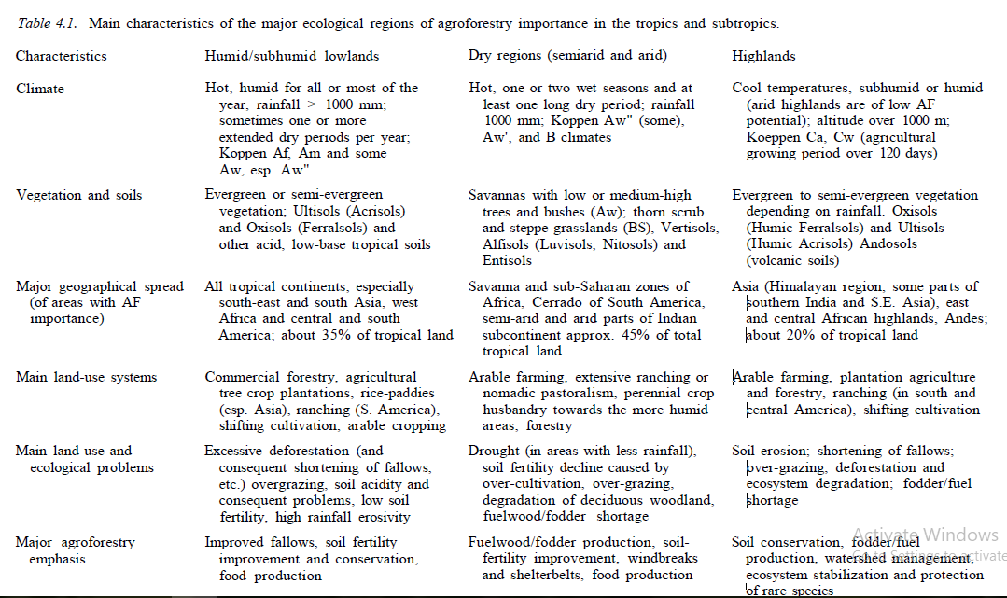
3.3. Ecological spread of major Agroforestry systems
A generalized overview of the most common agroforestry systems in different parts of the tropics and subtropics is given below.
a) Humid Lowlands
- Shifting cultivation
- Taungya
- Plantation-crop combinations
- Multilayer tree gardens
- Intercropping systems
b) Semiarid Lowlands
- Silvopastoral systems
- Windbreaks and shelterbelts
- Multipurpose trees for fuel and fodder
- Mutlipurpose trees on farmlands
c) Highlands
- Soil conservation hedges
- Silvopastoral combinations
- Plantation-crop combinations

CHAPTER FOUR

4. AN OVERVIEW OF GLOBAL AGROFORESTRY SYSTEMS
4.1. Agri-silvicultural systems
4.1.1. Shifting cultivation
In this system, forest patch is selected and cleared felled. The herbs, shrubs and twigs and branches (slashed vegetation) are burnt .Cultivation of crops is done for a few years until soil fertility declines. The site is than abandoned (fallow period) and new patch is selected for cultivation of crops. The site is again cultivated after giving rest for few years. Earlier the fallow cycle was of 20–30 year. However, due to increasing requirement for cultivation of land due to population pressure, fallow period has reduced from 25–30 years to 2–3 years which has broken down the resilience of ecosystem and the land is increasingly deteriorating. Thus now shifting cultivation has become source of ecological degradation, soil erosion and converting good forests into wastelands.
Effect of shifting cultivation
- Deforestation of hill slopes-in secondary succession, area is occupied by weeds, useless shrubs
- Soil erosion which leads to soil and nutrient losses, silting of reservoirs and streams, reduction in water-yield and landslips and landslides
- Shifting cultivation adversely affects cation exchange capacity and physical properties of soil.
- Increases soil pH and reducing microbial activity
  - More weed growth and lower crop yield
  - No opportunity for infrastructural development
4.1.2. Improved fallow
Fallowing is defined as leaving land that is normally cultivated temporarily uncultivated. An improved fallow is defined as enrichment of a natural fallow with trees, shrubs or herbaceous legumes planted at high density to improve soil fertility. Improved tree fallows have the potential to increase crop yields while also providing wood. They are able to restore soil fertility more rapidly than the traditional fallows and, hence, allow shortening of the required fallow period. Improved fallow is also known as enriched fallow. When established with only leguminous trees and/or shrubs, it could be called Leguminous fallow. That is, Leguminous fallows are natural fallows enriched with planted legumes to improve soil fertility. The objective of improved fallow species in shifting cultivation is to recover depleted soil nutrients. Once the soil has recovered, crops are reintroduced for one or more season. The best species for the fallow system should induce good nitrogen fixation in the soil. The main aim of the fallow is to maintain or restore soil fertility and reduce erosion; some plants can be introduced primarily for their economic value. Plants included in improved fallows should be compatible with future crops, free of any negative physical or chemical effects on the soil and not in competition with the crops to be planted later on the same site.
4.1.3. Taungya
The taungya system was used primarily as an inexpensive means of establishing timber plantations but is finally a recognized as AF system. The taungya (taung = hill, ya = cultivation) is a Burmese word coined in Burma in 1850. This is a modified form of shifting cultivation in which the labour is permitted to raise agri-crops in an area but only side by side with the forest species planted by it. The practice consists of land preparation, tree planting, growing agricultural crops for 1-3 years, until shade becomes too dense, and then moving on to repeat the cycle in a different area. A large variety of crops and trees, depending on the soil and climatic conditions, are grown in a system. In fact this system was introduced to raise forest plantations, but finally became recognized agroforestry system.

Advantages of Taungya:
- Artificial regeneration of the forest is obtained cheaply;
- Problems of unemployment are solved
- Helps towards maximum utilization of the site;
- Low cost method of forest plantation establishment;
- In every case, highly remunerative to the forest departments;
- Provision of food crops from forest land;
- Weed, climber growth, etc. is eliminated.
Disadvantage of the Taungya:
- Loss of soil fertility and exposure of soil;
- Danger of epidemics;
- Legal problems created;
- Susceptibility of land to accelerated erosion increases; and,
- It is a form of corruption of human labour
4.1.4. Home-gardens
The word “homegarden” has been used rather loosely to describe diverse practices, from growing vegetables behind houses to complex multistoried systems. It is used here to refer to intimate association of multipurpose trees and shrubs with annual and permanent crops and, invariably livestock within the compounds of individual houses, with the whole crop-tree-animal unit being managed by family labour. These systems are common in all ecological regions in the tropics and subtropics, especially in humid lowlands with high population density. It is deliberate integration of trees, crop and animals in a same unit of land in some form of spatial and temporal sequence around residential areas.

4.1.5. Multilayer tree gardens
In this system of agroforestry, various kinds of tree species are grown mixed. The major function of this system is production of food, fodder and wood products for home consumption and sale
4.1.6. Plantation crop combinations
Perennial trees and shrubs such as coffee, tea, coconut and cocoa are combined into intercropping systems in numerous ways, including:
i. Integrated multistory mixture of plantation crops
ii. Mixture of plantation crops in alternate or other crop arrangement;
iii. Shade trees for plantation crops
iv. Intercropping with agricultural crops.
Example, Coffee (Coffea arabica) is grown under the shade of Erythrina lithosperma as temporary shade while, permanent shade trees include Ficus glomerata, F. nervosa, Albizia chinensis, A. lebbek, A moluccana, A. sumatrana, Dalbergia latifolia, Bischofia javanica, Grevillea robusta.
4.1.7. Alley Cropping
Alley cropping, also known as hedgerow intercropping. In this perennial, preferably leguminous trees or shrubs are grown simultaneously with an arable crop. The trees, managed as hedgerows, are grown in wide rows and the crop is planted in the interspace or 'alley' between the tree rows. During the cropping phase the trees are pruned and leaves and twigs are used as mulch on the cropped alleys in order to reduce evaporation from the soil surface, suppress weeds and/or add nutrients and organic matter to the top soil. The primary purpose of alley cropping is to maintain or increase crop yields by improvement of the soil and microclimate and weed control. Farmers may also obtain tree products from the hedgerows, including fuel wood, building poles, food, medicine and fodder, etc
Layout of Alley:
The position and spacing of hedgerow and crop plants in an alley cropping system depend on plant species, climate, slope, soil conditions and the space required for the movement of people. Ideally, hedgerows should be positioned in an east to west direction so that plants on both sides receive full sunlight during the day. The spacing used in fields is usually 4 to 8 meters between rows and 25 cm to 2 meters between trees within rows. The closer spacing is generally used in humid areas and the wider spacing in sub-humid or semi-arid regions. The spacing used in fields is usually 4 to 8 meters between rows and 25 cm to 2 meters between trees within rows. The closer spacing is generally used in humid areas and the wider spacing in sub-humid or semi-arid regions.
Advantages of alley cropping
- Improve crop performance due to the addition of nutrients and organic matter into the soil
- Reduction of the use of chemical fertilizers,
- Improvement in the physical nature of the soil environment.
- Reductions in erosion losses.
- Provision of additional products such as forage, firewood or stakes when a multipurpose tree legume is used as the hedgerow, and
- Improvement in weed control.
4.1.8. Biomass transfer
This is the application of leafy biomass from to crop fields to improve soil fertility. Leguminous trees are most frequently used as biomass transfer; but there is increasing evidence that non-leguminous shrubs may also accumulate high concentrations of nutrients in their biomass.

4.1.9. Windbreaks and Shelterbelts
Windbreaks are narrow strips of trees, shrubs and/or grasses planted to protect fields, homes, canals, and areas from wind and blowing sand. Where wind is a major cause of soil erosion and moisture loss, windbreaks can make a significant contribution to sustainable production.
A shelterbelt is a wide strip of vegetation that slows wind speeds, thereby reducing wind erosion, evaporation and damage to towns, villages and adjoining farmlands by the wind. It is sometimes referred to as windbreak, although the latter often implies a single strip of trees and other vegetation. A shelterbelt presents a mechanical barrier to the impact of the wind, and separates two zones; the windward and the leeward zones. The windward zone refers to the side from which the wind blows, whilst the leeward zone relates to the side where the wind passes. As a rule of the thumb, a belt protects a distance up to its height on the windward side and up to 20 times its height on the leeward side..
Orientation of shelterbelts
As their main function is to protect agricultural lands against the hazards of wind and wind speed, shelterbelts are placed on the upwind side of the land to be protected. They are most effective when the shelterbelt is situated perpendicular (at right angles) to the prevailing wind direction.
4.1.10. Crops under tree cover
Farmers often leave or plant trees to provide shade for plantation crops such as coffee and tea. Young cocoa plants also need shade in the nursery and for the first 2-3 years in the field. The shade moderates the microenvironment so that excessive moisture stress is avoided and also reduces wind damage. The use of shade trees in coffee plantations is common in the tropics and legume trees are mostly used for this purpose. A major function of such trees is contribution of nutrients to low fertility soils wherever inorganic fertilizers are not used. Cordia africana, Gliricidia sepium and Ficus fasta are common shade tree species for coffee and bananas in Ethiopia.
4.1.11. Boundary planting
Certain multipurpose trees are used to mark farm boundaries. Unlike live fences, the trees on boundaries need not be closely spaced except when soil erosion control is also desired. Tree growing on farm boundaries requires agreement between neighboring farm owners to avoid conflicts. There are difficult ways of sharing trees planted on a boundary. Sometimes two rows of trees are planted, one on each side of the boundary, and then each farmer grows and manages his own trees. A disadvantage of this is that it occupies more land than a single row. Initially trees can be established at a close spacing (0.75 – 1.00m) and then later thinned for poles or firewood to a final spacing of 1.5 -3.0m. With double rows the spacing between the rows should not be less than 2m. The tree propagation method will depend on the species, but use of seedlings or transplanting of wildings is common.
4.2 .Mainly silvo-pastoral systems
4.2.1 Protein banks (Fodder tree banks)
In this system various multipurpose trees (protein rich trees) are planted on or around farmlands and rangelands. For cut and carry fodder production to meet the fodder requirements of livestock during the fodder deficit period in winter. These trees are rich in protein. Protein banks are blocks of forage plants deliberately planted to alleviate fodder shortages in arid, semi-arid and mountainous regions; especially during the dry seasons. The forage plants may be leguminous trees and shrubs or herbaceous legumes, and they may be grown in combination with suitable grasses. The fodder trees are pruned regularly to feed zero grazed livestock (animals that are kept in stalls). When based on legumes, the fodder banks become important sources of protein and are referred to as protein banks.

4.2.2 Trees and shrubs on rangelands or pasture
The primary use of trees in range and pasture land has been the provision of shade. Besides this vital function of trees on rangeland; trees still provide other benefits to livestock and the herdsmen. They provide fodder and wood. Normally such trees are scattered at random and there is no need to be particular regarding any regular spatial arrangement. The number of species with potential for this practice is great. They include Acacia nilotica, Acacia seyal, Acacia tortilis, Annona senegalensis etc..
4.2.3 Live fences for fodder trees and shrubs
Live fencing means fencing composed of living plants. Living fences are lines of trees or shrubs planted on farm boundaries or on the borders of farmyards, pasture plots or animals enclosures. Sometimes they are also used around agricultural fields. They serve mainly as field boundaries, to keep animals on the farm and off adjacent crop fields or farm areas. They can be made of single or multiple densely planted rows. Alternatively, one row of living fence posts can be planted widely spaced, with wire, sticks or dead branches between the trees. Both kinds are made of permanent lines of shrubs or trees that are regularly pollarded and trimmed.
The fences provide shade, protection and privacy for the animals. The trees can also serve as windbreaks that produce wood and foliage products. The foliage can be eaten by animals. Legumes are especially valued as they usually have high protein content. The most important component in the living fence practice is the animal component – the main reason for establishing living fences and the primary motive in management of the fences is to control livestock movement. In arid and semi-arid zones, lives fences are often made of thorny species of the Acacia or Prosopis genera. In the humid and sub-humid tropics, leguminous species such as Gliricidia sepium and Erythrina berteroana or species of multipurpose hedges are used.

4.2.4. Plantation crops with pastures and animals
Plantation trees such as coconut could be planted in scattered form on pasture land. Cattle and small ruminants can graze in open and lightly shaded pastures under such coconut trees. This practice is beneficial to the animals in the following ways:
- Pastures may grow more as trees bring up limiting nutrients from below pasture rooting depth.
- Trees may improve quantity and quality (e. g. protein, minerals, energy) of forage available.
- Some light shade may help pasture growth and quality in dry areas by improving soil surface microclimate.
- Trees may maintain forage supply when insects have attacked other pasture species.
- Forage tree leaves are less trampled than those of creeping or erect pasture grasses and legumes.
- By having shade beef animals grow better and dairy cows produce up to 3 litres more milk in the humid tropics.
- Animals can eat tree fruits and pods
  - .Agro-silvopastoral systems
4.3.1. Homegardens
The word “homegarden” has been used rather loosely to describe diverse practices, from growing vegetables behind houses to complex multistoried systems. It is used here to refer to intimate association of multipurpose trees and shrubs with annual and permanent crops and, invariably livestock within the compounds of individual houses, with the whole crop-tree-animal unit being managed by family labour. These systems are common in all ecological regions in the tropics and subtropics, especially in humid lowlands with high population density. The average size of a homegarden is usually much less than 1ha, yet in many parts of the world the fruit, nuts, edible leaves and other foodstuff grown in homegardens provide a substantial part of the household food requirement. Food production is the primary function and role of most, if not all, of the homegardens. An aspect of food production in homegardens is the almost continuous production that occurs throughout the year. The combination of crops with different production cycles and rhythms results in a relatively uninterrupted supply of food products. In most cases, animals are kept in the home garden. The animals can browse there and rest in the shade. Cattle, like buffaloes, are mostly kept for dairy products and land cultivation. Sheep, goats, chickens and fish are kept for household consumption.
4.3.2. Multipurpose woody hedgerows
In this system various woody hedges are especially for the aim of production of food, fodder, fuel-wood and soil conservation. They are fast growing and good coppicing capacity planted in order to browse by the animals, mulching purpose, green manuring purpose and soil conservation purpose.
4.3.3. Multipurpose woodlots
In this system special location-specific MPTs are grown mixed or separately planted for various purposes such as wood, fodder, soil protection, soil reclamation, etc
4.3.4. Other special agroforestry systems
These agroforestry systems are sometimes referred to as minor agroforestry technologies include apiculture, aquaforestry, sericulture etc.
i. Apiculture with Tree:
Apiculture is the science of bees and beekeeping. Beekeeping is the breeding and care of bees. Apiculture has continued to gain considerable attention in many developing countries due to the increasing importance of bees and honey. It is not just that bees and trees rhyme well, bees and trees are interdependent, and have been perfecting their relationship over the last 50 million years or so; literally millions of years before man appeared on the scene. Bees benefit trees and trees in turn provide series of benefits to bees. In this system nectar and pollen rich tree/shrubs are planted on the bunds of the farm. Some agriculture/oil seed crops are also grown. Main purpose of this system is production of honey.
ii) Aqua-forestry:
In this system, farmers are cultivating fish and prawn in saline water and growing coconut and other trees on bunds of ponds. These trees help in producing litter-feed to fishery and generate extra income to farmers. Now fish culture in mangroves is also advocated which forms a rich source of nutrition to aquatic life and breeding ground for juvenile fish, prawn and mussels. Aqua-forestry is very common in coastal regions (more evident along Andhra coast).
iii. Sericulture
It is the culture of silkworms. Mostly, these silkworms are fed leaves of mulberry tree (Morus alba). Silkworms produce silk and several by-products, which can be used for many purposes: textile, fibre, soap, vitamins, medicine and others. Silkworms depend upon tree leaves for their normal growth and development. Mulberry (Morus alba) leaves are excellent food for silks.

CHAPTER FIVE
5. SOIL AND AGROFORESTRY
5.1. Effects of trees on soils
Effects of trees on soils can be grouped into two categories that are beneficial and harmful effects.
a) Beneficial effects:
  - Trees help to secure and renew the soil.
  - Trees cover and protect the soils from extreme heat and cold.
  - Trees help to slow down the natural forces of soil erosion like wind, water and gravity.
  - Fallen leaves, wooden debris, twigs and fruits add organic matter and humus into the soil.
  - Legume vegetation helps to improve soil fertility fixing atmospheric nitrogen into the soil
  - Tree provides feed to animals and animals add organic matter (manure) into the soil.
  - Trees help to reduce surface run off by increasing infiltration of rain water into the soil.
  - Trees help to increase water holding capacity of soil.
  - Increase microbial activities into the soil, which converts organic matter into humus
  - Tree roots contain 20-25% of the total biomass which also helps to make soil more fertile.
  - Finally, trees improve the productivity and production of the land.
b) Harmful effects
- Trees make soils deficient in basic plant nutrients by regularly absorbing nutrients.
- Soil compaction occurs when animals are allowed for grazing the vegetation regularly.
- Adverse chemical, biological and allelopathy effects such as soils under pine trees are found acidic, and barren.
- Fast growing tree absorbs more water from the soil and then soils become dry more easily
- Nutrient loss from whole tree harvesting
- Shading effects on under storey crops
- Badly managed tree stand may cause soil erosion during tree harvesting, and affects hydrological cycle due to the increase in surface run off of rain water.
5.2. Nutrient cycling in Agroforestry systems
In an agroforestry system, plant nutrients are in a state of continuous, dynamic transfer. The plants take up the nutrients from the soil and use them for metabolic processes. Some of the plant parts such as dead leaves and roots are returned to the soil during the plant's growth, and, depending upon the type of land use and the nature of plants, plant parts are added to the soil when the plants are harvested. The litter or biomass so added decomposes through the activity of soil microorganisms, and the nutrients that had been bound in the plant parts are released to the soil where they become once again available to be taken up by plants. In a limited sense, nutrient cycling refers to this continuous transfer of nutrients from soil to plant and back to soil, and this is the sense in which it is used in this chapter. In a broader sense, nutrient cycling involves the continuous transfer of nutrients within different components of the ecosystem and includes processes such as weathering of minerals, activities of soil biota, and other transformations occurring in the biosphere, atmosphere, lithosphere, and hydrosphere. A simplified model of the nutrient cycle in a agroforestry system is presented in Figure 5.1.

INPUT
OUTPUT
5.3. Soil organic matter
Soil organic matter refers to all organic materials that are present in the soil. A vast majority of the organic materials are of plant origin; others include microbial tissue and dead biomass of soil fauna. Essentially, soil organic matter consists of two parts: fully decomposed organic matter, or humus, that is already a part of the soil colloidal complex, and plant and microbial remains that are in various stages of decomposition, commonly called litter. The larger fragments of plant litter, including roots, contained in a soil sample are retained by the 2 mm sieve when the sample is prepared for laboratory analysis; such coarse litter is not counted towards soil organic matter content. However, as time progresses the coarse litter is broken down through microbial decomposition to finer particles and passes through the 2 mm sieve; such fine, partly decomposed plant fragments are called the light fraction of organic matter because they are of relatively lower density (< 2.0 g cm3) and therefore can be separated by ultrasonic dispersion and flotation. The light fraction may hold substantial amounts (up to 25%) of plant nutrient reserves in the soil. Tropical soils generally contain much lower levels of soil organic matter than temperate soil; mainly because of faster rates of decomposition of soil organic matter.
5.4. Role of roots
The functions of roots include anchorage, the absorption of water and mineral nutrients, synthesis of various essential compounds such as growth regulators, and the storage of food in root crops such as sugar beet and cassava (Manihot,spp.).
i. Anchorage: The role of roots in anchorage often is taken for granted, but it actually is very important because the success of most land plants depends on their ability to stand upright. The mechanical strength of roots also is important in preventing overthrow of trees by wind and winter injury to crops such as winter wheat by frost heaving. Resistance to uprooting by grazing animals may also be important for small herbaceous pasture plants. Roots also increase the stability of soil on slopes.
ii. Roots as Absorbing Organs: The importance of deep, wide spreading root systems for absorption of water and minerals cannot be overemphasized.
iii. Synthetic Functions: Root cells possess many of the synthetic functions of shoot cells and some aerial roots even produce functional chloroplasts.
iv. Roots as Sensors of Water Stress: In recent years considerable attention has been given to the possibility that roots of plants in drying soil function as primary sensors of water stress.
A root's four major functions are:
- Absorption of water and inorganic nutrients;
- Anchoring of the plant body to the ground, and supporting it;
- Storage of food and nutrients;
- Vegetative reproduction and competition with other plants.
5.5. Trees and shrubs for soil improvement
To control the problems of soil fertility, AF approach might play a positive impact. There are different types of AF practices that improve soil fertility management/ improvement: fallows, hedgerow, alley cropping, tree on cropland, agroforestry trees and shrubs. Leguminous trees species have shown some potential for soil fertility improvement and soil conservation since soil fertility improvement can be achieved through biomass transfer, long/short term fallows, nitrogen fixation. Trees/shrubs improve the physical properties of soils. In particular, soil aggregation is higher in fields where trees are being grown, and this enhances water infiltration and water holding capacity of soils thereby reducing water runoff and soil erosion. The leaf litters in AF systems enrich the soil fertility by providing organic matters, leaves control the speed of the raindrops and allow them to go down to the land surface slowly which helps water to infiltrate into lower part of the soil surface. AF systems have high potential in solving the problem of soil fertility when compared to non-tree/ shrub based systems. The maintenance of soil fertility in AF based systems could be achieved through increase or maintain nutrient status, increasing soil fauna and flora, better soil aggregation, lower bulk density, improved soil porosity, increase water infiltration had compared to the bare soil.

CHAPTER SIX
6. AGROFORESTRY SPECIES: The multipurpose trees
The multipurpose tree species (MPTs) is a plant species that are purposefully grown so as to provide two or more than two products and also a service functions like shelter, shade, land sustainability of the land-use system. Many woody perennial species may be ‘multipurpose’ in one kind of system but ‘single purpose’ in another.
  - The role of multipurpose trees (MPTs) in agroforestry
There are various benefits obtained from multipurpose trees (MPTs) in agroforestry. Such as;
i. For food purposes
- Human food from trees (fruits, nuts, leaves, cereal substitutes, etc).
- Livestock feed from trees (one step down the tropic chain).
- Fertilizer trees for improving the nutritional status of food and feed crops through:
- Nitrogen fixation
- Access to greater volume of soil nutrients through deep rooting trees
ii. Water
- Improvement of soil moisture-retention in rain-fed cropping systems and pastures through improved soil structure and microclimate effects of trees.
- Regulation of stream flow for reduction of flood hazard and more even supply of water, through reduction of run-off and improvement of interception and storage in infiltration galleries, through various watershed protection practices involving trees.
- Protection of irrigation works by hedgerows of trees.
- Improvement of drainage from waterlogged or saline soils by phreatophytic trees.
- Increased biomass storage of water for animal consumption in forage and fodder trees (higher water content of tree fodder in dry season).
iii. Energy
- Firewood for direct combustion
- Pyrolytic conversion products (charcoal, oil, gas).
- Produces gas from wood or charcoal feed stocks.
- Ethanol from fermentation of high-carbohydrate fruits.
- Methanol from destructive distillation or catalytic synthesis processes using woody feedstock.
- Oils, latex, other combustible saps and resins.
- Augmentation of wind power using appropriate arrangements of trees to create venturi effects (wind power is proportional to the cube of wind velocity).
iv. Shelter
- Building materials for shelter construction
- Shade trees for humans, livestock and shade-loving crops.
- Wind-breaks and shelter-belts for protection of settlements, cropland, pasture and living fences.
v. Raw materials for processing
- Wood for a variety of craft purposes.
- Fiber for weaving industries.
- Fruits, nuts etc. for drying or other food-processing industries.
- Tannins, essential oil, medicinal ingredients etc.
vi. Cash
- Direct cash benefits from sale of above-listed products.
- Indirect cash benefits from productivity increases (or input savings)
- Via associated crops or livestock.
vii. Savings investment
- Addition of a viable emergency saving or investment enterprise to farms now lacking one.
- Improving exiting savings/investment enterprise (e.g., fodder for cattle as savings on the hoof).
Characteristics of MPTS
Multipurpose trees species should fulfill the following criteria:
- Wider adaptability to local climatic conditions.
- Thin and sparse crown that allows sunlight enter into the system
- Capacity to withstand various management practices like coppicing, lopping and pollarding etc.
- Quick sprouting habit.
- Productive capacity that includes poles, wood, food, fodder, medicinal and other products.
- Good leaf litter making nutrients available at appropriate times in the crop cycle.
- Few and shallow lateral roots (or prunable).
- Ability to assist in nitrogen fixation.
- Resistance to drought, flooding, soil variability and other climatic hazards.
- Deep thrusting taproot system.
- Easy to manage and cheap to establish
- Higher demand and better value for the produce.
  - Herbaceous species

A herbaceous species is a plant that does not have much wood and its stems are green and soft. These plants grow fast and produce flowers and many seeds in a short period of time. An herbaceous plant is an annual, biennial or perennial plant with leaves and a stem. Herbaceous plants die back every year when the weather gets cold. Herbaceous plants are made mainly of a component called cellulose
Most stems are found above ground, but some of them grow underground. Stems can be either unbranched or highly branched; they may be herbaceous or woody. Stems connect the roots to the leaves, helping to transport water, minerals, and sugars to different parts of the plant.
Examples of herbaceous biennials include carrot, parsnip and common ragwort; herbaceous perennials include potato, peony, hosta, mint, most ferns and most grasses
Differences in Herbaceous and woody Plants
The main and obvious difference between herbaceous and woody plants is the make-up of the stem. A woody plant is a plant that produces wood as its structural tissue. Woody plants are usually either trees, shrubs, or lianas. These are usually perennial plants whose stems and larger roots are reinforced with wood produced from secondary xylem. The main stem, larger branches, and roots of these plants are usually covered by a layer of bark. Wood is a structural cellular adaptation that allows woody plants to grow from above ground stems year after year, thus making some woody plants the largest and tallest terrestrial plants.
Wood is primarily composed of xylem cells with cell walls made of cellulose and lignin. Xylem is a vascular tissue which moves water and nutrients from the roots to the leaves. Most woody plants form new layers of woody tissue each year, and so increase their stem diameter from year to year, with new wood deposited on the inner side of a vascular cambium layer located immediately beneath the bark. Woody herbs are herbaceous plants that develop hard woody stems.

CHAPTER SEVEN

7. COMPONENT INTERACTIONS

  - Perception of different scientists about component interaction
Forestry, agriculture and livestock are the main components of agroforestry. Generally, trees grow in close proximity to crops and pastures, and therefore, interactions between trees and crops occur both above and below the ground, which will have both beneficial and harmful effects to understory crops.
  - Positive (production-enhancing) interactions
The Positive interaction of the components in agroforestry system is also known as facilitating interaction. Example,
a. Nutrient recycling; can be based on:
· Nutrients taken up in the topsoil by tree roots in competition with crops,
· Nutrients taken up while leaching down to a deeper layer with tree roots acting as a 'safety net'.
· Nutrients taken up from minerals in deeper layer, with deep tree roots acting as ‘nutrient pump'.
b. Litter production; if litter is high quality (low C/N ratio, low lignin and polyphenolic content), it will decompose rapidly and make nutrients available to the crop and the trees.
c. Mulch: Litter of low quality (high C/N ratio, high lignin and polyphenolic content) decomposes slowly and is suitable as mulch. Mulch maintains soil moisture during the dry season. Especially on sandy soils, where water supply for the crops could be a problem, mulch is important.
d. Nitrogen supply by tree roots to crop roots; either due to root decay or root death following tree pruning or by direct transfer if nodulated roots are in close contact with crop roots,
e. Tree and crop effects reducing weeds; (by shading in relevant parts of the year) and reducing dry-season fire risks.
f. Tree and crop effects reducing pest and disease pressure; by facilitating biological control agents.
j. Tree effects on microclimate; (reducing wind speed, increasing air humidity, providing partial shade)
h. Long term effects on reducing erosion; maintaining soil organic matter content and soil structure.
7.3. Negative (production-decreasing) interactions
The negative interaction of the components in agroforestry system is known as interference. Example,
a. Shading by the trees, reducing light intensity at the crop level
b. Root competition between tree and crop for water and/or nutrients in the topsoil. Hereby the tree root architecture is important. Shallow tree root systems are likely to compete more with the crop for scarce nutrients, while deep tree roots can act as a 'nutrient pump' or 'safety net' , where nutrients are so deep that they are out of reach for the crop roots
c. Trees and crops can be a host of each other’s pests and diseases
Table7.1. Analysis of interactions between two populations A and B (modified from Torquebiau, 1994). (0: No significant interaction; +: Advantage for the population in question (growth, survival, reproduction etc.); and - : disadvantage for the population in question).
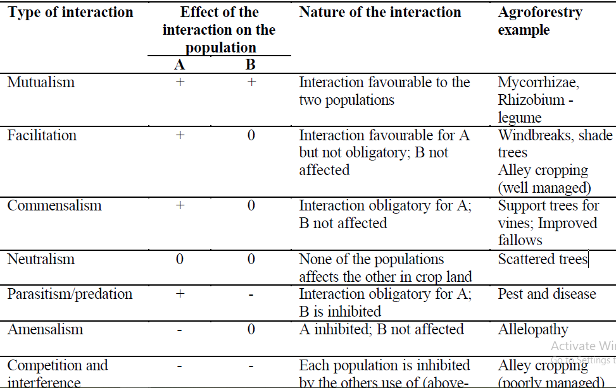

Figure1. Complementary(a), supplementary(b) and competitive(c) interactions between agroforestry components (Torquebiau, 1994).
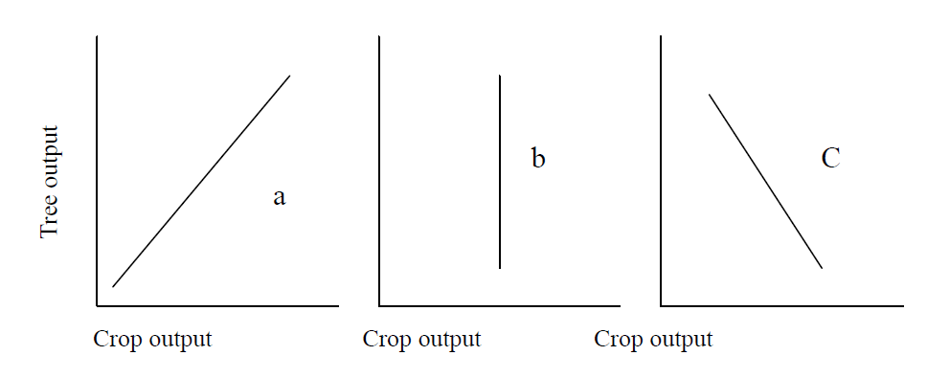

7.4. Component management
There are different types of silvi-cultural component managements in agroforestry systems. The major of them are discussed as follows.

i. Thinning
Felling made in immature stand for the purpose of improving the growth and form of the trees that remain without permanently breaking the canopy. It is mainly done:
  - To improve the hygiene of the crop by removing dead, dying and diseased trees
  - To ensure best physical conditions of growth
  - To obtain a desired type of crop
  - To improve the stand composition and afford protection from the spread of insects and diseases
  - To improve the quality of wood
  - Increase the net yield and financial return from the crop
ii. Pruning: refers to the removal of live or dead branches, and multiple leaders from standing trees for the improvement of the tree or timber. It allows the grower to manipulate the growth and development of the trees left after thinning to increase agriculture returns. It can be,
a) Natural; natural death and fall of branches of standing trees grown closely due to deficiency of light.
b) Artificial: Removal of branches with sharp tools in a dense crop.
- Pruning lower branches close to the trunk of tree makes small knotty core which gives clear straight grain timber.
- Removal of too many branches will retard the growth
- If pruning is left too late, central core of knotty wood become large thus reducing value of tree
iii. Pollarding: Cutting a pole tree at some height above the ground level so that it produces new shoots from below the cut. Pollarding is done at a height of 2- 2.5 m above ground level.
iv. Lopping: Removal of one year shoots or fresh growth from entire crown of the tree/plant in order to get sufficient fodder for livestock is known as lopping.
v. Coppicing: Cutting or heading back of main stem at 30 cm from the ground level.

CHAPTER EIGHT
8. SOCIOECONOMIC ASPECTS OF AGROFORESTRY
8.1. General principles of economic analysis
Most of the natural and human resources necessary for sustained economic development in developing countries are becoming increasingly scarce.
Table: 8.1. Principal Benefits and Costs of agroforestry

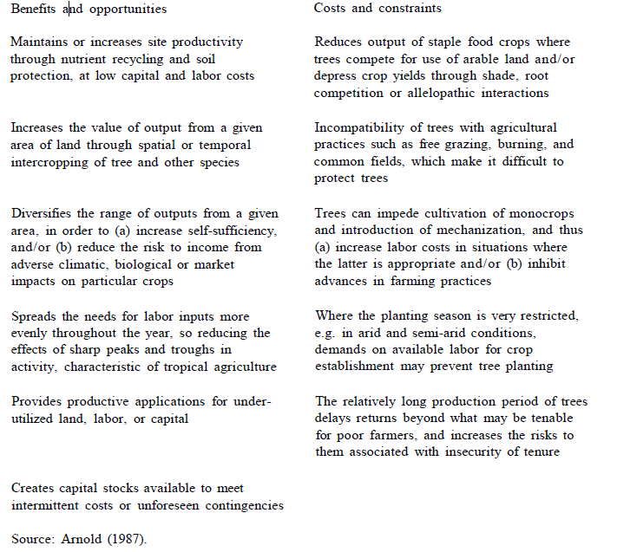

8.2. Financial and economic analysis
Financial analysis examines the feasibility of an undertaking from the private or individual's point of view while economic analysis concentrates on the desirability of an activity from the perspective of a society as a whole. More specifically, a financial profitability assessment of an agricultural enterprise, which used subsidized fertilizer, would include only in its cost calculations, the fertilizer price actually paid by the farmer.
An economic analysis, by contrast, would also include the subsidy expense incurred by the government in calculating the venture's total fertilizer cost from the view of society. In addition, in situations where market-generated prices do not reflect an input's or output's true societal value because of tariffs, price controls, or other influences, economic analyses can utilize shadow prices for a more accurate estimation of true costs and benefits. These shadow prices can be particularly valuable in adjusting for land and labor price distortions or to value non marketed environmental effects. The value of the contribution of land in foregone alternative agricultural enterprises (the opportunity cost), depending on the specific physical and demographic setting, could be much greater than the zero figure utilized.
8.3. Important Socio-cultural factors in Agroforestry

8.3.1. Land tenure
Land tenure systems that do not guarantee continued ownership and control of land are not likely to be conducive to the adoption of longer-term strategies (and relatively short-term practices that include benefits which will only be realized in the long run) such as agroforestry. Secure land rights, in particular, have proven pivotal in determining whether the benefits of agroforestry reach the intended beneficiaries. The traditional reservations of small farmers regarding tenure have included concerns over the loss of control of land rehabilitated through tree planting, or, in the case of pastoralists, the deprivation of access for grazing or fodder collection. Issues associated with tree tenure include the right to own or inherit trees, the right to plant trees, the right to use trees and tree products as well as the right to exclude others from such uses, and the right to dispose of tree products. Furthermore, these various rights differ widely across cultural zones and invariably have a major influence on the social acceptability of any new agroforestry initiative. In places where planting a tree may give the planter rights to the land on which it is planted, agroforestry practices may not be adoptable by people who, traditionally, are only given temporary to land (since planting a tree would change this temporary status).
8.3.2. Labor
Almost all agroforestry innovations demand changes in the labor practices of the farming system into which they are introduced. Furthermore, labor requirements are scrutinized by rural people before they decide whether or not to adopt a new agroforestry practice. Farm families have traditionally developed labor strategies to use inputs of various family members at various times of the year for different tasks. Obviously, additional labor for persons already fully occupied at peak labor seasons is considered more costly than when additional demands come during a slack season. For example, alley fanning is labor-intensive, with much of the demand occurring in the busiest time of the year, i.e., the rainy season. The cost of production will be increased considerably if additional labor hired. Although these additional labor costs will be offset by additional benefits, the immediate need for additional labor could sometimes be a disincentive to the adoption of the practice.
8.3.3. Marketability of products
Direct and immediate income that can be derived from a land-use system will be an important criterion in the appraisal of its social acceptability. The processing and sale of agricultural commodities and rural industries based on such commodities are an essential source of off-farm income for many farming societies. Recent studies of forest-based, small-scale enterprises have indicated that, in a number of countries, these enterprises are among the top three employers of rural people, especially the resource-poor and the landless (FAO, 1987).
Products from trees on farms are considered as free goods in many farming societies. Creating marketing opportunities for these "free goods," and thus increasing the demand for these products, will also require making appropriate provisions for meeting the local need of such locally-produced and "freely available" items (e.g., tannins, essential oils, and medicines). Market support would, then, offer a slightly different challenge to the one usually faced by agricultural extension agents whose products are more frequently fed into established market systems.
8.3.4. Other social factors
Social acceptability of agroforestry is very closely linked to the economic feasibility of the system. In a area where there is high for the integration of tree planting into the traditional farming system, social acceptability relied very heavily on cost-sharing devices between the government and rural farmers. Furthermore, the availability of a viable extension service and the potential of some direct economic output from the trees in the system were required for acceptance of agroforestry.
Indeed, a large number of other factors can be identified as extremely important in the social context of agroforestry introduction and development. Local use and knowledge, local organization and participation in tree management, off-farm and on-farm income, food security and human nutrition, and gender and age of farmers are some such issues that are commonly deemed as critical. As Hoskins (1987) pointed out, it is not easy to select and describe the crucial sociocultural variables in a universal way: situations differ depending on the locality, environment, and the major traditional production activities. Issues overlap and are not easily considered in isolation. Additionally, there are two other social factors that are extremely important in agroforestry development, but which are often inadequately and/or improperly considered. These are the experts' views on farmers' perceptions of tree planting, and governmental policies in relation to agroforestry implementation.
8.4. Social acceptability of Agroforestry
Whatever the potential advantages of agroforestry may be, the benefits can completely miss the poor unless the systems are designed to respond to the social milieu. The best measure of the social success of a given innovation is the readiness with which farmers accept it. Francis and Atta-Krah (1989) reported that, while the number of farmers who adopted alley farming increased from about 60 in 1987 to over 200 in 1989 in an on-farm research project in Southwest Nigeria, the same practice was of limited acceptability in a similar project site in Southeast Nigeria. The reason for the reduced acceptance in the latter case was traced to low soil fertility and high acidity levels, incompatibility of woody species with established cropping patterns and crop-rotation practices, the division of labor and the decision-making processes within the household, and land and tree tenure customs. This example illustrates the need for extension efforts that promote modified technologies according to local conditions. This is also an excellent example of where on-farm research (OFR) using a design appropriate for modified stability analysis. Bannister and Nair (1990) reported a similar situation in Haiti where, with minimum extension efforts, farmers willingly accepted hedgerow planting on farms along contours for soil conservation because they were convinced about the advantages. There is now a considerable and growing literature describing agroforestry techniques designed to address a range of problems under various farming conditions.

CHAPTER NINE
9. AGROFORESTRY EVALUATION
Agroforestry evaluation is defined as the periodic assessment of the performance of AF against its stated objectives. An evaluation studies the outcome of AF (changes in income, quality, benefits distribution, cost-effectiveness, etc.) with the aim of informing the design of future systems. This work will be carried out after 2-3 years of AF implementation or mid of the period or after the AF completion. For this, a set of criteria and indicators need to be developed.
Objectives of AF evaluation
• To check AF achievements and impacts.
• To check the assumption that whether AF inputs and objectives are achieved or not.
• To help the management in making decisions about the follow up AF or activities.
Types of evaluation
1. Formative and summative: The formative evaluation aims to determine whether the project (AF) is working or not as planned, and if not what can be done to improve it. Summative or terminal evaluation is done after the completion of the project. It measures the achievements of the project (AF) in terms of activities, outputs, effects and impacts.
2. External and internal: Internal evaluation is done by persons with in the project or institute, and external evaluation is carried out by people outside of the project or institute.
3. Informal and formal: Informal evaluations are the ones people ordinarily make about simple problem without much consideration of the principle of evaluation. Formal evaluation is scientific research based on statistical procedures.
4. Qualitative and quantitative: Qualitative evaluation uses non-numerical data, while quantitative evaluation uses numerical data.
9.1. Biological Concepts of AF evaluation
a) Productivity
The productivity of recommended agroforestry system should be high production in both agriculture and forest products. Productivity should also be seen from the point of view of improved stability of the farming system, increased labour efficiency, reduction of inputs and improve the value of the land etc. There are different ways in improving the productivity of agroforestry systems. These are:
• Increase in tree products
• Improved the yield of associated crops
• Reduction of cropping inputs
• Increase labor efficiency
• Diversification of production
b) Sustainability
It is a pattern of resource development and use that aims to meet human needs while preserving the environment so that these needs can be met not only in the present, but also for generations to come.
The agroforestry model should be for its ability to provide sustained yield overtime. The system must be based on the principles of optimal production in order to consider the ecological principles.
Analysis of the capacity of new technology to meet short and long-terms objectives; analysis of expected changes and requirements related to soils, water, vegetation, management, and commercial input/output streams, and sustainability of achievements.
9.2. Socioeconomic Concepts
i. Economic viability: The benefit/cost ratio, and cost effectiveness; net returns to land/labor/cash; risk and sensitivity analysis of proposed agroforestry models should be done for measuring economic viability.
ii. Farmer acceptability: It is comparability analysis with respect to resources and management, and social analysis with respect to defined rules and responsibilities within household obligations. It is essential to analyze who in the household makes decisions on the resources required, who has to do the work, and who will receive the benefit accruing from proposed changes. Proposed technology should be beneficial to the women of all households involved in this AF program.
iii. Adoption potential: Analysis of technology impacts in terms of number of farmers adopted this technology or lateral adoption, and institutional and infrastructural support system analysis should also be carried out while developing agroforestry projects.
iv. Multiple function: The species selected for agroforestry system must give multiple benefits such as food security, income generation, soil fertility improvement and environment protection etc to the farmers.
v. Adaptability
Technology (species and techniques) recommended for agroforestry system development should be socially and environmentally applicable in local situation for which it is designed
vi. Stratification
Design of planting schemes should consider the dimension of space and time. It must consider both horizontal as well as vertical perspectives

CHAPTER TEN
10. DIAGNOSIS AND DESIGN METHODOLOGY
10.1. Definition and Concepts
What is D&D stands for? Diagnosis and Design
D&D is a methodology for the diagnosis of land management problems and design of agroforestry solutions. It was developed by ICRAF to assist agroforestry researchers and development fieldworkers to plan and implement effective research and development projects.
Constraints of Agroforestry
- The interference of trees decreases the crop yield which is lower than the mono-cropping
- The tree canopy absorbs maximum light and causes competition for light(above ground competition)
- Felling of trees causes damage to the arable crop
- Competition for moisture between trees and arable crops is maximum when the trees have not deep tap root system (blow ground competition).
- Some of the trees serves as host to pest that harm main crop
- Agroforestry system requires more for its management
- Longer gestation period for tree delay the returns to the farmer
- Farmers give more weightage to field crops compare to tree crop
- Certain tree species produce chemical exudation which affects the growth of agriculture crops
The Genesis of D&D
•Agroforestry in itself is described as „a new name for an old practice‟.
•The D&D methodology is an adaptation of old or existing methodologies to the specific needs and conditions of agroforestry.
•Several methodologies have been developed for holistic evaluation and analysis of land use systems. The most significant among these are:
i) Farming Systems Research /Extension (FSR/E)
ii) Land Evaluation methodology
•Each of these two was developed with specific objectives and conditions. For example, the FSR/E was developed in response to the failures or inadequacies of the traditional transfer-of-technology extension methods that were initiated to disseminate the researcher-driven green revolution technologies to resource-poor, small scale farmers.
•FSR/E was designed to be interdisciplinary and holistic as well as demanding farmer involvement from the outset. The D&D arose, in the words of J.B. Raintree, who directed its development at ICRAF, “Out of the demands of the agroforestry situation. It gives a special focus on agroforestry related constraints and opportunities within existing land use systems and highlights agroforestry potentials that might be overlooked by other methodologies. For example, for most FSR/E practitioners, the trees within the farming system tend to be invisible”.
The key features of the D&D:
A. Flexibility: D&D is a flexible discovery procedure which can be adapted to fit the needs and resources of d/t users.
B. Speed: D&D has been designed with the option of a „rapid appraisal‟ application at the planning stage of a project with in-depth follow up during project implementation.
C. Repetition: D&D is an open-ended learning process. Since initial designs can almost always be improved, the D&D process need not end until further improvements are no longer necessary.

Criteria of a good agroforestry design
There is no substitute for good design. A good agroforestry design should fulfill the following criteria:
A. Productivity: There are many different ways to improve productivity with agroforestry: increased output of tree products, improved yields of associated crops, reduction of cropping system inputs, increased labour efficiency, diversification of production, satisfaction of basic needs, and other measures of economic efficiency or achievement of biological potential.
B. Sustainability: By seeking improvements in the sustainability of production systems, agroforestry can achieve its conservation goals while appealing directly to the motivations of low income farmers, who may not always be interested in conservation for its own sake.
C. Adaptability: No matter how technically elegant or environmentally sound an agroforestry design may be, nothing practical is achieved unless it is adapted by its intended users. This means that the technology has to fit the social as well as the environmental characteristics of the land use system for which it is designed.
Who can make use of D&D?
•Researchers
•Extension officer
•Government field workers
•NGOs
10.2. Procedures in Conducting Diagnosis and Design
The process can be subdivided into small steps and used selectively for varying purposes, but the hierarchical logic of D&D is quite robust and generally applicable to virtually any problem in technology design. The more detailed procedural suggestions are best thought of optional steps for collecting and processing the information needed to answer the basic question shown in the table 1. At any time you feel you are getting lost in the details, simply return to this outline of basic procedures for a reorientation to know where you are in the process.
Table 6.1 Basic procedure of D&D
