CHAPTER ONE
EXCHANGE RATE AND EXCHANGE MARKET

Definition of foreign exchange market
Given money (currency), in addition to buying goods and services, can buy another money (currency). It may also be sold by itself for yet another currency. This implies that there is market (a place or an arrangement) in which currencies of different countries are purchased and sold.
 The foreign exchange market refers to the organizational setting with in which individuals businesses, governments and banks buy and sell foreign currencies.
Unlike commodity or stock exchanges, the foreign exchanges market:
 is not an organized structure
 has no centralized meeting place and no formal requirements for participation
 is not limited to any one country. For any currency, such as the Ethiopian Birr, the foreign exchange market consists of all locations where birr’s are exchanged for other national currencies. The birr can be exchanged for any other currency everywhere in the world if the participants agree to do so. Although, it could be operated anywhere else, three of the largest foreign exchange markets in the world are located in London, New York and Tokyo.
However like other markets, the exchange market is very competitive because foreign exchange dealers are in constant telephone and computer contact.

Participants in the Foreign Exchange Market
The main participants in the foreign exchange market can be categorized as follows.
Retail Clients: -In the retail market, individuals (tourists, foreign students, patients traveling to
another countries for medical treatment) small companies, small exporters and importers operate.
Money transfer companies/remittance companies (for example like Western Union) are
also major players in the retail market.
Retail traders buy/sell currency for their genuine business/personal requirements. For
example, an exporter enters into forward contract to convert foreign currency to domestic
currency. A tourist buys foreign currency in the spot market before undertaking the
journey. A UK patient visiting India to undertake an operation that would have cost him
a fortune at UK.
These are made up of business investors, multi-national corporations and so on. These need foreign exchange for the purpose of operating their business. Commonly they do not directly purchase or sell foreign currency themselves; rather they operate by placing buy/sell orders with the commercial banks.
Commercial Banks: – The commercial banks carry out buy/sell orders from their retail
clients and buy/sell currencies on their own account so as to alter the structure of their assets
and liabilities in different currencies. Banks may deal either directly with other banks or
through foreign exchange brokers.
Foreign exchange brokers: -Brokers on the other hand, help clients to get a better rate on the currency trade by making available quotes offered by dealers. Brokers charge a commission for providing these services.
Communication between brokers and clients also used to be through dedicated telephone lines.
Commonly banks do not trade directly with one another, rather
they offer to buy and sell currencies via foreign exchange brokers. Brokers intermediate the
exchange currencies between different clients. The benefits of brokers is that, they collect,
buy and sell order for most currencies from different banks around the world thereby the
most favorable quotation can be obtained quickly and at lower cost.
Hedgers are traders who undertake forex trading because they have assets or liability in
foreign currency. For example, when an importer requiring foreign currency, sells
domestic currency to buy foreign currency, he is termed as a hedger. The importer has a
foreign currency liability. Similarly, an exporter sells foreign currency and buys domestic
currency is a hedger.
Speculators are traders who essentially buy and sell foreign currency to make profit from
the expected futures movement of the currency.
Arbitrageurs buy and sell the same currency at two different markets whenever there is
price discrepancy.
Central banks (monetary authority)- The monetary authority of a country cannot be
indifferent to change in the external value of its currency, even if exchange rates of the major
industrial nations have been left to fluctuate freely since 1973.
Central banks frequently intervene by buying /selling their currencies to influence the rate at
which their currency is traded. Under a fixed exchange rate system the authorities are obliged
to purchase their currencies when there is excess supply and sell the currency when there is
excess demand
- Different Concepts of Exchange Rate
- Types of Foreign Exchange Transactions
When conducting purchases and sales of foreign exchange, banks promise to pay a stipulated amount of currency to another bank or customer on an agreed-up on date. Banks typically engage in three types of foreign exchange transactions:
- Spot transactions: refer to an immediate purchase and sale of foreign currency for cash settlement not more than two business days after the date the transactions are recorded as spot deals. The two-day period, known as immediate delivery, allows time for the two parties to forward instructions to debit and credit bank accounts at home and abroad. Spot transactions are the most widely used.
- Forward transaction: a business or financial institution knows it will be receiving or paying an amount of foreign currency on a specific date in the future. For example, in June an Ethiopian importer may arrange for a special Ethiopian New Year shipment of Japanese Toyota to arrive in August. The agreement with the Japanese manufacturer may call for payment in yen (Japanese currency) on August 15. To guard against the possibility of the yen’s becoming more expensive in terms of the birr, the importer may contract with his bank to buy yen at a stipulated price, but not actually receive them until August 15 when they are needed. When the contract matures, the Ethiopian importer pays for the yen with a known amount of birr.
Forward transactions differ from spot transactions in that their maturity date is more than two business days in the future. A forward exchange contact’s maturity date can be a few months, or even years, in the future. The exchange rate is fixed when the contact is initially made.
- Swap transactions: entail the conversion of one currency to another currency at one point, with an agreement to reconvert it back to the original currency at some point in the future. The rates of both exchanges are also agreed to in advance. Swaps provide an efficient mechanism through which banks can meet their foreign exchange needs over a period of time.
Banks are able to use a currency for a period in exchange for another currency that is not needed during that time. As an example for a swap transaction, consider Dashen Bank with excess balances of birrs but a shortage of dollars to meet the requirements of its client. At the same time, Bank of Abyssinia may have excess balances of dollars and insufficient amounts of birr. The two banks could negotiate a swap agreement in which Dashen Bank agrees to exchange birrs for dollars today and dollars for birr in the future. The key aspect is that the two banks arrange the swap as a single transaction in which they agree to pay and receive stipulated amounts of currencies at specified rates.
- Functions of foreign exchange market
- The principal function of foreign exchange market is the transfer of funds from one nation to another is also called transfer function.
- The role of commercial banks as clearing houses for the foreign exchange demanded and supplied in the course of foreign transactions by the nations residents.
- Credit function: credit is usually needed when goods are in transit and also to allow the buyer to resell the goods and make payment. Most commonly, exporter allows 90 days for importer to pay. However, the exporter usually discounts the importers’ obligation to pay at the foreign department of his commercial bank. As a result, the exporter receives payment right away, and the bank will eventually collect the payment from the importer when due.
- The other most important function of foreign exchange market is to provide the facilities for hedging (exchange risk avoidance) and speculation (exchange risk taking).
- Minimizing Foreign Exchange Risk: The foreign exchange market provides "risk transfer" facilities to third parties through Forward, Futures, Options, and Swaps markets.

  - Exchange rate regimes, Spot versus forwarforeignexchange rate markets
- Exchange rate regime
Exchange rate ‘regime’: in finance exchange rate is the rate at which one curruncy will be exchanged for other. It is also value of one country’s curruncy in relation to other country’s. It is the type of criterion that a country chooses to set the value of its exchange rate, whether flexible (i.e. determined by market forces) or fixed or any other form between these two extremes. Exchange Rate ‘System’: refers to an agreement by which some countries, in a region or at the global level, set their (reciprocal) exchange rates according to a given mechanism (e.g. the Bretton Woods System of exchange rates 1944-1973).
There are three main types of exchange rate regime:
Flexible rates;
Fixed-rate, unified currency; and,
Pegged exchange rates.
- Flexible exchange Rate Regimes: Under a flexible rate system, the exchange rate is determined by supply and demand for foreign exchange. Here there is no intervention by the national bank rather the forces of demand for and supply of both foreign and domestic currencies determine the level of the ongoing exchange rate.

The demand for foreign exchange:
It originates from domestic citizen’s purchases for foreign goods, services, and assets (real or financial). In other words, a nation’s demand for foreign exchange is derived from, or corresponds to, the debit items on its balance of payments. For example, the Ethiopian demand for dollars may stem from its desire to import American commodities, to make investments in America, or to make transfer payments to residents in America.
Like most demand schedules that you learned, in other courses, the demand for foreign exchange is inversely related with its price.
In figure 1.1 (a) shows how the exchange rate is initially determined by the equality of
demand (D1) and supply (S1) of dollar at the exchange rate of 9.50 birr per dollar.

The supply of foreign exchange
It originates from sales of goods, services, and assets from domestic economy to foreigners. The supply of foreign exchange for a given country results from transactions that appear on the credit side of that country’s BoP’s. The supply of pounds, for instance, is generated by the desire of US residents and businesses to import Ethiopian goods and services, to lend funds and make investments in Ethiopia, and to extend transfer payments to Ethiopian residents. In each of these cases, the Americans offer dollars in the foreign exchange market to obtain the birr they need to make payments to Ethiopians. In the figure given below, (b) shows the impact of
increase in supply of dollar due to an increase demand for Ethiopian export and thus for birr.
The increased supply of dollar shifts the supply curve S1 to the right to S2 , resulting in a
depreciation of dollar from 9.50 to 9.40 .or appreciation of birr In general, the essence of a
floating exchange rate is that the exchange rate adjusts in response to any changes in the
supply and demand for currency.
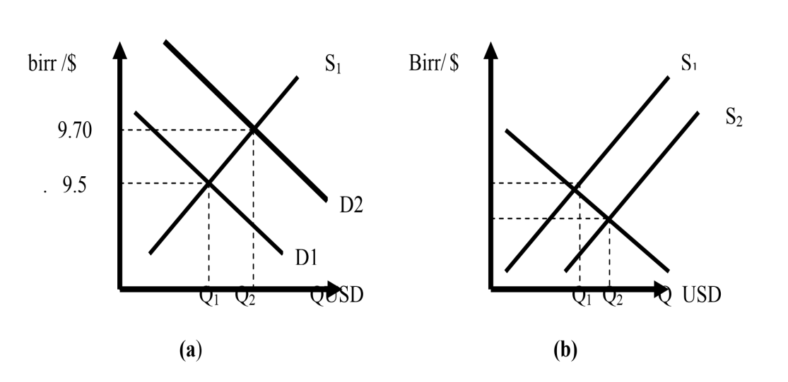
Figure 1.1 floating exchange rate regimes (a) increase in demand and (b) increase in supply
The supply of pounds is denoted by line in figure 1.1.The graph represents the number of pounds offered by the British to obtain birr’s which to buy Ethiopian goods, services and assets. It is depicted in the figure as a positive function of the Ethiopian exchange rate. As the Ethiopian birr depreciates against the pound (i.e. if the birr price of the pound rises), the British will be inclined to buy more Ethiopian commodities.
- Fixed-rate, unified currency regime:
In fixed exchange rate regime, exchange rate is fixed by the authorities and cannot adjust in
response to the change in supply and demand for currency. Figure 1.5 illustrates the mechanism of fixing exchange rate.
In figure below, the exchange rate is assumed to be fixed by monetary authorities at the point where demand intersect the supply curve at birr 9.50. If there is an increased demand for dollar which shifts the demand curve from D1 to D2, there is a resulting pressure for the
dollar to be revaluated. To control the appreciation of dollar, the National Bank of Ethiopia
will sell Q1 Q2 amount of dollar to purchase birr with dollars in the foreign exchange market.
This save of dollar by National Bank of Ethiopia shifts the supply curve of dollar from S1 to
S2. Such intervention eliminate the excess demand for dollar so that exchange rate will
remain fixed at birr 9.5. This intervention will decrease the amount of birr in circulation and
decreases the National Bank’s dollar reserve. Similarly figure 1.2 (b) presents a situation where the exchange rate is pegged by the National Bank at the point where S1 intersects D1 at birr 9.50 per dollar.
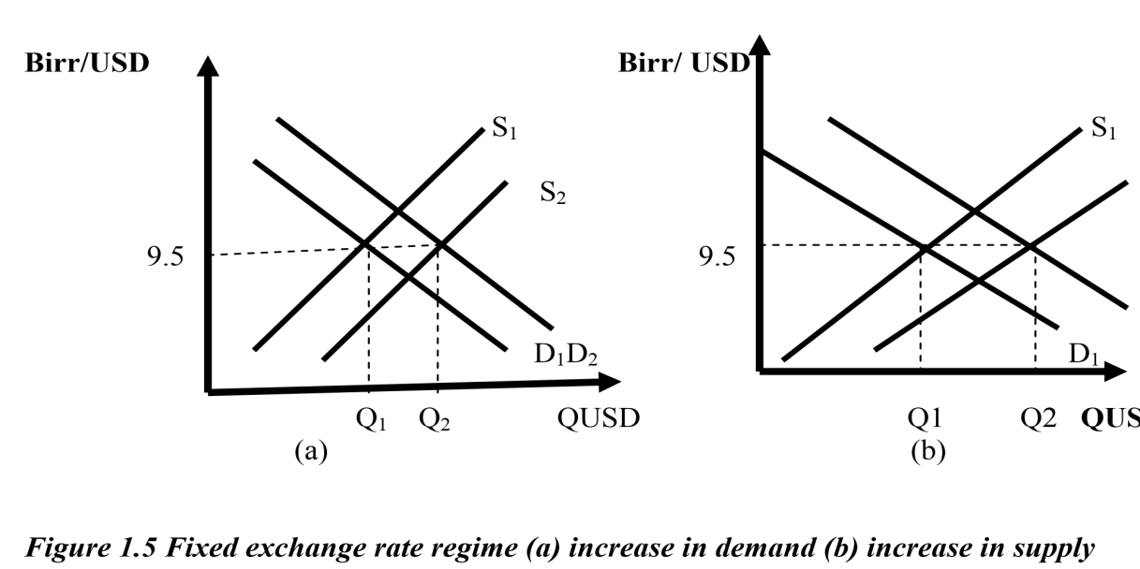
If there is an increase in demand for Ethiopian export, there will be an increased demand for
birr and increased supply of dollar which shifts the supply curve to S2. That is excess supply of dollar at the prevailing exchange rates and there will be a pressure on the dollar to be
devaluated or domestic currency to be revalued.
- To avoid this, the National (Central) Bank of Ethiopia has to intervene in the foreign exchange market by purchasing Q1 Q2 amount of dollar to keep the exchange rate fixed at birr 9.50 per dollar. This intervention is shown by a right ward shit of the demand curve from D1 to D2.
- Such intervention removes the excess supply of dollar so that the exchange rate remain pegged at birr 9.50 per pound and it leads to an increase in the Ethiopian National Bank’s reserves of dollar and in the amount of birr in circulation.
- Pegged exchange rate system: pegged exchange rate also known as fixed exchange rate, is types of exchange rate in which country’s value is fixed against either the value of others country’s currency or other measure of value such as gold. A system where the country commits to using monetary and fiscal policy to maintain the exchange-rate value of the domestic currency at a fixed rate or within a narrow band relative to another currency (or bundle of currencies). Unlike the case of a currency board, however, countries with a pegged exchange rate continue to conduct monetary policy.
  - Spot versus forward foreign exchange rate markets
Spot exchange rate
The spot exchange rate is the quotation between two currencies for immediate delivery. In
other words, the spot exchange rate is the current exchange rates of two currencies vis-à-vis
each other. In practice, there is normally a two-day lag between a spot purchase or sale and
the actual exchange of currencies to allow for verification, paper work and clearing of
payments. In the spot transaction, the seller of the currency has to deliver the currency he has
sold” on the spot”, usually within two days.
Forward exchange rate
This is the exchange rate that calls for delivery of the foreign exchange one, three, six, twelve or twenty-four months after the date of the contract is signed. It is an exchange rate at which forward transaction takes place. In other word, it involves an agreement today to buy or sell a specified amount of a foreign currency at a specified future date at a rate agreed upon today (the forward rate, FR). The equilibrium forward rate is determined at the intersection of the market demand and supply curves of foreign exchange for future delivery. For example, you may agree to buy $2000 a month later at a rate of 8.60 birr per dollar = FR = 8.6. Note that no currencies are paid out on the day you sign the agreement. It is rather after a month that you will get the $2000 when you pay Br.17200 (= 2000x8.60). At the time payments are paid out, the spot rate may be exactly equal to, greater than, or less than the forward rate.

It consists of:
- Forward discount: is the percentage per year by which the forward rate is below the spot rate. That means if the forward rate is below the present spot rate, the foreign currency is said to be at a forward discount (FD) with respect to the domestic currency.
- Forward premium: is the percentage per year by which the forward rate is above the sport rate. That means if the forward rate is above the present spot rate the foreign currency is at a forward premium (FP) with respect to the domestic currency.
- Forward discounts and premiums are usually expressed as percentages per year; corresponding spot rate. It can be calculated formally using the following formu
Forward premium (Discount) = Forward rate – Spot rate χ 12_ χ 100
Spot rate No. of Months forward

If the result is negative, it means a forward discount. A positive result implies a forward premium of the foreign currency
- Cross exchange rate
  - The exchange rate between currencies A and B given the exchange rate between currency A and C and between B and C.
  - Example
    - Suppose dollar/yen exchange rate is $0.01 and the dollar/pound exchange rate is $2.
    - The cross exchange rate between yen and pounds is $2 ÷ $0.01 = 200 ¥/£.
  - Foreign Exchange Risks, Hedging and Speculation
We have already said earlier that the foreign exchange market is a market with characterized by the probability occurring losses or risk. In this section, we will try to formally examine the meaning of foreign exchange risks.
A. Foreign Exchange Risk
With the passage of time, a nation’s demand and supply curves for foreign exchange shift, causing the spot (and the forward) rates of exchange to frequently vary. They change as a result of changes in tastes for domestic and foreign products in the nation and abroad, different growth and inflation rates in different nations, changes in relative rates of interest, changing expectations and so on.
In general, whenever a future payment must be made or received in a foreign currency, a foreign exchange risk is involved because spot exchange rates vary over time. Businessmen are risk averse and will want to avoid or insure themselves against their foreign exchange risk.
Note that a foreign exchange risk could also arise from the need to value inventories and assets held abroad interims of the domestic currency for inclusion in the firm’s consolidation balance sheet, and in estimating the domestic currency value of the future profitability of the firm.
You have to bear in mind that exchange arbitrage does not involve any exchange risk. This is because in exchange arbitrage, the currency is bought at a cheaper price in one monetary center to be resold immediately at a higher price in another monetary center.
B. Hedging
Hedging is the avoidance (covering) of a foreign exchange risk. It involves different mechanisms by businessmen in the spot or forward markets. In a world of foreign exchange uncertainty, the ability of traders and investors to hedge greatly facilitates the international flow of trade and investments. Without hedging, there could be smaller international capital flows, less trade and specialization in production, and smaller benefits from trade.
C. Speculation
Speculation is the attempt to profit by trading on expectations about prices of currencies in the future. Speculators (financial institutions, firms or individuals) buy currencies that they expect to go up in value and sell currencies that they expect to go down in value. Speculation is the opposite of hedging. Whereas a hedger seeks to cover a foreign exchange risk, a speculator accepts and even seeks out a foreign exchange risk. If the speculator correctly anticipates future changes in spot rates, he makes a profit, otherwise incurs a loss.
Note the difference between arbitrage and speculation. With arbitrage, a currency trader simultaneously buys a currency at a low price and sells that currency at a higher price, thus making a risk-less profit. A speculator’s goal however is to buy a currency at one moment (such as today) and sell that currency at a higher price in the future (such as 3 months from today). Speculation thus implies a deliberate assumption of exchange risk.
To understand speculation, it is better to take examples on the most speculated currencies in the two markets – the spot market and the forward market.
Speculating in the Spot Market
Imagine that you are a currency speculator in international stock markets like in New York, willing to risk money on your own opinion about future prices of a foreign currency- say a Ethiopian birr
Case – 1: Speculating on a Ethiopian birr appreciation
Given: Today’s spot price is $0.40 per birr
Assumption: In 3 months, the spot price of the birr will rise to $0.50.
Procedure:
- Purchase birr at today’s rate of $0.40 and deposit them in a bank to earn interest.
- In 3 months, sell the birrs at the prevailing spot price of $ 0.50 per birr.
Outcome:
- If assumption is right, profit= $0.10 per birr.
- If assumption is wrong and the spot price of the birr falls instead, you incur a loss, reselling birrs at a price lower than the purchase price.
Case - 2: Speculating on a Ethiopian birr depreciation
Given: Today’s spot price is $ 0.40 per birr.
Assumption: In 3 months, the spot price will fall to $0.25 per birr.
Procedure:
- Borrow birr today, exchange them for dollars at the prevailing spot price of $0.40 per birr, and deposit the dollars in a bank to earn interest.
- In 3 months, buy birrs at the prevailing spot price of $ 0.25 per birr and use them to pay back the loan.
Outcome:
- If the assumption is right, profit= $0.15 per birr. (This return is reduced by the interest paid on borrowed money, but increased by the interest received on the bank savings account.)
- If the assumption is wrong and the spot price of the birr rises instead, you will incur a loss, buying birr at a higher price than the initial selling price.

Speculating in the Forward Market
Although speculation in the spot market can lead to profits, it has a serious drawback: the speculator must have a large amount of idle cash or has to borrow, which requires interest payments. Speculation in the forward market, however, does not require cash or credit facilities. All the speculator needs to do is signing a forward contract with a bank to either purchase or sell a specified amount of foreign currency at a specified future date. In practice, most speculation is done in the forward market.
There are two type of arbitrage:
- Exchange arbitrage
- Interest arbitrage
- Exchange Arbitrage
The exchange rate between any two currencies is kept the same in different monetary centers by what is known as exchange arbitrage.
Exchange arbitrage: is the simultaneous purchase and sale of a currency in different foreign exchange markets in order to profit from exchange rate differentials in the two locations. To illustrate, suppose the dollar / pound exchange rate is $2= ₤1 in New York but ₤ 1 = $ 2.01 in London, A foreign exchange trader (called an arbitrageur) would find it profitable to purchase pounds in New York at $2 per pound and immediately sell them in London for $2.01 per pound. A profit of 1 cent would be made on each pound sold, less the cost of bank transfer and the interest charge on the money tied up during the arbitrage process, which are insignificant. Note that if the arbitrageur buys and sells ₤1 Million, his profit will be $ 10, 000 for only a few minutes work.
However, arbitrage increases the demand for pounds in New York, thereby exerting an upward pressure on the dollar price of pounds in New York (i.e., more than $2). At the same time, the sale of pounds in London increases the supply of pounds there, which makes the dollar price of pounds to fall below $ 2.01. This continues until the dollar price of pounds quickly becomes equal both in New York and London (say at $ 2.005 = ₤1), thus eliminating the profitability of further exchange arbitrage. Arbitrage between the two currencies therefore unifies the foreign exchange markets.
Exchange arbitrage can be:
- Two – point arbitrage: in which two currencies are traded between two financial centers.
- Three–point arbitrage (or triangular arbitrage) involves three currencies and three financial markets. Three-point arbitrage requires switching funds among three currencies in order to profit from exchange rate inconsistencies.
- Interest Arbitrage
Interest arbitrage: refer to the process of moving funds in to foreign currencies to take advantage of higher investment yields abroad. But, investors assume a risk when they have foreign investments. When the investment’s proceeds are converted back in to the home currency, their value may fall because of a change in the exchange rate. Investors can eliminate this exchange risk by obtaining ‘cover’ in the forward market
Foreign exchange market and financial market
Financial market: a market in which people and entities can trade financial securities, commodities, and other fungible items of value at low transaction costs and at prices that reflect supply and demand.”
Types of financial market
- Capital markets: is the part of financial system concerned with rising capital by dealing in share, bonds and other long term investment. It is the market where buyers and sellers engage in trade of financial securities like bond, stocks etc.
- stock (equity) markets
- fixed income (bond) markets
- +6commodity markets

