CHAPTER 2: INNATE IMMUNITY
Innate Immunity: is organism’s first line of defense against infection. Innate immunity comprises three types of defensive barriers: Anatomical barriers, Humoral barriers and Cellular barriers.
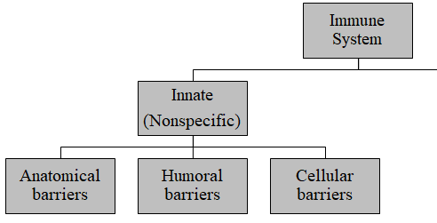
2.1. Different lines and layers of defense
1. Anatomical barriers to infections
A. Mechanical factors
The epithelial surfaces form a physical barrier that is very impermeable to most infectious agents. Thus, the skin acts as our first line of defense against invading organisms.The desquamation of skin epithelium also helps remove bacteria and other infectious agents that have adhered to the epithelial surfaces. Movement due to cilia or peristalsis helps to keep air passages and the gastrointestinal tract free from microorganisms. The flushing action of tears and saliva helps prevent infection of the eyes and mouth. The trapping affect of mucus that lines the respiratory and gastrointestinal tract helps protect the lungs and digestive systems from infection.
B. Chemical factors
Include temperature, pH, and various soluble and cell-associated molecules. Many species are not susceptible to certain diseases simply because their normal body temperature inhibits growth of the pathogens. Chickens, for example, have innate immunity to anthrax because their high body temperature inhibits the growth of the bacteria. Gastric acidity is an innate physiologic barrier to infection. Since newborn child stomach acidity content is less they are susceptible than adult. A variety of soluble factors (proteins) like lysozyme, interferon, and complement contribute to innate immunity.
Fatty acids in sweat inhibit the growth of bacteria. Lysozyme and phospholipase found in tears, saliva and nasal secretions can breakdown the cell wall of bacteria and destabilize bacterial membranes. The low pH of sweat and gastric secretions prevents growth of bacteria. Defensins (low molecular weight proteins) found in the lung and gastrointestinal tract have antimicrobial activity. Surfactants in the lung act as opsonins (substances that promote phagocytosis of particles by phagocytic cells).
C. Biological factors
The normal flora of the skin and in the gastrointestinal tract can prevent the colonization of pathogenic bacteria by secreting toxic substances or by competing with pathogenic bacteria for nutrients or attachment to cell surfaces.Biological barrier or the normal flora of the skin and in the gastrointestinal tract can prevent the colonization of pathogenic bacteria by secreting toxic (antimicrobial) substances or by competing with pathogenic bacteria for nutrients or attachment to cell surfaces (compete for receptor sites on epithelial cells). Pathogen invasion of the vaginal epithelium is limited by the lactic acid produced by commensal bacteria. If the activity of this normal flora disturbed by antibiotics the susceptibility to obligate and opportunistic infections will increase.
2. Humoral barriers to infection
The anatomical barriers are very effective in preventing colonization of tissues by microorganisms. However, when there is damage to tissues the anatomical barriers are breeched and infection is occurs. Once infectious agents have penetrated tissues, another innate defense mechanism comes into play, namely acute inflammation. Humoral factors play an important role in inflammation, which is characterized by edema and the recruitment of phagocytic cells.
These humoral factors are found in serum or they are formed at the site of infection.
A. Complement system
The complement system is the major humoral nonspecific defense. Once activated, complement can lead to increased vascular permeability, recruitment of phagocytic cells, and lysis and opsonization of bacteria.

B. Coagulation system
Depending on the severity of the tissue injury, the coagulation system may or may not be activated. Some products of the coagulation system can contribute to the nonspecific defenses because of their ability to increase vascular permeability and act as chemotactic agents for phagocytic cells. In addition, some of the products of the coagulation system are directly antimicrobial. For example, β-lysin, a protein produced by platelets during coagulation can lyse many Gram + bacteria by acting as a cationic detergent.
C. Lactoferrin and transferrin
By binding iron, an essential nutrient for bacteria, these proteins limit bacterial growth.
D. Interferons
Interferons are proteins that can limit virus replication in cells.
E. Lysozyme
Lysozyme breaks down the cell wall of bacteria.
F. Interleukin-1 – Il-1
This induces fever and production of acute phase proteins, some of which are antimicrobial because they can opsonize bacteria.
3. Cellular barriers to infection
These cellular defenses are the main line of defense in the non-specific immune system. Leukocytes (WBCs) are defensive and divided into two groups: polymorphonuclear leukocytes (Granulocytes) and mononuclear leukocytes (agranulocytes).
- Granulocytes: Neutrophils, Basophils and Eosinophils
A. Neutrophils: Polymorphonuclear cells (PMNs), main work is phagosytosis and kill organisms.Polymorphonuclear cells (PMNs) are recruited to the site of infection where they phagocytose invading organisms and kill them intracellularly. In addition, PMNs contribute to collateral tissue damage that occurs during inflammation.
B. Basophils- have role in allergy and inflammation reactions and release chemicals (vasoactive amines) as histamine, serotonin, and heparin (anticoagulant).
C. Eosinophils- have proteins effective in killing eukaryotic parasite, E.g. helminthes.
D. Mastcells: contain the vasoactive amines histamine and serotonin.

- Agranulocytes: divided into two categories: monocytes and lymphocytes.
A. Monocytes- are the largest of all WBC and have phagocytic capabilities. They differentiation to phagocytic cell called macrophages.
- Macrophages are found in all tissues and organs and they are responsible for: phagocytic and intracellular killing of microorganisms or infected (altered) self-target cells. Also contribute to tissue repair and act as antigen-presenting cells.
Monocytesare called as monocyte while they are in the blood but after differentiation and get in to body tissue they are called Macrophage. Monocytes found in different organs
- Kuffer cells – in liver
- Alveolar macrophage – in the lung
- Microglial cells – in the CNS
B. Natural killer (NK) and lymphokine activated killer (LAK) cells: These cells are not part of the inflammatory response but they are important innonspecifically kill virus infected cells and tumor cells without stimulation.
2.2. Pattern recognition in innate immune system
What are PAMPs and DAMPs?
Inflammation results from stimuli signaling damage or infection. The inflammatory response can be beneficial or harmful depending on the type and duration of stimuli. The source, structure, and abundance of these stimuli vary quite a bit. One major category of inflammatory stimulation is the family of pathogen-associated molecular patterns (PAMPs) and damage-associated molecular patterns (DAMPs). PAMPs are derived from microorganisms and thus drive inflammation in response to infections. One well-known PAMP is lipopolysaccharide (LPS), which is found on the outer cell wall of gram-negative bacteria. DAMPs are derived from host cells including tumor cells, dead or dying cells, or products released from cells in response to signals such as hypoxia. Because they are derived from host materials, DAMPs induce what’s known as sterile inflammatory responses. DAMPs are often created or exposed in environments of trauma, ischemia, or tissue damage and do not require pathogenic infection. These environments are created in settings such as myocardial infarction, cancer, autoimmune disease, and atherosclerosis.

Pattern recognition receptors: signaling downstream of PAMPs and DAMPs
PAMPs and DAMPs bind to pattern recognition receptors, which include Toll-like receptors (TLRs), cytoplasmic NOD-like receptors (NLRs), intracellular retinoic acid-inducible gene-I)-like receptors (RLR), transmembrane C-type lectin receptors. Cell types expressing pattern recognition receptors include innate immune cells such as macrophages, monocytes, dendritic cells, and mast cells but also non-immune cells such as epithelial cells and fibroblasts. Pattern recognition receptor-ligand binding and their concomitant conformational changes prompt a cascade of downstream signaling that result in transcriptional changes as well as post-translational modifications.
Pattern recognition receptor responses are context-dependent
Pattern recognition receptors are capable of recognizing a variety of molecular patterns, which in turn induce a receptor-dependent response. A single pattern recognition receptor can recognize multiple PAMPs and DAMPs and the structural and molecular mechanisms mediating how this happens are still being studied. Furthermore, simultaneous signaling within the same cell can modulate downstream responses to pattern recognition receptor engagement. For example, cytokines can stimulate downstream signaling that may be complimentary, amplifying, or inhibitory to pattern recognition receptor signaling pathways. Thus, such complexities make the study of PAMP- and DAMP-induced inflammatory responses complicated but quite fascinating.
2.3. Determinants of innate immunity
Determinants recognized by components of the innate (non-specific) immune system differ from those recognized by the adaptive (specific) immune system. The components of the innate immune system recognize broad molecular patterns found in pathogens but not in the host. Thus, they lack a high degree of specificity. The broad molecular patterns recognized by the innate immune system are called PAMPS (pathogen associated molecular patterns) and the receptors for PAMPS are called PRRs (pattern recognition receptors). A particular PRR can recognize a molecular pattern that may be present on a number of different pathogens enabling the receptor to recognize a variety of different pathogens. The targets of PRR are molecules of the pathogen or secretions produced by the pathogen but not by the host. Self-non-self-discrimination may be called as perfect because it doesn’t give response if the antigen molecules have similarity with self. PRR on the cell membrane are protein like antigen receptor of B- and T-cell but have different gene for encoding receptor. PPR on the cell membrane include Scavenger receptor and Toll-like receptor.
- Scavenger receptor: expressed on macrophage and dendritic cell that can bind and internalize Gram +ve and -ve bacteria and phagocytosis apoptotic host cell. Generally it is called active investigator of host cell.
- Toll-like receptor (TLR): recognize patterns of many microbial pathogens and activate defense response. Signal TLR activate secretion of cytokines which promote inflammatory response that attract macrophage and neutrophils to the site of infection. Also activate APC, macrophage and dendritic cell, to present antigens to T-cells. This is the indication of relationship between innate and adaptive immunity system.
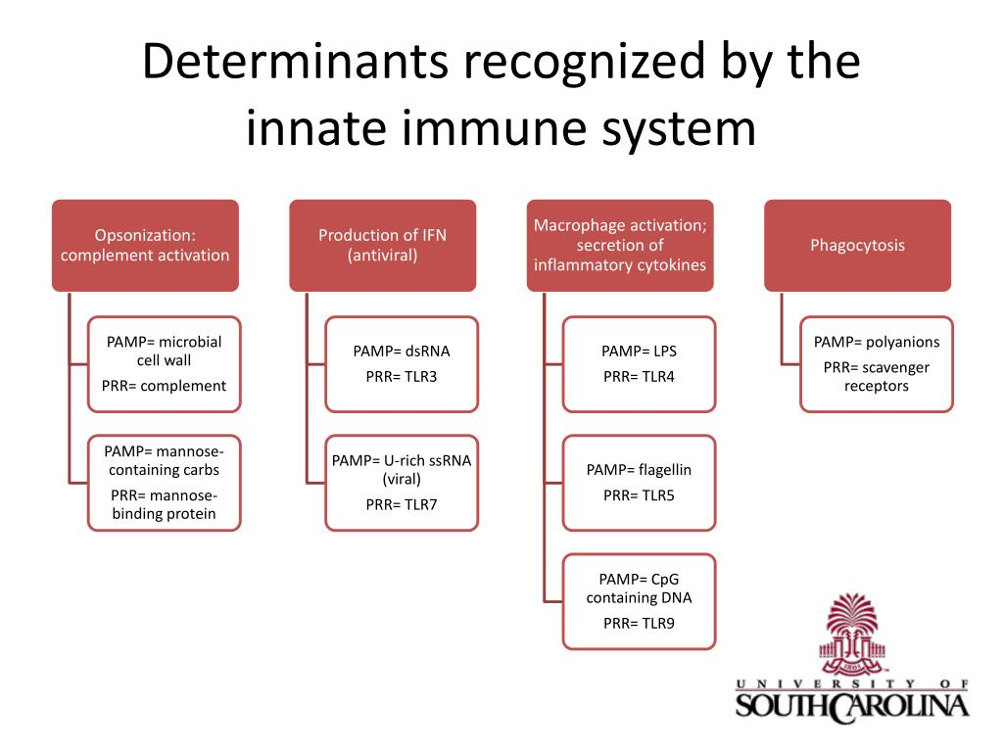

CHAPTER 3: RESPONSE OF THE INNATE IMMUNE SYSTEM
3.1. Phagocytosis
What is Phagocytosis?
It’s the process by which a cell ingests a solidextracellular particle (such as a bacterium) byengulfing it within a membrane enclosedvesicle (sometimes called a vacuole). Cells that normally carry out this function arereferred to as phagocytic, or simply as phagocytes.
Types of Phagocytes
All of the phagocytes in the human body aretypes of white blood cells (leukocytes):
Neutrophils
- Highly phagocytic cells that rapidly exit the blood intodamaged or infected tissue, “gobble up”bacteria, etc…
Macrophages
- Monocytes migrate to damaged, infected tissue from blood and differentiate into highly phagocytic macrophages
Dendritic Cells
- Found in skin, mucous membranes, thymus, lymph nodes
- Generally, all phagocytic white blood cells ingest and destroy pathogens and other debris by this basic process
Phagocytosis is one type of endocytosis, the general term for the uptake by a cell of material from its environment. In phagocytosis, a cell’s plasma membrane expands around the particulate material, which may include whole pathogenic microorganisms, to form large vesicles called phagosomes. The phagocytosis cells are blood monocytes, neutrophils, and tissue macrophages. Other forms of endocytosis are receptor-mediated endocytosis, in which extracellular molecules are internalized after binding by specific cellular receptors, and pinocytosis, the process by which cells take up fluid from the surrounding medium along with any molecules contained in it.
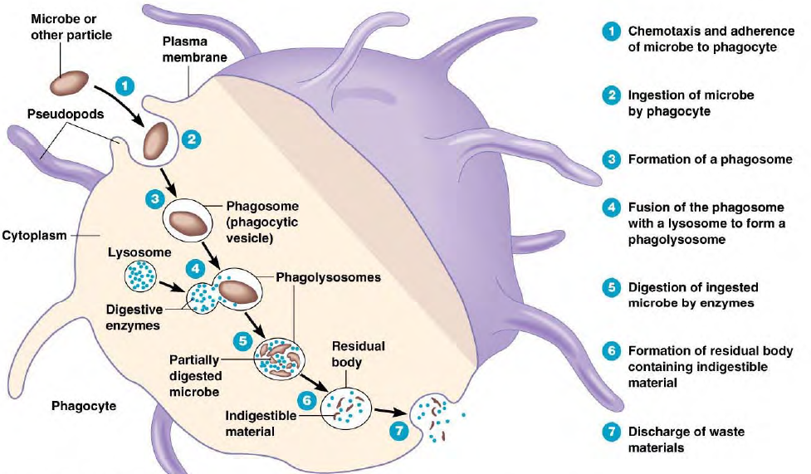
Figure 3.1: Mechanisms of Phagocytosis
3.2. Inflammation
What is Inflammation?
Inflammation is a localized response initiated bydamaged or infected tissues to aid tissue repairand the elimination of pathogens.
Inflammation Triggers
- Any type of physical damage to and/or microbial penetration of a tissue will trigger a local inflammatory response.
- Initiated by the release of inflammatory mediators from cells in the tissue that is damaged e.g. Histamine prostaglandins leukotrienes.
Tissue damage caused by a wound or by an invading pathogenic microorganism induces a complex sequence of events collectively known as the inflammatory response. Molecular component of a microbe trigger an inflammatory response via interaction with cell surface receptors. There are five basic signs of inflammation as redness, swelling, heat, pain and loss of function, these all reflect the three major events of an inflammatory response:
1. Vasodilation - an increase in the diameter of blood vessels of nearby capillaries occurs as the vessels that carry blood away from the affected area constrict, resulting in engorgement of the capillary network. The engorged capillaries are responsible for tissue redness (erythema) and an increase in tissue temperature.
2. Tissue swelling: An increase in capillary permeability facilitates an influx of fluid and cells from the engorged capillaries into the tissue. The fluid that accumulates (exudate) has much higher protein content than fluid normally released from the vasculature. Accumulation of exudate leads to tissue swelling (edema)
3.Influx of phagocytes: Influx of phagocytes from the capillaries into the tissues is facilitated by the increased permeability of the capillaries. As phagocytic cells accumulate at the site and begin to phagocytose bacteria, they release lytic enzymes, which can damage nearby healthy cells. The accumulation of dead cells, digested material, and fluid forms a substance called pus.
There are varieties of chemical initiate as mediators, some of these mediators are derived from invading microorganisms, released from damaged cells in response to tissue injury, some are generated by several plasma enzyme systems, and some are products of various white blood cells participating in the inflammatory response.
E.g., a.Histamine: is chemical released by a variety of cells in response to tissue injury and one of mediators of the inflammation.
b.Kinins:small peptides normally present in blood plasma and activated during tissue injury. A particular kinin, called bradykinin, also stimulates pain receptors in the skin and causes an individual to protect the injured area.
c. Enzymes of the blood-clotting system enter to the tissue and form strand of fibrin then the fibrin strands wall off the injured area prevents the spread of infection and bleeding.
Tissue Repair
- Once the area has been secured (all pathogens are destroyed, all breaches are sealed), dead and damaged cells can be broken down and the tissue can regenerate.
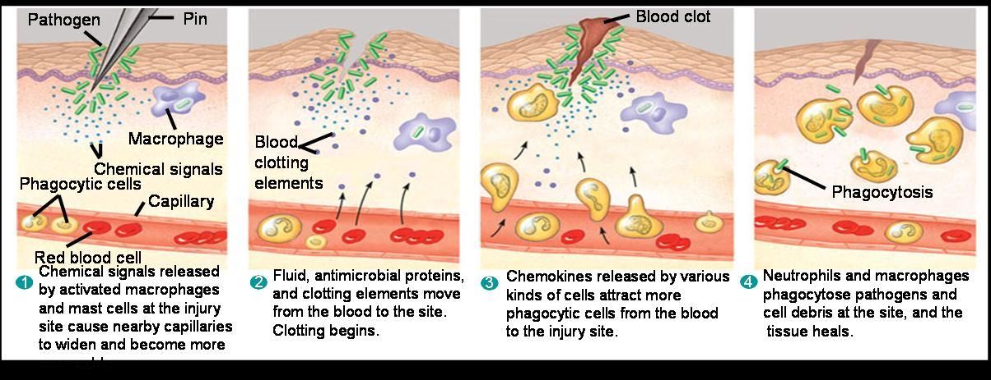
Figure 3.2: Mechanisms of Inflammation
Once the inflammatory response has subsided and most of the debris has been cleared away by phagocytic cells, tissue repair and regeneration of new tissue begins
3.3. Complement
The complement system is the major effector of the humoral branch of the immune system. Complement has more than 30 soluble and cell-bound proteins and it has role in both innate and acquired immunity. Complement system carry out a number of basic functions:
- Lysis of cells, bacteria, and viruses
- Opsonization: opsonize bacteria and promotes phagocytosis of particulate antigens
- Binding to specific complement receptors on cells of the immune system, triggering specific cell functions, inflammation, and secretion of immuno-regulatory molecules
- Immune clearance, which removes immune complexes from the circulation and deposits them in the spleen and liver and remove apoptotic cells
The components of complement system and complement activation Pathways
The Complement Components; proteins and glycoproteins that compose the complement system are synthesized mainly by liver hepatocytes, blood monocytes, tissue macrophages, and epithelial cells of the gastrointestinal and genitourinary tracts. They circulate in the serum in inactive forms as pro-enzymes, or zymogens. The complement-reaction sequence starts with an enzyme cascade. Complement components are designated by numerals (C1–C9), by letter symbols or by trivial names (e.g., homologous restriction factor). Peptide fragments formed by activation of a component are denoted by small letters. In most cases, the smaller fragment resulting from cleavage of a component is designated “a” and the larger fragment designated “b” (E.g., C3a, C3b; note that C2 is an exception: C2a is the larger cleavage fragment). The larger fragments bind to the target near the site of activation, and the smaller fragments diffuse from the site and can initiate localized inflammatory responses by binding to specific receptors. The complement fragments interact with one another to form functional complexes that have enzymatic activity. Three pathways have been identified in the sequence of reactions carried out by the complement system. They are called the classical pathway, the lectin pathway, and the alternative pathway, or properdin pathway. The classical pathway begins when antibodies bind to antigens, such as microbes, and involves complement proteins C1, C4, and C2.
The lectin pathway begins when macrophages complete phagocytosis, releasing cytokines that cause the liver to produce lectin proteins. The lectins bind to carbohydrates such as mannose, which are part of a characteristic pattern of carbohydrates found on bacteria and some viruses. This then activates C4 and C2.
The alternative pathway is activated by contact between complement proteins and polysaccharides at the pathogen surface. Complement proteins called factor B, factor D, and factor P (properdin) replace C1, C4, and C2 in the initial steps. However, the components of both pathways activate reactions involving C3 through C9. Both classical and alternative pathways lead to the activation of C5 convertase and result in the production of C5b which is essential for the activation of the membrane attack pathway.
The contributions of the complement system to innate defenses depend on C3, a key protein in the system. Once C3 is formed, it immediately splits into C3a and C3b, which then participate in three kinds of molecular defenses: opsonization, inflammation, and membrane attack complexes.
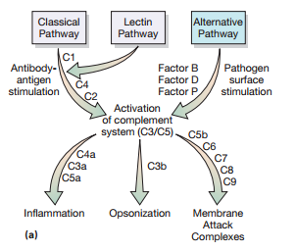
The components of complement system
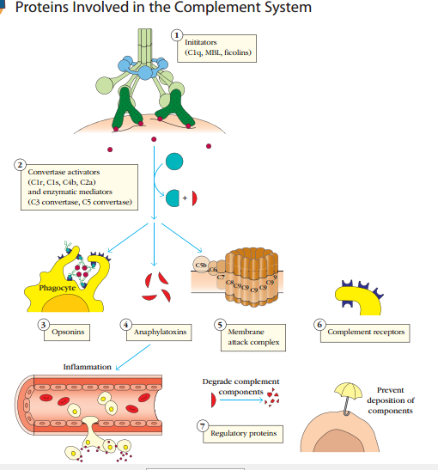

3.3.1 Classical pathway
It begins with the formation of soluble antigen-antibody complexes (immune complexes). Complements like C1, C2, C3, and C4, are present in plasma in functionally in-active forms. The formation of an antigen-antibody complex induces conformational changes in the Fc portion of the IgM molecule that expose a binding site for the C1 component of the complement system.
C1 activation: C1 binds only to the antibody molecules that have interacted with antigen. The binding of C1 to antibody is via C1q and C1q must cross link at least two antibody molecules before it is firmly fixed. The binding of C1q results in the activation of C1r which in turn activates C1s. The result is the formation of an activated “C1qrs”, which is an enzyme that cleaves C4 into two fragments C4a and C4b.
C4 and C2 activation (generation of C3 convertase): The C4b fragment binds to the membrane and the C4a fragment is released into the microenvironment. Activated “C1qrs” also cleaves C2 into C2a and C2b. C2a binds to the membrane in association with C4b, and C2b is released into the microenvironment. The resulting C4bC2a complex is a C3 convertase, which cleaves C3 into C3a and C3b.
C3 activation (generation of C5 convertase): C3b binds to the membrane in association with C4b and C2a, and C3a is released into the microenvironment. The resulting C4bC2aC3b is a C5 convertase. The generation of C5 convertase is the end of the classical pathway. C3b may also bind directly to cell membranes.
If the product of classical pathway unregulated it have detrimental effects. Unregulated production of C2b results in edema, C3a/C4a – anaphylaxis, C3b/C4b – opsonin (activate phagocytic cell). They are regulated by di-associator (break binding), in-activator and degradation facilitator.
3.3.2 Membrane attack complex ( lectin pathway)
It is very similar to the classical pathway. It is initiated by the binding of mannose-binding lectin (MBL) to bacterial surfaces with mannose-containing polysaccharides (mannose). Binding of MBL to a pathogen results in the association of two serine proteases. Including, MASP-1 and MASP-2 (MBL-associated serine proteases). MASP-1 and MASP-2 are similar to C1r and C1s, respectively and MBL is similar to C1q.
Formation of the MBL/MASP-1/MASP-2 tri-molecular complex results in the activation of the MASPs and subsequent cleavage of C4 into C4a and C4b. The C4b fragment binds to the membrane and the C4a fragment is released into the microenvironment. Activated MASPs also cleave C2 into C2a and C2b. C2a binds to the membrane in association with C4b and C2b is released into the microenvironment. The resulting C4bC2a complex is a C3 convertase, which cleaves C3 into C3a and C3b. C3b binds to the membrane in association with C4b and C2a and C3a is released into the microenvironment. The resulting C4bC2aC3b is a C5 convertase. The generation of C5 convertase is the end of the lectin pathway. The biological activities and the regulatory proteins of the lectin pathway are the same as those of the classical pathway.
3.3.3 Alternative pathway
It is antibody independent, no need for antigen-antibody complexes for initiation. It generates C5b, like classical pathway. It involves four serum proteins: C3, factor B, factor D, and properdin. The alternative pathway is initiated by cell-surface constituents of foreign particles, E.g., gram -ve and +ve bacteria. Serum C3 hydrolysis to yield C3a and C3b; the C3b component can bind to foreign surface antigens or to the host’s own cells. The C3b present on the surface of the foreign cells can bind another serum protein called factor B to form a complex and this complex active serum protein called factor D. Factor D cleaves the C3b-bound factor B, releasing a small fragment (Ba) that diffuses away and generating C3bBb, it also called C3 convertase. The serum protein properdin binds to this C3 convertase and stabilizes it.
This C3bBb activate un-hydrolyzed C3 to generate more C3b. The C3 convertase activity of C3bBb generates the C3bBb3b (C3bBbC3b) complex, which exhibits C5 convertase activity. The generation of C5 convertase is the end of the alternative pathway. The non-enzymatic C3b component binds C5, and the Bb component subsequently hydrolyzes the C5 to generate C5a and C5b; the latter binds to the antigenic surface. The alternative pathway provides a means of non-specific resistance against infection without the participation of antibodies and hence provides a first line of defense against a number of infectious agents.

Amplification loop of C3b formation
In serum there is low level spontaneous hydrolysis of C3 to produce C3i. Factor B binds to C3i and becomes susceptible to Factor D, which cleaves Factor B into Bb. The C3iBb complex acts as a C3 convertase and cleaves C3 into C3a and C3b. Once C3b is formed, Factor B will bind to it and becomes susceptible to cleavage by Factor D. The resulting C3bBb complex is a C3 convertase that will continue to generate more C3b, thus amplifying C3b production. If this process continues unchecked, the result would be the consumption of all C3 in the serum. This C3 deficiency and increased susceptibility to certain infections.
Regulation of the amplification loop
As spontaneously produced C3b binds to autologous host membranes, it interacts with DAF (decay accelerating factor), which blocks the association of Factor B with C3b thereby preventing the formation of additional C3 convertase. In addition, DAF accelerates the dissociation of Bb from C3b in C3 convertase that has already formed, thereby stopping the production of additional C3b. Some cells possess complement receptor 1 (CR1). Binding of C3b to CR1 facilitates the enzymatic degradation of C3b by Factor I. In addition, binding of C3 convertase (C3bBb) to CR1 also dissociates Bb from the complex. Thus, in cells possessing complement receptors, CR1 also plays a role in controlling the amplification loop.
Finally, Factor H can bind to C3b bound to a cell or in the fluid phase and facilitate the enzymatic degradation of C3b by Factor I. Thus, the amplification loop is controlled by either blocking the formation of C3 convertase, dissociating C3 convertase, or by enzymatically digesting C3b.
Membrane attack (Lytic)
The membrane-attack complex formed by complement activation can lyse bacteria, parasites, viruses, erythrocytes, and nucleated cells. The C5 convertase from the classical (C4b2a3b), lectin (C4b2a3b) or alternative (C3bBb3b) pathway cleaves C5 into C5a and C5b. C5a remains in the fluid phase and the C5b rapidly associates with C6 and C7 and inserts into the membrane. Subsequently C8 binds, followed by several molecules of C9. The C9 molecules form a pore in the membrane through which the cellular contents leak and lysis occurs. Lysis is not an enzymatic process; it is thought to be due to physical damage to the membrane. The complex consisting of C5bC6C7C8C9 is referred to as the membrane attack complex (MAC).

