Worksheet 2
- A one-component system consists of the following phases: 1 liquid (L), 1 vapor (V), and 3 solids (S₁, S₂, and S₃). Construct the P-T diagram which satisfies the following conditions: S₁, and S₂ can be melted and sublimed. S₃, can be melted but not sublimed. S₃, is denser than S₁, S₂, and the liquid. The liquid is denser than S₂, which is denser than S₁. The transformations S₁ →S₂ and S₁→ S₃ are both endothermic.
- If a system is found to obey the phase rule, may we assume that the system is at equilibrium? Explain your answer.
- Classify the following systems as monovariant, divariant, or invariant. Explain your answers.
  - Alpha quartz in equilibrium with beta quartz at the transition temperature.
  - Monoclinic zirconia at room temperature.
  - Ice in equilibrium with its vapor.
- In the binary system shown on Fig. below, determine the following:
  - The temperature at which 30 wt% of B crystals are in equilibrium with a liquid composed of 60 wt% B and 40 wt% A.
  - The composition of the sample described in part a.
  - Show by means of a sketch how the microstructure of this sample would look at the temperature determined in part a.
  - Show by means of a sketch the appearance of the microstructure for this sample if it were cooled to 500°C.

- System V₂O₅-NiO is shown on Fig. below.
  - Label all areas in the diagram.
  - Make an isoplethal study in the system on cooling a melt of 45 mol% NiO and 55 mol% V₂O₅. Calculate before and after each change of phase:
(1) the percentage of each phase present.
(2) the percent of each component in each phase.
  - Make an isoplethal study in the system on cooling a melt of 60 mol% NiO and 40 mol% V₂O₅.

- System R-G is shown on Fig. below. Make an isoplethal study for a melt of composition 20 wt% G and 80 wt% R.

- For Fig. shown below.
  - Label primary phase fields.
  - Construct Alkemade lines.
  - Indicate slopes of boundary lines.

- For Fig. shown below
  - Make an isoplethal study for a melt of composition A=30%, B=5%, C=65%.
  - Make a sketch of the isothernial section at 1100ºC and at 700ºC.
  - Make a sketch to represent the vertical section taken along a line front C to 80% B (on the line AB).
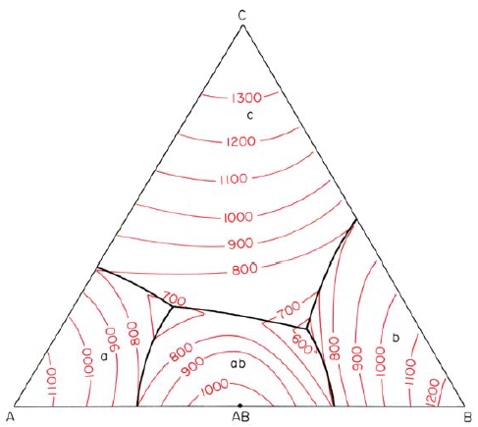

- For Fig. below.
  - Make an isoplethal study for a melt of composition G = 70%, R=10%, K=20%.
  - Construct a phase analysis diagram from the data calculated in part (a).
