- Determine the appropriate two-dimensional coordinate transformation for the following data at a 0.01 level of significance when transforming the XY coordinates into the EN coordinate system.
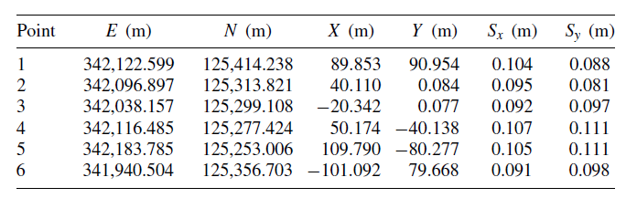

- Using a weighted three-dimensional coordinate transformation and the follow set of data:
(a) Determine the transformation parameters and their standard deviations.
(b) Compute the XYZ coordinates and their standard deviations for points 7 to 10.
