Chapter 4 Cadastral Map

4.1 Cadastral Mapping
Cadastre is a technical term for a set of records showing the extent, value and ownership (or other basis for use or occupancy) of land. Strictly speaking, a cadastre is a record of areas and values of land and of landholders that originally was compiled for purposes of taxation. In many countries there is, however, no longer any land tax and in practice the cadastre serves two other equally important purposes. It provides a ready means of precise description and identification of particular pieces of land and it acts as a continuous record of rights in land.
In cities there is always great demand for a variety of maps. City administration, technical services, planners, investors, and those concerned with all facets of city life cannot operate properly without suitable maps. These maps may vary in scale, content, or form of presentation. General planning requires maps at scales such as 1:5000, and 1:10000, but the execution of some projects may require plans at a scale of 1:1000 or larger. For administration, land use, cadastre, or detailed planning, maps at scales of 1:500 to 1:2000 are usually used. There is also a need for a variety of special or thematic maps, particularly at smaller scales. These maps usually depict specific information; the scale is selected to permit the coverage of the whole city by a single map sheet.
To systematize the subject, we shall subdivide city maps into the following three categories.
- The city base map is the original map of the city prepared from actual field surveying or photogrammetric plots. It contains complete planimetric and vertical information and may consist of several overlays.
- Derived maps are basically similar in content to the city base map but are usually at smaller scales; they are derived from the base map and use a certain generalization in presentation. Reduction to required scales, such as 1:5000 and 1: 10000, may be done photographically or by other, cartographic means.
- Thematic maps include maps not listed in category 1 or 2. Usually, they are single-factor maps providing, on a reference background, quantitative or qualitative information on the phenomenon in question.
With the advancement of the techniques of computer storage of map content and automatic map drawing, some changes may be expected in the approach to the general question of city maps. Computers provide almost unlimited flexibility in handling the stored data and can translate data into a graphical product—a map manuscript—at any desired scale. As a result, it is likely that the traditional classification of maps into “original” or “derived” categories may lose its significance in future. Maps will be at different scales; each map will have its own characteristics, but all will be plotted from the original and continuously updated field or photogrammetric data. Even then, the concept of a “base city map” will probably continue to be used in reference to the most detailed map, which depicts the ground situation with maximum fidelity.
The production of a specific map at any scale covering the whole city is a major and costly undertaking. Understandably, many map users, preoccupied with their own responsibilities, insist on having their particular requirements satisfied. This could result in a very costly proliferation of all kinds of maps at various scales, none of them properly maintained or kept up to date. By making appropriate decisions on the selection of map scales for the city in advance, the number of maps can not only be reduced to a minimum but the general quality can also be improved. The availability of maps at definite scales usually induces the users to tailor their demands accordingly, with a resultant uniformity of scales.
Two distinct steps are involved in the production of a map: (1) compilation of the map manuscript and (2) final drafting, cartographic enhancement, and map reproduction.
The compilation of a map manuscript for the base map and the derived map is the responsibility of the city surveying department or the commercial or other survey organization that has been contracted for the job. The actual cartographic processing of the manuscripts, including the final printing, can also be done by specialized printing houses on a contractual basis. In larger cities, however, the volume and variety of cartographic products is such that the establishment of cartographic printing facilities within the city-survey department should be considered. The availability of cartographic in-house printing facilities permits prompt attention to urgent needs and better integration of cartographic work within the framework of the surveying and photogrammetric activities of the city.
A cadastral mapping system should contain the following components.
  - geodetic control network
  - current, accurate, base map layer (ideally, photogrammetrically derived tied to the geodetic control)
  - cadastral overlays delineating all real property parcels
  - a unique parcel identifier assigned to each parcel
  - a series of parcel data files containing parcel identifiers, ownership and assessment data
  - additional overlays of interest to the assessor such as municipal boundaries, zoning, and flood plains

In creating or revising a cadastral mapping system, the assessor should make every effort to cooperate with other public and private sector entities, and thus create a true multipurpose cadastre. Such a system meets the needs of other offices in the jurisdiction, and of outside agencies and entities, and allows efficient sharing of maps and data. However, should efforts at cooperation fail, it may become necessary for the assessor to develop a single-purpose mapping system. In any case, the assessor must retain the ultimate authority to inventory, create, and define parcels and parcel identifiers.

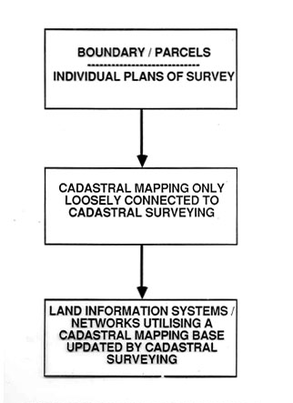
Figure 4-1 Cadastral mapping trends
A modern cadastre normally consists of a series of large-scale maps or plans, and corresponding registers. Both the plans and the registers may be stored in computers. The present chapter deals with the essential features of cadastral maps with particular reference to the form they take when drawn on paper or displayed on a computer screen. While the survey of an individual parcel of land has in some countries resulted in a “cadastral map” for that plot of land and may have been unconnected to any adjoining land parcels, the true cadastral map covers all parcels within an area rather than isolated plots. It can act as an index for other land parcel surveys that show more detailed information or can be of sufficiently large scale for the dimensions of each plot to be obtainable from the map. In this chapter, the term ‘cadastral map’ will be associated with any parcel of land whether defined by ownership, value or use provided that the parcel has an independent identity and is relevant to the management of land as a resource. A cadastral map will show the boundaries of such parcels but may in addition incorporate details of the resources associated with them, including the physical structures on or beneath them, their geology, soils, and vegetation and the manner in which the land is used.
The scale of cadastral maps is of great importance. Since the object of the map is to provide a precise description and identification of the land, the scale must be large enough for every separate plot of land which may be the subject of separate possession (conveniently called a “survey plot” or “land parcel”) to appear as a recognizable unit on the map. When map data are stored in a computer, they may be drawn at almost any scale and this can give an impression of greater accuracy than the quality of the survey data may warrant.
Since the map and the corresponding registers form complementary parts of the same system of description and identification, there must be some system of cross-referencing between what is shown on the map and what is recorded in the registers. This usually means that either names or numbers must be given to each separate land parcel. These references are known as property identifiers (PID) or unique parcel reference numbers (UPRN). Various reference systems have been developed including:
- The name of the grantor or grantee
- A sequential title number
- The volume and folio numbers on which the plot is registered
- The name of a farm or locality with an individual plot number
- The registration block and individual plot numbers
- A post office address
- A street index reference and parcel number
- A grid coordinate or “geocode”
The reference chosen should be easy to understand and easy to remember; easy to use for the public and by computers; permanent so that it does not change with the sale of a property, but capable of being updated when there is for example a subdivision of the land; unique; accurate; and economic to introduce.
It is essential that when these numbers or names are drawn on a map that they do not obscure the details of the map itself. The cadastral map should show the boundaries of each land parcel and in some jurisdictions may also show its area and the actual length and bearing of each boundary line. These considerations may obviously demand a scale somewhat larger than that required merely to indicate each surveyed plot.
The smallest satisfactory scale depends primarily on the area of the smallest survey plot likely to be met with, and may thus vary greatly in different circumstances. A much larger scale will be necessary for cadastral maps of towns than for those of rural areas. Similarly a closely occupied countryside consisting of small fields and holdings will require maps on a larger scale than is necessary in areas where there are large farms with open fields.
The maps with which most people are familiar are topographic maps at scales of around 1:50,000. Such maps make it possible to show accurately (though not always to scale) the position of roads, railways, footpaths, villages, rivers, streams, bridges, important buildings, administrative boundaries and other similar features as well as the relief of the land, the depth of water and variations in tide level. These maps are however quite inadequate for cadastral purposes. A simple example will make this point clear. A carefully drawn pencil line will have a width of perhaps half a millimetre. On a map on the scale of 1:50,000 this would represent a line of 25 metres wide of the ground. There are many countries, especially hilly countries, with separate fields less than 25 metres wide. Most cadastral maps need to be at scales of between 1:500 and 1:2,500 although in densely developed areas a larger scale may be needed while in open countryside much smaller scales may be acceptable.
Large-scale plans are initially much more expensive to make per unit area than small-scale maps, but it must always be remembered that, once the large- scale survey has been completed, accurate maps on any smaller scale can be derived from them. The converse is not however true for although larger-scale maps can easily be constructed by using computers, they can never be more accurate than the original data from which they were first compiled.
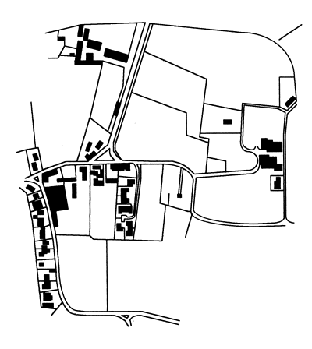
Figure 4-2 Topographic Plan showing physical detail
Usually cadastral maps need only be “planimetric” maps, that is to say, they need not show topographical relief. There may be special reasons why altitudes should be recorded on cadastral maps, but ordinarily all that is needed is a plan of what is seen, without stereoscopy, from a point vertically above the piece of land observed. Distances recorded on such plans are the horizontal distances between points and not the surface distances actually measured on the ground. Thus the area recorded for a plot of land on a steep hillside will be the horizontal equivalent which may be significantly less than the actual surface area.
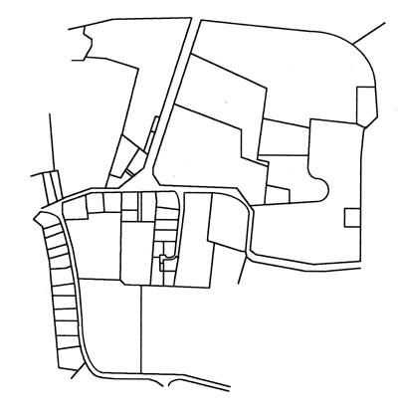
Figure 4-3 Cadastral Plan showing boundaries of land ownership
A third important requirement of cadastral maps is that they should show a sufficient number of points which can be accurately identified on the ground to enable any other point on the ground to be identified on the map (or vice versa) by eye or by simple and short measurements. Professionally this requirement is satisfied by marks recording the original triangulation stations, or the stations on supplementary theodolite traverses, but this is usually inadequate or inconvenient for practical purposes. In areas where there are permanent fences or fields surrounded by embankments, the fences and banks may provide an adequate means of detailed identification, but in unfenced open fields without any embankments, some means of indicating the land parcel boundaries on the ground will be necessary.
A good mark must be durable in itself and not easy to remove either accidentally or willfully. In many countries it is also desirable that the material of which it is made should not be of a kind that encourages theft. Since the marks must be easily recognizable they must be fairly conspicuous on the surface but for important points, such as those used as control for surveys, there are advantages in supplementing surface marks with marks that are set in concrete and buried beneath them.
One principal method of identification used in cadastral maps is the “grid”. In some countries, such as much of the public lands in the United States, a grid has been laid out on the ground creating a “rectangular system”. All parcels of land are formed by straight lines, often running north to south and east to west. The problem with such a system is that it is unsympathetic to the natural topography but its advantage is its simplicity and the relative clarity of the boundaries on the ground. More commonly however a grid is used as a referencing system so that the coordinates of all boundary turning points can be measured, calculated and recorded. The data can then be stored in a computer and used either to draw the cadastral maps or else for helping a surveyor to re- establish lost boundary marks.
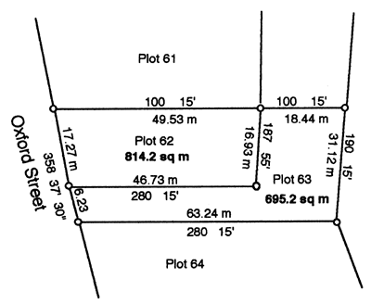
Figure 4-4 Cadastral Plan showing bearings and distances of sides, areas, and plot numbers

The A4 size of cadastral map is a certificate issued officially by the municipality in order to legalize the ownership of the parcel to an individual or group of individuals or company, etc. This map should contain textual and spatial information components. It gets its textual information such that parcel identifiers like owners name, plan number, etc from cartography (area, dimension, neighboring), land registry, city administration, (Municipality, ketena, kebele) housing associations, etc. and the spatial information from cadastral map that show all the parcels of the town graphically from the municipality archive. The scale of this map is determined depending on the size of the parcel, starting from 1:500 to 10,000. The map will show the Parcel number, location, boundary, dimension, area, cartographic elements like North arrow/ Northing, scale bar/text, etc.
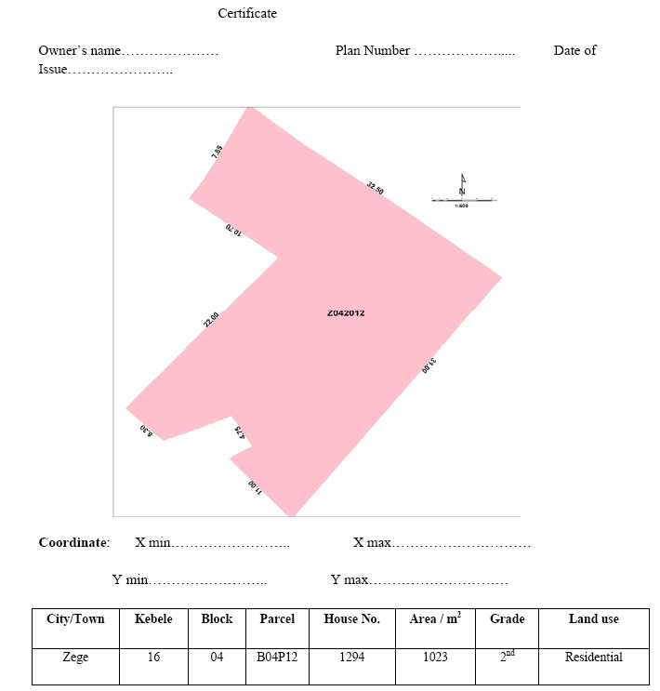
Figure 4-5 An Example of cadastre map (Source: Prime Cadastral Manual)
The land parcel reference number can be used to identify the plot. It can be cross-referenced both to the files that contain more detailed survey information about the parcel such as its dimensions, and to the data on ownership, value and use. In many countries the records of survey are held in one government department (the Survey Department) while text data and details of title are held in another. The latter may, for example, be the Lands Department, the Ministry of Justice or even the Government Treasury. It is important that wherever records of land parcels are maintained, every authority adopts the same standard land parcel referencing system.

It is also essential that changes in land parcel boundaries be recorded as soon as they are agreed. All interested parties must be notified immediately of any changes that have taken place affecting land parcels, for example where there has been formal subdivision. A cadastral map must be up to date at all times.

4.2 Cadastral Maps Preparation Guidelines
Map layouts can be portrait or landscape. When choosing a layout to be used in a report, match the map layout to the text layout and be consistent so that the reader does not have to continually turn the report in order to see figures and text the right way up.
Map title
The map title should be set in large bold text to stand out from other annotation on the map. It should be placed in such a way as not to be confused with other map text. The lettering size can be adjusted to suit the map size and to accommodate long titles. Cadastral office uses Title Block, which (with its whole contents) must be placed on separate layer. This title block provides space for map/plan title.

Map placement
The placement of the map should be such that it does not intrude on the frame/title block, reference, index map and other elements.

North / South orientation
On manually compiled maps, the orientation of the map may be adjusted to fit the page. As a general rule, orientation should be north-south with north at the top of the page. If any other orientation is used, remember to include a north arrow.

Identification of Position of mapped area
There should be enough orientation features to ensure that map readers can see what area has been mapped. Features, which are helpful, include towns, roads, railways, rivers, coastline and borders. Grids are used for this purpose in Cadastral office. Grids must be placed on a separate layer.

Map extent
Information should be shown up to the neat line of the map, except for special cases such as when the boundary of a catchment is used as the edge of the map. For cadastral map/plan show the area in question, adjacent properties ought to be indicated in dashed lines of the thickness corresponding to the lines used on the plan. Plan the scale of your cadastral map having in mind the way to represent clearly the smallest property; remember about various annotations and servitudes, that will have to appear on the plan/map.

Map Sheet Size
A uniform size for map sheets facilitates handling and storage of maps.
- 75x75 cm
- 80x60 cm
- 80x64 cm
- A0,A1, A2, A3, A4 etc., based on your purpose, plotting hardware

Arrows
In some instances arrows indicating details will be unavoidable. They must be drawn on separate layer. Arrow heads size not exceeding 3 mm on the drawing. Arrow must clearly point to the detail being described. Use a north arrow consistent in size and style with the rest of the map (in cases when title block is not applied). Place it above the scale bar and any scale numeral.

Figure 4-6 Example of north arrow

Scale
A scale bar or numerical scale e.g. 1:50 000 is essential. If a numerical scale is indicated, it should be in the fractional form, e.g. 1:1000 000. Include 'fine tuning' blocks for a section of the scale bar. Use a 'rational' subdivision for the scale bar, for example 5, 10, 15, 20 rather than 12.5, 25, 37.5. Cadastral offices’ title block contains scale bar appropriate scale should be entered in space provided.

Table 4-1 Standard scale for cadastral maps
Scale ranges | Typical standard scales
1:500 to 1:5000 | 1:500  1:1000  1:2000
1:5 000 to 1:13 000 | 1:5 000  1:7 500  1:10 000
1:13 000 to 1:33 000 | 1:15 000  1:20 000  1:25 000
1:33 000 to 1:83 000 | 1:50 000  1:75 000
1:83 000 to 1:183 000 | 1:100 000  1:150 000
1:183 000 to 1:433 000 | 1:200 000  1:250 000
1:433 000 to 1:1 082 000 | 1:500 000  1:1 000 000
> 1:1 082 000 | 1:2 500 000  1:7 500 000

Map reference (Legend)
All features on a map must be explained in the reference. The map reference should be clearly separated from the map. Some time it is necessary to add notes on a cadastral plan – place them in a discreet, but clear manner, so they do not “overtake” the whole map.

Guidelines for text
Ensure sufficient contrast between the type and the background. Do this by choosing appropriate colours, and placing a mask around the text, if necessary: Text should not overlap other information. Use the automatic text placement commands if necessary, to space text so that it does not overlap: In general, lettering should be written from the left, parallel to the lines of latitude. If you are doing a manual layout, place the labels for fixed features and those most difficult to arrange first and fit the others in the remaining space. Writing positioned vertically on the map should read from the lower edge to the upper edge. Text, which at any angle than vertical should read from, left to right. Avoid placing text at an angle of 45. Text crossed by the boundary lines is unacceptable. Use a text size, which reflects the size of the object being labelled.

Map symbol
These are some general rules for map symbols:
Area features should be large enough so that the reader can match the colouring or hatching with the reference. Detailed coverage displayed at a small, overview scale may have to be generalised to achieve this. The larger the area being shaded, the lighter the colour (or coarser the hatching) that should be used. Area shading should not obscure linear elements. Likewise, linear elements should be represented in such a way as to stand out against background shading. When generalising map information, keep all mapped features at a similar level of generalisation. Some of the standard symbols used in cadastral maps shown below.
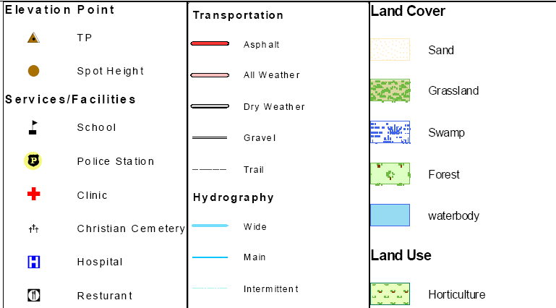

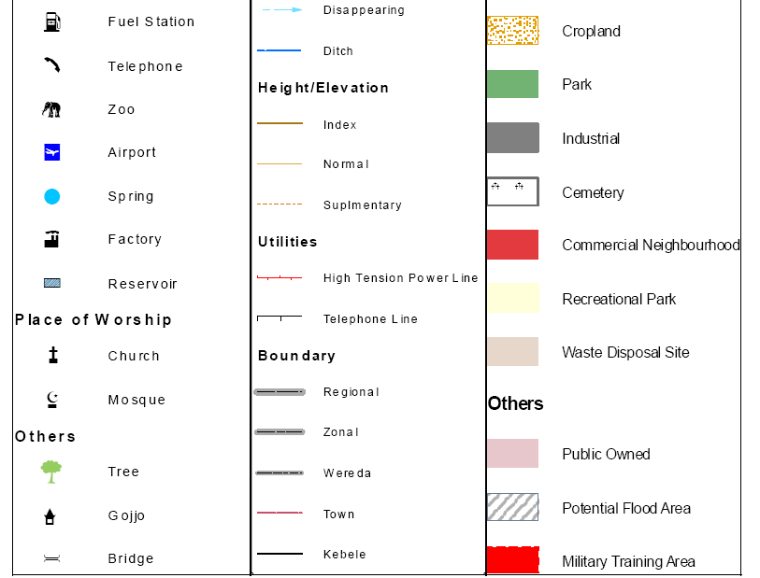

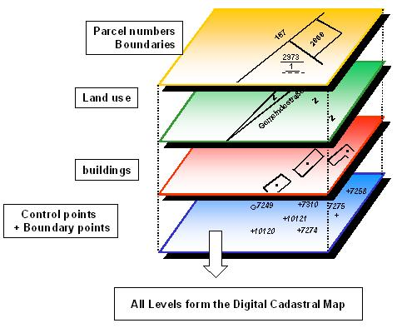

Figure 4-7 Layers of digital cadastral map

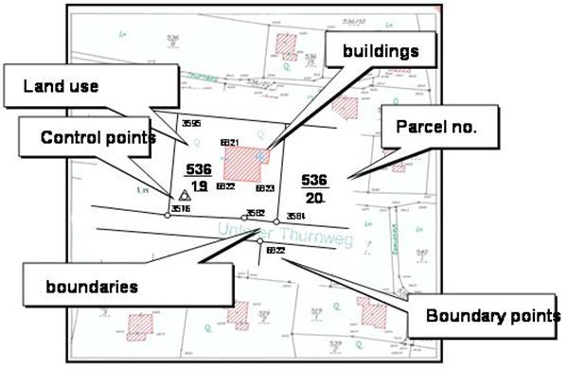
Figure 4-8 Digital Cadastral map

Accuracy of map
Accuracy of map data is the degree toward which any given feature(s) on a map conforms to its true position on the ground
- Horizontal Accuracy /positional according the National Mapping - EMA = -/+ 30cm (at the scale of 1:2,000)
- Vertical Accuracy- Globally there are accepted accuracy levels set by NMAs, National Mapping Agencies, and accordingly the Ethiopian National Mapping - EMA standard is = 0.25 or ¼ of the contour interval – 1:500 -0.5m, 1:1000m -1m, 1:5000 - 2m, 5m. But when we go specific, Contour Interval/CI/ depend on the topography of the land feature of the town. When we are dealing with flat area we usually use 1 meter CI. In normal condition 2 meters and in a very hill feature we go up to 4 meters CI.
- Temporal accuracy = time of the data
- Content accuracy of the cadastral data is also important. Content accuracy has to do with the correctness and completeness of the attribute data associated with the points, lines, and polygons that comprise the cadastral database.
4.3 Functions of Cadastral Maps
The specifications of cadastral maps are usually influenced more by the requirements of land markets and land registration than any other use. However the requirements of other users of cadastral maps are sometimes in conflict with these land market requirements. If a multi-purpose cadastral map is to be established and maintained, and this is to be done through the cadastral or land registration process, then a good appreciation of the requirements of these other users is important, as discussed below.
While it is recognized that many people will have different views on the ranking of the map attributes (high, medium or low) for the different map functions, the major objective of this analysis has been to show that a multi-purpose digital cadastral map has quite different characteristics to a cadastral map designed to support a land market or land registration system.
- Requirements of land markets and land registration Land registration requires each parcel to be uniquely defined spatially so that land owners are secure in their rights and can trade those land rights. By its nature land markets operate in a sporadic manner and as such do not demand a systematic inventory of land parcels. Land markets also operate on "user pays" principles and as such there is little financial justification to invest heavily in cadastral maps. However it is generally considered that a cadastral system based on an accurate cadastral map will be more efficient and less expensive than a system with a charting or index map. In countries which do not use an accurate cadastral map (such as Australia historically) or countries which have efficient and effective manual cadastral maps there is little justification for computerizing the cadastral map and creating a digital cadastre database (DCDB) from a land market perspective.

- Requirements for land tax and land valuation The levying of land taxes requires a systematic inventory of land parcels since all or most parcels must be included in the system. This is also a government function and as such is government funded. The raising of revenue by governments using land taxation has reduced in importance over the last century and has been replaced by personal income taxation and in more recent times by value added taxation (VAT). Therefore the emphasis on land taxation and the systems which support it have reduced. In addition the basis of land tax has moved from being based on the productivity of the land to that based on market value of the property. Combining the reduced emphasis on land taxation with the inherent low accuracy required of cadastral maps for land taxation, results in a system where the only real requirement is that every parcel is shown and that the system is kept up-to-date. This is especially the case when annual land taxes are levied, with a result that often such systems are only updated every three or four years.

- Requirement for utilities management Utilities are generally only interested in managing their infrastructure and in serving their customers. In an ideal world they do not have a requirement for accurate cadastral maps since they are more interested in specific topographic detail such as roads, kerbs and buildings. They do not require all the detail normally shown on topographic maps, especially contours. However where accurate up-to-date topographic maps are not available, which is the case in Australia and many countries, an accurate and systematic cadastral map is required.
In general there are a number of approaches used by utility companies in managing their distribution systems. Utilities providing water, sewerage and drainage systems require accurate maps since the lines are usually shown in an absolute sense in space while other systems such as telephone or cable TV systems often use more diagrammatic maps with cables related to boundaries by approximate offsets. The systems requiring accurate maps locate their lines either absolutely by coordinates or relative to a physical feature or a parcel boundary or in combination.
Increasingly utilities are managing their facilities using digital mapping systems and GIS and as such require a digital map. These systems are often referred to as AM/FM systems (Automated Mapping/Facilities Management). This need is causing utilities to increasingly require more accurate larger scale maps and to show their facilities absolutely. As a result only the "absolute position" has been used in the table since it has most impact on the design of the cadastral map.
- Requirement for urban land management Urban areas or cities require a complete record of all land parcels to manage the land use, infrastructure and assets, and to control development in their areas of responsibility. These requirements demand a relatively high accuracy for individual parcels. This is because the cadastral maps must be able to overlay the large scale topographic maps having a high degree of technical detail (not contours). Furthermore the system should be complete and up-to-date.

- Requirement for rural land management Different countries have different land management requirements. In Denmark and other European countries the cadastre plays a central role in land management both in urban and rural areas. Many other government organizations also use the cadastral map for land management and environmental management purposes. In rural areas knowledge of the ownership rights is also important. However the topographic map (including contours) is just as important or more important than the cadastral map for land management.
There is an increasing trend to undertake GIS type analyses for land management purposes which means that the cadastral and topographic maps need to be overlayed and match.
In summary there are different requirements of a cadastral map from different users. A multi-purpose map which meets the needs of all these users would have to meet all their technical requirements.
Obviously the establishment and maintenance of such a large scale multi-purpose map in digital form is very expensive and difficult to justify, even for the most developed country, however it is the direction that large scale digital mapping is heading. The big question in creating such a system is who will pay to establish the digital map and who will maintain it. The trend to have the DCDB and the digital topographic map on the same coordinate network so that they can be overlaid easily, is causing these two functions to be undertaken by one organization controlling the cadastre and topographic mapping.

Chapter 5 Property Formation

5.1 Introduction
Property boundaries can be altered by property formation, by the creation of new real property units out of land from pre-existing one or by the amendments of existing units. Property formation, in other words, means both the formation and re-formation of property units. The amendment of property boundaries normally requires cadastral procedures, conducted by cadastral authority.

Property formation is a measure whereby
- The division into properties is changed
- Easements are formed, amended or cancelled, or
- A building or other construction belonging to a property is transferred to another property
Property units are created by:
- Subdivision
- Partition
- Amalgamation
Re-formation of property units means an amendment of pre-existing property units without the formation of new ones. Re-formation of property units takes place through re-allotment. Re-allotment can mean a variety of measures, namely:
- Transfer of land from one property unit or joint property unit to another property unit or joint property unit.
- Formation of a joint property unit
- Transfer of a share in a joint property unit from one property unit to another
- Formation, amendment or cancellation of easements
- Transfer of buildings other construction belonging to one property unit to another property unit
The following can be settled by property definition
- The correct drawing a boundary: if all the boundary around a property unit are determined, then the course of the entire extent of the property unit will be determined
- The existence of an easement or utility of easement, i.e. whether a property unit can be encumbered by an easement or utility of easement or whether a property unit is entitled to any thing of the kind.
- The substance of an easement or utility of easement, i.e. the right conferred by an easement or the encumbrance prevailing.
- A property unit’s share in a joint property unit
- The property unit to which a certain area of land (parcel) belongs
- Whether buildings or other constructions belong to a property unit
A single cadastre procedure may include a variety of property formation measures and property definitions. This means subdivision and re-allotment can be taken place simultaneously. For example, it may be desired to form a new property unit out of land from two different units. Land can then be transferred from one unit to another by means of re-allotment and subdivision performed afterwards.
5.2 Formation Property Units
5.2.1 Subdivision
Subdivision is the commonest method for forming new property units. By means of subdivision one can subdivide a certain area of land or water from an existing property unit to form a new property unit. This is the commonest form of subdivision.

It is also possible for an area to be to be subdivided from jointly owned land or from an entire joint property unit. The area of land thus parcelled off from jointly owned land becomes a property unit.

The portion of a property unit parcelled off is called a subdivided lot. What remains of the original property unit after the parcelling is called the residual property unit. The residual property unit and lot together are called subdivided parcels. The whole of the original property unit with which subdivision begins is called, in its undivided state, a subdivision unit. When subdivision takes place from a joint property unit, all the property units with a share in the joint property unit become residual property unit.

Simultaneously with subdivision, an easement can be formed between a lot and a residual property unit. For example, the lot may need the right to construct a road across the residual property unit. This right can be secured by the formation of an easement. If several lots are subdivided at once from the same property unit, easements can also be formed between different lots, just as between a lot and the residual property unit. An easement affecting an area other than the residual property unit or lot cannot be created by subdivision. If an easement is needed on another property, this has to be formed by re-allotment or as a contracted easement.
It is also possible, in connection with subdivision, for part of the land area of the original property unit (the subdivision unit) to be made a joint property unit common to the residual property unit and the lot.
If the subdivision unit is encumbered by an easement, the easement will impinge on the subdivision parcel (residual property unit or lot) where the easement is located. If the subdivision unit is subject to an easement which does not have a definite area of application (an unlocalized easement), such as the right of gatherinng firewood on the property, the easement applies both to the residual property unit and to the lot after subdivision.
When the subdivision unit has an easement on another property unit, it can be decided, in the course of subdivision, whether the easement belong to the residual property unit, to the lot or to both of them jointly. If the easement is to apply jointly in favor of lot and residual property unit or jointly to several subdivided parcels, this must not result in the actual burden on the servient property ( the property unit granting the easement) being different from what applied at the time of the grant. If there are several dwellings on a property unit and all of them use the same exit road, traffic on that road is unlikely to be increased by subdividing of an area occupied by one of the houses. It should, then, be possible for an existing easement to apply to both subdivided parcel and residual title. If, on the other hand, the subdivided area is undeveloped, a different situation applies.

If a subdivision unit has a share in a joint property unit, it can be decided, in the course of subdivision, that the entire share or a certain part of it is to belong to a lot. A residual property unit and lot, then, can have the original share partitioned between them. On the other hand it is not possible to increase or reduce the original share, because other properties with share in the joint property unit must not be affected by the measure taken.

Subdivision can take place following application by the owner of the parcelling unit, who then becomes owner both of the residual title and of the subdivided parcel. Title deed registration does not have to be applied for. If the property unit is jointly owned by two or more parties, they become joint owners of the new property unit. Ownership cannot be directly divided between lot and residual property unit by means of subdivision.

Even if ownership cannot be directly divided up through subdivision, it is permissible to sell part of one’s property unit before subdivision has taken place. However, there has to be congruence between title to land and property unit boundaries. In order for the transfer of title to be definitive, therefore, it must be possible for the area to be subdivided toa particular property unit. An application for this kind of subdivision has to be filed with the cadastral authority within six month of a contract of sale being drawn up, otherwise the purchase will be voided. So as not to jeopardize the validity of the sale, both seller and buyer can apply for subdivision. If no application is made or if property subdivision is not carried out in accordance with the document of sale, the purchase will be void.
When subdivision is carried out as a consequence of an area of land having been sold, structure of the subdivision parcel has to agree with the content of these. When this is not possible, a different structure can, in certain cases, be agreed on as part of the cadastral procedures. Only minor adjustments are allowed. If bigger changes are required, a new or supplementary contract of sale has to be drawn up in order for the parcelling to be carried out on the basis of the document of sale.

When subdivision is based on the sale of the land, the buyer has to apply for title deed registration of his acquisition. Only a dormant title deed registration is obtainable before the subdivision has been completed.

If the subdivision unit is mortgaged the residual title and the lot will be encumbered with a joint mortgage. If the lot is sold the new property will only have a subsidiary responsibility for the mortgage. The Cadastral Authority can decide that the lot shall be relieved of the mortgage after a claim from the owner of the residual title or the lot. A mortgagee should approve the measure if it could endanger his right.

5.2.2 Subdivision Survey
Land parcel sub-division is a continuous operation which takes place until a particular land parcel is ‘too small’ to sub-divide. If this aspect of ‘too small’ is not carefully specified and controlled, the danger always exists that for one reason or another, a certain piece of land may be the object of, for instance, so much heated argument that those involved may demand that sub-division of the land be done at whatever cost and price. That land sub-division is one of those occurrences which assure the land surveyor of continued engagement long after initial land parcellation and allocation in a country has been completed cannot be denied. Such sub-divisions arise for a variety of reasons including: the fulfillment of wills and inheritance rites; the wish of land owners to mortgage or to give their beloved ones part of their land, land held in co-ownership may need to be apportioned; courts of law may initiate sub-division in order to settle unfulfilled obligations (like unpaid debts) by land owners and so on. The list can be longer than this. For any one of these reasons, the surveyor will be required to carry out a sub-division according to some specifications. Before undertaking any sub-division of a previously surveyed piece of land, the go-ahead from the appropriate authority must be sought and obtained. Among other things, the granting of such a go-ahead takes into account the size of the land which is the subject of sub-division and assess the size of the resulting portions in the light of economic viability; examine, for example, the existence of legal encumbrances like mortgages, easements, leases, rights of way, caveats etc; and find out how the sub-division might affect them. These aspects must be thoroughly examined in order to avoid disappointments which might occur due to conflicting interests. Once a go-ahead has been granted, the surveyor can start the sub-division. Let us now examine the surveyor’s technical manoeuvres and considerations.

5.2.2.1 Connecting Sub-division Surveys
Surveyors undertaking sub-division surveys have often tied the new points established onto any coordinated points available in the neighborhood without due regard as to how the previously coordinated points had been fixed. This is an improper procedure.

Good survey practice demands that the surveyor does a thorough data searching which must include proper understanding of the history of the previous survey which established the boundaries of the land parcel being sub-divided. This means getting the appropriate survey records and reports. From these, he/she should acquire knowledge about the methods used to fix all those old beacons which are to be used for the sub-division work; he/she should also find out something about accuracies attained, the relationship of the fixes used and so on.

Where surveys within a block or plot sub-divisions are concerned, attempts should first be made to exhaust all possibilities to tie the sub-division survey to the existing old beacons for the plot or block being sub-divided instead of going straight for control or other points. Control points or other points should only be considered where the old boundary beacons for the plot/block are lost, misplaced or damaged. This requirement is intended to avoid accumulation of errors in a block and so maintain consistency within a block being sub-divided.

5.2.2.2 Area Sub-division by Specified Lines
Area Sub-division by a Line Starting at a Given Point on the Boundary
Consider that you are given plot ABCDEFG. (Figure 5.1), and that it is to be sub-divided into two portions of given sizes by a line starting at point B. The steps to be followed are:
- Calculate, from coordinates, the total area of plot ABCDEFG
- From the plan of the plot, estimate the most probable position of the line BX that would cut the plot into the required parts starting at a known point as it does, line BX will meet the opposite boundary at an unknown point X on either FE or GF. The position of X is our interest in this case. Let’s suppose point X is on line GF.

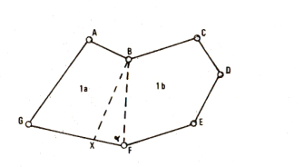
Figure 5-9 Area Sub-division from known point B
- Choose a known point close to X - in this case it is point F.
- Calculate area ABFG (or area BCDEF) and compare it with the required sizes of the resulting plots 1a and lb.
- If area ABFG is greater than the required size for plot la, then obtain the difference, say da. This da, is the amount across which line BF has to sweep if BF is hinged at B. and F rotated clockwise to X.
- In triangle BFX, bearings and distances BF and FG can be computed Hence angle BFG can be derived. Thence distance FX can be solved from:
da = 1/2BF. FX. Sin(BFG)
- Since bearing and distance FX are now known, the coordinates of point X can be derived and the sub-division effected in the field.

Area Sub-division by a Line of a Given Bearing
The Steps to follow are as outlined below:
- Calculate the total area of plot ABCDEFG as above (see Figure 5.2). The sub-division gives plot 2a and 2b.
- Estimate the most likely position of say line XY on the bearing given, to divide the plot into the required parts and sizes.
- Since X and Y are on unknown points on boundaries BC and GF respectively. it is reasonable to at least start from one known point which is close to the line XY. In this case either B or F could be such a point. Let’s choose point B.
- Construct line BY’ parallel to XY and let ii he assumed to approximating the position of XY.
- Compute the coordinates of point Y’ from the known data. i.e. bearings BY’ and GY’, coordinates of points B and G. Accordingly the coordinates of point Y’ may be derived by computing an intersection or, easier still, through solving triangle BGY’.
- Calculate area ABY’G (or if you like BC DEFY’).
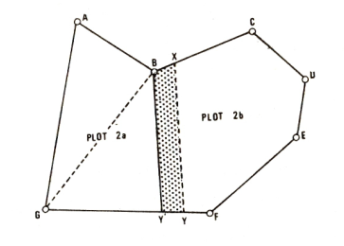
Figure 5-10 Area sub-division by a line of a given bearing
- Compare the size of ABY’CJ with the required portion.
For the sake of this discussion, let’s suppose that area ABY’G is short of the required area by an amount da. Then:

- Derive da from the difference between the required size of the resulting plot 2a and the area ABY’G. This has to make line BY’ shift parallel to itself till it coincides with the position XY, thereby sweeping through the area shaded in the diagram. Then we can say that: da = area BXYY’
- The area BXYY’ forms a trapezium and it is required to know the separation h between the two parallel lines BY’ and XY from which distances BX and Y’Y and hence the coordinates of the points X and Y can be computed. Reference to a diagram drawn to scale becomes more important from this stage onwards.

Area Sub-division by a Give and Take Line
Sometimes it may happen that the boundary of two contiguous plots is a Zigzag line. The neighbors owning such parcels may wish to reduce the number of lines forming the common boundary without either of them losing land to the other.
Figure 5-2 Area Subdivision by a give and take line

Area Sub-division into Proportional Parts
This method is confined to regular figures like triangles and rectangles where area calculations would not be necessary. In such situations, the proportional parts would further require to be simple numbers like 1:2, 1:3, 2:3 and so forth. Good knowledge of the geometry of various figures, together with their properties is invaluable here.

5.2.2.3 Boundary Re-Establishment
Boundary beacon destruction or displacement is often a recurring problem particularly in urban areas. Such destruction, removal or displacement may be accidental as during construction activities; or wilful, as when there is a dispute over the position of a common boundary between neighbors. On this, Dale (1976:20) observes:

In many countries within the Commonwealth the high rate of loss of corner monuments is treated with despair... and has become an accepted fact of life”. He goes on to say that “Surveyors General are ... reluctant to prosecute or enforce their powers to charge contractors for replacing concrete marks...

However, following occurrences of any of these events, the affected boundary beacons (also known as lost beacons/markers) will at some stage need to be re-established, either because a plot owner wants to recover his lost boundaries; or the position of the lost beacon needs to be restored for purposes a court settlement over a disputed boundary, plot sub-division, boundary extension, boundary fencing etc. Therefore, in this section, we intend to see how the surveyor will go about re-establishing the position of a lost boundary marker.

When we talk of boundary re-establishment or restoration we are referring to the position of a boundary which has been established by a lawfully authorized land surveyor, and the position of such a boundary has been approved by the Director of Surveys and Mapping. Boundary re-establishment, therefore, involves trailing in the foot-steps of the original surveyor who established the boundary in the first instance. Accordingly, the surveyor seeking to re-establish lost boundaries must retrieve all relevant records and reports which will enable him/her to understand how the original boundaries were established. A routine similar to data searching for sub-division surveys is repeated here in the acquisition of the relevant data. In addition to that information, maps and air photographs showing any boundary changes may help in locating the most probable positions of old boundaries. These are particularly useful and even indispensable where the lost boundaries are general.

In numerical surveys, the surveyor will need to have at least two recovered boundary points from which to start retracement of the boundaries. Where these two points are inter-visible and are in situ, boundary retracement becomes easy. If no beacons of the original survey or of any other survey can be recovered in the immediate neighborhood, then the surveyor will be forced to undertake a separate survey in the form of a triangulation, a traverse etcetera - possibly from distant survey marks in order to establish some new points in the neighborhood of the points which are being considered for reestablishment. From these new points, the old points may be searched by bearing and distance measurements which are made from pre-computed data.

Since the method of fixation of the old points is in all practical cases bound to bear certain errors (e.g. systematic and residual) which are quite different from those of the new points, the computed data is also bound to have errors which result from these two methods. The combined errors have quite substantive effects in the searching. Therefore, as beacon searching proceeds, the surveyor should bear this in mind and take all suitable precautions. Before a beacon can finally be described as missing the surveyor should exhaust all searching by ensuring that searching measurements have actually been made from recovered points which have been proved to be in situ. Replacement of lost boundary beacon(s) should, as far as is practicable, be made on the basis of placement data which has been pre-computed from existing beacons of the original survey. Points in the control framework covering the area or other boundary beacons whose fixation is not closely related to that of the lost beacons may only be used if the field conditions dictate so. The beacons to be used for the replacement must themselves have been proved, by measurement checks, to be in situ before they can be used. Such check measurements must be recorded in the field notes.

Lost boundary beacons should be replaced by new beacons with entirely different numbers. This is intended to avoid confusion which may be caused by the occurrence of either the same beacon number with two (though slightly) different sets of coordinates, or the possibility that the beacon declared missing might have been removed and erected elsewhere in the neighborhood.

After replacement of a missing beacon in accordance with pre-computed data, check angle and distance measurements to, or from, it must be made and recorded. Such check measurements must be truly independent as far as all other factors will permit. By this is meant that they mu be measured to or from points which were not used for the emplacement of the new beacon. The new coordinates will then be computed and compared with the old ones for acceptability or rejection -as the case may be. The reestablished field notes, diagrams, computations and detailed report on the survey should be submitted.

Checking of Surveys
In addition to the insistence made to surveyors that they should always use self checking methods and independent checks both during field work and in computations of survey jobs, there is, as Dale (1976:96) notes, a rigorous system laid down for the checking and examination of all survey jobs before they can be approved. The need for such rigorous checks and examinations arises basically from the acceptance by the state, of the responsibility to protect the interests of land holders through assurance that gross errors or blunders, most likely to occur in numerical surveys, do not get mixed into the final description of land parcel.

After execution of a job to its completion, the field surveyor passes her field notes and computations to a fellow surveyor who checks the completeness of all the reductions in the field notes as well as the computations and the clarity of the survey method used. The checking is mostly a re-computation of the entire survey. As he/she checks the work of his/her colleague, he/she ticks in pencil, all correct reductions and computations. Where he/she discovers an anomaly he/she should neatly cross the wrong figures such that they remain readable and then write the correct figures adjacent to the ones he/she struck out - continuing with the checking until the task is complete. If the job is acceptable, a suitable scale is selected and a plan produced, checked and a report for the survey written. The whole job (field notes, computations, report and the plan) should be submitted to the Director of Surveys and Mapping for further scrutiny.

In order to facilitate and speed up the checking of surveys, all field surveyors are advised to strictly adhere to the standard methods of recording and reducing field notes and computations.

The following guidelines can be used to assist when checking surveys:

- Surveys should conform to planning proposals and any deviations should clearly be explained in the surveyor’s report;
- Fixation of beacons should be by normal methods and these should be depicted on the working plans as these give a quick guidance of the methods used;
- Measurements on the plans should be the same as those indicated in the field sheets and on the field diagrams for plots;
- Accuracies of the traverses, bearing and distance fixations and online should be to acceptable limits:
- Where road reserves are applicable, they should be computed or be physically measured in the field and indicated on the field diagrams;
- Areas of all large plots and all irregular plots should be calculated and written on the plan;
- Linear measurement sheets should be neatly presented, indicating the instruments used, the last date of tape standardization and the unit of measurements;
- Survey reports should be exhaustive, explaining survey method, accuracy attained and any other information to make the checking easier.
- (Plans must be drawn accurately, neatly, at suitable scales and appropriately signed.
- All field sheets and computations should be corrected in green in the field office before they are submitted to the headquarters;
- Not-Placed points (NP) must, as far as possible, be avoided otherwise explanatory notes must be given. All side lengths of plots must be measured and where computed distances are indicated on the plan explanation must be given as to why they were not measured;
- North point, scale, grid lines and values etcetera should always be indicated on the plans;

- Plans must indicate as much as possible all nearby/adjacent surveys;
- Where old beacons have been re-fixed, comparison of old and new coordinates must be given. Where old and new coordinates do not differ much, old values must be retained in the computations;
- Datum points must always be checked before commencement of any survey and type of control used (whether national or local or adjacent survey plot beacons) must be stated;
- Rejected computations should not be destroyed but cancelled and enclosed with the accepted ones.

5.2.3 Partition
When several persons jointly own a property unit with a specified share each, i.e. have joint title in it, one or more of them may request that his share be hived off into a separate area of land, forming a new property unit. In this way the share in the jointly owned property unit can be converted into a separate property unit in its own right.

Always, when partition takes place, the whole of the property unit affected is divided up into new property units. The parcels are usually termed “partition lots”. These lots form new property units. After the partition, the original property unit no longer exists.

In order for a partition to take place, it does not have to be desired by all the joint owners of a property unit. If one joint owner applies for cadastral procedure, this is sufficient for the possibility to be considered of carrying out a partition as applied for. As part-owner of a jointly owned property unit, then, one can have one's share converted into a new property unit,' whether one likes it or not. This is, of course, conditional on the requirements for partition being satisfied and on the new property units being judged suitable.
,
It is not mandatory for the shares of all joint owners to form separate property unit. Joint owners can ask for their combined shares to be put into a common area. A common area is also defined for those joint owners not desiring any partition. Partition automatically transforms the title in a share of the jointly owned property unit into a title in a newly formed property unit. No title deed registration need be applied for.
.
A partition then, can mean the owner, say, of one-third of a property unit asking for his third to be measured out as an area of the land, the value of which, in principle, corresponds to one-third of the total land value, because when his share in the property is converted into the land area which will fonn a new property unit, this subdivision is based on the value of the land. No allowance is made for the value of the buildings belonging to the property unit. There are limits to how far one can depart from the value of the share when setting out the area on the ground, if the joint owners are not in agreement.

Special rules apply to the valuation of different parts of a property unit, which is to be partitioned, and concerning the possibility of compensatory payment between joint owners if the value of a lot is not entirely matched by the value of the share in the original property unit. The differences in value between the new property units and corresponding shares in the value of the original property unit, buildings included, have to be made good in money. This means the party acquiring a building on his land having to pay compensation to the party not acquiring any building.

Easements can be created between the different lots. A certain area can also be designated as common to the lots. Easements cannot be formed in such a way as to affect a property unit other than the one, which is partitioned. An easement affecting another property unit can only formed by re-allotment.

When a property unit, which is partitioned, is encumbered by an easement, the easement will, after the partitioning, encumber the lot or lots where it is localised. Unlocalised easements encumber all lots,

If a property unit, which is partitioned, has a share in jointly owned land, that share has to be distributed between the lots. This can be done by dividing the share between the different lots or by transferring the entire share to one of them. The same applies when the partition unit has an easement in another property unit.

5.2.4 Amalgamation
Entire property units can be amalgamated into a new property unit. Subdivided parcels can also be amalgamated. So too can a complete property unit and a subdivided parcel.

In order for amalgamation of property units to be possible, must have the same owner. Property units belonging to different persons cannot be amalgamated to form a single property unit. If there are several joint owners of property units, which are to be merged, ownership must be distributed in the same way in all property units, which the amalgamation involves. It is not possible, for example, to own half of one property unit and one-third of another if the two units are to be amalgamated.

There is, however, an exception to this requirement of common ownership for property units to be amalgamated. If property units are owned by husband and wife, amalgamation is possible subject to certain conditions.

If property units, which are to be amalgamated, are mortgaged, special rules apply for the protection of the mortgagees.
The property units included in an amalgamation cease to exist. This means that all rights and obligations belonging to the property unit will be transferred to the new unit.

5.2.5 Re-allotment
Reallotment means re-formation of existing property units. Reallotment can mean the transfer of land from one property unit to another. Easements and joint property units can be formed by reallotment. It is also possible for shares in joint property units to be transferred from one property unit to another, and for easements to be amended or cancelled.
Reallotment can take place by agreement between the owners of the property units affected. In certain cases it can also take place coercively i.e. against the wishes of a property owner e.g. for the purpose of planning implementation.

In order for reallotment to be possible, there are a number of conditions, which have to be satisfied. The provisions are of two kinds: those designed for the protection of individual property owners and proprietors and beneficial interests, and those for the protection of public interests.
The provisions for the protection of private interests are optional, which means they can be overridden by an agreement. In coercive reallotment, these conditions always have to be satisfied.

The provisions for the protection of public interests always apply in connection with reallotment, i.e. both when the property owners are agreed among themselves in fovor of reallotment and when reallotment is carried out coercively.
Land transfer
Land can be transferred by reallotment from one or more property units to one or more others. Reallotment can mean anything from the transfer of a small area of land from one property unit to another to a complete redeployment of land holdings within a larger area (land consolidation).

An official easement applying in a certain area of land (a localized easement) or a utility easement continues to apply in the land area transferred, even if, as a result of reallotment, that area is transferred from the property unit in which the grant was made to another property unit. The easement or utility easement "goes with the land".
Contractual easement and leases grant in a certain area of land, on the other hand, cease to apply if the land in which the grant was made is transferred from the grantor (servient) property unit to another property unit. It is possible, however, in connection with land transfer to resolve that a contractual easement or lease will continue to apply in the area transferred.

Unlocalized easements will apply in the servient property unit as it stands after reallotment. This means that, if a size of a property unit increases, the geographical scope of the easement will expand so as to include the whole area of the property unit after reallotment. Conversely, the area of application will shrink when the property unit is divested of land.
If the value of the land of which a property unit is divested does not agree with the value of the land added to the same property unit, compensation has to be paid for the difference.

Chapter 6 Property Description Methods

6.1 Introduction
Many territorial animals identify land parcels by marking the boundaries with their scent, scrapes, or other physical signs that tell other animals, “This is mine—keep out.” The human race is no different from other territorial animals in this respect. The method of marking boundaries most frequently used by humans consists of marking boundary corners with physical objects, such as posts, rocks, pipes, or iron rods, and marking the lines between the corners with fences, ditches, roadways, or tree lines. This is fine for demonstrating to others the physical limits of a parcel of land. This is not adequate, however, when the need arises to define or describe that parcel to others who cannot visit each boundary corner. The private ownership of land and the statutes that regulate the transfer of that ownership require that each and every separate parcel, public or private, be capable of being uniquely distinguished from all other parcels in writing. The systems of identification used may vary but usually take some form of one of three basic systems of identification for original tracts. They are the “metes and bounds” system, the block and lot system, and the coordinate system.

The first system, the “metes and bounds” system, requires that privately owned land be identified by naming the adjoining owners and physical limits (bounds) of a property, and that a report of the dimensions (metes) be included in the description of the property. The metes and bounds system of identifying or describing real property has often been erroneously referred to as the “legal description” when, in fact, any proper description based on any of the systems of identifying land parcels is a “legal” description. The additional requirement that all land transactions be in writing and recorded with some governmental body to assist the local tax collector in developing a record of property owners (and tax debtors) meant that a general description of the property that simply named all adjoiners (bounds) was insufficient. The area (therefore the value) was a part of the record that was most important to the tax collector.

The second system comes into play where large tracts have been subdivided into several smaller lots. In these cases, reference to the lot and/or block numbers or letters shown on a “subdivision plat” is the means by which a land parcel is identified. The subdivision plat is a plan, usually recorded, that specifies the location and dimensions of several parcels of land. A subdivision plat may divide a tract of land that was originally defined by metes and bounds, or another subdivision plat.

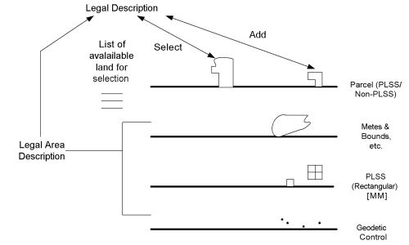
Figure 6-11 Property description methods

The third system is when we are using coordinates (usually national coordinates) to describe the boundary.

The purpose of a land description is to identify the location of a legal interest in land. Whereas the land interest is the primary subject matter of the deed itself, locatability is the underlying intent of the deed description. A description incorporated into a deed is often called a “legal description,” which is shortened in surveyor’s jargon to “the legal.” Surveyors usually think of descriptions as merely means to identify lines and corners of land parcels. It is useful to remember that identification of the land interest conveyed is a more exact legal purpose. The practical act of finding described monuments and other evidence usually summarizes the surveyor’s involvement with descriptions of existing tracts of land, but when preparing new descriptions, surveyors should be aware of legal matters related to the interest in the land, locatability, and avoiding ambiguity.
The courts have held that a description is “legally sufficient” if the property can be identified by a competent surveyor, with or without the aid of extrinsic evidence. This is the “minimum standard,” legally, on preparing descriptions. The review herein will give special emphasis to the qualities needed to not only assure that descriptions are legally sufficient, but also free of the ambiguities that cause confusion, cost, and the possibility of legal action.
Descriptions are of two basic types: written and graphical. Written descriptions contain words and phrases, which, together comprise “calls” or references to corners, monuments, lines, parcels, records, and measurements. Graphical descriptions (maps) show most of the above in the form of scaled drawings, eliminating most of the narrative required using purely written descriptions. Often, written descriptions “call for” (refer to) a map. The description of such land parcels are actually a combination of written and graphical methods. Written descriptions prevail for metes and bounds surveys. Although written words generally seem more ambiguous than sketches for surveyors and engineers, most other people who deal with land boundaries seem to prefer them, and are more confused by graphics.
Ideally, description drafters should know or understand measurements and surveying related mathematics, the location of monuments and other physical evidence affecting the identification of the land interest, how to allow the principles of boundary location to control the precise words and other variables that might be included, and how the preparation affects a surveyor’s ability to locate the land interest being described. They should know the meaning of legal words used in descriptions and how to use them properly, understand the legal relationship of the parcel of land with adjoiners (senior and junior rights, overlapping claims, etc.), and how choices of words and other features might affect title or other rights. In addition to the above special knowledge, drafters should possess basic skills in written and/or graphical communication, including knowledge of proper grammar, punctuation, and spelling. Ambiguities occur in descriptions because the preparer did not have sufficient skill or knowledge in land surveying and conveyancing.

6.2 Written Description

6.2.1 Metes and Bound Method
The most common written description form is metes and bounds. A “true” metes and bounds description is a perimeter description of a tract of land containing recitations of measurements and boundaries, in sequence, around a parcel of land from a point of beginning. Bearings and distances are usually given for each line, although azimuths, interior angles, or deflection angles can be used for direction relationships. Metes and bounds descriptions usually close with a statement of the area and various other clauses.
The pure bounds description contains only citations of boundaries, with no measurements. One form of such a description is the same as metes and bounds, but has the measurements omitted. Another form of bounds description reads, as an example “bounded on the north by (a land parcel of record), on the east by (another record parcel), on the south by (perhaps a highway),…”, etc. The bounds description is often preferred by title companies because there can be no gaps or overlaps once the adjoiners’ properties are located. However, more time and expense is required to survey them since measurements are omitted and the adjoiners’ lands must all be surveyed. Such descriptions are often used by lawyers to describe a remainder.
A proportional description is used to describe a fractional part of a larger area. An example is “the east half of Lot 2,…”. Such a description is used where the intent is clearly to divide something in exact proportions. The advantage is that the stated proportional rights are maintained regardless of the actual size discovered by an accurate survey. The disadvantages are that there is sometimes ambiguity regarding the division line’s direction, and additional surveying is usually required because of lack of complete dimensions around the proportions described.
An area description is similar to the proportional conveyance, except that an exact area is specified rather than a fraction of a whole. “The east 2.0 acres of Lot 2…” would be an example of an area description. Such a description is appropriate when the intent is to describe an exact area. As with the proportional description, ambiguity can result if the dividing line is not clearly described.
A linear description is similar to the above, except that a linear dimension is given instead of area. An example is “the east 40 m of Lot 2…”. The intent here is clearly to convey a 40-m wide strip of land from the east side of the lot. The dividing line should be unambiguous as parallel with the east line of the lot.
A strip description is one conveying land of a specified linear dimension on both sides of a described line. A highway centerline description is an example of a strip description. The usual form is something like: “all that land lying 50 m right and left of a line described as follows…”, after which the line is described by metes and bounds. The advantage of such a description is its simplicity. The disadvantage is that the dimensions of the boundaries are not given and much surveying and calculation must usually be done to survey such an area. A description specifying an area on one side of a line is a variation of the strip conveyance.
A reference description refers to a map. When such descriptions are used, the map is the primary description, the words merely being as necessary to specify a particular area on the map or make a clear reference that the drawing is to be considered as the description. Such a description is not technically a written description, the words being only as necessary to refer to the plat. Lots in a platted subdivision and aliquot parts of the public land survey system are examples of reference descriptions. Reference descriptions generally apply to platted subdivisions. However, a metes and bounds survey could also be described by a graphical description, with only a short reference to the plat being made in writing.
The metes and bounds format: The metes and bounds description is so ingrained in the land title community and dovetails so well with the laws regulating the transfer of titles that, even in areas where more precise land identification systems are used, the metes and bounds description is often used to supplement land record system descriptions. A complete boundary description using the metes and bounds system will incorporate the following:
- A commencing point that is well known, easily found, permanent, recoverable, recognizable, and preferably public in origin. The purpose of the commencing point is to clarify the location of the parcel in relationship to some universally recognized landmark.

- A point-of-beginning that is a part of the property being described. The purpose of the point-of-beginning is to emphasize that the limits of the parcel itself are to follow in the dialogue. The point of beginning is used purely for descriptive purposes and is not the point where a Land Surveyor “begins” a survey.

- A report of the physical objects (monuments) that mark the location of ends, and sometimes areas, along each line.

- A report of the contiguous owners along each line or land record identification of the contiguous parcels (bounds).

- A direction, usually a bearing, for each line. In some cases, the angle formed at a corner may be reported in lieu of a bearing. In the cases of curved or meandering boundaries, the appropriate words necessary to describe the configuration of the line are used.
- A distance between each corner (metes).
- The area of the parcel.
- Reference to the particular plat or map of survey that forms the basis for the description
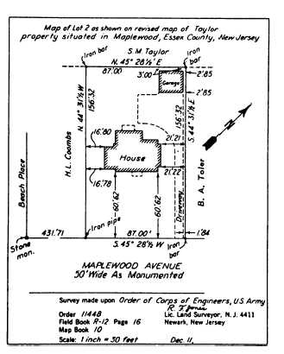
Figure 6-12 Lot map by metes and bounds

.
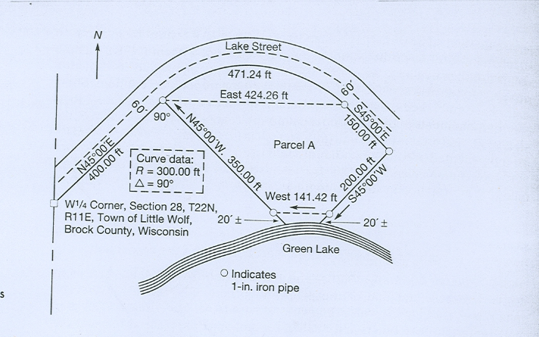
Figure 6-13 Metes and bounds tract

6.2.2 Block and Lot System
Landowners often wished to divide their large tracts into smaller parcels. One of the ways in which this was frequently done was to produce a subdivision plan or map in which the smaller parcels were identified by a lot number or some other identification. This map was then recorded in the local conveyance office, and any title transfers would refer to the subdivision name and lot number.

This system has many advantages. In urban situations, where public streets are created, the addition of the concept blocks greatly reduces the verbiage needed to describe any particular lot. The plat can be used by the owner as a sales aid. Buyers can readily see on the map, if not on the ground, the configuration of the property being purchased. The tax collector can use the map to develop a record of the ownership and relative worth of the properties. Deeds that refer to lot and block identifiers may be supplemented by a metes and bounds description, which refers to street right-of-way corners and adjoining lots to confirm the lot and square.

The mapped system of real property identification has one very important distinguishing feature that greatly separates it from the metes and bounds system. Unlike the previous system discussed, the lot and block does not necessarily depend on monumentation or possession to create boundaries to the property. Before local governments began to exercise their authority, it was not uncommon for owners to draw a platted subdivision of their property solely based on the old metes and bounds system description. It may be that none of the corners in the subdivision was ever monumented. It is just as possible that the lot and block was properly performed and that all of the newly created corners were monumented. The lot and block should be separated into two additional categories.
Subdivisions in which all of the lots were mapped and recorded at one time are very different from subdivisions in which the lots were created one at a time. If the former is true, none of the lots can claim “seniority of title.” If the lots are created and sold one at a time and some chronological sequence can be established for the transfer of title, then a seniority of title can be established. A lot and block usually expresses the intent to convey a parcel of property of specific dimensions. The survey markers, if any are set, reflect a corporeal attempt to place on the ground the limits intended by the survey map. Any blunder in the setting of these survey marks can be corrected at any time, provided that correction is geometrically possible and sufficient acquisitive acts have not taken place.
Frequently, only the street rights-of-way were monumented by the original subdivider. This created the blocks or squares of the subdivision but did not monument the individual lots. In general, it is public reliance on the monumented location of the street rights-of-way that will, in most cases, causes any excesses or deficiencies to be isolated within each block. It is because of this public reliance that block corner monumentation usually ranks above lot corners in importance during boundary recovery.
Lot and Block is typically create land parcels that are quite small. Because of their small size, along with the fact that most platted subdivisions are relatively modern, it is more likely that resurveys of individual lots will discover the dimensions to be identical, or at least very close to, the dimensions reported on the original subdivision plat. More often than not, this is because the typically short distances encountered in modern Lot and Block reduces measurement errors to values that are less than the inherent errors produced by centering on corner monuments.

As urban areas grow, adjoining parcels of land are subdivided to create streets, blocks, and lots according to an orderly and specific plan. Each new subdivided parcel, called a subdivision, is assigned a name and annexed by the city. Block and lot number, tract and lot number, or subdivision name and lot number identifies the individual lots within the subdivided areas. Examples are:

lot 34 of Tract 12314 as per map recorded in book 232, pages 23 and 24 of maps, in the office of the county recorder of ……………………
lot 9 except the North twelve (12) feet thereof, and the East twenty-six (26) feet of lot 10, ………………………. [Parts of two lots are included in the parcel described.]
That portion of lot 306 of Tract 4178 in the …………………., as per Map recorded in Book 75, pages 30 to 32 inclusive of maps in the office of the County Recorder of said County, lying Southeasterly of a line extending Southwesterly at right angles ~om the Northeasterly line of said lot, from a point in said Northeasterly line distant Southeasterly twenty-three and seventy-five hundredths (23.75) feet from the most Northerly corner of said lot.

The block-and-lot system is a short and unique method of describing property for transfer of title. Standard practice calls for a map or plat of each subdivision to be filed with the proper office. The plat must show the types and locations of monuments, dimensions of-all blocks and lots, and other pertinent information such as the locations and dimensions of streets and easements, if any. These subdivision plats are usually kept in map books in the city or county recorder's office.
Lot and block descriptions typically are created simultaneously and thus are not subject to junior or senior right. In performing resurveys to find or reestablish lot corners, therefore, any excess or deficiency found in the measurements is prorated equally among the lots.

In many counties and municipalities the land of the community is divided into subdivisions called blocks, tracts, or subdivisions. Each of these subdivisions is further subdivided into lots. Blocks and tracts usually have numbers, while a subdivision usually has a name. Each lot within a block, tract, or subdivision usually has a number. Cadastral survey, a map book is prepared that shows the location and boundaries of each major subdivision and of each of the lots it contains. The map book is filed in the county or city recorder’s office, and henceforward, in deeds or other instruments, a particular lot is described as, for example, “Lot 72 of Tract 5417 as per map recorded in book 72, pages 16 and 17, of maps, in the office of the county/city recorder of [named] county/city”; or as “Lot 32 of Christopher Hills Subdivision as per. . . .”

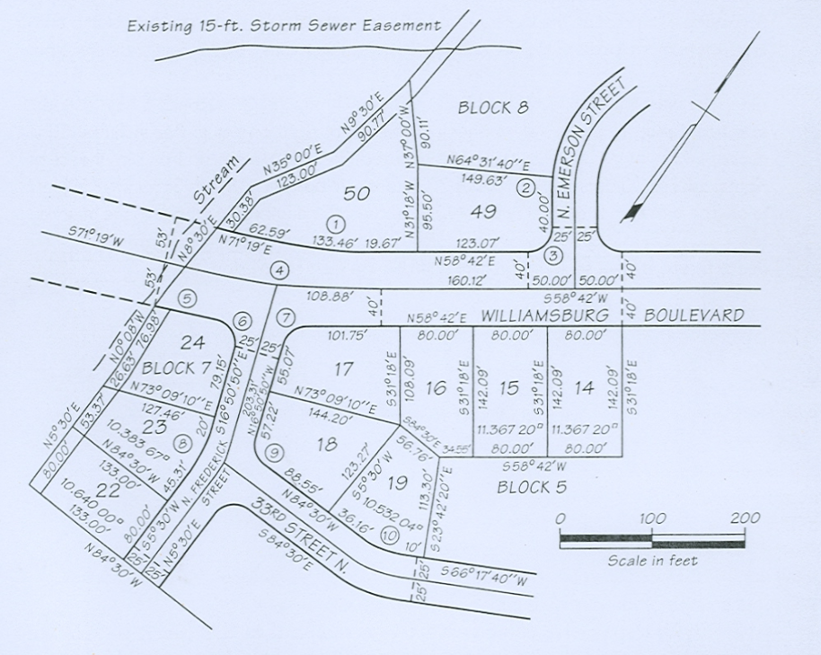
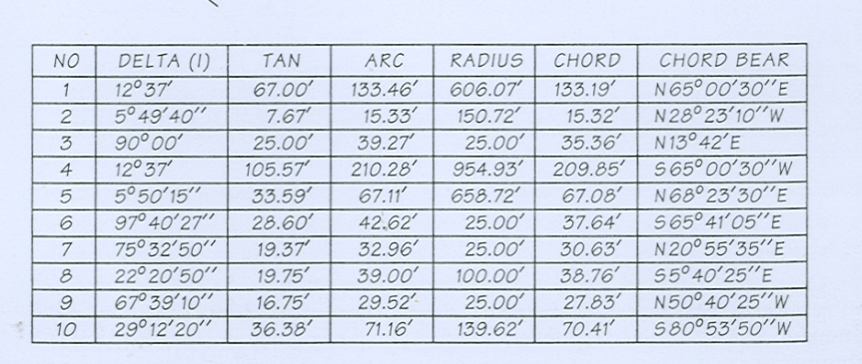
Figure 6-14 Small Subdivision map

6.2.3 Coordinate Method
State plane coordinate systems provide a common reference system for surveys in large regions, even entire states. Several advantages result from using them on property surveys. One of the most significant is that they greatly facilitate the relocation of lost and obliterated corners. Every monument, which has known state plane coordinates, becomes a "witness" to other comer markers whose positions are given in the same system. State plane coordinates also enable the evaluation of adjoiners with less fieldwork. As cities and counties develop land information systems (LISs) and geographic information systems (GISs), descriptions by coordinates are becoming more common. Many local and state governments currently require state plane coordinates on the comers of recorded subdivision plat boundaries, and on the exteriors of large boundary surveys. It is only a matter of time before state plane coordinates are required on all descriptions of land.

A coordinate description of comers may be used alone, but is usually prepared in conjunction with an alternative method. An example of a description by coordinates of a parcel in California follows.
A parcel of tide and submerged land, in the state-owned bed of Seven Mile Slough, Sacramento County, California, in projected Section 10, T 3 N, R 3 E, Mt. Diablo Meridian, more particularly described as follows:
BEGINNING at a point on the southerly bank of said Seven Mile Slough which bears S62°37' E, 860 feet from a California State lands Commission brass cap set in concrete stamped "JACK 1969," said point having coordinates of X = 2,106,973.68 . and Y = 164,301.93 as shown on Record of Survey of Owl Island, filed October 6, 1969, in Book 27 of Surveys, Page 9, Sacramento County Records, thence to a point having coordinates of X = 2,107,196.04 and Y = 164,285.08; thence to a point having coordinates of X = 7,107,205.56, Y = 164,410.72; thence to a paint having coordinates of X = 2,106,983.20, Y = 164,427.57; thence to the paint of beginning. Coordinates, bearings, and distances in the above description are based on the California Coordinate System, Zone II.

Current methods of boundary definition (such as metes and bound method) have been adequate for a long period of time. However, the techniques are a very indirect way of defining a point and disputes arise when different surveyors use different data to determine the location of a boundary.

Alternatively, a coordinate can provide a unique and unambiguous definition of a point and GPS can provide the necessary technology to quickly and accurately locate that point. At present most surveyors compute new subdivisions by coordinates, lay in the corners by coordinates, then prepare “metes and bounds” documents to satisfy the legal requirements for land transfer. Technology has allowed surveyors to adopt a coordinate based approach and this can be used to reform the land ownership record system.
To gain maximum benefit from existing data, the building process should not only extract data from the plats and build the boundary network, but it should also analyze the data and provide a measure as to the reliability and accuracy of the computed coordinates. This will then open the way for these coordinates to become the definition of property boundaries.

The problem that every surveyor faces when redefining an old boundary is what to adopt as evidence to the original marking. Clearly, the subdivision plats are documentary evidence as to the original intention and survey marks placed at the time of subdivision give evidence as to the location of specific corners and the quality of the survey work. Other physical objects which may be shown on the plat such as fences and structures (often referred to as "monuments") can also be used to provide guidance if the original marking is gone.

As time progresses and evidence of the original subdivision marks are lost, the original subdivision pattern becomes irregular and disjointed. The aim of each survey is often to find a solution to minimize the chance of litigation rather than try and define the true location of a boundary. Many surveys are carried out under tight cost constraints and therefore are limited in area and in the amount of detailed investigated. The process of assembling and analyzing all of the dimensional data for an area is not only a comprehensive way of assessing the documentary evidence, but it also allows the surveyor to check on marks which may be physical evidence of boundary position.

