CEng-3154: ENGINEERING HYDROLOGY FOR CIVIL ENGINEERING STUDENTS TABLE OF CONTENTS
- METEOROLOGICAL AND HYDROLOGICAL DATA ANALYSIS FOR THE PURPOSE OF HYDROLOGICAL STUDIES 3
  - GENERAL 3
  - METEOROLOGICAL DATA 3
    - Principles of Data Analysis 3
  - AREAL ESTIMATION 6
  - HYDROLOGICAL DATA 8
    - Missing Data and Comparison with the Precipitation Records 8
- RAINFALL-RUNOFF RELATIONSHIPS (APPLICATION OF DIFFERENT RAINFALL- RUNOFF MODELS) 10
  - HYDROLOGICAL MODELS 10
  - DETERMINISTIC HYDROLOGICAL MODELS 10
    - Empirical (Black Box) Models 10
    - Lumped Conceptual Models 11
    - Distributed Process Description Based Models 11
  - STOCHASTIC TIME SERIES MODELS 12
  - RATIONAL METHOD 13
    - Runoff Coefficient 13
    - Rainfall intensity 14
    - Time of Concentration 15
  - SCS CURVE NUMBER METHOD 20
  - TIME-AREA METHOD 25
  - STREAM FLOW HYDROGRAPH 26
    - Hydrograph Analysis 27
    - Factors affecting flood hydrograph 29
    - Effective Rainfall 29
    - Separation of Base Flow and Runoff 30
  - THE UNIT HYDROGRAPH (UH) 31
    - Derivation of the Unit Hydrograph from single storms 33
    - Changing of the Duration of the UH 33
  - APPLICATIONS OF UNIT HYDROGRAPH 36
  - SYNTHETIC UNIT HYDROGRAPHS 36
    - Snyder’s method 37
  - UH FROM A COMPLEX STORM 39
  - INSTANTANEOUS UNIT HYDROGRAPH (IUH) 40
  - DIMENSIONLESS UNIT HYDROGRAPH 42
  - HYDROLOGY OF UNGAUGED CATCHMENTS 43
- FLOOD ROUTING 48
  - GENERAL 48
  - SIMPLE NON-STORAGE ROUTING 49
  - STORAGE ROUTING 50
  - RESERVOIR OR LEVEL POOL ROUTING 51
  - CHANNEL ROUTING 53
    - MUSKINGUM METHOD OF ROUTING 54
    - APPLICATION OF THE MUSKINGUM METHOD 55
  - HYDRAULIC ROUTING 55
- FREQUENCY ANALYSIS (PROBABILITY IN HYDROLOGY) 56
  - GENERAL 56
  - FLOW FREQUENCY 56
  - FLOOD PROBABILITY 58
    - Selection of Data 58
    - Plotting Positions 59
    - Theoretical Distributions of Floods 60
    - Extreme-Value Type I Distribution (Gumbel’s Method) 60
    - Gumbel's Equation for Practical Use 61

    - Confidence Limits for the fitted data 63
    - Log-Pearson Type III Distribution 64
  - REGIONAL FREQUENCY ANALYSIS 69
  - LOW FLOW ANALYSIS 69
    - Definitions and Basic Concepts 69
    - Low flow frequency analysis 70
    - Drought analysis 72
  - PRECIPITATION PROBABILITY 74
  - READING ASSIGNMENT 74
  - RISK, RELIABILITY AND SAFETY FACTOR 74
- STOCHASTIC HYDROLOGY 76
  - INTRODUCTION 76
  - TIME SERIES 76
  - PROPERTIES OF TIME SERIES 77
  - ANALYSIS OF HYDROLOGIC TIME SERIES 78
    - Trend component 79
    - Periodic component 81
    - Stochastic component 84
  - TIME SERIES SYNTHESIS 85
  - SOME STOCHASTIC MODELS 85
    - Purely random stochastic models 86
    - Autoregressive models 86
    - First order Markov process with periodicity: Thomas - Fiering model 87
    - Moving average models 89
    - ARMA models ………………90
  - THE USES OF STOCHASTIC MODELS 93
- RESERVOIR CAPACITY DETERMINATION 95
  - MASS CURVE (RIPPLE'S) METHOD 95
  - RESERVOIRS AND SEDIMENTS 100
  - SEDIMENT LOAD PREDICTION 101
- URBAN HYDROLOGY 103
  - CATCHMENT RESPONSE MODIFICATIONS 103
  - URBAN DEVELOPMENT PLANNING 104
  - DRAINAGE DESIGN 104
    - Impervious areas 104
  - THE TRANSPORT AND ROAD RESEARCH LABORATORY (TRRL) HYDROGRAPH METHOD (WATKINS, 1962) 106

MAIN COURSE SYLLABUS
CEng-3154-ENGINEERING HYDROLOGY
PREREQUISITE: CEng2151, Hydraulics II
Rainfall-runoff relationships, application of different models; hydrology of ungauged catchments; flood routing: reservoir routing, channel routing; frequency analysis: rainfall, low flow and floods; basic concepts of stochastic hydrology; reservoirs: determination of reservoir capacity, reservoir simulation, reservoir sedimentation; basic concepts of urban hydrology.

Meteorological and Hydrological Data Analysis for The Purpose of Hydrological Studies

General
Hydrological studies require extensive analysis of meteorological, hydrological and spatial data to represent the actual processes taking place on the environment and better estimation of quantities out of it. Precipitation is the source of all waters which enters the land. Hydrologists need to understand how the amount, rate, duration, and quality of precipitation are distributed in space and time in order to assess, predict, and forecast hydrologic responses of a catchment.

Estimates of regional precipitation are critical inputs to water-balance and other types of models used in water-resource management. Sound interpretation of the prediction of such models requires an assessment of the uncertainty associated with their output, which in turn depends in large measure on the uncertainty of the input values.

The uncertainties associated with a value of regional precipitation consist of:
- Errors due to point measurement
- Errors due to uncertainty in converting point measurement data into estimates of regional precipitation

It is therefore, necessary to first check the data for its quality, continuity and consistency before it is considered as input. The continuity of a record may be broken with missing data due to many reasons such as damage or fault in recording gauges during a period. The missing data can be estimated by using the data of the neighboring stations correlating the physical, meteorological and hydrological parameters of the catchment and gauging stations. To estimate and correlate a data for a station demands a long time series record of the neighboring stations with reliable quality, continuity and consistency.

Meteorological data

Principles of Data Analysis
- Corrections to Point Measurements

Because precipitation is the input to the land phase of the hydrologic cycle, its accurate measurement is the essential foundation for quantitative hydrologic analysis. There are many reasons for concern about the accuracy of precipitation data, and these reasons must be understood and accounted for in both scientific and applied hydrological analyses.

Rain gages that project above the ground surface causes wind eddies affecting the catch of the smaller raindrops and snowflakes. These effects are the most common causes of point precipitation-measurement. Studies from World Meteorological Organization (WMO) indicate that deficiencies of 10% for rain and well over 50% for snow are common in unshielded gages. The daily measured values need to be updated by applying a correction factor K after

corrections for evaporation, wetting losses, and other factors have been applied. The following equations are recommended for U.S. standard 8-Inch gauges with and without Alter wind shields.

Correction factor for unshielded rain gauges:

K_{ru} = 100 exp (-4.605 + 0.062 V_{a}^{0.58}) (1.1)
Correction factor for Alter wind shielded rain gauges:

K_{ru} = 100 exp (-4.605 + 0.041 V_{a}^{0.69}) (1.2)
Where:
V_{a} = Wind speed at the gage orifice in m/s (Yang et al. 1998)

Errors due to splashing and evaporation usually are small and can be neglected. However, evaporation losses can be significant in low-intensity precipitations where a considerable amount could be lost. Correction for wetting losses can be made by adding a certain amount (in the order of 0.03 – 0.10 mm) depending on the type precipitation.

Systematic errors often associated with recording type rain gauges due to the mechanics of operation of the instrument can be minimized by installing a non recording type gauge adjacent to each recording gauge to assure that at least the total precipitation is measured. Instrument errors are typically estimated as 1
– 5% of the total catch (Winter (1981)).

Although difficult to quantify and often undetected, errors in measurement and in the recording and publishing (personal errors) of precipitation observations are common. To correct the error some subjectivity is involved by comparing the record with stream flow records of the region.

- Estimation of Missing Data
When undertaking an analysis of precipitation data from gauges where daily observations are made, it is often to find days when no observations are recorded at one or more gauges. These missing days may be isolated occurrences or extended over long periods. In order to compute precipitation totals and averages, one must estimate the missing values.

Several approaches are used to estimate the missing values. Station Average, Normal Ratio, Inverse Distance Weighting, and Regression methods are commonly used to fill the missing records. In Station Average Method, the missing record is computed as the simple average of the values at the nearby gauges. Mc Cuen (1998) recommends using this method only when the annual precipitation value at each of the neighboring gauges differs by less than 10% from that for the gauge with missing data.

P = 1 [P + P +... + P ]

(1.3)

x M 1 2 n
Where:
P_{x} = The missing precipitation record
P₁, P₂ , …, P_{m} = Precipitation records at the neighboring stations M = Number of neighboring stations
If the annual precipitations vary considerably by more than 10 %, the missing record is estimated by the Normal Ratio Method, by weighing the precipitation at the neighboring stations by the ratios of normal annual precipitations.

P = Nx ⎡ P1 + P2

+...+ Pm ⎤

(1.4)

⎢
N
x M
N
⎣ 1 2
⎥
Nm ⎦

Where:
N_{x} = Annual-average precipitation at the gage with missing values
N₁ , N₂ , …, N_{m} = Annual average precipitation at neighboring gauges

The Inverse Distance Method weights the annual average values only by their distances, d_{m}, from the gauge with the missing data and so does not require information about average annual precipitation at the gauges.
m

D = ∑ d −b
m

(1.5)

m=1
The missing value is estimated as:

P = 1 m
∑
x
D m=1
d −b N

(1.6)

The value of b can be 1 if the weights are inversely proportional to distance or 2, if the weights are proportional to distance squared.
m
m

If relatively few values are missing at the gauge of interest, it is possible to estimate the missing value by regression method.

- Checking the Consistency of Point Measurements

If the conditions relevant to the recording of rain gauge station have undergone a significant change during the period of record, inconsistency would arise in the rainfall data of that station. This inconsistency would be felt from the time the significant change took place. Some of the common causes for inconsistency of record are:
- Shifting of a rain gauge station to a new location
- The neighbor hood of the station may have undergoing a marked change
- Change in the immediate environment due to damages due to deforestation, obstruction, etc.
- Occurrence of observational error from a certain date both personal and instrumental

The most common method of checking for inconsistency of a record is the Double-Mass Curve analysis (DMC). The curve is a plot on arithmetic graph paper, of cumulative precipitation collected at a gauge where measurement conditions may have changed significantly against the average of the cumulative precipitation for the same period of record collected at several gauges in the same region. The data is arranged in the reverse order, i.e., the latest record as the first entry and the oldest record as the last entry in the list. A change in proportionality between the measurements at the suspect station and those in the region is reflected in a change in the slope of the trend of the plotted points.
If a Double Mass Curve reveals a change in slope that is significant and is due to changed measurement conditions at a particular station, the values of the earlier period of the record should be adjusted to be consistent with latter period records before computation of areal averages. The adjustment is done by applying a correction factor K, on the records before the slope change given by the following relationship.

K = Slope for period AFTER slopechange Slope for period Before slopechange

Areal Estimation

(1.7)

Rain gauges represent only point measurements. in practice however, hydrological analysis requires knowledge of the precipitation over an area. Several approaches have been devised for estimating areal precipitation from point measurements. The Arithmetic mean, the Thiessen polygon and the Isohyetal method are some the approaches.

The arithmetic mean method uses the mean of precipitation record from all gauges in a catchment. The method is simple and give good results if the precipitation measured at the various stations in a catchment show little variation.

In the Thiessen polygon method, the rainfall recorded at each station is given a weightage on the basis of an area closest to the station. The average rainfall over the catchment is computed by considering the precipitation from each gauge multiplied by the percentage of enclosed area by the Thiessen polygon. The total average areal rainfall is the summation averages from all the stations. The Thiessen polygon method gives more accurate estimation than the simple arithmetic mean estimation as the method introduces a weighting factor on rational basis. Furthermore, rain gauge stations outside the catchment area can be considered effectively by this method.

The Isohyetal method is the most accurate method of estimating areal rainfall. The method requires the preparation of the isohyetal map of the catchment from a network of gauging stations. Areas between the isohyets and the catchment boundary are measured. The areal rainfall is calculated from the product of the inter-isohyetal areas and the corresponding mean rainfall between the isohyets divided by the total catchment area.
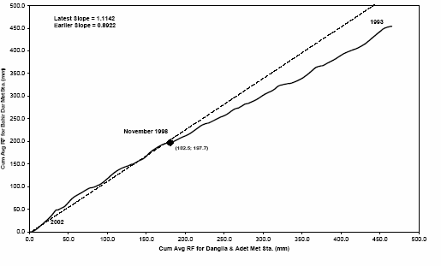
- Double Mass Curves for Bahir

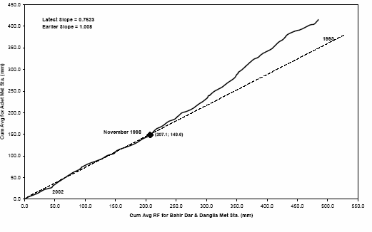

- Double Mass Curves for Adet
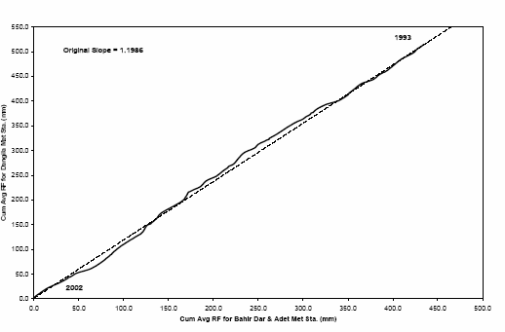

- Double Mass Curves for Dangila Figure 1.1: Double Mass Analysis

The updated records are computed using equation as given below:
P_{cx} = P_{x}K (1.8)
Where the factor K is computed by equation (g) Table 1: Slopes of the DMC and correction factor K
Stations | Average slopes
Stations | Slope for period after slope  change | Slope for period  before slope change | K
Bahir Dar | 1.114 | 0.892 | 1.249
Adet | 0.752 | 1.008 | 0.746
Dangila | 1.1986 | 1.1986 | 1.000

Precipitation records at Bahir Dar and Adet meteorological station beyond November 1998 should be updated by applying the correction factors 1.25 and
0.75 respectively.

Hydrological Data
The availability of stream flow data is important for the model calibration process in catchment modelling. Measured hydrograph reflects all the complexity of flow processes occurring in the catchment. It is usually difficult to infer the nature of those processes directly from the measured hydrograph, with the exception of some general characteristics such as mean times of response in particular events. Moreover, discharge data are generally available at only a small number of sites in any region where different characteristics of the catchment are lumped together.

Missing Data and Comparison with the Precipitation Records
The data so far collected do not indicate any missing data. The potential errors in the discharge records would affect the ability of the model to represent the actual condition of the catchment and calibrating the model parameters. If a model is calibrated using data that are in error, then the model parameter values will be affected and the prediction for other periods, which depend on the calibrated parameter values, will be affected.

Prior to using any data to a model it should be checked for consistency. In data where there is no information about missing values check for any signs that infilling of missing data has taken place is important. A common indication of such obvious signs is apparently constant value for several periods suggesting the data has been filled. Hydrographs with long flat tops also often as sign of that there has been a problem with the measurement. Outlier data could also indicate the problem.

Even though there is a danger of rejecting periods of data on the basis on these simple checks, at least some periods of data with apparently unusual behavior need to be carefully checked or eliminated from the analysis.

The available stream flow data for this analysis generally has corresponding match with the precipitation records in the area. The high flows correspond to the rainy seasons. In some of the years there are remarkably high flow records, for instance in the month of august 2000 and 2001 the flow records are as high as 100 and 89 m3/s compared to normal rainy season records which is between 30 and 65 m3/s. These data might be real or erroneous. On the other hand the values match to the days of the peak rainfall records in the area in both the cases.

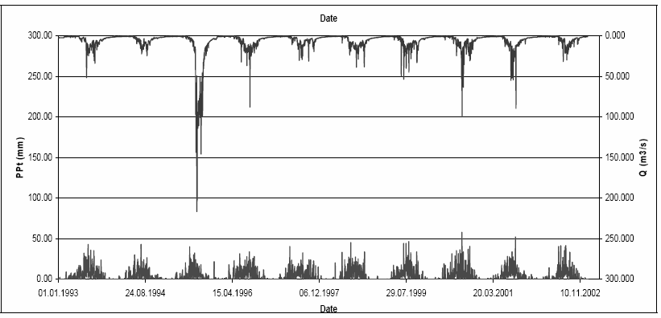
Figure 1.2: Koga stream flow record compared with the precipitation record.

However, the stream flow records of 1995 are exceptionally higher and different from flow magnitudes that had been records for long period of time at Koga River. It is not only the magnitude which is different from the normal flow record, but also it contradicts with the magnitude of the precipitation recorded during the year. These records might be modeled or transferred flows. Hence, the flow records of this year are excluded from being the part of the analysis.

Rainfall-Runoff Relationships (Application of Different Rainfall-Runoff Models)

Hydrological Models
The two classical types of hydrological models are the deterministic and the stochastic types.
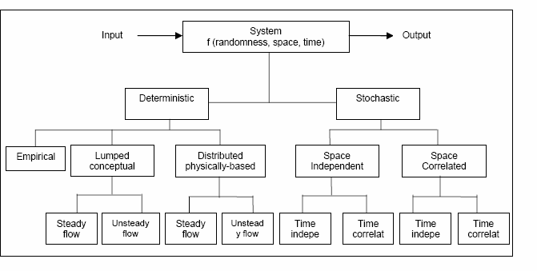
Figure 2.1: Classification of hydrological models according to process description

Deterministic Hydrological Models
Deterministic models permit only one outcome from a simulation with one set of inputs and parameter values. Deterministic models can be classified to whether the model gives a lumped or distributed description of the considered area, and whether the description of the hydrological processes is empirical, conceptual, or more physically-based. As most conceptual models are also lumped and as most physically based models are also distributed. The three main groups of deterministic models:
- Empirical Models (black box)
- Lumped Conceptual Models (grey box)
- Distributed Process (Physically) Description Based Models (white box)

Empirical (Black Box) Models
Black box models are empirical, involving mathematical equations that have been assessed, not from the physical processes in the catchment, but from analysis of concurrent input and output time series.

The first of this kind of model was the Rational Method published by the Irish engineer Thomas James Mulvaney (1822-1892) in 1851. The model was a single simple equation often used for drainage design for small suburban and urban watersheds. The equation assumes the proportionality between peak discharge, qpk, and the maximum average rainfall intensity, ieff:
qpk = CR* ieff*AD
Where AD is drainage area and CR is the runoff coefficient, which depends on watershed land use.

The equation was derived from a simplified conceptual model of travel times on basins with negligible surface storage. The duration of the rainfall to be used in the equation is the mean intensity of precipitation for duration equal to the time of concentration and an exceedence probability of P.

The model reflects the way in which discharges are expected to increase with area, land use and rainfall intensity in a rational way and hence its name Rational Method.

The scaling parameter C reflects the fact that not all the rainfall becomes discharge. The method does not attempt to separate the different effects of runoff production and runoff routing that controls the relationship between the volume of rainfall falling on the catchment in a storm and the discharge at the hydrograph peak. In addition, the constant C is required to take account of the nonlinear relationship between antecedent conditions and the profile of storm rainfall and the resulting runoff production. Thus, C is not a constant parameter, but varies from storm to storm on the same catchment, and from catchment to catchment for similar storms.

The other best known among the black box models is the unit hydrograph model which was published by Sherman (1932), who used the idea that the various time delays for runoff produced on the catchment to reach the outlet could be represented as a time distribution without any direct link to the areas involved. Because the routing procedure was linear, this distribution could be normalized to represent the response to a unit of runoff production, or effective rainfall, generated over the catchment in one time step. The method is one of the most commonly used hydrograph modelling techniques in hydrology, simple to understand and easy to apply. The unit hydrograph represents a discrete transfer function for effective rainfall to reach the basin outlet, lumped to the scale of the catchment.

Other empirical models are developed using linear regression and correlation methods used to determine functional relationships between different data sets. The relation ships are characterized by correlation coefficients and standard deviation and the parameter estimation is carried out using rigorous statistical methods involving tests for significance and validity of the chosen model.

Lumped Conceptual Models
Lumped models treat the catchment as a single unit, with state variables that represent average values over the catchment area, such as storage in the saturated zone. Due to the lumped description, the description of the hydrological processes cannot be based directly on the equations that are supposed to be valid for the individual soil columns. Hence, the equations are semi-empirical, but still with a physical basis. Therefore, the model parameters cannot usually be assessed from field data alone, but have to be obtained through the help of calibration.
One of the first and most successful lumped digital computer models was the Stanford Watershed model developed by Norman Crawford and Ray Linsley at Stanford University. The Stanford model had up to 35 parameters, although it was suggested that many of these could be fixed on the basis of the physical characteristics of the catchment and only a much smaller number needed to be calibrated.

Distributed Process Description Based Models
Another approach to hydrological processes modelling was the attempt to produce models based on the governing equations describing all the surface and subsurface

flow processes in the catchment. A first attempt to outline the potentials and some of the elements in a distributed process description based model on a catchment scale was made by Freeze and Harlan (1969). The calculations require larger computers to solve the flow domain and points at the elements of the catchment.

Distributed models of this type have the possibility of defining parameter values for every element in the solution mesh. They give a detailed and potentially more correct description of the hydrological processes in the catchment than do the other model types. The process equations require many different parameters to be specified for each element and made the calibration difficult in comparison with the observed responses of the catchment.

In principle parameter adjustment of this type of model is not necessary if the process equations used are valid and if the parameters are strongly related to the physical characteristics of the surface, soil and rock. In practice the model requires effective values at the scale of the elements. Because of the heterogeneity of soil, surface vegetation establishing a link between measurements and element values is difficult. The Distributed Process Description Based Models can in principle be applied to almost any kind of hydrological problem. The development is increased over the recent years for the fact that the increase in computer power, programming tools and digital databases and the need to handle processes and predictions of runoff, sediment transport and/or contaminants.

Another reason is the need of the models for impact assessment. Changes in land use, such as deforestation or urbanization often affect only part of a catchment area.
With a distributed model it is possible to examine the effects of such land use changes in their correct spatial context by understanding the physical meaning between the parameter values and the land use changes.

Recent examples of distributed process based models include the SHE model (Abbott et al., 1986), MIKE SHE (Refsgaard and Storm, 1995), IHDM (Institute of Hydrology Distributed Model; Calver and Wood 1995), and THALES (Grayson et al. 1992), etc.

Stochastic Time Series Models
Stochastic models allow for some randomness or uncertainty in the possible outcomes due to uncertainty in input variables, boundary conditions or model parameters. Traditionally, a stochastic model is derived from a time series analysis of the historical record. The stochastic model can then be used for the generation of long hypothetical sequences of events with the same statistical properties as the historical record. In this technique several synthetic series with identical statistical properties are generated. These generated sequences of data can then be used in the analysis of design variables and their uncertainties, for example, when estimating reservoir storage requirements.

With regard to process description, the classical stochastic simulation models are comparable to the empirical, black box models. Hence, stochastic time series models are in reality composed of a simple deterministic core (the black box model) contained within a comprehensive stochastic methodology.

So, these are the broad generic classes of rainfall-runoff models, lumped or distributed; deterministic or stochastic.

The vast majority of models used in rainfall-runoff modelling are deterministic. Simpler models still offer so wide applicability and flexibility. If the interest is in simulating and predicting a one time series, for instance, run-off prediction, simple lumped parameter models can provide just as good simulation as complex process description based models.

Rational Method
One of the most commonly used for the calculation of peak flow from small areas is the rational formula given as:

Qp =
1

3.6
C(itc, p ) A
(2.1)

Where, Q_{p} = peak flow (m³/s)
C = dimensionless runoff coefficient
i_{(tc,p)} = the mean intensity of precipitation (mm/h) for a duration equal to t_{c} and an exceedence probability p
A = drainage area in Km²
Assumptions inherent in the Rational Formula are as follows:
- The peak flow occurs when the entire watershed is contributing to the flow
- The rainfall intensity is the same over the entire drainage area
- The rainfall intensity is uniform over a time duration equal to the time of concentration, t_{c} . the time of concentration is the time required for water to travel from the hydraulically most remote point of the basin to the point of interest
- The frequency of the computed peak flow is the same as that of the rainfall intensity, i.e., the 10-yr rainfall intensity is assumed to produce the 10-yr peak flow
- The coefficient of runoff is the same for all storms of all recurrence probabilities
Because of these inherent assumptions, the Rational Formula should only be applied to drainage areas smaller than 80 ha.

Runoff Coefficient
The ground cover and a host of other hydrologic abstractions considerably affect the coefficient. The rational equation in general relates the estimated peak discharge to a theoretical maximum of 100% runoff. The Values of C vary from 0.05 for flat sandy areas to 0.95 for impervious urban surfaces, and considerable knowledge of the catchment is needed in order to estimate an acceptable value. The coefficient of runoff also varies for different storms on the same catchment, and thus, using an average value for C, gives only a rough estimate of Q_{p} in small uniform urban areas. On top of this the Rational Formula has been used for many years as a basis for engineering design for small land drainage schemes and storm-water channels.

If the basin contains varying amount of different land cover or other abstractions, a coefficient can be calculated through areal weighing as shown in equation (2.2). Typical values are given in table 2.1 below.

Weighted C =
∑(Cx Ax )

Atotal
(2.2)

Where x = subscript designating values for incremental areas with consistent land cover

Table 2.1: Runoff coefficients for Rational formula
Type of Drainage Area | Runoff Coefficient, C∗
Business:  - Downtown areas Neighbor hood areas | 0.70 – 0.95  0.50 – 0.70
Residential:
- Single –family areas | 0.30 – 0.50
- Multi- units, detached | 0.40 – 0.60
- Multi-units, attached | 0.60 -0.75
- Suburban | 0.25 – 0.40
- Apartment dwelling areas | 0.50 – 0.70
Industrial
- Light areas | 0.50 – 0.80
- Heavy areas | 0.60 – 0.90
Parks, cemeteries | 0.10 – 0.25
Playgrounds | 0.20 – 0.40
Railroad yard areas | 0.20 – 0.40
Unimproved areas | 0.10 – 0.30
Lawns:
- Sandy soil, flat 2% | 0.05 – 0.10
- Sandy soil, average, 2-7% | 0.10 – 0.15
- Sandy soil, steep, 7% | 0.15 – 0.20
- Heavy soil, flat, 2% | 0.13 – 0.17
- Heavy soil, average 2-7% | 0.18 – 0.22
- Heavy soil, steep, 7% | 0.25 – 0.35
Streets:
- Asphalted | 0.70 – 0.95
- Concrete | 0.80 – 0.95
- Brick | 0.70 – 0.85
Drives and walks | 0.75 – 0.85
Roofs | 0.75 – 0.95

Rainfall intensity
Rainfall intensity, duration curve and frequency curves are necessary to use the Rational method. Regional IDF curves need to be developed for the catchment in question.

- Higher values are usually appropriate for steeply sloped areas and longer return periods because infiltration and other losses have a proportionally smaller effect on runoff in these cases

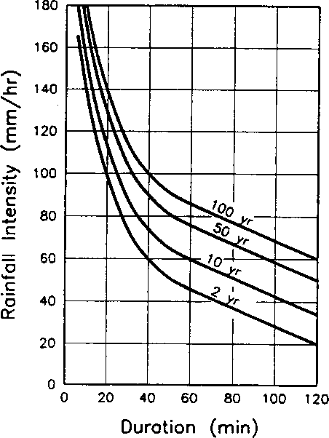

Figure 2.2: Example of IDF Curve

Time of Concentration
t_{c} is the time of concentration, the time required for rain falling at the farthest point of the catchment to flow to the measuring point of the river. Thus, after time t_{c} from the commencement of rain, the whole of the catchment is taken to be contributing to the flow. The value of i, the mean intensity, assumed that the rate of rainfall is constant during t_{c}, and that all the measured rainfall over the catchment area contributes to the peak flow. The peak flow Q_{p} occurs after the period t_{c}.

There are a number of methods that can be used to estimate time of concentration (t_{c}), some of which are intended to calculate the flow velocity within individual segments of the flow path (e.g. shallow concentrated flow, open channel flow, etc.) the time of concentration can be calculated as the sum of the travel times within the various consecutive flow segments.

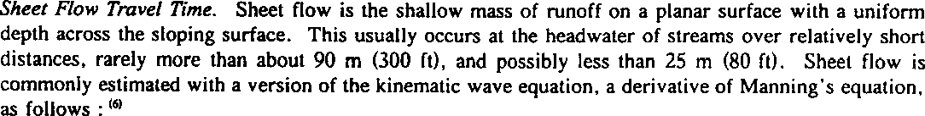

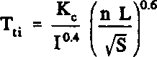
(2.3)
Where:
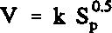
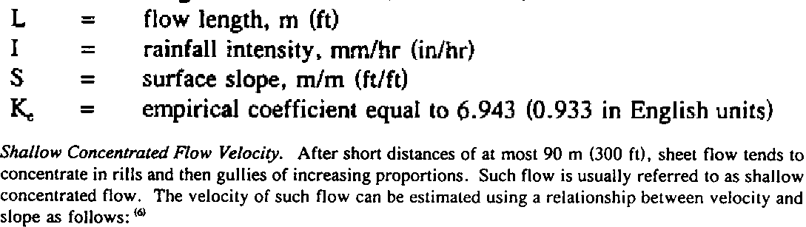

(2.4)
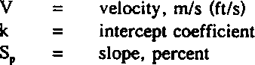

Open Channel and pipe flow velocity: Flow in gullies empties in to channels or pipes. Open channel flow is assumed to begin where the stream follows and defined path and becomes visible/significant. Manning’s equation can be used to estimate average flow velocities in pipe and open channels.
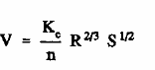 (2.5)

Table 2.2: Intercept coefficients for velocity versus slope relationship of equation (2.5)
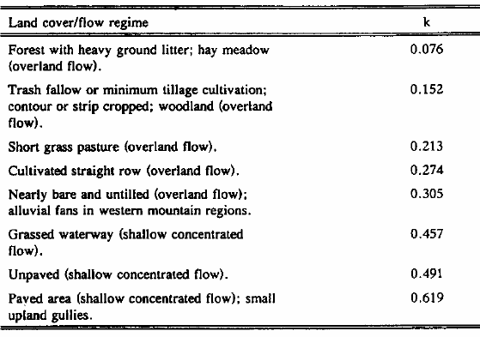

Table 2.3: Manning’s Roughness coefficient (n) for overland flow
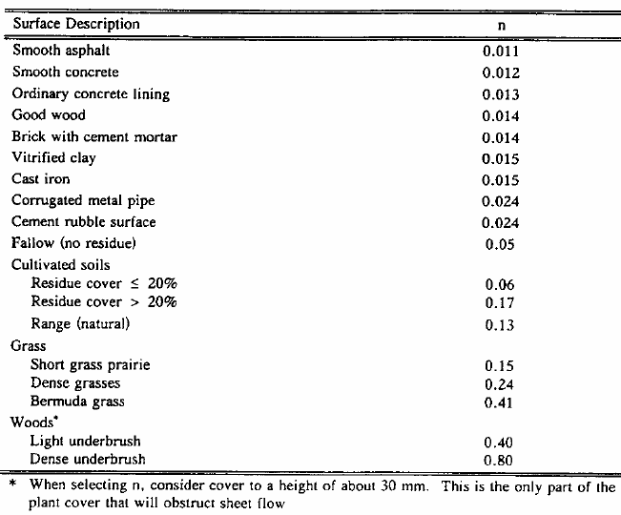

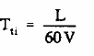
(2.6)
Where:
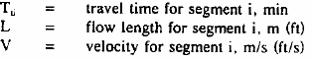

For small natural catchments, a formula derived from data published by Kirprich for agricultural areas could be used to give t_{c} in hours by the following relationship:

⎛ L ⎞0.8
t ( Hr ) = 0.00025⎜ ⎟
⎜ ⎟ (2.7)
S
c
⎝ ⎠

Where: L = the length of the catchment along the longest river channel (in m)
S = overall catchment slope (in m/m)

Example 2.1:
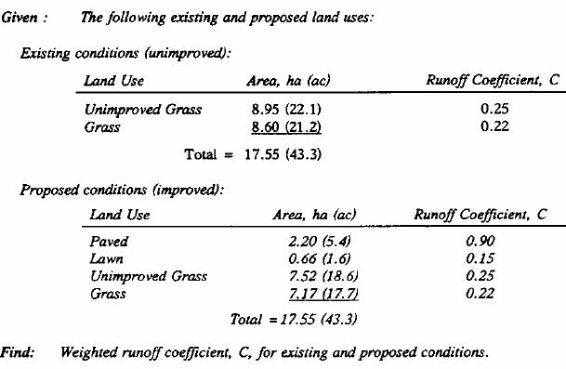
Solution:

Example 2.2:
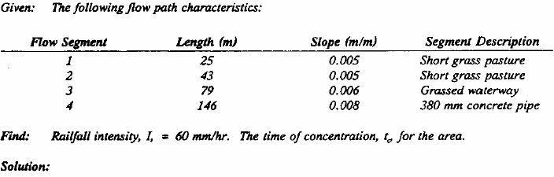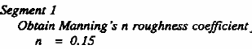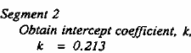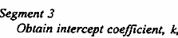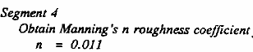
= 0.457

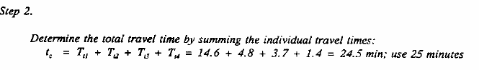

Example 2.3:
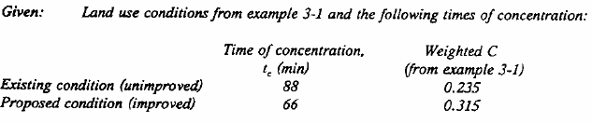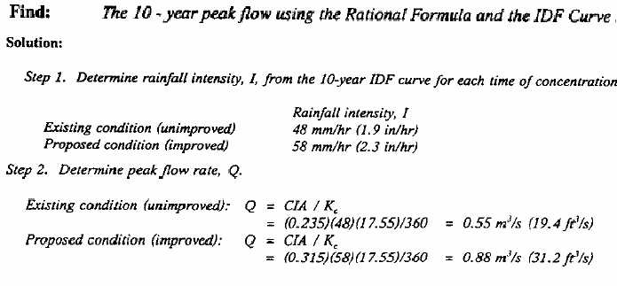

  - 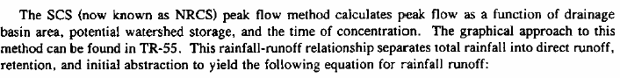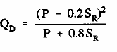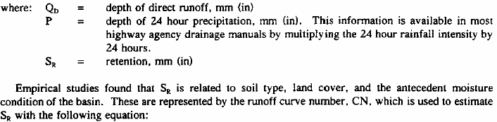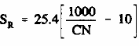SCS Curve Number Method
(2.8)
(2.9)

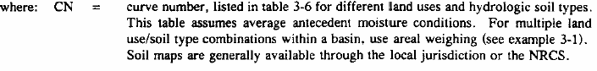
Table 2.4: Runoff Curve Numbers for Urban areas (Average watershed conditions, I_{a} = 0.2 S_{R})
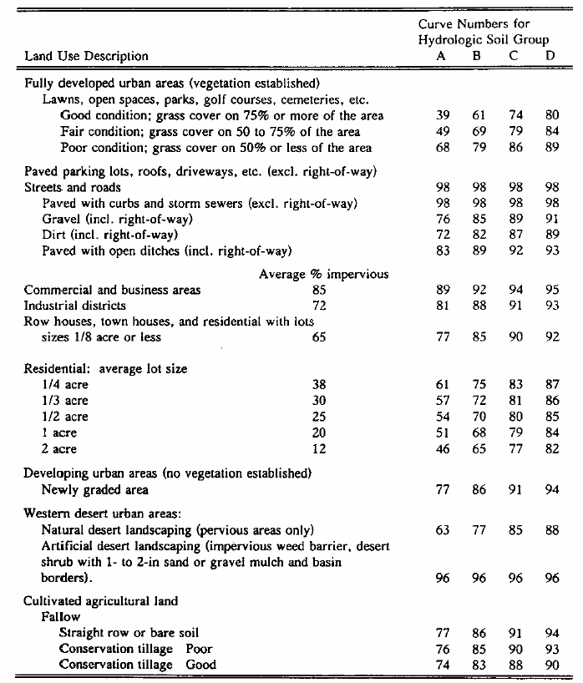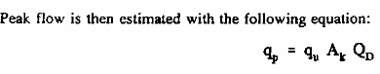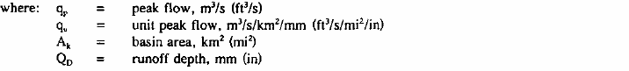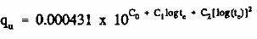
(2.10)
(2.11)

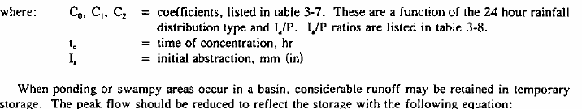

F_{p} = adjustment factor, listed in table 2.6

(2.12)

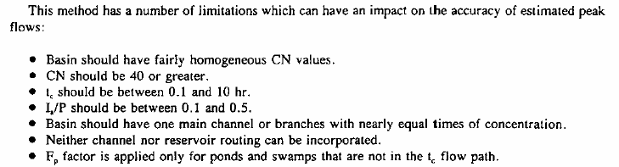

Example 2.4:
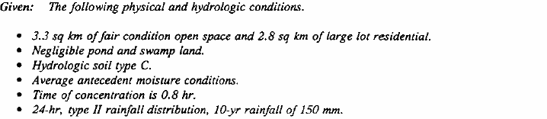
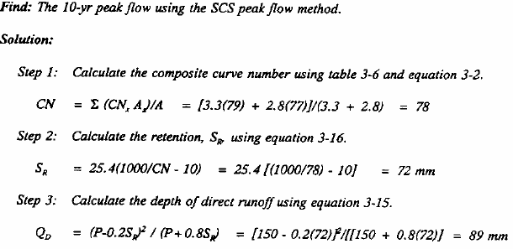

Table 2.5: Coefficients for SCS peak Discharge Method (equation 2.11)
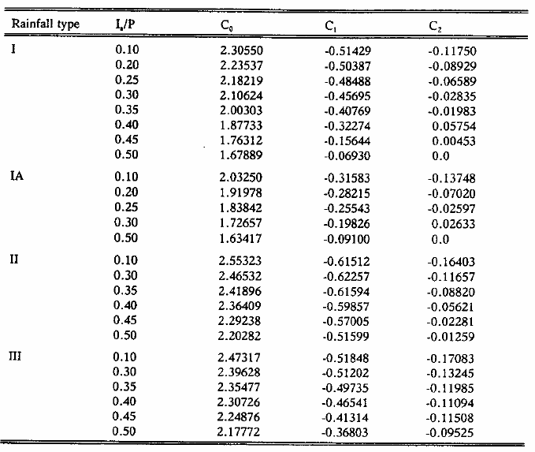
Table 2.6: Adjustment factor (F_{p}) for pond and swamp areas that are spread throughout the watershed
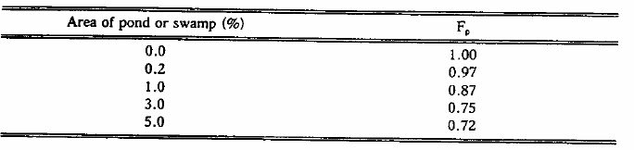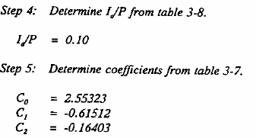

Table 2.7: I_{a}/P for selected rainfall depths and Curve Numbers
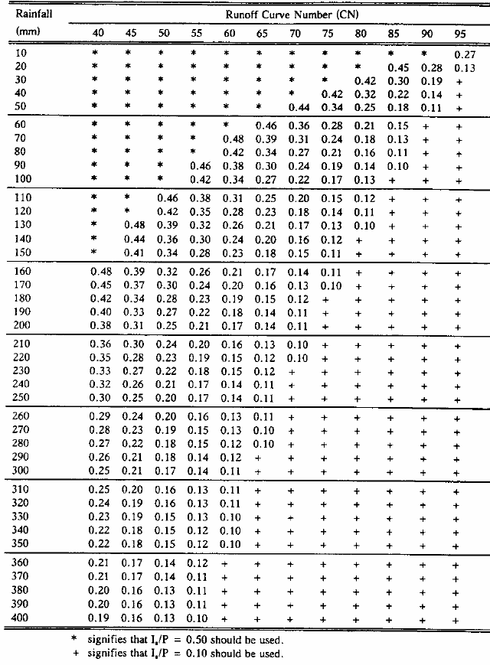

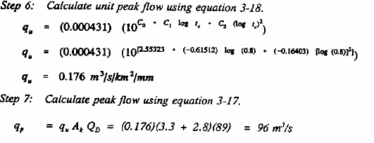

Time-Area Method
The time – area method of obtaining runoff or discharge from rainfall can be considered as an extension and improvement of the rational method. The peak discharge Q_{p} is the sum of flow – contributions from subdivisions of the catchment defined by time contours (called isochrones), which are lines of equal flow – time to the river section where Q_{p} is required. The method is illustrated in Figure 2.2(a).

Isochrones

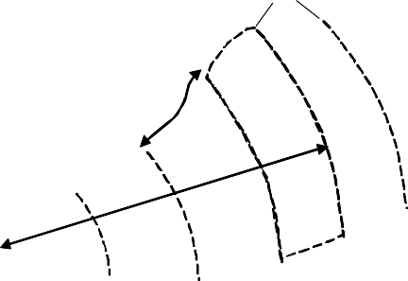25
∆T
I₁
I₀
I₃
I
I
4
2

X ∆A1

∆T

∆A2

∆A3

∆A4

3∆T

∆A5

4∆T

Tc

5∆T

20

15
Rainfall Intensity, i

10

5

0
∆T 2∆T

3∆T 4∆T 5∆T Time, T

∆T 2∆T

- Rainfall bar graph and Catchment showing isochrones of travel time
dA/dT
0 Time, T 0 Time,T
- Time-area curve c) Time-area concentration curve
A TC
Are a
Figure 2.3: Time-area method

The flow from each contributing area bounded by two isochrones (T - ΔT, T) is obtained from the product of the mean intensity of effective rainfall (i) from time (T - ΔT, T) is obtained from the product of the mean intensity of effective rainfall
(i) from time T-ΔT to time T and the area (ΔA). Thus Q₄, the flow at X at time 4h is given by:

Q₄ = I₃ ΔA₁ ⁺ i₂ΔA₂ + i₁ΔA₃ + i₀ ΔA₄
i.e.
T

QT =
∑ i( T − K )
k = 1
ΔA(k )
(2.13)

As the assumption for the rational method, the whole catchment is taken to be contributing to the flow after T equals to Tc.
Hence the peak flow contributed from the whole catchment after T_{c} of the commencement of rain is:

Qp =

n
∑i( n−k ) ΔA(k )
k − 1
(2.14)

Where n, the number of incremental areas between successive isochrones, is given by Tc/ΔT, and k is a counter.

The unrealistic assumption made in the rational method of uniform rainfall intensity over the whole catchment and during the whole of T_{c} is avoided in the time – area method, where the catchment contributions are subdivided in time. The varying intensities within a storm are averaged over discrete periods according to the isochrones time interval selected. Hence, in deriving a flood peak for design purposes, a design storm with a critical sequence of intensities can be used for the maximum intensities applied to the contributing areas of the catchment that have most rapid runoff. However, when such differences within a catchment are considered, there arises difficulty in determining T_{c}, the time after the commencement of the storm when, by definition, Q_{p} occurs.

Example 2.5: Time-Area Method

STREAM FLOW HYDROGRAPH
A hydrograph is a graphical plot of discharge of a natural stream or river versus time. The hydrograph is a result of a particular effective rainfall hyetograph as modified by basin flow characteristics. By definition, the volume of water under an effective rainfall hyetograph is equal to the volume of surface runoff.

It has three characteristic parts: the rising limb, the crest segment and the falling limb or depletion curve.

With reference to figure 2.4 the effective rainfall hyetograph consisting of a single block of rainfall with duration D (T is also used in the lecture note alternatively) shown in the upper left part of the figure produced the runoff hydrograph. The areas enclosed by the hyetograph and the hydrograph each represent the same volume, V, of water from the catchment. The maximum flow rate on the hydrograph is the peak flow, q_{p}, while the time from the start of the hydrograph to q_{p} is the time to peak, t_{p.} The total duration of the hydrograph known as the base time, t_{b}.

The lag time, t_{L} is the time from the center of mass of effective rainfall to the peak of runoff hydrograph. It is apparent that t_{p} = t_{L} + D/2, using this definition. Some define lag time as the time from center of mass of effective rainfall to the

center of the runoff hydrograph.

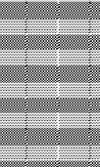Rain fall
D
Effective rainfall
Peak Flow, q_{p}
tp
t_{L}
Rising Limb
Recession Limb
Base Flow

t_{b}
Time

Q

A B

Figure 2.4: Runoff Hydrograph

    - Hydrograph Analysis

One of the major tasks of the hydrograph analysis is to produce rainfall-runoff relationships for a catchment area, for predicting runoffs as a result of certain rains which does not involve the direct measurement of runoff.

Hydrograph describes the whole time history of the changing rate of flow from a catchment due to rainfall event rather than predicting only the peak flow (Rational Method). A natural hydrograph would be the result of continuous measurements of discharge (with a recording device) producing the required relationship for any times interval, e.g. for a single flood event related to a single storm.

Hydrograph may also show mean values of events observed over a long period (of several years) as daily, monthly or annual averages in their temporal distribution over a year (or the rainy season or any other defined period of interest) giving the solution of specific problems (average storage behavior, average available discharge, etc).

Depending upon the unit of time involved, we have:
      - Annual hydrographs showing the variation of daily or weekly or 10 days daily mean flows over a year.
      - Monthly hydrographs showing the variation of daily mean flows over a month

      - Seasonal hydrographs representing the variation of the discharge in a particular season such as the monsoon season or dry season
      - Flood hydrographs or hydrographs due to storm representing stream flow due to a storm over a catchment

The hydrograph of stream flow against time has two main components, the area under the hump, labeled surface runoff (which is produced by volume of water derived from the storm event), and the broad band near the time axis, representing base flow contributed from groundwater.

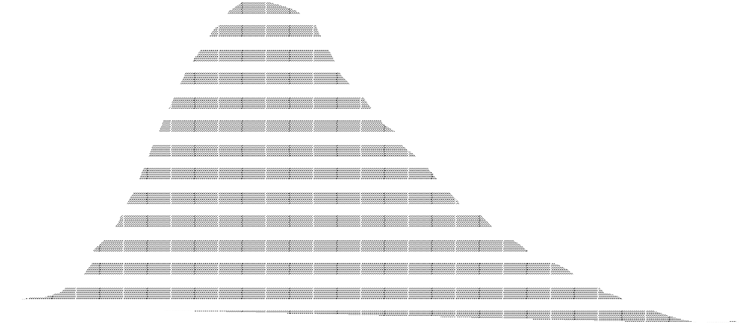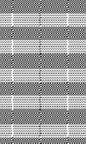Q
Surface Run off
Surface Run off
Peak Flow, q_{p}
Inflection Point
Surface Run off
B
Base Flow

A
Base Flow
Base Flow

Figure 2.5: Runoff Hydrograph

Time

At the beginning of the rainfall, the river level (and hence the discharge) is low and a period of time elapses before the river begins to rise. During this period the rainfall is being intercepted by vegetation or is soaking into the ground and making up soil-moisture deficits. The length of the delay before the river rises depends on the wetness of the catchment before the storm and on the intensity of the rainfall itself.

When the rainfall has satisfied catchment deficits and when surfaces and soils are saturated, the rain begins to contribute to the stream flow. The proportion of rainfall that finds its way into a river is being the effective rainfall, the rest being lost as in the form of evaporation, detention on the ground and vegetation surface or retention in the soil. As the storm proceeds, the proportion of effective rainfall increases and that of lost rainfall decreases.

The volume of surface runoff, represented by the area under the hydrograph minus the base flow, can be considered in two main subdivisions to simplify the complex water movements over the surface and in the ground. The effective rainfall makes the immediate contribution to the rising limb from A to the peak of the hydrograph and, even when the rainfall stops, continue until the inflection

point (condition of maximum storage). Beyond this point, it is generally considered that the flow comes from the water temporarily stored in the soil. This so-called interflow continues to provide the flow of the recession curve until the water from the whole of the effective rainfall is completely depleted at B.

The boundary between surface runoff and base flow is difficult to define and depends very much on the geological structure and composition of the catchment. Permeable aquifers, such as limestone and sandstone strata, sustain high base flow contributions, but impervious clays and built-up areas provide little or no base flow to a river. The base flow levels are also affected by the general climatic state of the area: they tend to be high after period of wet weather and can be very low after prolonged drought. Groundwater provides the total flow of the recession curve until the next period of wet weather.

The main aims of the engineering hydrologist are to quantify the various components of the hydrograph, by analyzing past events, in order to relate effective rainfall to surface runoff, and thereby to be able to estimate and design for future events. As a result of the complexity of the processes that create stream flow from rainfall, many simplifications and assumptions have to be made.

Factors affecting flood hydrograph
Table 2.8: Factors affecting flood hydrograph
Physiographic factors |  | Climatic factors
1 | Basin characteristics  - shape  - size  - slope  - nature of the valley  - elevation  - drainage density Infiltration characteristics  - land use and cover  - soil type and geological conditions  - lakes, swamps and other storages  Channel characteristics: cross-section, roughness and storage capacity | 1 | Storm characteristics: precipitation, intensity, duration, magnitude and movement of storms
2 |  | 2 | Initial losses
 |  | 3 | Evapotranspiration
3

Effective Rainfall
At the start of a hydrograph analysis it is advisable to begin with a hydrograph produced by a single rain event to identify the runoff characteristics of the catchment area. Such a single event hydrograph is produced by the net or effective rain forming a flood wave or the direct runoff which will be super imposed on the existing flow (base flow) of the river.

The portion of rainfall that finds its way into a river is known as the effective rainfall, the rest being lost in evaporation, detention on the vegetation and ground surface or retention in the soil. As the storm proceeds, the portion of effective rainfall increases and that of lost rainfall decreases.

For the purposes of correlating direct runoff hydrograph (DRH) with the rainfall, which produces the flow, it is necessary to obtain the effective rainfall hydrograph (hyetograph) (ERH) which can be obtained by deducting the losses from the total rain. At the beginning of a storm there could be considerable interception of the rainfall and initial wetting of surfaces before the rainfall become ‘effective’ to form surface runoff.

The loss-rate is dependent on the state of the catchment before the storm and is difficult to assess quantitatively. The two simplified methods of determining the effective rainfall are:
- The φ-index method
- The initial and continuing loss method.

- The φ-index method: this method assumes a constant loss rate of φ-mm from the beginning of the rainfall event. This amount accounts for interception, evaporation loss and surface detention in pools and hollows.
- Initial and continuing loss rate method: In this method all the rainfall up to the time of rise of the hydrograph is considered lost, and there is a continuing loss-rate at same level after words.

A choice between the two methods depends on knowledge of the catchment but, as the timing of the extent of initial loss is arbitrary, the fixing of the beginning of effective rainfall at the beginning of runoff in the stream neglects any lag time in the drainage process and thus somewhat unrealistic. A constant loss-rate, the φ-index, would therefore seem to be more readily applicable.

Separation of Base Flow and Runoff
The total runoff consists of direct runoff and the base flow. For hydrograph analysis the base flow has to be separated from the total runoff.

There are several methods of base flow separation. Some of them that are that are in common use are:

Straight-line method (Method-I)
The separation of the base flow is achieved by joining with a straight-line beginning of the direct runoff to a point on the recession limb representing the end of the direct runoff. Point B the end of the recession limb may be located by an empirical equation for the time interval N (days) from the peak to the point B is
N = 0.83A^{0.2} (2.15)

Where A = drainage in km² and N in days

Method-II
In this method the base flow curve existing prior to the commencement of the surface runoff is extended till it intersects the ordinate drawn at the peak Point
C. This point is joined to point B by a straight line. Segment AC and CB
separate the base flow and surface runoff.

Method-III
In this method the base flow recession curve after the depletion of the floodwater is extended backwards till it intersects the ordinate at the point of inflection (line EF). Points A and F are joined by an arbitrary smooth curve. This method of base-flow is realistic in situations where the groundwater

contributions are significant and reach the stream quickly.
The surface runoff obtained after the base-flow separation is known as direct runoff hydrograph (DRH).

Q
Peak
Pi
Method -III
Method -I
C
Method -II
Tim

Figure 2.6: Base flow separation

The Unit Hydrograph (UH)

A major step forward in hydrological analysis was the concept of the unit hydrograph introduced by the American engineer Sherman in 1932.

The unit hydrograph (UH) of duration T is defined as the storm runoff due to unit depth (e.g. 1 mm rain depth) of effective rainfall, generated uniformly in space and time on the catchment in time T. The duration can be chosen arbitrarily so that we can have a 1h UH, a 6h UH, etc. in general a D-h hour unit hydrograph applicable to a given catchment. The definition of unit hydrograph implies the following.

- The unit hydrograph represents the lumped response of the catchment to a unit rainfall excess of T-h duration to produce a direct-runoff hydrograph. It relates only the direct runoff to the rainfall excess. Hence the volume of water contained in the unit hydrograph must be equal to the rainfall excess. As 1 mm depth of rainfall excess is considered the area of the unit hydrograph is equal to a volume given by 1 mm over the catchment.
- The rainfall is considered to have an average intensity of excess rainfall (ER) of 1/T mm/h for the durationT-h of the storm.
- The distribution of the storm is considered to be all over the catchment.

The requirement of uniformity in areal distribution of the effective rainfall is rarely met and indeed unless the non-uniformity is pronounced, its effect is neglected.

RF
TUH
Q
R
T
RF
2xTUH
Q
T
R
a) b)

RF
Surface runoff
due to (R1 +R2)
(R2) x TUH
(R1) x TUH

R1

R2

Q

T 2T c) t
Figure 2.7: The unit hydrograph produced by 1 mm of effective rainfall

The figure shows the definition of rainfall-runoff relationship with 1mm of uniform effective rainfall occurring over a time T producing the hydrograph labeled TUH. The units of the ordinates of the t-hour unit hydrograph are m³/s per mm of rain. The volume of water in the surface runoff is given by the area under the hydrograph and is equivalent to the 1mm depth of effective rainfall over the catchment area.

The unit hydrograph method makes several assumptions that give it simple properties assisting in its application.

- There is a direct proportional relationship between the effective rainfall and the storm runoff. This is known as Law of proportionality.

Figure 1.6 b) above shows that two units of effective rainfall falling in time T produce a surface runoff hydrograph that has its ordinates twice the TUH ordinates, and similarly for any proportional value. For example, if
6.5 mm of effective rainfall fall on a catchment area in T h, then the hydrograph resulting from that effective rainfall is obtained by multiplying the ordinates of the TUH by 6.5From this law it can be seen that different rain intensities with the same duration of the rain will produce hydrographs with different magnitudes but the same base length;

however, there will be only one unit hydrograph for the same duration.

If the UH for a certain duration T is known then the runoff of any other rain of the duration T may be computed by multiplying the UH ordinates with the ratio of the given rain intensity with unit rain. i.e.:

Qt = αUH ; where α =
net ra inf all unit ra inf all

- The total hydrograph of direct runoff due to n successive amounts of effective rainfall (for instance R₁ and R₂) is equal to the sum of the n successive hydrographs produced by the effective rainfall (the latter lagged by T h on the former). This is known as Law of Superposition. Once a TUH is available, it can be used to estimate design flood hydrographs from design storms. The law of superposition is demonstrated in Figure 1.6 c above.

- The third property of TUH assumes that the effective rainfall-surface runoff relationship does not change with time, i.e., the same TUH always occurs whenever the unit of effective rainfall in T h is applied on the catchment. Using this time invariance assumption, once a TUH has been derived for a catchment area, it could be used to represent the response of the catchment whenever required.

Derivation of the Unit Hydrograph from single storms
The derivation of the unit hydrograph of a catchment from single storms proceeds in the following stages:
      - The rainfall records are scanned to find a storm of desired duration that gives a fairly uniform distribution in time and space. The hyetograph of this storm is constructed using a convenient uniform interval of time.
      - The base flow is separated from the hydrograph using one of the methods presented in section 1.7.3.
      - The surface runoff volume is determined as a depth of flow by numerical integration:

d = 3.6 Δt ΣQ
A
(2.16)

Where,
d = depth of surface runoff in mm
Δt = uniform time interval in hours at which the ordinates of the surface runoff are measured
ΣQ = sum of all ordinates of surface runoff hydrograph in m³/s A = catchment area in Km²
      - The ordinates of the surface runoff hydrograph are divided by the runoff depth d due to the ordinates of the unit hydrograph.
      - The unit hydrograph for effective rainfall of duration T, the TUH, is plotted, and the area under the curve is checked to see if the enclosed volume is equivalent to unit effective rainfall over the area of catchment.

Example 2.6 Derivation of Unit Hydrograph

    - Changing of the Duration of the UH
There are two methods to change the duration of unit hydrograph: (i) by superposition from u(T₁,t) to u(T₂,t), where T₂ = n*T₁, with n an integer > 1,

hence only enlargements of multiple of T₁ are possible, (ii) by S-curve technique from u(T₁,t) to u(T₂,t) where T₂ = α*T₁, with α a real > 0, hence, T₂ may be larger than T₁ but also smaller than T₁. It should be remembered that a unit hydrograph refers to unit depth of rainfall excess so if the duration is T hours the excess rainfall intensity is 1/T.

Enlargement of T by superposition:
Say, it is required to derive from U(T₁,t) a unit hydrograph of U(T₂,t) with T₂ = 3T₁. The U(T₁,t) refers to a rainfall intensity of 1/T₁ to give a unit depth, whereas U(T₂.t) should refer to 1/T₂ to give unit depth of effective rainfall. The U(T₂.t) is obtained by superposition of three U(T₁,t) shifted T₁ hours apart. By adding the ordinates of U(T₁,t) u(T₁, t-T₁) and u(T₁,t-2T₁) at the corresponding times the resulting hydrograph Q(t) will refer to an effective rainfall of 3T₁*1/T₁ = 3 units. Hence to get U(T₂,t) all Q(t) ordinates have to be multiplied by (i₂/i₁) = (1/T₂)/(1/T₁) = T₁/T₂ = 1/3, to let it refer to unit depth of rainfall.

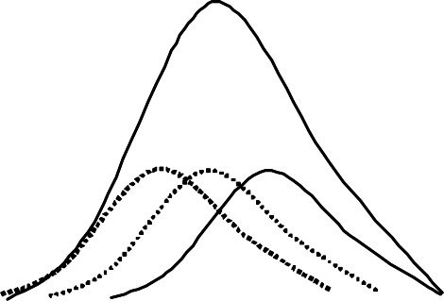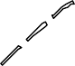ie 1/T₁

Σ (1,2,3)

Q_{t}
u(1,t)

u(3,t)

t

Figure 2.8: Conversion from u(1,t) to u(3,t)

Example 2.7:

S-curve:
The S-curve is the hydrograph of runoff of continuous rainfall of intensity i.e.
=1/T₁. To derive the S-curve assume a T-hour unit hydrograph with non-zero ordinates: u₁, u₂, u₃…,u_{n}. The base length is (n+1) T. the S-curve is obtained by superposition of n T-hour UHs as shown in figure 2.9. The maximum is reached after n time of T hours. This maximum is equal to Q_{s}, i.e. the equilibrium discharge:

Qs =
2.778 A
T1

(2.17)

Where, Q_{s} = the maximum rate at which an ER intensity of 1/T can drain out of the catchment of area, A (km²)
T₁ = unit storm in hours

Figure 2.9: S-curve derivation
0 1 2 3 4 5 6 7 8 9 10 11 12 13 14 15 16 17
Time (hr)
0
S₁ S2
S₃
500
S₄
1000
S₅
S₆
1500
S₇
S₈
2000
S₉
Q_{s}
S10
S11
2500

The S-curve is computed using the following scheme:
S₁ = u₁
S₂ = u₁+u₂ = u₂+S₁
S₃ = u₁+u₂+u₃ = u₃ +S₂
.
.
.
S_{n} = u₁+u₂+u₃+…+u_{n} = u_{n}+S_{n-1} (2.18)
So, generally;
S_{i} = u_{i}+S_{i-1} for i = 1,…,n S_{i} = S_{i-1} for i >n

The T₂-hour UH is obtained from the difference between two S-curves distanced T₂-hours apart, corrected for the effective intensity as follows. Since the S-curve refers to continuous rain of 1/T₁ units, the difference between the S-curves displaced by T₂ hours represents surface runoff from (1/T₁)xT₂. A rainfall with duration T₂ requires an intensity i₂ = 1/T₂ to give unit depth. Hence, the S-curve difference has to be multiplied with the ratio i₂/i₁= (1/T₂)/(1/T₁) = T₁/T₂ to get a unit depth in T₂ hours. Hence, u(T₂,t) follows from:

u(T , t) = T1 (S (T , t) − S (T , t − T ))
2

(2.19)

1 1 2
Q (m3/s)
T
2
Note that the base length follows from T_{b2} = T_{b1} - T₁ +T₂. The procedure is shown in figure 2.10 below.

Figure 2.10:1-Hr and 2-Hr UHs from S-Curve of 1 and 2 Hrs
18
16
14
12
10
Time (Hr)
8
6
4
2
0
0
2UH
1UH
500
1000
1500
S-Curve@2hr
2000
S-Curve@1hr
2500
3000
Discharge (m3/s)

The errors in interpolation of UH ordinates often result in oscillation of S-curve at the equilibrium value, Q_{s}. This results in the derived T-h UH having an abnormal sequence of discharges (sometimes even negative values) at the tail end. The S-curve and the resulting T h UH is adjusted by smoothening the curves.

Applications of Unit Hydrograph

As the UH establishes a relationship between the DRH and ERH for a catchment, they are of immense value in the study of the hydrology of a catchment.

They are of great use in:

    - The development of flood hydrograph for extreme rainfall magnitudes for use in design of hydraulic structures
    - Extension of flood-flow records based on rainfall records
    - The development of flood forecasting and warning systems based on rainfall.

Synthetic Unit Hydrographs
To develop unit hydrographs to a catchment, detailed information about the rainfall and the resulting flood hydrograph are needed. However, such information might be available only at a few locations and in a majority of catchments, especially those, which are at remote locations; the data could normally be scarce. In order to construct UH for such areas, empirical equations of regional validity, which relate the important hydrograph characteristics to the basin characteristics are of most important. Unit hydrographs derived from such relationships are known as synthetic unit hydrographs.

2.10.1 Snyder’s method
Snyder (1938), based on a study of a large number of catchments in the Appalachian highlands of eastern United States developed a set of empirical equations for synthetic-unit hydrographs in those areas.

The most important characteristics of a basin affecting a hydrograph due to a given storm is basin lag. Actually basin lag (also known as lag time) is the time difference between the cancroids of the input (rainfall excess) and the out put (surface runoff) i.e. T_{L}. Physically, it represents the main time of travel of water particles from all parts of the catchment to the outlet during a given storm. Its value is determined essentially on the physical features of the catchment, such as size, length, stream density and vegetation. For its determination, however, only a few important catchment characteristics are considered. For simplicity, Snyder has used a somewhat different definition of basin lag (denoted by t_{p}) in his methodology. This t_{p} is practically of the same order of magnitude as T_{L} and in this section the term basin lag is used to denote Snyder’s t_{p}.

The first of the Snyder’s equation relates the basin lag t_{p}. Defined as the time interval from the mid point of the unit rainfall excess to the peak of the unit hydrograph (Figure 2.12 below) to the basin characteristics as:
t_{p} = C_{t} (LL_{c})^{0.3} (2.20)
Where,
t_{p} in hours
L = basin length measured along the watercourse from the basin divide to the gauging station in km.
L_{c} = distance along the main watercourse from the gauging station to the point opposite (or nearest) the watershed centroid in km
C_{t} = a regional constant representing watershed slope and storage
The value of C_{t} in Snyder’s study ranged from 1.35 to 1.65. However, studies by many investigators have shown that C_{t} depends upon the region under study and wide variations with the value of Ct ranging from 0.3 to 6.0 have been reported.

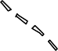Outlet
Tributary
Catchment boundary
Centroid of Catchment
L
Lc

Figure 2.11: Basin characteristics

Q_{p}
t_{p}
1/3 W₅₀
2/3 W₅₀
t_{r}
1/3 W₇₅ 2/3 W₇₅
W75
W50
t_{b}
Time
tpk

0.75Q_{p}
Discharge

0.50Q_{p}

Figure 2.12: Elements of synthetic unit hydrograph

Important relationships:
Basin lag tp
⎛ LLca ⎞
n

t p = CtL ⎜ ⎟
S
⎝ ⎠
(2.21)

C_{tL} and n are basin constants. (n= 0.38 and C_{tL} = 1.715, 1.03, 0.50 for mountainous, foot-hill and valley drainages of USA)
Standard duration of effective rainfall, t_{r} (in hours)

tr =
t p

5.5

(2.22)

Peak discharge Q_{p} (m³/s) of unit hydrograph of standard duration t_{r}
Q = 2.78Cp A
ps t

p
Where A = km^{2,} C_{p} = regional constant
(2.23)

If a non-standard rainfall duration t_{R} h is adopted, instead of the value t_{r} to derive a unit hydrograph the value of the basin lag is affected. The modified basin lag is given by:

tR
t' p = t +
p
- tr
4

(2.24)

= 21 t
22 p
- tR
4

Where t’_{p} = basin lag in hours for an effective duration of t_{R}. Therefore Q_{p},

Q = 2.78Cp A
p t'

p
Note that when t_{R} = t_{r} implies Q_{P} = Q_{ps}

The time base of unit hydrograph is given by Snyder as:
(2.25)

t =( 3 + t'p )
b 8
days = (72 + 3t'p
) hours
(2.26)

This equation gives reasonable estimates of time base for large catchments; it may give excessively large values of time base for small catchments.
Taylor and Schwartz recommend
t = ⎛ tR ⎞

b 5⎜ t'p + 2 ⎟ hours
⎝ ⎠ (2.27)
With t_{b} taken as the next larger integer value divisible by t_{R} i.e. t_{b} is about five times the time to peak.

To assist in the sketching of unit hydrographs,

W50
= 5.87
q1.08

and W75
= W50
1.75

(2.28)

Where W₅₀ = width of unit hydrograph in hour at 50% peak discharge W₇₅ = width of unit hydrograph in hour at 75% peak discharge q = Q_{p}/A = peak discharge per unit catchment area in m³/s/km²
Since the coefficients C_{t} and C_{p} vary from region to region, in practical applications it is advisable that the value of these coefficients are determined from known unit hydrographs of meteorologically homogeneous catchments and then used in the basin under study. This way Snyder’s equations are of use in scaling the hydrograph information from one catchment to another similar catchment.

UH from a complex storm
In nature storms are most likely occurring with changing intensities over their total duration. Natural hydrograph related to such complex storms may be considered as several superimposed hydrographs related to single storms of constant intensity forming the total given storm.

The resulting storm from the complex storm is divided into sub storms of equal duration and constant intensity. After defining the effective rain from the individual storm and computing the direct runoff hydrograph, the composite DRH is obtained.

At various time intervals 1D, 2D, 3D, … from the start of the ERH, let the ordinates of the unit hydrograph be u₁, u₂, u₃, … and the ordinates of the composite DRH be Q₁, Q₂, Q₃,….

Then;

Q₁ = R₁u₁
R2u1
R2u2
R2u3
Q₂ =R₁u₂ + R₂u₁
Q₃ = R₁u₃ +R₂u₂ + R₃u₁ Q₄ = R₁u₄ + R₂u₃ +R₃u₂
Q₅ = R₁u₅ + R₂u₄ +R₃u₃ (2.29)
……………………………..
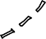And so on.
Discharge
R3u1
R3u2

Time
Figure 2.13: Unit hydrograph from complex storm

From equation (2.29) the values of u_{3,} u_{2,} and u₁ … can be determined. However this method suffers from the disadvantage that the errors propagate and increases as the calculations proceeds.
R1u1
R1u2
R1u3
R1u4

The Un at higher n values (towards the end of the recession limb) can contain oscillations, if so, the final values may be smoothened to find a reasonable curvature. The reason for such behavior is the accumulation of small errors through the whole process of calculation. Matrix methods with optimization schemes are useful to reduce the number of unknown variables.

The other approach is to fit a suitable shape of UH to an average profile of the individual UH. An arithmetic mean of superimposed ordinates may be lower than the individual peaks. The proper procedure is to compute average peak flow and time to peak. The average unit hydrograph is then sketched to conform to the shape of other graphs, passing through the computed average peak and having the required unit volume.

Instantaneous unit Hydrograph (IUH)
For a given catchment a number of unit hydrographs of different durations are possible. The shape of these different UHs depends upon the value of D. As the value of D is reduced, the intensity of rainfall excess being equal to 1/D increases and the unit hydrograph becomes more skewed. A finite UH is indicated as the duration D→o. The limiting case of a unit hydrograph of zero

duration is known as instantaneous unit hydrograph (IUH). This IUH is a fictitious, conceptual UH which represent the direct runoff from the catchment due to an instantaneous precipitation of the rainfall excess volume of 1 unit (cm). IUH is represented by U(t) or sometimes by U(0,t). It is a single-peaked hydrograph with a finite base width and its important properties being:
1. 0 ≤ u ≤ u(t) a positive value, for t > o; 2. u(t) =0 for t ≤0;
3. u(t) → = 0 for t → ∞;
∞
- ∫ u(t)dt = unit depthover thecatchment; and
0
- Time to peak = time to the centroid of the curve.
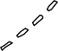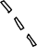
ERH
B
B
A
C
D
D
C
A
Time
Figure 2.14: Unit hydrograph of different duration
Discharge

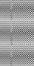I( t )
t ₀
I( t )
0
t
t
dt
u( T - t )
( T- t )
( T- t )
Q ( t )
T
T
0

Q ( t )

Figure 2.15: Convolution of I(t) of IUH

Consider an effective rainfall I(t) of duration t₀ applied to a catchment as shown in figure 2.15;
Each infinitesimal element of the ERH will operate on the IUH to produce a DRH whose discharge at time t is given by:
t

Q(t) = ∫u(T − t) I (t)dt
0
t’ = t when t< t₀ t’ = t₀ when t≥ t₀
(2.30)

Equation (2.30) is called the convolution integral. The main advantage of IUH is that, it is independent of the duration of ERH and thus has one parameter less than a D-h unit hydrograph. This fact and the definition of IUH make it eminently suitable for theoretical analysis of excess-runoff relationship of a catchment. For a given catchment IUH, being independent of rainfall characteristics, is indicative of the catchment storage characteristics.
Derivation of IUH
As dt is made smaller and smaller, i.e., as dt→0 an IUH results.

⇒ u(t)
= lim ⎛ S2
- S ⎞
⎟
1
= 1 ds
(2.31)

dt →0 ⎝
⎜
idt ⎠
i dt

if I = 1, then u(t) = ds’/dt = slope of S-curve of intensity 1 and 2 of unit depth Derivation of D-hour UH from IUH
From ds’ = u(t)dt, integrating between two points 1 and 2
t2

S '2
- S '1 ∫u(t) dt
t1
2.32)

If u(t) is linear within the range 1 to 2, then for small values of ∆t (t₂ –t₁) by taking:
− 1
u(t) = = [u(t ) + u(t )]

u(t) 1 2
2
(2.33)

S ' −S ' = 1 [(u(t ) − u(t ))](t

- t )

2 1 2 1
2 2 1

But (S’₂-S’₁)/(t₂-t₁) = ordinate of a unit hydrograph of duration D₁ = (t₂ –t₁). Thus, in general terms, for small values of D₁, the ordinates of a D₁, the ordinates of a D₁-hour UH are obtained by the equation:

D − hour UH ) = 1 [(IUH )
- (IUH ) ]
(2.34)

1 t 2 t
t − D1

Dimensionless Unit Hydrograph
Dimensionless unit hydrograph is used to develop a synthetic Uh in place of Synder’s equations. A typical UH developed by SCS has ordinates expressed as a ratio to the peak discharge (Q/Q_{p}) and the abscissa as ratio of time to peak time (t/t_{pk}).
⇒ Q/Q_{p} = 1.0, when t/t_{pk} = 1.0

Figure 2.16: Dimensionless SCS unit hydrograph
Time Ratio, t/t_{pk}
20
15
10
5
0
0
0.2
0.4
0.6
0.8
1
Discharge Ratio, Q/Q p

Hydrology of Ungauged Catchments

Extrapolation of flow data to ungauged sites:
All too often the stream flow data that are available from measured gauging stations are not from location for which a project site analysis is to be made. Methods are required to develop extrapolation of measured flow data which will be representative of a given site on a stream.
In regions where stream flow does not vary with respect to the contributing drainage area flow duration curves can be plotted for the gauged sites. From these developed flow duration curves, a family of parametric flow duration curves can be developed, in which flow is plotted against the average annual
runoff ( R ) or annual discharge, Q at the respective gages for several exceedence interval percentages. A separate curve is developed for each exceedence interval used. A correlation analysis is then performed to obtain
the best-fitting curve for the data taken from the measured records of stream
flow.

Flow

Figure 2.17: FDC for gauging stations in a homogeneous drainage basin
Exceedence Percentage
80 90 100
70
50 60
30 40
20
10
0
10
100
Gage 2

Gage 1
1000
Gage 4
Gage 3
10000
Average annual runoff (R)
10000
1000
100
10
10
100
1000
10000
100000
Discharge (Q)

Figure 2.18: Parametric flow duration curves

Determination of average annual discharge:

To use the parametric flow duration curves effectively, it is necessary to
determine the average annual discharge, Q , at the point or location on the stream for which a flow analysis is to be made. Isohytal maps developed for normal annual precipitation in a river basin are helpful for determining the annual discharge. The records of precipitation and stream flow data should represent the same period of record.

Utilizing the records of average annual precipitation input to the basins at measured streams nearby or having similar hydrologic characteristics, a runoff coefficient is estimated for the drainage basin being studied. The product of this

coefficient and the computed normal annual precipitation input to the basin and the basin area can be used to calculate the average annual discharge as:

Q = k P A
T

(2.35)

With the average runoff annual discharge estimate it is possible to enter the parametric flow duration curve and determine values of flow for different exceedence percentages for which the parametric flow duration curve has been developed.

Example 2.7: Hydrology of Ungauged Catchment

A drainage basin has a power plant site located at the mouth of the catchment. An upstream reservoir regulates the flow at the upper portions of the drainage. The area of the hydrologic map representative of the drainage basin below the reservoir has been planimetered and given in table A below. A runoff coefficient for the basin on the annual basis is 0.65. The historic monthly flows of a nearby stream gauge on the downstream side of the stream are presented in table B. The gauge records are considered to be a good representation of seasonal variation of runoff for the ungauged portion of the river drainage basin. The outflows from the reservoir are given in table C. Using the information provided compute the river flow at its mouth that would be useful for the hydropower study. Scale of the isohytal map is 1:400,000.

Table a: Values of planimetered areas downstream of the reservoir
Avg value of precipitation between Isohytal lines (mm) | Planimetered Area (mm²)
762 | 11.94
889 | 26.13
1016 | 14.45
Table b: Monthly flows for an average year in a representative gauged stream
Month | Jan | Feb | Mar | April | May | June | July | Aug | Sept | Oct | Nov | Dec
No. of Days | 31 | 28 | 31 | 30 | 31 | 30 | 31 | 31 | 30 | 31 | 30 | 31
Discharge (m3/s) | 7.11 | 7.14 | 9.88 | 33.13 | 80.02 | 64.31 | 22.57 | 11.84 | 9.40 | 9.40 | 9.51 | 8.44

Table c: Out flow from the upper reservoir
Month | Jan | Feb | Mar | April | May | June | July | Aug | Sept | Oct | Nov | Dec
Discharge (m3/s) | 1.42 | 1.27 | 2.27 | 2.83 | 5.66 | 7.08 | 7.08 | 5.66 | 1.98 | 1.84 | 1.70 | 1.56

Solution:
Step 1: Compute the average annual runoff using NAP
− −

Q = k P A
− = ∑ P A =
P ∑ A
−

762 *11.94 + 889 * 26.13 + 1016 *14.45

11.94 + 26.13 + 14.45

= 895.07mm

Q = 0.65 * 895.07 /1000 * 52.52 /(1000 *1000) * 400,0002 = 4888941.2 m3 / year

− 4888941.2
=
Q
24 * 60 * 60
= 56.58 m3
/ sec/ day

Step 2: Compute yearly runoff from the representative gauge

Month | Jan | Feb | Mar | April | May | June | July | Aug | Sept | Oct | Nov | Dec
No. of Days | 31 | 28 | 31 | 30 | 31 | 30 | 31 | 31 | 30 | 31 | 30 | 31
Discharge (m3/s) | 7.11 | 7.14 | 9.88 | 33.13 | 80.02 | 64.31 | 22.57 | 11.84 | 9.40 | 9.40 | 9.51 | 8.44
Run off  (m3/s)/(day) | 220.41 | 199.92 | 306.28 | 993.9 | 2480.62 | 1929.3 | 699.67 | 367.04 | 282 | 291.4 | 285.3 | 261.64
Yearly Total (m3/s)(days) | 8317.48

Step 3: Compute monthly fraction of runoff

q = Runoff
for themonth
, q (Jan) =
220.41 = 0.026

i Total runoff
for the Re cord period i
8317.48

Month | Jan | Feb | Mar | April | May | June | July | Aug | Sept | Oct | Nov | Dec
Monthly fraction | 0.026 | 0.024 | 0.037 | 0.119 | 0.298 | 0.232 | 0.084 | 0.044 | 0.034 | 0.035 | 0.034 | 0.031

Step 4: Compute flow for the downstream portion
Q (Jan) = 0.026 * 56.58 = 0.05 m3 / sec
31
Month | Jan | Feb | Mar | April | May | June | July | Aug | Sept | Oct | Nov | Dec
Monthly flow  (m3/s) | 0.05 | 0.05 | 0.07 | 0.23 | 0.54 | 0.44 | 0.15 | 0.08 | 0.06 | 0.06 | 0.06 | 0.06

Step 5: Compute the total flow at the outlet Step 6: Compute the flow duration curve
 | Jan | Feb | Mar | April | May | June | July | Aug | Sept | Oct | Nov | Dec
Monthly flow (m3/s) | 0.05 | 0.05 | 0.07 | 0.23 | 0.54 | 0.44 | 0.15 | 0.08 | 0.06 | 0.06 | 0.06 | 0.06
Flow from  upper Res(m3/s) | 1.42 | 1.27 | 2.27 | 2.83 | 5.66 | 7.08 | 7.08 | 5.66 | 1.98 | 1.84 | 1.70 | 1.56
Total Flow | 1.47 | 1.32 | 2.34 | 3.06 | 6.20 | 7.52 | 7.23 | 5.74 | 2.04 | 1.90 | 1.76 | 1.62

Flow | Flow Descending order | Rank | %Exceeded or Equaled
7.52 | 7.52 | 1 | 8.33%
7.23 | 7.23 | 2 | 16.67%
6.20 | 6.20 | 3 | 25.00%
5.74 | 5.74 | 4 | 33.33%
3.06 | 3.06 | 5 | 41.67%
2.34 | 2.34 | 6 | 50.00%
2.04 | 2.04 | 7 | 58.33%
1.90 | 1.90 | 8 | 66.67%
1.76 | 1.76 | 9 | 75.00%
1.62 | 1.62 | 10 | 83.33%
1.47 | 1.47 | 11 | 91.67%
1.32 | 1.32 | 12 | 100.00%

Q (m³/s)

Figure 2.19: Flow duration curves The firm flow = 1.32 m³/sec
% of time Exceeded or Equalled
100.00%
80.00%
60.00%
40.00%
20.00%
8.00
7.50
7.00
6.50
6.00
5.50
5.00
4.50
4.00
3.50
3.00
2.50
2.00
1.50
1.00
0.50
0.00
0.00%
Flow Duration Curve

Tutorial Problem Set 1 ( Taken from Chapter 13 – Rainfall-Runoff Relation ship, Elisabeth Shaw)
For G-2HA&B
- The principal dimensions of a catchment are shown in Figure 1 below. If all isochrones at intervals of 1 min are arcs of circles centered at the outfall and the velocity of flow is assumed constant at 1 ms-1, draw the time area diagram for the catchment. Ignore times of entry. A design storm has the following sequence of 1-min intensities:
5.1, 6.4, 8.1, 10. 7, 14.1, 19.6, 30.3, 43.8, 28.0, 20.8, 12.3 and 4. 5 mm h-1
Assuming a runoff coefficient of 0.25, estimate the peak rate of flow at the outfall.
150 m
Outfall
Figure 1
360 m
200 m
- The 1-h 1 mm unit hydrograph for a small catchment is given in the Table 1 below. Determine the peak of the hydrograph that should result from the following storm: 5 mm in the first hour, no rain in the next 30 min, and 8 mm of rain in the next final hour. Assume a loss rate of 3 mmh-1 in the first hour and 2 mmh-1 for the remainder of the storm
Table 1

Time (h) | 0 | 0.5 | 1.0 | 1.5 | 2.0 | 2.5 | 3.0 | 3.5 | 4.0 | 4.5
Flow(m3/s) | 0 | 0.9 | 3.0 | 5.5 | 4.3 | 3.0 | 1.9 | 1.0 | 0.4 | 0

- During a notable storm, rainfall measurements were made at five stations in a particular river catchment. Given the ordinates of the 5-h (1mm) unit hydrograph shown in Table 2 below, derive the outflow hydrograph of the storm for the gauging station at the river outlet, assuming 80% of the total precipitation is lost at a constant rate.
(Note: Refer Figure P4 on Page 543 from Elisabeth Shaw)
Table 2

Time(h) | 0 | 5 | 10 | 15 | 20 | 25 | 30 | 35 | 40
U(m³s⁻¹) | 0 | 0.8 | 5.0 | 7.5 | 5.0 | 2.7 | 2.0 | 1.6 | 1.3
Time (h) | 45 | 50 | 55 | 60 | 65 | 70 | 75 | 80
U(m³s⁻¹ | 1.1 | 0.9 | 0.8 | 0.6 | 0.4 | 0.3 | 0.1 | 0

- An acceptable 1-h unit hydrograph (10 mm) has been derived for a catchment. Its ordinates are shown in Table 3. What is the approximate area of the catchment? Determine the peak flow that would result from a storm whose effective rainfall, assumed over the whole catchment, is given in Table 4.
Table 3

Time (h) | 0 | 1 | 2 | 3 | 4 | 5 | 6 | 7
u(t) (m³s⁻¹) | 0 | 12 | 35 | 24 | 16 | 8 | 3 | 0

Table 4
Time (h) | 0 | 1 | 2 | 30
Total accumulated effective rainfall (mm) | 0 | 6 | 26 | 35

- The ordinates of the 1-h unit hydrograph of a catchment area are summarized in Table 5 below.
Table 5

Time(h) | 0 | 1 | 2 | 3 | 4 | 5 | 6 | 7
TUH Ordinate (m³s⁻¹) | 0 | 0.8 | 5.0 | 7.5 | 5.0 | 2.7 | 2.0 | 1.6
Time (h) | 8 | 9 | 10 | 11 | 12 | 13 | 14 | 15
TUH Ordinate (m³s⁻¹ | 1.1 | 0.9 | 0.8 | 0.6 | 0.4 | 0.3 | 0.1 | 0

  - Derive the S-Curve for the catchment
  - Use the S-Curve to obtain the 2-h unit hydrograph; and
  - Forecast the peak runoff that would result from storm in which the effective rainfall totals in two consecutive 2-h periods were 20 mm and 5 mm.

Arbaminch University, Department of Hydraulic Eng’g

Suggested solution for Tutorial Problem Set 1 (Taken from Chapter 13 – Rainfall-Runoff Relation ship, Elisabeth Shaw)

    - Time Area Method

 | Intensity
Area | I1 | I2 | I3 | I4 | I5 | I6
A1 | A1I1
A2 | A2I1 | A1I2
A3 | A3I1 | A2I2 | A1I3
A4 | A4I1 | A3I2 | A2I3 | A1I4
A5 | A5I1 | A4I2 | A3I3 | A2I4 | A1I5
A6 | A6I1 | A5I2 | A4I3 | A3I4 | A2I5 | A1I6
 |  | A6I2 | A5I3 | A4I4 | A3I5 | A2I6
 |  |  | A6I3 | A5I4 | A4I5 | A3I6
 |  |  |  | A6I4 | A5I5 | A4I6
 |  |  |  |  | A6I5 | A5I6
 |  |  |  |  |  | A6I6

Intensity | I1 | I2 | I3 | I4 | I5 | I6 | I7 | I8 | I9 | I10 | I11 | I12
mm/hr | 5.1 | 6.4 | 8.1 | 10.7 | 14.1 | 19.6 | 30.3 | 43.8 | 28.0 | 20.8 | 12.3 | 4.5

Option-I:

Max Sum | 64.000 | 89.200 | 126.600 | 146.500 | 156.600 | 154.800 | 139.700

AiIi | AiIi | AiIi | AiIi | AiIi | AiIi | Qp (l/s)
38070 | 0 | 0 | 0 | 0 | 0 | 2.64
114210 | 52920 | 0 | 0 | 0 | 0 | 11.61
190350 | 158760 | 81810 | 0 | 0 | 0 | 29.93
228420 | 264600 | 245430 | 118260 | 0 | 0 | 59.49
142762.5 | 317520 | 409050 | 354780 | 75600 | 0 | 90.26
47587.5 | 198450 | 490860 | 591300 | 226800 | 56160 | 111.89
0 | 66150 | 306787.5 | 709560 | 378000 | 168480 | 113.12
0 | 0 | 102262.5 | 443475 | 453600 | 280800 | 88.90
0 | 0 | 0 | 147825 | 283500 | 336960 | 53.35
0 | 0 | 0 | 0 | 94500 | 210600 | 21.19
0 | 0 | 0 | 0 | 0 | 70200 | 4.88
0 | 0 | 0 | 0 | 0 | 0 | 0.00

HE-232-Engineering Hydrology for G2-HA&B Lecture Note/2004/2005/Mulugeta Bereded 1

Option –II:

A*I | A*I | A*I | A*I | A*I | A*I | A*I | A*I | A*I | A*I | A*I | A*I | Q_{p} (l/s)
13770.0 | 0.0 | 0.0 | 0.0 | 0.0 | 0.0 | 0.0 | 0.0 | 0.0 | 0.0 | 0.0 | 0.0 | 0.96
41310.0 | 17280.0 | 0.0 | 0.0 | 0.0 | 0.0 | 0.0 | 0.0 | 0.0 | 0.0 | 0.0 | 0.0 | 4.07
68850.0 | 51840.0 | 21870.0 | 0.0 | 0.0 | 0.0 | 0.0 | 0.0 | 0.0 | 0.0 | 0.0 | 0.0 | 9.90
82620.0 | 86400.0 | 65610.0 | 28890.0 | 0.0 | 0.0 | 0.0 | 0.0 | 0.0 | 0.0 | 0.0 | 0.0 | 18.30
51637.5 | 103680.0 | 109350.0 | 86670.0 | 38070.0 | 0.0 | 0.0 | 0.0 | 0.0 | 0.0 | 0.0 | 0.0 | 27.04
17212.5 | 64800.0 | 131220.0 | 144450.0 | 114210.0 | 52920.0 | 0.0 | 0.0 | 0.0 | 0.0 | 0.0 | 0.0 | 36.45
0.0 | 21600.0 | 82012.5 | 173340.0 | 190350.0 | 158760.0 | 81810.0 | 0.0 | 0.0 | 0.0 | 0.0 | 0.0 | 49.16
0.0 | 0.0 | 27337.5 | 108337.5 | 228420.0 | 264600.0 | 245430.0 | 118260.0 | 0.0 | 0.0 | 0.0 | 0.0 | 68.92
0.0 | 0.0 | 0.0 | 36112.5 | 142762.5 | 317520.0 | 409050.0 | 354780.0 | 75600.0 | 0.0 | 0.0 | 0.0 | 92.77
0.0 | 0.0 | 0.0 | 0.0 | 47587.5 | 198450.0 | 490860.0 | 591300.0 | 226800.0 | 56160.0 | 0.0 | 0.0 | 111.89
0.0 | 0.0 | 0.0 | 0.0 | 0.0 | 66150.0 | 306787.5 | 709560.0 | 378000.0 | 168480.0 | 33210.0 | 0.0 | 115.43
0.0 | 0.0 | 0.0 | 0.0 | 0.0 | 0.0 | 102262.5 | 443475.0 | 453600.0 | 280800.0 | 99630.0 | 12150.0 | 96.66
0.0 | 0.0 | 0.0 | 0.0 | 0.0 | 0.0 | 0.0 | 147825.0 | 283500.0 | 336960.0 | 166050.0 | 36450.0 | 67.42
0.0 | 0.0 | 0.0 | 0.0 | 0.0 | 0.0 | 0.0 | 0.0 | 94500.0 | 210600.0 | 199260.0 | 60750.0 | 39.24
0.0 | 0.0 | 0.0 | 0.0 | 0.0 | 0.0 | 0.0 | 0.0 | 0.0 | 70200.0 | 124537.5 | 72900.0 | 18.59
0.0 | 0.0 | 0.0 | 0.0 | 0.0 | 0.0 | 0.0 | 0.0 | 0.0 | 0.0 | 41512.5 | 45562.5 | 6.05
0.0 | 0.0 | 0.0 | 0.0 | 0.0 | 0.0 | 0.0 | 0.0 | 0.0 | 0.0 | 0.0 | 15187.5 | 1.05

Time (Minute)
18
16
14
12
10
8
6
4
2
0
100.00

80.00

60.00

40.00

20.00

0.00
(10; 115.43)
140.00

120.00
Runoff Hydrograph
Concentration Time (min)
6
5
4
3
2
1
0
10000
20000
30000
40000
50000
60000
Q (m³/s)
Are a (m ²)

Q (m³/s)
dA /d T

    - Determination of Peak of the hydrograph
Time (min)
6
5
4
3
2
1
18700
16700
14700
12700
10700
8700
6700
4700
2700
Time (hr)
5
4
3
2
1
0
6

5

4

3

2

1

0
1-Hr UH

Time (h) | 0 | 0.5 | 1 | 1.5 | 2 | 2.5 | 3 | 3.5 | 4 | 4.5
Flow(m3/s) | 0 | 0.9 | 3 | 5.5 | 4.3 | 3 | 1.9 | 1 | 0.4 | 0

Q (m³/s)

Time (Minute) | RF (mm) | Loss Rate (mm/hr) | Loss (mm) | Effective RF
60 | 5 | 3 | 3 | 2
30 | 0 | 2 | 1 | 0
60 | 8 | 2 | 2 | 6

Time (h) | U(m³/s) | 2 mm | 0 mm | 6 mm |  |  |  | Outflow
0.0 | 0.0 | 2 |  |  | 0 |  |  | 0
0.5 | 0.9 | 2 | 0 |  | 1.8 | 0 |  | 1.8
1.0 | 3.0 | 2 | 0 |  | 6 | 0 |  | 6
1.5 | 5.5 | 2 | 0 | 6 | 11 | 0 | 0 | 11
2.0 | 4.3 | 2 | 0 | 6 | 8.6 | 0 | 5.4 | 14
2.5 | 3.0 | 2 | 0 | 6 | 6 | 0 | 18 | 24
3.0 | 1.9 | 2 | 0 | 6 | 3.8 | 0 | 33 | 36.8
3.5 | 1.0 | 2 | 0 | 6 | 2 | 0 | 25.8 | 27.8
4.0 | 0.4 | 2 | 0 | 6 | 0.8 | 0 | 18 | 18.8
4.5 | 0.0 | 2 | 0 | 6 | 0 | 0 | 11.4 | 11.4
5.0 |  |  | 0 | 6 |  | 0 | 6 | 6
5.5 |  |  |  | 6 |  |  | 2.4 | 2.4
6.0 |  |  |  | 6 |  |  | 0 | 0

    - Derive the outflow hydrograph of the storm for the gauging station at the river outlet, assuming 80% of the total precipitation is lost at a constant rate
Time (Hr)
7.0
6.0
5.0
4.0
3.0
2.0
1.0
0.0
30

25

20

15

10

5

0
(3.0, 36.8)
35
Out Flow Hydrograph
40

Time (Hr) | Average R (mm) | Loss | Effec. RF (mm) | By Theisson Polygon Method
5 | 32 | 25.6 | 6.4 | 32.1875 | 6.4375
5 | 24 | 19.2 | 4.8 | 24.0625 | 4.8125

Time(h) | 0 | 5 | 10 | 15 | 20 | 25 | 30 | 35 | 40
U(m³s⁻¹) | 0 | 0.8 | 5.0 | 7.5 | 5.0 | 2.7 | 2.0 | 1.6 | 1.3
Time (h) | 45 | 50 | 55 | 60 | 65 | 70 | 75 | 80
U(m³s⁻¹ | 1.1 | 0.9 | 0.8 | 0.6 | 0.4 | 0.3 | 0.1 | 0

Time(h) | U(m³s⁻¹) | R1 = 6.4  mm | R2 = 4.8  mm | Outflow Hydro. | R1 = 6.4375  mm | R2 = 4.8125  mm | Outflow Hydro.
0 | 0 | 0 |  | 0 | 0.00 |  | 0.00
5 | 0.8 | 5.12 | 0 | 5.12 | 5.15 | 0.00 | 5.15
10 | 5 | 32 | 3.84 | 35.84 | 32.19 | 3.85 | 36.04
15 | 7.5 | 48 | 24 | 72 | 48.28 | 24.06 | 72.34
20 | 5 | 32 | 36 | 68 | 32.19 | 36.09 | 68.28
25 | 2.7 | 17.28 | 24 | 41.28 | 17.38 | 24.06 | 41.44
30 | 2 | 12.8 | 12.96 | 25.76 | 12.88 | 12.99 | 25.87
35 | 1.6 | 10.24 | 9.6 | 19.84 | 10.30 | 9.63 | 19.93
40 | 1.3 | 8.32 | 7.68 | 16 | 8.37 | 7.70 | 16.07
45 | 1.1 | 7.04 | 6.24 | 13.28 | 7.08 | 6.26 | 13.34
50 | 0.9 | 5.76 | 5.28 | 11.04 | 5.79 | 5.29 | 11.09
55 | 0.8 | 5.12 | 4.32 | 9.44 | 5.15 | 4.33 | 9.48
60 | 0.6 | 3.84 | 3.84 | 7.68 | 3.86 | 3.85 | 7.71
65 | 0.4 | 2.56 | 2.88 | 5.44 | 2.58 | 2.89 | 5.46
70 | 0.3 | 1.92 | 1.92 | 3.84 | 1.93 | 1.93 | 3.86
75 | 0.1 | 0.64 | 1.44 | 2.08 | 0.64 | 1.44 | 2.09
80 | 0 | 0 | 0.48 | 0.48 | 0.00 | 0.48 | 0.48
90 |  |  | 0 | 0 |  | 0.00 | 0.00

Q (m³/s)

    - Determine the peak flow that would result from a storm whose effective rainfall, assumed over the whole catchment
Time (hr)
100
80
60
40
20
0
60
50
40
30

20
10
0
(15, 72)
80
70
Outflow Hydro.

Time (h) | 0 | 1 | 2 | 3 | 4 | 5 | 6 | 7
u(t) (m³s⁻¹) | 0 | 12 | 35 | 24 | 16 | 8 | 3 | 0

Time (h) | 0 | 1 | 2 | 3 | Time | 0 | 1 | 2 | 3
Total acc. Eff.RF(mm) | 0 | 6 | 26 | 35 | RF (mm) | - | 6 | 20 | 9

Time (h) | u(t) (m³s⁻¹) (10 mm) | u(t) (m³s⁻¹) (1 mm) |  |  |  | Total Hydrograph
0 | 0 | 0 | 0 |  |  | 0
1 | 12 | 1.2 | 7.2 | 0 |  | 7.2
2 | 35 | 3.5 | 21 | 24 | 0 | 45
3 | 24 | 2.4 | 14.4 | 70 | 10.8 | 95.2
4 | 16 | 1.6 | 9.6 | 48 | 31.5 | 89.1
5 | 8 | 0.8 | 4.8 | 32 | 21.6 | 58.4
6 | 3 | 0.3 | 1.8 | 16 | 14.4 | 32.2
7 | 0 | 0 | 0 | 6 | 7.2 | 13.2
8 | 98 |  |  | 0 | 2.7 | 2.7
9 |  |  |  |  | 0 | 0

d = 3.6 Δt ΣQ
A

From this the approximate area of the catchment = 35.28 sq. km.

Q (m3/s)

    - a) Derive the S-Curve for the catchment
Time (Hr)
10
8
6
4
2
0
60
40
20
0
(3; 95.2)
120
100
80
Total Hydrograph

Time (Hr) | TUH  Ord. |  |  |  |  |  |  |  |  |  |  |  |  |  |  | S-  Curve
0 | 0 |  |  |  |  |  |  |  |  |  |  |  |  |  |  | 0
1 | 25 | 0 |  |  |  |  |  |  |  |  |  |  |  |  |  | 25
2 | 125 | 25 | 0 |  |  |  |  |  |  |  |  |  |  |  |  | 150
3 | 358 | 125 | 25 | 0 |  |  |  |  |  |  |  |  |  |  |  | 508
4 | 465 | 358 | 125 | 25 | 0 |  |  |  |  |  |  |  |  |  |  | 973
5 | 405 | 465 | 358 | 125 | 25 | 0 |  |  |  |  |  |  |  |  |  | 1378
6 | 305 | 405 | 465 | 358 | 125 | 25 | 0 |  |  |  |  |  |  |  |  | 1683
7 | 220 | 305 | 405 | 465 | 358 | 125 | 25 | 0 |  |  |  |  |  |  |  | 1903
8 | 170 | 220 | 305 | 405 | 465 | 358 | 125 | 25 | 0 |  |  |  |  |  |  | 2073
9 | 130 | 170 | 220 | 305 | 405 | 465 | 358 | 125 | 25 | 0 |  |  |  |  |  | 2203
10 | 90 | 130 | 170 | 220 | 305 | 405 | 465 | 358 | 125 | 25 | 0 |  |  |  |  | 2293
11 | 60 | 90 | 130 | 170 | 220 | 305 | 405 | 465 | 358 | 125 | 25 | 0 |  |  |  | 2353
12 | 35 | 60 | 90 | 130 | 170 | 220 | 305 | 405 | 465 | 358 | 125 | 25 | 0 |  |  | 2388
13 | 20 | 35 | 60 | 90 | 130 | 170 | 220 | 305 | 405 | 465 | 358 | 125 | 25 | 0 |  | 2408
14 | 8 | 20 | 35 | 60 | 90 | 130 | 170 | 220 | 305 | 405 | 465 | 358 | 125 | 25 | 0 | 2416
15 | 0 | 8 | 20 | 35 | 60 | 90 | 130 | 170 | 220 | 305 | 405 | 465 | 358 | 125 | 25 | 2416
16 |  | 0 | 8 | 20 | 35 | 60 | 90 | 130 | 170 | 220 | 305 | 405 | 465 | 358 | 125 | 2416

Q (m 3/s)

- Use the S-Curve to obtain the 2-h unit hydrograph
Time (hr)
S
1 2 3 4 5 6 7 8 9 10 11 12 13 14 15 16 17
0
S
0
S
S
500
S
1000
S
S
1500
S
S
Q
S
S
2000
2500

Time (Hr) | S-  Curve | Lagged by 2 hr | S1 – S2 | 2TUH | RF1=20mm | RF2=5mm | Total
0 | 0 |  | 0 | 0 | 0 |  | 0
1 | 25 |  | 25 | 12.5 | 250 |  | 250
2 | 150 | 0 | 150 | 75 | 1500 | 0 | 1500
3 | 508 | 25 | 483 | 241.5 | 4830 | 62.5 | 4892.5
4 | 973 | 150 | 823 | 411.5 | 8230 | 375 | 8605
5 | 1378 | 508 | 870 | 435 | 8700 | 1207.5 | 9907.5
6 | 1683 | 973 | 710 | 355 | 7100 | 2057.5 | 9157.5
7 | 1903 | 1378 | 525 | 262.5 | 5250 | 2175 | 7425
8 | 2073 | 1683 | 390 | 195 | 3900 | 1775 | 5675
9 | 2203 | 1903 | 300 | 150 | 3000 | 1312.5 | 4312.5
10 | 2293 | 2073 | 220 | 110 | 2200 | 975 | 3175
11 | 2353 | 2203 | 150 | 75 | 1500 | 750 | 2250
12 | 2388 | 2293 | 95 | 47.5 | 950 | 550 | 1500
13 | 2408 | 2353 | 55 | 27.5 | 550 | 375 | 925
14 | 2416 | 2388 | 28 | 14 | 280 | 237.5 | 517.5
15 | 2416 | 2408 | 8 | 4 | 80 | 137.5 | 217.5
16 | 2416 | 2416 | 0 | 0 | 0 | 70 | 70

Discharge (m3/s)
Flow (m3/s)

- Forecast the peak runoff that would result from storm in which the effective rainfall totals in two consecutive 2-h periods were 20 mm and 5 mm.
18
16
14
12
10
Time (Hr)
8
6
4
2
0
0
2UH
1UH
500
1000
1500
S-Curve@2hr
2000
S-Curve@1hr
2500
3000
20
18
16
14
12
10
Time (Hr)
8
6
4
2
0
10000

8000

6000

4000

2000

0
(5, 9907.5)
12000
Flood Hydroraph due to RF1(20mm) and RF2(5mm)

FLOOD ROUTING

General
At a river gauging station, the stage and discharge hydrographs represent the passage of waves of river depth and stream flow during flood, respectively. As this wave moves down the river, the shape of the wave gets modified due to various factors, such as channel storage, resistance, lateral addition or withdrawal of flows etc. when a flood wave passes through a reservoir, its peak is attenuated and the time base is enlarged (translated) due to the effect of storage. Flood waves passing down a river have their peaks attenuated due to friction if there is no lateral inflow. In both reservoir and channel conditions the time to peak is delayed, and hence the peak discharge is translated.

Flood routing is the technique of determining the flood hydrograph at a section of a river by utilizing the data of flood flow at one or more upstream sections. The hydrologic analysis of problems such as flood forecasting, flood protection, reservoir and spillway design invariably include flood routing. In these applications two broad categories of routing can be recognized. These are:
    - Reservoir routing and
    - Channel routing
In reservoir routing the effect of a flood wave entering a reservoir is studied. Knowing the volume-elevation characteristics of the reservoir and the out flow elevation relationship for spillways and other outlet structures in the reservoir; the effect of a flood wave entering the reservoir is studied to predict the variation of reservoir elevation and out flow discharge with time. This form of routing is essential (i) in the design of the capacity of spillways and other reservoir outlet structures and (ii) in the location and sizing of the capacity of reservoirs to meet specific requirements.

In channel routing the changes in the shape of a hydrograph as it travels down a channel is studied. By considering a channel reach and an input hydrograph at the upstream end, this form of routing aims to predict the flood hydrograph at a various sections of the reach. Information on the flood-peak attenuation and the duration of high-water levels obtained by channel routing is utmost importance in flood forecasting operations and flood protection works.

A variety of flood routing methods are available and they can be broadly classified in to two categories as: (i) hydraulic routing and (ii) hydrologic routing. Hydrologic routing methods employ essentially the equation of continuity and a storage function, indicated as lumped routing. Hydraulic methods, on the other hand, employ the continuity equation together with the equation of motion of unsteady flow. The basic differential equations used in the hydraulic routing, known as St. Venant equations afford a better description of unsteady flow than hydrologic methods.

A flood hydrograph is modified in two ways as the storm water flows downstream. Firstly, and obviously, the time of the peak rate of flow occurs later at downstream points. This is known as translation. Secondly, the magnitude of the peak rate of flow is diminished at downstream points, the shape of the

hydrograph flattens out, and the volume at the floodwater takes longer to pass a lower section. This modification of the hydrograph is called attenuation.

Q (m³/s)
Translation
Upstream
Attenuated peak
Downstream

Figure 3.1: Flood translation and attenuation

Simple Non-storage Routing
Time

Relationship between flood events and stages at upstream and downstream points in a single river reach can be established by correlating known floods and stages at certain conditions. The information could be obtained from flood marks on river banks and bridge sides. Measurements/estimates of floods can then be related to known the level of the flood at the upstream and downstream locations. With such curves it is possible to give satisfactory forecasts of the downstream peak stage from an upstream peak stage measurement.
Peak H Upstream (m)
Peak H downstream (m)
Figure 3.2: Peak stage relationship

The time of travel of the hydrograph crest (peak flow) also need to be determined to know the complete trace of modification of the wave. Curves of upstream stage plotted against time travel to the required downstream point can be compiled from the experience of several flood events.

Peak travel time to downstream point
Peak H Upstream (m)
Figure 3.3: Flood Peak travel time

The complexities of rainfall-runoff relationships are such that these simple methods allow only for average conditions. Flood events can have very many different causes that produce flood hydrographs of different shapes.

The principal advantages of these simple methods are that they can be developed for stations with only stage measurements and no rating curve, and they are quick and easy to apply especially for warning of impending flood inundations when the required answers are immediately given in stage heights.

Storage Routing
When a storm event occurs, an increased amount of water flows down the river and in any one short reach of the channel there is a greater volume of water than usual contained in temporary storage. If at the beginning of the reach the flood hydrograph is (above normal flow) is given as I, the inflow, then during the period of the flood, T1, the channel reach has received the flood volume given by the area under the inflow hydrograph. Similarly, at the lower end of the reach, with an outflow hydrograph O, the flood is given by the area under the curve. In a flood situation relative quantities may be such that lateral and tributary inflows can be neglected, and thus by the principle of continuity, the volume of inflow equals the volume of outflow, i.e. the flood
T 1 T 3 T

volumeV
= ∫ Idt = ∫Odt . At intermediate time T, an amount ∫ Idt
has entered

0 T 2 0
T

the reach and an amount ∫Odt
0
has left the reach. The difference must be

stored within the reach, so the amount of storage, S, within the reach at time t =
T

T is given by
S = ∫ (I − O) dt .
0

The principle of hydrologic flood routings (both reservoir and channel) uses the continuity equation in the form of “Inflow minus outflow equals rate of change of storage”.

i.e. Where:
ds = I dt t
- Ot
(3.1)

I_{t} = Inflow in to the reach
O_{t}= Outflow from the reach

dS/dt =Rate of change of storage within the reach.
Alternatively, the continuity (storage) equation can be stated as in a small time interval Δt the difference between the total inflow volume and total outflow volume in a reach is equal to the change in storage in that reach, i.e.,
_

I Δt − O Δt = ΔS
Where, I = average inflow in time Δt
_
O = average outflow in time Δt
ΔS = change in storage
Δt = routing period.
OR equation 3.2 can be rewritten as:
(3.2)

Si +1 − Si
= 1 (I

+ I ) − 1 (O

+ O )
(3.3)

Δt 2
i+1 i
2 i +1 i

The time interval Δt should be sufficiently short so that the inflow and out flow hydrographs can be assumed to be straight line in that interval. As a rule of thumb Δt ≤ 1/6 of the time to peak of the inflow hydrograph is required.

The continuity equation (I-Q = dS/dt), forms basis for all the storage routing methods. The routing problem consists of finding Q as a function of time, given I as a function of time, and having information or making assumptions about storage, S.

Reservoir or level pool routing
A flood wave I(t) enters a reservoir provided with an outlet such as a spillway. The outflow is a function of the reservoir elevation only, i.e., O = O (h). The storage in the reservoir is a function of the flow reservoir elevation, S = S(h). Further, the water level in the reservoir changes with time, h = h(t) and hence the storage and discharge change with time. It is required to find the variation of S, h and O with time, i.e., find S=S (t), O = O (t) and h = h (t), given I =I (t)

I S

O = O(h)
Reservoir S=S(h)

t
Inflow I =I(t)
t t

Output

h

t

Figure 3.4: Storage routing (schematic)
Depending on the forms of the outlet relations for O (h) will be available. For reservoir routing, the following data have to be known:
- Storage volume versus elevation for the reservoir
- Water surface elevation versus out flow and hence storage versus outflow discharge
- Inflow hydrograph, I= I(t); and
- Initial values of S, I and O at time t = 0

The finite difference form of the continuity equation (Equation. 3.4) can be rewritten as:

(I1 + I 2 )Δt

2
− (O1 + O2 )Δt
2
= S2
- S1
(3.4)

Where, (I₁+I₂)/2= I ; (O₁₊ O₂)/2 = O and S₂-S₁=ΔS and suffixes 1 and 2 to denote the beginning and end of the time interval Δt
Rearranging Equation (3.4) to get the unknowns S₂ and O₂ on one side of the equation and to adjust the O₁ term to produce:

⎛ S2 + O2 ⎞ = ⎛ S1

+ O1 ⎞ +

I1 + I 2 − O

(3.5)

⎜ Δt 2 ⎟ ⎜ Δt 2 ⎟ 2 1
⎝
⎝
⎠
⎠
Since S is a function of O, [(S/Δt) + (O/2)] is also a specific function of O (for a
given Δt). Replacing {(S/Δt) + (O/2)} by G, for simplification, equation (3.5) can be written:
G₂ = G₁ + I_{m} –O₁ or more generally
G_{i+1} = G_{i} + I_{m,i} - O_{i} (3.6)
Where:
I_{m} = (I₁ + I₂)/2
To apply this method we need beside I_{t} also the G-O relation. The latter is easily established from S-H and O-H relations, where for equal values of H, S and O are determined; after which the proper interval Δt the G-O relation is established. Note that G is dependent on the chosen routing interval Δt.
The routing period, Δt, has to be chosen small enough such that the assumption of a linear change of flow rates, I and O, during Δt is acceptable (as a guide, Δt should be less than 1/6 of the time of rise of the inflow hydrograph).
So, in short, the method consists of three steps:
- Inspect the inflow hydrograph and select the routing interval: Δt ≤ 1/6 time to peak
- Establish the G-O relation
- Carry out the routing according to equation (3.6)
A useful check on the validity of any level pool routing calculation is that the peak of the outflow hydrograph should occur at the intersection of the inflow and out flow hydrograph on the same plot. At that point, I = O, so ds/dt = 0, i.e. storage is a maximum and therefore O is a maximum. Therefore, the temporary storage is depleted.

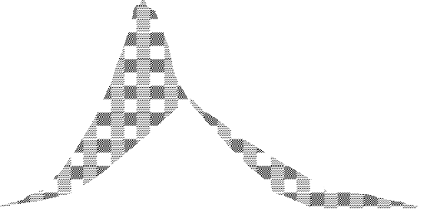Q
I
Stored

Peak O
O
Released

t
Figure 3.5: Storage routing (schematic)

Table 3.1: Tabular computation of level pool routing

G1
O2
.
.
.
Oi
G2
.
.
.
Gi
Oj
Gj

{(Ii + Ij )} - Oi

{(I1 + I2 )} - O1
O1
(Ii + Ij)/2
(I1+I2)/2
I1

I2
.
.
.
Ii

Ij
1

2
.
.
.
i

j
e G
d (Im - O)
c O
b Im
a I

T

Example 2.1 (Reservoir routing)

Channel routing
In reservoir routing presented in the previous section, the storage was a unique function of the outflow discharge, S=f(O). However in channel routing the storage is a function of both outflow and inflow discharges and hence a different routing method is needed. The flow in a river during a flood belongs to the category of gradually varied unsteady flow.
For a river reach where the water surface cannot be assumed horizontal to the river bottom during the passage of a flood wave, the storage in the reach may be split up in two parts: (i) prism storage and (ii) wedge storage
Prism Storage is the volume that would exist if uniform flow occurred at the downstream depth, i.e. the volume formed by an imaginary plane parallel to the channel bottom drawn at a direct function of the stage at the downstream end of the reach. The surface is taken parallel to the river bottom ignoring the variation in the surface in the reach relative to the bottom. Both this storage and the outflow can be described as a single function of the downstream water level and the storage is a single function of the out flow alone.
Wedge Storage is the wedge-like volume formed b/n the actual water surface profile and the top surface of the prism storage. It exists because the inflow, I, differs from O (out flow) and so may be assumed to be a function of the difference between inflow and outflow, (I-O).
I
O
(I-O)
t
(I-O)
T
t
S =
T
∫ ( I − O ) dt
0
O

+ I-O
-

S

0 t
Figure 3.6: Determining storage in a river reach

At a fixed depth at a downstream section of river reach, prism storage is constant while the wedge storage changes from a positive value at the advancing flood wave to a negative value during a receding flood.

The total storage in the channel reach can be generally represented by:
S = f₁(O)+f₂(I-O) (3.7)
And this can then be expressed as:
S = K (x I^{m} + (1-x)O^{m}) (3.8)
Where K and x are coefficients and m is a constant exponent. It has been found that the value of m varies from 0.6 for rectangular channels to value of about 1.0 for natural channels.

Muskingum Method of Routing
Using m =1 for natural channels, equation (2.8), reduces to a linear relationship for S in terms of I and Q as
S= K (x I+ (1-x)O (3.9)

This relationship is known as the Muskingum Equation. In this the parameter x is known as weighing factor and take a value between 0 and 0.5. When x=0, obviously the storage is a function of discharge only and equation (3.9) reduces to:
S = KQ (3.10)

Such storage is known as linear storage or linear reservoir. When x= 0.5 both the inflow and out flow are equally important in determining the storage.

The coefficient K is known as storage-time constant and has dimensions of time. K is approximately equal to the time of travel of a flood wave through the channel reach.
As before, writing the continuity equation in finite difference form, we can write S₂ - S₁ = {(I₁+I₂)Δt}/2 - {(O₁+O₂) Δt}/2 (3.11)
For a given channel reach by selecting a routing interval Δt and using the
Muskingum equation, the change in storage can be determined.
S₁ = K(xI₁ + (1-x) O₁) (3.12)
S₂ = K(xI₂ + (1-x) O₂) (3.13)
Substituting equations (3.12) and (3.13) in equation (3.11) and after rearrangements gives:
O₂ = c₁I₁ +c₂I₂ +c₃O₁ and more generally as

O i + 1 =
Where
c 1 I i
+ c 2 I i + 1 +
c 3 O i
(3.14)

C₁= C₂=
C₃=
Δt + 2Kx

Δt + 2K − 2Kx
Δt − 2Kx

Δt + 2K − 2Kx
− Δt + 2k − 2KX

Δt + 2k − 2kx

Note that ΣC=1 and thus when C₁ and C₂ have been found C₃=1-C₁-C₂. Thus the outflow at the end of a time step is the weighted sum of the starting inflow and outflow and the ending inflow. It has been found that best results will be obtained when routing interval should be so chosen that K>Δt>2kx. If Δt < 2kx, the coefficient C₂ will be negative.

Application of the Muskingum Method:
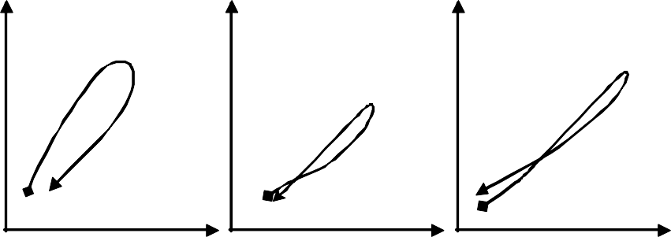In order to use equation (2.14) for O_{i+1}, it is necessary to know K and x for calculating the coefficients, C. Using recorded hydrographs of a flood at the beginning and end of the river reach, trial values of x are taken, and for each trial the weighted flows in the reach, [xI+(1-x)O], are plotted against the actual storages determined from the inflow and out flow hydrographs as indicated in the following figure.
a) X₁
b) X₂
c) X₃
S
S
S
xI+(1-x)Q
xI+(1-x)Q
xI+(1-x)Q

Figure 3.7: Trial plots for Muskingum x values

When the looping plots of the weighted discharge against storages have been narrowed down so that the values for the rising stage and the falling stage for a particular value of x merge together to form the best approximation to a straight line, then that x value is used, and the slope of the straight line gives the required value of K. for natural channels, the best plot is often curved, making a straight line slope difficult to estimate.

Example 3.2 (Channel routing)

Hydraulic Routing

Tutorial Problem Set 2 (Taken from Chapter 16 – Flood Routing, Elisabeth Shaw) For G-2HA&B
- The Muskingum constants, K and x, are estimated for a given river reach to be 12 hr and 0.2. Assuming an initial steady flow, determine the peak discharge at the downstream end of the reach for the inflow hydrograph shown in the table 1 below.
Table 1

Time from start  Of rise (hr) | 0 | 6 | 12 | 18 | 24 | 30 | 36 | 42
Inflow (m³s⁻¹) | 25.0 | 32.5 | 58.0 | 65.0 | 59.4 | 49.5 | 42.5 | 35.0

- The crest of a 20 m wide reservoir spillway consists of two 10 m wide gates, one of which is kept 0.5m lower than the other. The flow Q (m³s⁻¹), over each gate is given by Q = C_{d}bh^{3/2} where b (m) is the gate width and h (m) is the head on the gates. Position, can be taken as 2.0 (m^{1/2}s⁻¹) for each gate. Initial flows into and out of the 1 ha reservoir are equal at 10 m³s⁻¹). The inflow into the reservoir is to be increased steadily to 20 m³s⁻¹ over 1h. Find the outflow at the end of that time, assuming the gate positions remain unchanged ( 1 ha = 10⁴m² )

- A lake, having steep banks and a surface area of 6 km², discharges into a steep channel which is approximately rectangular in section, with a width of 50 m. Initially, conditions are steady with a flow of 170 m³s⁻¹ passing through the lake; then a flood comes down the river feeding the lake, giving rise to the inflow hydrograph shown in table 2. Compute the outflow hydrograph and plot it on the same graph with the inflow hydrograph. Note the difference in magnitude and time between the two peaks. (Critical flow exists at the lake outlet, g = 9.81 ms⁻¹.)
Table 2

Time from start (hr) | 0 | 1 | 2 | 3 | 4 | 5 | 6
Inflow (m³s⁻¹) | 170 | 230 | 340 | 290 | 220 | 180 | 170

- Discharge measurements at two gauging stations for a flood flow on the Macquarie River in Australia are given in Table 3. It is assumed that there are no tributaries to the river between the upstream stations B and the downstream station W. Apply the Muskingum method of flood routing to derive a model for

calculating sequential outflows at the downstream end of the reach from measured flows at B. From the given inflows, derive the computed peak outflow discharge and its time of arrival at W.
Table 3

Time(h) | 0 | 4 | 8 | 12 | 16 | 20 | 24
B(m³s⁻¹) | 595 | 1699 | 3837 | 5636 | 4305 | 3059 | 2271
W(m³s⁻¹) | 130 | 496 | 1189 | 2209 | 3087 | 3823 | 3781
Time (h) | 28 | 32 | 36 | 40 | 44 | 48
B (m³s⁻¹) | 1756 | 1359 | 1062 | 830 | 637 | 504
W (m³s⁻¹) | 3285 | 2393 | 1841 | 1416 | 1147 | 850

- Analysis of past records for a certain river reach yielded the values of Muskingum coefficient x = 0.22 and K = 1.5 days. Route the flood shown in Table 4 through the reach. The inflow continues at 14.2 m³s⁻¹ after day 12.

Table 4
Day | 1 | 2 | 3 | 4 | 5 | 6
Inflow (m³s⁻¹) | 14.2 | 76.7 | 129.4 | 166.8 | 171.9 | 113.8
Day | 7 | 8 | 9 | 10 | 11 | 12
Inflow( m³s⁻¹) | 187.8 | 264.2 | 152.1 | 75.0 | 45.0 | 14.2

FREQUENCY ANALYSIS (PROBABILITY IN HYDROLOGY)

General

Water resource systems must be planned for future events for which no exact time of occurrence can be forecasted. Hence, the hydrologist must give a statement of the probability of the stream flows (or other hydrologic factors) will equal or exceed (or be less than) a specified value. These probabilities are important to the economic and social evaluation of a project. In most cases, absolute control of the floods or droughts is impossible. Planning to control a flood of a specific probability recognizes that a project will be overtaxed occasionally and damages will be incurred. However, repair of the damages should be less costly in the long run than building initially to protect against the worst possible event. The planning goal is not to eliminate all floods but to reduce the frequency of flooding, and hence the resulting damages. If the socio-economic analysis is to be correct, the probability of flooding must be eliminated accurately. For major projects, the failure of which seriously threatens human life, a more extreme event, the probable maximum flood, has become the standard for designing the spillway.

This chapter deals with techniques for defining probability from a given set of data and with special methods employed for determining design flood for major hydraulic structures.

Frequency analysis is the hydrologic term used to describe the probability of occurrence of a particular hydrologic event (e.g. rainfall, flood, drought, etc.). Therefore, basic knowledge about probability (e.g. distribution functions) and statistics (e.g. measure of location, measure of spread, measure of skewness, etc) is essential. Frequency analysis usually requires recorded hydrological data.

Hydrological data are recorded either as a continuous record (e.g. water level or stage, rainfall, etc.) or in discrete series form (e.g. mean daily/monthly/annual flows or rainfall, annual series, partial series, etc.).

For planning and designing of water resources development projects, the important parameters are river discharges and related questions on the frequency & duration of normal flows (e.g. for hydropower production or for water availability) and extreme flows (floods and droughts).

Flow Frequency
The question a planner or decision maker would ask a hydrologist concerning normal flows is the length of time (duration) that a certain river flow is expected to be exceeded. An answer to this question is provided by the flow duration curve (FDC) that is the relationship between any given discharge and the percentage of time that the discharge is exceeded. Taking the n-years of flow records from a river gauging stations, there are 365(6)n daily mean discharges. The discharge is compiled, starting with the highest values. If N number of data points are used for analysis, the plotting position of any discharge (or class value) Q is:
Pp = m / (N+1) (4.1)
Where, m = is the order number of the discharge (or class value)
Pp = percentage probability of the flow magnitude being equalled or exceeded.

The FDC only applies for the period for which it was derived. If this is a long period, say more than 10 to 20 years, the FDC may be regarded as a probability curve or flow frequency curve, which may be used to estimate the percentage of time that a specified discharge will be equalled or exceeded in the future. An example is demonstrated in table 4.1 below.

Table 4.1: Flow records

Flow Duration Curve

1400

1200

1000

800

600

400

200

0
0% 10% 20% 30% 40% 50% 60% 70% 80% 90% 100%
% Exceeded or Equalled

Discharge (m3/s) | Descending Order | Rank | %Exceeded or Equaled (m / (N+1))
(a) | (b) | (c) | (d)
106.70 | 1200 | 1 | 8.33%
107.10 | 964.7 | 2 | 16.67%
148.20 | 497 | 3 | 25.00%
497.00 | 338.6 | 4 | 33.33%
1200.00 | 177.6 | 5 | 41.67%
964.70 | 148.2 | 6 | 50.00%
338.60 | 142.7 | 7 | 58.33%
177.60 | 141 | 8 | 66.67%
141.00 | 141 | 9 | 75.00%
141.00 | 126.6 | 10 | 83.33%
142.70 | 107.1 | 11 | 91.67%
126.60 | 106.7 | 12 | 100.00%

Figure 4.1: Flow Duration Curve
Q (m3/s)
The shape of the flow-duration curve gives a good indication of a catchment’s characteristics response to its average rainfall history. An initially steeply sloped curve results from a very variable discharge, usually from small catchments with little storage where the stream flow reflects directly the rainfall pattern. Flow duration curves that have very flat slope indicate little variation in flow regime, the resultant of the damping effects of large storages.

Flood Probability

Selection of Data
If probability analysis is to provide reliable answers, it must start with a data series that is relevant, adequate, and accurate. Relevance implies that the data must deal with the problem. Most flood studies are concerned with peak flows, and the data series will consist of selected observed peaks. However, if the problem is duration of flooding, e.g., for what periods of time a highway adjacent to a stream is likely to be flooded, the data series should represent duration of flows in excess of some critical value. If the problem is one of interior drainage of a leveed area, the data required may consist of those flood volumes occurring when the main river is too high to permit gravity drainage.

Adequacy refers primarily to length of record, but sparisty of data collecting stations is often a problem. The observed record is merely a sample of the total population of floods that have occurred and may occur again. If the sample is too small, the probabilities derived cannot be expected to be reliable. Available stream flow records are too short to provide an answer to the question: How long must a record be to define flood probabilities within acceptable tolerances?

Accuracy refers primarily to the problem of homogeneity. Most flow records are satisfactory in terms of intrinsic accuracy, and if they are not, there is little that can be done with them. If the reported flows are unreliable, they are not a satisfactory basis for frequency analysis. Even though reported flows are accurate, they may be unsuitable for probability analysis if changes in the catchment have caused a change in the hydrologic characteristics, i.e., if the record is not internally homogenous. Dams, levees, diversions, urbanization, and other land use changes may introduce inconsistencies. Such records should be adjusted before use to current conditions or to natural conditions.
There are two data series of floods:

The annual series, and
      - The partial duration series.

The annual series constitutes the data series that the values of the single maximum daily/monthly/annually discharge in each year of record so that the number of data values equals the record length in years. For statistical purposes, it is necessary to ensure that the selected peak discharges are independent of one another. This data series is necessary if the analysis is concerned with probability less than 0.5. However as the interest are limited to relatively rare events, the analysis could have been carried out for a partial duration series to have more frequent events.
.
The partial duration series constitutes the data series with those values that exceed some arbitrary level. All the peaks above a selected level of discharge (a threshold) are included in the series and hence the series is often called the Peaks Over Threshold (POT) series. There are generally more data values for analysis in this series than in the annual series, but there is more chance of the peaks being related and the assumption of true independence is less valid.

Plotting Positions
Probability analysis seeks to define the flood flow with probability of p being equaled or exceed in any year. Return period T_{r} is often used in lieu of probability to describe a design flood. Return period and probability are reciprocals, i.e,

p = 1/T_{r} (4.2)
To plot a series of peak flows as a cumulative frequency curves it is necessary to decide on a probability or return period to associate with each peak. There are various formulas for defining this value as shown in table 4.2.

The probability of occurrence of the event r times in n successive years can be obtained from:

P =nC Prqn−r =
n! Prqn−r

rn r
(n − r)!r! ^{(4.3)}

Where q = 1 - P.
Table 4.2 Plotting-position formulae
Method | P
California | m / N
Hazen | (m - 0.5) / N
Weibull | m / (N+1)
Chegodayev | (m - 0.3) / (N+0.4)
Gringorten | (m - 3/8) / (N + 1/4)

Consider, for example, a list of flood magnitudes of a river arranged in descending order as shown in Table 4.3. The length of record is 50 years.

Table 4.3: Calculation of Frequency T
Order No. m | Flood magnitude Q (m³/s) | T in years = 51/m
1 | 160 | 51.00
2 | 135 | 25.50
3 | 128 | 17.00
4 | 116 | 12.75
. | . | .
. | . | .
. | . | .
49 | 65 | 1.04
50 | 63 | 1.02
The last column shows the return period T of various flood magnitude, Q. A plot of Q Vs T yields the probability distribution. For small return periods (i.e. for interpolation) or where limited extrapolation is required, a simple best-fitting curve through plotted points can be used as the probability distribution. A logarithmic scale for T is often advantageous. However, when larger extrapolations of T are involved, theoretical probability distributions (e.g. Gumbel extreme-value, Log- Pearson Type III, and log normal distributions) have to be used. In frequency analysis of floods the usual problem is to predict extreme flood events. Towards this, specific extreme-value distributions are assumed and the required statistical parameters calculated from the available data. Using these flood magnitude for a specific return period is estimated.

Theoretical Distributions of Floods

Statistical distributions are usually demonstrated by use of samples numbering in the thousands. No such samples are available for stream flow and it is not possible to state with certainty that a specific distribution applies to flood peaks. Numerous distributions have been suggested on the basis of their ability to “fit” the plotted data from streams.

Chow has shown that most frequency-distribution functions applicable in hydrologic studies can be expressed by the following equation known as the general equation of hydrologic frequency analysis:

xT = x + Kσ (4.4)
Where x_{T} = value of the variate X of a random hydrologic series with a return period T, x = mean of the variate, σ = standard deviation of the variate, K =
frequency factor which depends upon the return period, T and the assumed frequency distribution.

Extreme-Value Type I Distribution (Gumbel’s Method)

This extreme value distribution was introduced by Gumbel (1941) and is commonly known as Gumbel's distribution. It is one of the most widely used probability- distribution functions for extreme values in hydrologic and meteorological studies for prediction of flood peaks, maximum rainfalls, and maximum wind speed, etc. Therefore, this extreme value theory of Gumbel is only applicable to annual extremes. In contrast to the previous example, in the Gumbel method the data are ranked in ascending order and it makes use of the probability of non-exceedence q=1-P (the probability that the annual maximum flow is less than a certain magnitude). The return period T is therefore given by T = 1 / P = 1 / (1-q).

Gumbel makes use of a reduced variate y as a function of q, which allows the plotting of the distribution as a linear function between y and X (the maximum flow in this case). Gumbel also defined a flood as the largest of the 365 daily flows and the annual series of flood flows constitute a series of largest values of flow. According to his theory of extreme events, the probability of occurrence of an event equal to or larger than a value x₀ is
- y

P( X ≥ x0
) =1− e −e

(4.5)

In which y is a dimensionless variable given by
y = α(X-a) (4.6)
a= x − 0.45005σ x
α = 1.2825
σ
x

Thus
1.2825(X − X )
ο X
y=

+0.577

(4.7)

Where x = mean and σ_{x} = standard deviation of the variate X. In practice it is the value of X for a given P that is required and as such Eq.(4.7) is transposed as

y = -1n(-1n(q)) = -1n(-1n(1-p)) (4.8)
meaning that the probability of non-exceedence equals:

y

P( X ≤ x
) = q = e
−e
0 (4.9)

Noting that the return period T = 1/P and designating; y_{T} = the value of y, commonly called the reduced variate, for a given T

y =− ⎡ ⎛
⎛ T ⎞⎞ ⎤

T ⎢ln⎜⎝ ln⎜⎝ T −

⎟⎠ ⎟⎠ ⎥

⎣ 1 ⎦
y =− ⎡0.834 + ⎛
⎛ T ⎞⎞⎤

(4.10)

T ⎢ 2.303log⎜⎝ log⎜⎝ T −
⎟⎠ ⎟⎠ ⎥

Or ⎣ 1 ⎦
(4.10a)

Now rearranging Eq.(4.7), the value of the variate X with a return period T is

x = x + Kσ
T
x
(yT −0.577)
K =

(4.11)

Where

1.2825
(4.12)

Note that Eq. (4.12) is of the same form as the general equation of hydrologic- frequency analysis, Eq. (4.4). Further eqs (4.11) and (4.12) constitute the basic Gumbel's equations and are applicable to an infinite sample size (i.e. N → ∞).

Since practical annual data series of extreme events such as floods, maximum rainfall depths, etc., all have finite lengths of record; Eq. (4.12) is modified to account for finite N as given below for practical use.

Gumbel's Equation for Practical Use

Equation (4.11) giving the variate X with the return period T is used as

x = x + Kσ
T
n − 1 (4.13)

=
∑(x−x )2
N −1

Where σn-1 = standard deviation of the sample K = frequency factor expressed as K= yT − yn
Sn
(4.14)
In which y_{T} = reduced variate, a function of T and is given by

y =− ⎡ ⎛
⎛ T ⎞⎞ ⎤

T ⎢ln⎜⎝ ln⎜⎝ T −

⎟⎠ ⎟⎠ ⎥

⎣
(4.15)
or
⎡
1 ⎦

⎛ ⎛ T

⎞⎞⎤

yT =− ⎢0.834+2.303 log⎜log⎜ T − 1⎟⎟⎥
⎣ ⎝ ⎝ ⎠⎠⎦

yn = reduced mean, a function of sample size N and is given in Table 4.4; for N → ∞, yn → 0.577.
S_{n} = reduced standard deviation, a function of sample size N and is given in Table 4.5; for N → ∞, S_{n} → 1.2825.
These equations are used under the following procedure to estimate the flood magnitude corresponding to a given return period based on annual flood series.
- Assemble the discharge data and note the sample size N. Here the annual flood value is the variate X. Find x and σ_{n-1} for the given data.
- Using Tables 4.4 and 4.5 determine yn and S_{n} appropriate to given N
- Find y_{T} for a given T by Eq.(4.15).
- Find K by Eq.(4.14).
- Determine the required x_{T} by Eq.(4.13).

To verify whether the given data follow the assumed Gumbel's distribution, the following procedure may be adopted. The value of x_{T} for some return periods T<N are calculated by using Gumbel's formula and plotted as x_{T} Vs T on a convenient paper such as a semi-log, log-log or Gumbel probability paper. The use of Gumbel probability paper results in a straight line for x_{T} Vs T plot. Gumbel's distribution has the property which gives T = 2.33 years for the average of the annual series when N is very large. Thus the value of a flood with T = 2.33 years is called the mean annual flood. In graphical plots this gives a mandatory point through which the line showing variation of x_{T} with T must pass. For the given data, values of return periods (plotting positions) for various recorded values, x of the variate are obtained by the relation T = (N+1)/m and plotted on the graph described above. A good fit of observed data with the theoretical variation line indicates the applicability of Gumbel's distribution to the given data series. By extrapolation of the straight-line x_{T} Vs T, values of x_{T}> N can be determined easily.

The Gumbel (or extreme-value) probability paper is a paper that consists of an abscissa specially marked for various convenient values of the return period T (or corresponding reduced variate y_{T} in arithmetic scale). The ordinate of a Gumbel paper represent x_{T} (flood discharge, maximum rainfall depth, etc.), which may have either arithmetic scale or logarithmic scale.

Table 4.4: Reduced mean yn in Gumbel's extreme value distribution, N = sample size
N | 0 | 1 | 2 | 3 | 4 | 5 | 6 | 7 | 8 | 9
10 | 0.4952 | 0.4996 | 0.5035 | 0.5070 | 0.5100 | 0.5128 | 0.5157 | 0.5181 | 0.5202 | 0.5220
20 | 0.5236 | 0.5252 | 0.5268 | 0.5283 | 0.5296 | 0.5309 | 0.5320 | 0.5332 | 0.5343 | 0.5353
30 | 0.5362 | 0.5371 | 0.5380 | 0.5388 | 0.5396 | 0.5402 | 0.5410 | 0.5418 | 0.5424 | 0.5430
40 | 0.5436 | 0.5442 | 0.5448 | 0.5453 | 0.5458 | 0.5463 | 0.5468 | 0.5473 | 0.5477 | 0.5481
50 | 0.5485 | 0.5489 | 0.5493 | 0.5497 | 0.5501 | 0.5504 | 0.5508 | 0.5511 | 0.5515 | 0.5518
60 | 0.5521 | 0.5524 | 0.5527 | 0.5530 | 0.5533 | 0.5535 | 0.5538 | 0.5540 | 0.5543 | 0.5545
70 | 0.5548 | 0.5550 | 0.5552 | 0.5555 | 0.5557 | 0.5559 | 0.5561 | 0.5563 | 0.5565 | 0.5567
80 | 0.5569 | 0.5570 | 0.5572 | 0.5574 | 0.5576 | 0.5578 | 0.5580 | 0.5581 | 0.5583 | 0.5585
90 | 0.5586 | 0.5587 | 0.5589 | 0.5591 | 0.5592 | 0.5593 | 0.5595 | 0.5596 | 0.5598 | 0.5599
100 | 0.5600

Table 4.5: Reduced standard deviation S_{n} in Gumbel's extreme value distribution, N
= sample size
N | 0 | 1 | 2 | 3 | 4 | 5 | 6 | 7 | 8 | 9
10 | 0.9496 | 0.9676 | 0.9833 | 0.9971 | 1.0095 | 1.0206 | 1.0316 | 1.0411 | 1.0493 | 1.0565
20 | 1.0628 | 1.0696 | 1.0754 | 1.0811 | 1.0864 | 1.0915 | 1.0961 | 1.1004 | 1.1047 | 1.1086
30 | 1.1124 | 1.1159 | 1.1193 | 1.1226 | 1.1255 | 1.1285 | 1.1313 | 1.1339 | 1.1363 | 1.1388
40 | 1.1413 | 1.1436 | 1.1458 | 1.1480 | 1.1499 | 1.1519 | 1.1538 | 1.1557 | 1.1574 | 1.1590
50 | 1.1607 | 1.1623 | 1.1638 | 1.1658 | 1.1667 | 1.1681 | 1.1696 | 1.1708 | 1.1721 | 1.1734
60 | 1.1747 | 1.1759 | 1.1770 | 1.1782 | 1.1793 | 1.1803 | 1.1814 | 1.1824 | 1.1834 | 1.1844
70 | 1.1854 | 1.1863 | 1.1873 | 1.1881 | 1.1890 | 1.1898 | 1.1906 | 1.1915 | 1.1923 | 1.1930
80 | 1.1938 | 1.1945 | 1.1953 | 1.1959 | 1.1967 | 1.1973 | 1.1980 | 1.1987 | 1.1994 | 1.2001
90 | 1.2007 | 1.2013 | 1.2020 | 1.2026 | 1.2032 | 1.2038 | 1.2044 | 1.2049 | 1.2055 | 1.2060
100 | 1.2065

Confidence Limits for the fitted data
Since the value of the variate for a given return period, x_{T} determined by Gumbel's method can have errors due to the limited sample data used; an estimate of the confidence limits of the estimate is desirable. The confidence interval indicates the limits about the calculated value between which the true value can be said to lie with a specific probability based on sampling errors only.

For a confidence probability c, the confidence interval of the variate x_{T} is bound by value x₁ and x₂ given by
x_{1/2} = x_{T}± f (c) S_{e} (4.16)

Where f(c) = function of the confidence probability c determined by using the table of normal variate as

C in per cent | 50 | 68 | 80 | 90 | 95 | 99
f(c) | 0.674 | 1.00 | 1.282 | 1.645 | 1.96 | 2.58
σ
S_{e} = probable error = b n−1 (4.16a)
N

b=
1 + 1.3K + 1.1K 2
K = frequency factor given by Eq.(4.14)

σ_{n-1} = standard deviation of the sample N = sample size
It is seen that for a given sample and T, 80% confidence limits are twice as large as the 50% limits and 95% limits are thrice as large as 50% limits.

In addition to the analysis of maximum extreme events, there also is a need to analyze minimum extreme events; e.g. the occurrence of droughts. The probability distribution of Gumbel, similarly to the Gaussian probability distribution, does not have a lower limit; meaning that negative values of events may occur. As rainfall or river flows do have a lower limit of zero, neither the Gumbel nor Gaussian distribution is an appropriate tool to analyze minimum values. Because the logarithmic function has a lower limit of zero, it is often useful to first transform the series to its logarithmic value before applying the

theory. Appropriate tools for analyzing minimum flows or rainfall amounts are the Log-Normal, Log-Gumbel, or Log-Pearson distributions.

Log-Pearson Type III Distribution
This distribution is widely used in USA. In this distribution the variate is first transformed into logarithmic form (base 10) and the transformed data is then analysed. If X is the variate of a random hydrologic series, then the series of Z variates where
Z = log x (4.18)
are first obtained. For this z series, for any recurrence interval T, equation (4.4) gives

zT = z + K
ο (4.19)
z z

Where K_{z} = a frequency factor which is a function of recurrence interval T and the coefficient of skew C_{s},
∑(z − z )2 N −1

σ_{z} = standard deviation of the Z variate sample =
N ∑(z − z ) 3
( )
and C_{s} = coefficient of skew of variate Z = 3
( N − 1)( N − 2) σ z
(4.19a)
(4.19b)

z = mean of the z values
N = sample size = number of years of record
The variations of K_{z} = f(C_{s}, T) is given in Table 4.6. After finding z_{T} by Eq.(4.19), the corresponding value of x_{T} is obtained by Eq.(4.18) as x_{T} = antilog(z_{T}) (4.20)

Sometimes, the coefficient of skew C_{s}, is adjusted to account for the size of the sample by using the following relation proposed by Hazen (1930)

Cˆ = C
⎛ 1 + 8.5 ⎞

(4.21)

s s ⎜ ⎟
⎝ N ⎠

Where
Cˆ s = adjusted coefficient of skew. However the standard procedure for

use of Log-Pearson Type III distribution adopted by U.S. Water Resources Council does not include this adjustment for skew.
When the skew is zero, i.e. C_{s} = 0, the Log-Pearson Type III distribution reduces to Log-normal distribution. The Log-normal distribution plots as a straight line on logarithmic probability paper.

Table 4.6: K_{z} = F(C_{s}, T) for use in Log-Pearson Type III Distribution
Coef. of skew, C_{s} | Return Period T in years
Coef. of skew, C_{s} | 2 | 10 | 25 | 50 | 100 | 200 | 1000
3.0 | -0.396 | 1.180 | 2.278 | 3.152 | 4.051 | 4.970 | 7.250
2.5 | -0.360 | 1.250 | 2.262 | 3.048 | 3.845 | 4.652 | 6.600
2.2 | -0.330 | 1.284 | 2.240 | 2.970 | 3.705 | 4.444 | 6.200
2.0 | -0.307 | 1.302 | 2.219 | 2.912 | 3.605 | 4.298 | 5.910
1.8 | -0.282 | 1.318 | 2.193 | 2.848 | 3.499 | 4.147 | 5.660
1.6 | -0.254 | 1.329 | 2.163 | 2.780 | 3.388 | 3.990 | 5.390
1.4 | -0.225 | 1.337 | 2.128 | 2.706 | 3.271 | 3.828 | 5.110
1.2 | -0.195 | 1.340 | 2.087 | 2.626 | 3.149 | 3.661 | 4.820

Table 4.6: (Cont’d)
Coef. of skew, C_{s} | Return Period T in years
Coef. of skew, C_{s} | 2 | 10 | 25 | 50 | 100 | 200 | 1000
1.0 | -0.164 | 1.340 | 2.043 | 2.542 | 3.022 | 3.489 | 4.540
0.9 | -0.148 | 1.339 | 2.018 | 2.498 | 2.957 | 3.401 | 4.395
0.8 | -0.132 | 1.336 | 1.998 | 2.453 | 2.891 | 3.312 | 4.250
0.7 | -0.116 | 1.333 | 1.967 | 2.407 | 2.824 | 3.223 | 4.105
0.6 | -0.099 | 1.328 | 1.939 | 2.359 | 2.755 | 3.132 | 3.960
0.5 | -0.083 | 1.323 | 1.910 | 2.311 | 2.686 | 3.041 | 3.815
0.4 | -0.066 | 1.317 | 1.880 | 2.261 | 2.615 | 2.949 | 3.670
0.3 | -0.050 | 1.309 | 1.849 | 2.211 | 2.544 | 2.856 | 3.525
0.2 | -0.033 | 1.301 | 1.818 | 2.159 | 2.472 | 2.763 | 3.380
0.1 | -0.017 | 1.292 | 1.785 | 2.107 | 2.400 | 2.670 | 3.235
0.0 | 0.000 | 1.282 | 1.751 | 2.054 | 2.326 | 2.576 | 3.090
-0.1 | 0.017 | 1.270 | 1.716 | 2.000 | 2.252 | 2.482 | 2.950
-0.2 | 0.033 | 1.258 | 1.680 | 1.945 | 2.178 | 2.388 | 2.810
-0.3 | 0.050 | 1.245 | 1.643 | 1.890 | 2.104 | 2.294 | 2.675
-0.4 | 0.066 | 1.231 | 1.606 | 1.834 | 2.029 | 2.201 | 2.540
-0.5 | 0.083 | 1.216 | 1.567 | 1.777 | 1.955 | 2.108 | 2.400
-0.6 | 0.099 | 1.200 | 1.528 | 1.720 | 1.880 | 2.016 | 2.275
-0.7 | 0.116 | 1.183 | 1.488 | 1.663 | 1.806 | 1.926 | 2.150
-0.8 | 0.132 | 1.166 | 1.448 | 1.606 | 1.733 | 1.837 | 2.035
-0.9 | 0.148 | 1.147 | 1.407 | 1.549 | 1.660 | 1.749 | 1.910
-1.0 | 0.164 | 1.128 | 1.366 | 1.492 | 1.588 | 1.664 | 1.880
-1.4 | 0.225 | 1.041 | 1.198 | 1.270 | 1.318 | 1.351 | 1.465
-1.8 | 0.282 | 0.945 | 1.035 | 1.069 | 1.087 | 1.097 | 1.130
-2.2 | 0.330 | 0.844 | 0.888 | 0.900 | 0.905 | 0.907 | 0.910
-3.0 | 0.396 | 0.660 | 0.666 | 0.666 | 0.667 | 0.667 | 0.668

The flood-frequency analysis described above is a direct means of estimating the desired flood based upon the available flood-flow data of the catchment. The results of the frequency analysis depend upon the length of data. The minimum number of years of record required to obtain satisfactory estimates depends upon the variability of data and hence on the physical and climatological characteristics of the basin. Generally a minimum of 30 years of data is considered as essential. Smaller lengths of records are also used when it is unavoidable. However, frequency analysis should not be adopted if the length of records is less than 10 years.

Flood-frequency studies are most reliable in climates that are uniform from year to year. In such cases a relatively short record gives a reliable picture of the frequency distribution. With increasing lengths of flood records, it affords a viable alternative method of flood-flow estimation in most cases.

A final remark of caution should be made regarding to frequency analysis. None of the frequency distribution functions have a real physical background. The only information having physical meaning are the measurements themselves. Extrapolation beyond the period of observation is dangerous. It requires a good engineer to judge the value of extrapolated events of high return periods. A good impression of the relativity of frequency analysis can be acquired through the comparison of result obtained from different statistical methods. Generally they differ considerably.

Example 4.1
Annual maximum recorded floods in a certain river, for the period 1951 to 1977 is given below. Verify whether the Gumbel extreme-value distribution fit the recorded values. Estimate the flood discharge with return period of (i) 100 years and (ii) 150 years by graphical extrapolation.

Solutions: The flood discharge values are arranged in descending order and the plotting position return period T_{P} for each discharge is obtained as

TP =
N + 1= 28 . Where m = order number. The discharge magnitude

m m

Q can be plotted against the corresponding T_{P} on a Gumbel extreme probability paper.

Year | Max. flood (m³/s) | Year | Max. flood (m³/s) | Year | Max. flood (m³/s)
1951 | 2947 | 1960 | 4798 | 1969 | 6599
1952 | 3521 | 1961 | 4290 | 1970 | 3700
1953 | 2399 | 1962 | 4652 | 1971 | 4175
1954 | 4124 | 1963 | 5050 | 1972 | 2988
1955 | 3496 | 1964 | 6900 | 1973 | 2709
1956 | 2947 | 1965 | 4366 | 1974 | 3873
1957 | 5060 | 1966 | 3380 | 1975 | 4593
1958 | 4903 | 1967 | 7826 | 1976 | 6761
1959 | 3757 | 1968 | 3320 | 1977 | 1971
The statistics x and σ_{n-1} for the series are next calculated and are shown in table below.

Order number M | Flood discharge x (m³/s) | T_{P}  (years) | Order number M | Flood discharge x (m³/s) | T_{P}  (years)
1 | 7826 | 28.00 | 15 | 3873 | 1.87
2 | 6900 | 14.00 | 16 | 3757 | 1.75
3 | 6761 | 9.33 | 17 | 3700 | 1.65
4 | 6599 | 7.00 | 18 | 3521 | 1.56
5 | 5060 | 5.60 | 19 | 3496 | 1.47
6 | 5050 | 4.67 | 20 | 3380 | 1.40
7 | 4903 | 4.00 | 21 | 3320 | 1.33
8 | 4798 | 3.50 | 22 | 2988 | 1.27
9 | 4652 | 3.11 | 23 | 2947 | -
10 | 4593 | 2.80 | 24 | 2947 | 1.17
11 | 4366 | 2.55 | 25 | 2709 | 1.12
12 | 4290 | 2.33 | 26 | 2399 | 1.08
13 | 4175 | 2.15 | 27 | 1971 | 1.04
14 | 4124 | 2.00
N = 27 years, x = 4263 m³/s, σ_{n-1} = 1432.6 m³/s

Using these the discharge x_{T} for some chosen return interval is calculated by using Gumbel's formulae [Eqs.(4.15), (4.14) and (4.13)]. From Tables 4.4 and 4.5, for N = 27, y_{n} = 0.5332 and S_{n} = 1.1004.

Choosing T = 10 years, by Eq.(4.15), y_{T} = -[ln(ln(10/9))] = 2.25037 and
K = (2.25307-0.5332)/1.1004 = 1.56 and x_{T} = 4263 + (1.56*1432.6) = 6499m³/s.
Similarly, values of x_{T} are calculated for two more T values as shown below.

T  (Years) | X_{T}[obtained by Eq.(3.13)] (m³/s)
5.0 | 5522
10.0 | 6499
20.0 | 7436

When these values are plotted on Gumbel probability paper, it is seen that these points lie on a straight line according to the property of the Gumbel's extreme probability paper. Then by extrapolation of the theoretical x_{T} Vs T relationship, from this plot, at T = 100 years, x_{T} = 9600m³/s and at T = 150 years, x_{T} = 10700m³/s. [By using Eq. (4.13) to (4.15), x₁₀₀ = 9558m³/s and x₁₅₀
= 10088m³/s.]

Example 4.2:
Data covering a period of 92 years for a certain river yielded the mean and standard deviation of the annual flood series as 6437 and 2951 m³/s respectively. Using Gumbel's method, estimate the flood discharge with a return period of 500 years. What are the (a) 95% and (b) 80% confidence limits for this estimate?
Solution: From Table 4.4 and 4.5 for N = 92 years, yn = 0.5589, and S_{n} = 1.2020. Then
y₅₀₀ = -[ln((ln(500/499))] = 6.21361
K₅₀₀ = (6.21361 - 0.5589)/1.2020 = 4.7044, Hence, x₅₀₀ = 6437 + 4.7044*2951 = 20320m³/s.
1 + 1.3(4.7044) + 1.1(4.7044)2

From Eq.(6.16a), b=
= 5.61

S = probable error = 5.61 * 2951 = 1726
92
e

- For the 95% confidence probability f(c) = 1.96 and by Eq.(4.16) x_{1/2} = 20320x_{T}± (1.96*1726), which results in x₁ = 23703m³/s and x₂ = 16937m³/s. Thus the estimated discharge of 20320m³/s has a 95% probability of lying between 23700 and 16940m³/s.

- For 80% confidence probability, f(c) = 1.282 and by Eq.(4.16) x_{1/2} = 20320x_{T}± (1.282*1726), which results in x₁ = 22533m³/s and x₂ = 18107m³/s. Thus the estimated discharge of 20320 m³/s has an 80% probability of lying between 22533 and 18107m³/s.

For the data of Example 4.2, the values of x_{T} for different values of T are calculated and can be shown plotted on a Gumbel probability paper.

Figure 4.2: Confidence bands for Gumbel’s distribution: Example 4.2.
Fitted Line
95%
80%
95%
80%
T (Return Period), Yrs
Q (m3/s)

Example 4.3: For the annual flood series data given in Example 3.1, estimate the flood discharge for a return period of (a) 100 years (b) 200 years and (c) 1000 years by using Log-Pearson Type III distribution.
Solution: The variate z = log x is first calculated for all the discharges in table below. Then the statistics z , σ_{z} and C_{s} are calculated from table 4.6 to obtain

σ_{z} = 0.1427
C = 27 * 0.0030
s (26)(25)(0.1427) 3

z = 3.6071 C_{s} = 0.043
The flood discharge for a given T is calculated as below. Here, values of K_{z} for given T and C_{s} = 0.043 are read from table 4.6.

z =3.6071, | σ_{z} = 0.1427, | C_{s} = 0.043
T  (years) | K_{z}  (from table 3.5) (for C_{s} = 0.043) |  | K_{z}σ_{z} | Z_{T} = z + K_{z}σ_{z} | X_{T} = antilog z_{T} (m³/s)
100 | 2.358 |  | 0.3365 | 3.9436 | 8782
200 | 2.616 |  | 0.3733 | 3.9804 | 9559
1000 | 3.152 |  | 0.4498 | 4.0569 | 11400

Year | Flood x( /s) | z = log x | Year | Flood x(m³/s) | z = log x
1951 | 2947 | 3.4694 | 1965 | 4366 | 3.6401
1952 | 3521 | 3.5467 | 1966 | 3380 | 3.5289
1953 | 2399 | 3.3800 | 1967 | 7826 | 3.8935
1954 | 4124 | 3.6153 | 1968 | 3320 | 3.5211
1955 | 3496 | 3.5436 | 1969 | 6599 | 3.8195
1956 | 2947 | 3.4694 | 1970 | 3700 | 3.5682
1957 | 5060 | 3.7042 | 1971 | 4175 | 3.6207

Year | Flood x( /s) | z = log x | Year | Flood x(m³/s) | z = log x
1958 | 4903 | 3.6905 | 1972 | 2988 | 3.4754
1959 | 3751 | 3.5748 | 1973 | 2709 | 3.4328
1960 | 4798 | 3.6811 | 1974 | 3873 | 3.5880
1961 | 4290 | 3.6325 | 1975 | 4593 | 3.6621
1962 | 4652 | 3.6676 | 1976 | 6761 | 3.8300
1963 | 5050 | 3.7033 | 1977 | 1971 | 3.2947
1964 | 6900 | 3.8388

  - Regional Frequency Analysis
A regional frequency analysis usually involves a regression analysis of gauged watersheds within the general region. Through this powerful technique, sufficiently reliable equations can be derived for peak flow of varying frequency given quantifiable physical basin characteristics and rainfall intensity for a specific duration. Once these equations are developed, they can then be applied to ungauged basins within the same region.

A regional analysis usually consists of the following steps:

- Select components of interest, such as mean and peak flows.
- Select definable basin characteristics of gauged watershed: drainage area, length, slope, etc.
- Derive prediction equations with single-or multiple-linear regression analysis.
- Map and explain the residuals (differences between computed and observed values) that constitute “unexplained variances” in statistical analysis on a regional basis.

The equation can then be used in ungauged areas within the same region and for data of similar magnitude to that used in the development process.

Low Flow Analysis
Characterization of the magnitude, frequency, and duration of low stream flows and droughts is vital for assessing the reliability of flows for all in-stream and withdrawal uses and for defining resource shortages and drought.

Definitions and Basic Concepts

Low Stream flows
The objective of low-flow analysis is to estimate the frequency or probability with which stream flow in a given reach will be less than various levels. Thus the flow-duration curve; is an important tool of low-flow analysis; from it one can readily determine the flow associated with any exceedence or non-exceedence probability. Most of the time, the flow exceeded 95% of the time, q₉₅, is a useful index of water availability that is often used for design purposes.

For purposes of statistical analysis, low flows are defined as annual minimum flows averaged over consecutive-day periods of varying length. The most commonly used averaging period is d = 7days, but analyses are often carried out for d = 1,3, 15, 30, 60, 90 and 180 days as well. Low-flow quantile values are cited as "dQp," where p is now the annual non-exceedence probability (in

percent) for the flow averaged over d-days. The 7-day average flow that has an annual non-exceedence probability of 0.10 (a recurrence interval of 10 yr), called "7QI0," is commonly used as a low-flow design value. the “7Q10” value is interpreted as follows:

In any year there is a 10% probability that the lowest 7-consecutive-day average flow will be less than the 7QIO value.

Droughts
Droughts are extended severe dry periods. To qualify as a drought, a dry period must have duration of at least a few months and be a significant departure from normal. Drought must be expected as part of the natural climate, even in the absence of any long term climate change. However, “permanent” droughts due to natural climate shifts do occur, and appear to have been responsible for large scale migrations and declines of civilizations through human history. The possibility of regional droughts associated with climatic shifts due to warming cannot be excluded.
As shown in Figure 3.3, droughts begin with a deficit in precipitation that is unusually extreme and prolonged relative to the usual climatic conditions (meteorological drought). This is often, but not always, accompanied by unusually high temperatures, high winds, low humidity, and high solar radiation that result in increased evapotranspiration.

These conditions commonly produce extended periods of unusually low soil moisture, which affect agriculture and natural plant growth and the moisture of forest floor (Agricultural drought). As the precipitation deficit continues, stream discharge, lake, wetland, and reservoir levels, and water-table decline to unusually low levels (Hydrological drought). When precipitation returns to more normal values, drought recovery follows the same sequence: meteorological, agricultural, and hydrological.
Meteorological drought is usually characterized as a precipitation deficit.

Low flow frequency analysis
As noted earlier, the objective of low flow frequency analysis is to estimate quantiles of annual d-day-average minimum flows. As with floods, such estimates are usually required for reaches without long-term stream flow records. These estimates are first developed by analyzing low flows at gauging stations.

Low flow analysis at gauging stations:
For gauged reach, low flow analysis involves development of a time series of annual d-day low flows, where d is the averaging period. As shown in the table below, the analysis begins with a time series of average daily flows for each year. Then the overlapping d-day averages are computed for the d values of interest. For each value of d, this creates 365-(d-1) values of consecutive d-day averages for each year. The smallest of these values is then selected to produce an annual time series of minimum d-day flows. It is this time series that is then subjected to frequency analysis to estimate the quantiles of the annual d-day flows.

Example 4.4: Computation of d-consecutive Day averages for low flow analysis. Values in bold are minimum for the period shown

Day | 1-Day Average (m³/s) | 3-Day Average (m³/s) | 7-Day Average (m³/s) | 15-Day Average (m³/s)
1 | 5.75
2 | 5.55 | 5.59
3 | 5.47 | 5.45
4 | 5.32 | 5.34 | 5.35
5 | 5.24 | 5.24 | 5.24
6 | 5.15 | 5.13 | 5.29
7 | 4.98 | 5.04 | 5.52
8 | 4.98 | 5.29 | 5.70 | 5.60
9 | 5.89 | 5.97 | 5.78 | 5.58
10 | 7.05 | 6.52 | 5.82 | 5.63
11 | 6.63 | 6.48 | 5.87 | 5.73
12 | 5.78 | 5.95 | 5.93 | 5.77
13 | 5.44 | 5.51 | 5.87 | 5.78
14 | 5.32 | 5.39 | 5.76 | 5.77
15 | 5.41 | 5.41 | 5.81 | 5.76
16 | 5.49 | 5.71 | 5.85 | 5.75
17 | 6.23 | 6.25 | 5.83 | 5.67
18 | 7.02 | 6.42 | 5.78 | 5.54
19 | 6.00 | 6.12 | 5.70 | 5.50
20 | 5.32 | 5.43 | 5.61 | 5.52
21 | 4.96 | 5.04 | 5.39 | 5.53
22 | 4.84 | 4.89 | 5.12 | 6.08
23 | 4.87 | 4.81 | 5.13 | 6.79
24 | 4.73 | 4.91 | 5.22
25 | 5.13 | 5.30 | 5.31
26 | 6.03 | 5.71 | 6.55
27 | 5.97 | 5.86 | 8.15
28 | 5.58 | 8.37
29 | 13.56 | 11.73
30 | 16.06

Low flow analysis at ungauged stations:
As with floods, estimates of low flow quantiles are usually required for stream reaches where there are no long-term gauging station records. There are two basic approaches to developing such estimates:

      - Relate dQp values to drainage-basins characteristics via regression analysis.
      - During the low flow season, make a number of spot measurements of discharge at the ungauged stream reach where the dQp estimate is needed. Then relate those flows to concurrent flows at a nearby gauging station using
q_{u} = a + bq_{g} (4.22)
where:
q_{u} is the flow at the ungauged site, q_{g} is the concurrent flow at the gauged site, and a and b are estimated via regression anlysis. Then estimate the dQp at the ungauged site, dQpu, as:
dQp_{u} = a + b.dQ_{g} (4.23)
where:
dQq_{g} is the dQp value established by frequency analysis at the gauged site. In order to minimize errors when using this procedure, each pair of flows used to

establish equation (4.22) should be from a separate hydrograph recession, the r² value for the relation of equation (4.22) should be at least 0.70 and the two basins should be similar in size, geology, topography, and climate.

Drought analysis
The objective of drought analysis is to characterize the magnitude, duration, and severity of meteorological, agricultural, or hydrological drought in a region of interest. The analysis process can be structured in terms of five questions:
- What type of drought of interest?
- What averaging period will be used?
- How will “drought” be quantitatively defined?
- What are the magnitude-frequency relations of drought characteristics?
- How are regional aspects of drought addressed?

Drought type:
As noted, one may be interested in one or more of the basic types of drought, each reflected in time series of particular types of data: meteorological (precipitation); agricultural (soil moisture); or hydrological (stream flow, reservoir levels, or ground water levels)
High temperature, high w inds, low humidity,
more solar radiation
Reduced streamf low and lake, reservoir, ground w ater, and
w etland levels
Plant w ater stress, reduced biomass and
Soil-w ater deficiency
Precipitation Deficiency
Naural climate variability
Environmental
impacts
Social impacts
Economic
impacts

Increased evapotranspiration: reduced infiltration, runof f, recharge
Meteorological drought
Time

Figure 4.3: Sequence of drought impacts
Hydrological drought
Agricultural drought

Averaging Period:
As with time-series analysis generally, drought analysis requires selection of an averaging period (dt). Since drought by definition have significant duration, one would usually select dt = 1 month, 3 months, or 1 yr, with the choice depending on the available data and the purposes of the analysis. For a given record length the selection of dt involves a trade-off in uncertainty of the analysis:

Smaller sample size
greater uncertanity

Longer dt

Lower autocorrelation

smaller uncertainity

Drought definition:
Figure 4.4 shows a time series of a selected quantity, X (e.g., precipitation, stream flow, ground water level), averaged over an appropriate dt. The quantitative definition of drought is determined by the truncation level, X₀, selected by the analyst: Values of X < X₀ are defined as droughts. Typical values for X₀ might be:
_
X 0 = X ( mean value of X )
X 0 = X 50 ( median of X ) or
_
X 0 = X − σ n −1 (mean min us one s tan dard deviation)

Dracup et al. (1980) suggested choosing
_
X 0 = X

because it standardizes the

analysis and gives more significance to extreme events, which are usually of most interest.
Once X₀ is determined, each period for which X < X₀ constitutes a “drought” and each “drought” is characterized by the following measures:
Duration, D = length of period for which X < X₀; Severity, S = cumulative deviation from X₀; Intensity (or magnitude), I = S/D.
Note that if X is stream flow [L³T⁻¹], then the dimensions of S are [L³T⁻¹]x[T]
=[L³] and the dimensions of I are [L³T⁻¹]

Magnitude- Frequency Relations:
Once the severities, durations, and intensities of “drought” have been determined for a given time series, the magnitude-frequency characteristics of each of those quantities can be analyzed.
8
X0
S
S₂
1
S₃
D₁
D₁
7
Drought Measure, X0
6
5
4
3
2
1
0
0 1 2 3 4 5 6 7 8 9 10 11 12 13
Duration, D
Figure 4.4: Quantitative definition of droughts. X is a drought measure, X₀ is the truncation level. D₁, D₂, D₃ are durations of droughts 1, 2 and 3. The areas
S₁, S₂, S₃ are severities of droughts 1, 2 and 3.

Precipitation Probability
The preceding discussions on flood probability apply generally to precipitation. Annual maximum hourly or daily amounts ordinarily conform to Gumbel Type I, Log-Pearson or Log-Normal distribution. In humid areas, where the mean is high, monthly, seasonal, or annual totals will approximate a normal distribution. In drier areas a skew distribution such as the Log-Pearson, Log-Normal may give a better fit.

Reading Assignment
- Depth-Area-Duration Relationships
- Depth-Area Relation
- Maximum Depth-Area-Duration Curve (DAD Curve)
- Intensity-Duration-Frequency Relationships

Risk, Reliability and Safety factor
Risk and Reliability: The designer of a hydraulic structure always faces a nagging doubt about the risk of failure of his structure. This is because the estimation of the hydrologic design values (such as the design flood discharge and the river stage during the design flood) involve a natural or inbuilt uncertainty and as such a hydrological risk of failure. As an example, consider a weir with an expected life of 50 years and designed for a flood magnitude of return period T=100 years. This weir may fail if a flood magnitude greater than the design flood occurs within the life period (50 years) of the weir.

The probability of occurrence of an event (x≥x_{T}) at least once over a period of n successive years is called the risk, R . Thus the risk is given by R = 1 - (probability of non-occurrence of the event x≥x_{T} in n years)

R n ⎛

1 ⎞ n

= 1 − (1 − P) = 1 − ⎜⎝1 − T ⎟⎠
1
(4.24)

Where P = probability P(x≥x_{T}) =

T
The reliability R_{e}, is defined as
T = return period

⎛ 1 ⎞ n

Re = 1 − R = ⎜⎝1 − T ⎟⎠
(4.25)

It can be seen that the return period for which a structure should be designed depends upon the acceptable level of risk. In practice, the acceptable risk is governed by economic and policy considerations.

Safety Factor: In addition to the hydrologic uncertainty, as mentioned above, a water resource development project will have many other uncertainties. These may arise out of structural, constructional, operational and environmental causes as well as from non-technological considerations such as economic, sociological and political causes. As such, any water resource development project will have a safety factor for a given hydrological parameter M as defined below.

Safety factor (for the parameter M) = (SF) _{m}=

= Actual value of the parameter M adopted in the design of the project Value of the parameter M obtained from hydrological considerations only

= C_{am} / C_{hm} (4.26)

The parameter M includes such items as flood discharge magnitude, maximum river stage, reservoir capacity and free board. The difference (C_{am} - C_{hm}) is known as Safety Margin.

Example 4.5: A bridge has an expected life of 25 years and is designed for a flood magnitude of return period 100 years. (a) What is the risk of this hydrological design? (b) If 10% risk is acceptable, what return period will have to be adopted?

Solution:
(a) The risk R for n = 25 years and T = 100 years is:

R = ⎛

1 ⎞ 25

1 − ⎜⎝1 − 100⎟⎠
22.2%.
= 0.222 . Hence the inbuilt risk in this design is

⎛ 1 ⎞ 25 ⎛

1 ⎞ 25

(b) If R =10% = 0.10, 0.10 = 1 − ⎜⎝1 − T ⎟⎠
years
⇒ ⎜⎝1 − T ⎟⎠

= 0.90
and T = 238

(c) say 240 years. Hence to get 10% acceptable risk, the bridge will have to be designed for a flood of return period T = 240 years.

Exercise: Annual flood data of a certain river covering the period 1948 to 1979 yielded for the annual flood discharges a mean of 29,600m³/s and a standard deviation of 14,860m³/s. for a proposed bridge on this river near the gauging site it is decided to have an acceptable risk of 10% in its expected life of 50 years. (a) Estimate the flood discharge by Gumbel's method for use in the design of this structure (b) If the actual flood value adopted in the design is 125,000m³/s what are the safety factor and safety margin relating to maximum flood discharge? (Answers (a) 105,000m³/s and (b) (SF)_{flood} = 1.19, Safety Margin for flood magnitude = 20,000m³/s)

STOCHASTIC HYDROLOGY

INTRODUCTION
Stochastic hydrology describes the physical processes involved in the movement of water onto, over, and through the soil surface. Quite often the hydrologic problems we face do not require a detailed discussion of the physical process, but only a time series representation of these processes. Stochastic models may be used to represent, in simplified form, these hydrologic time series. Some background in probability and statistics is necessary to fully understand this concept.

TIME SERIES
The measurements or numerical values of any variable that changes with time constitute a time series. In many instances, the pattern of changes can be ascribed to an obvious cause and is readily understood and explained, but if there are several causes for variation in the time series values, it becomes difficult to identify the several individual effects. In Fig. 5.1, the top graph shows a series of observations changing with time along the abscissa; the ordinate axis represents the changing values of y with time, t. From visual inspection of the series, there are three discernible features in the pattern of the observations. Firstly, there is a regular gradual overall increase in the size of values; this trend, plotted as a separate component y1(t), indicates a linear increase in the average size of y with time. The second obvious regular pattern in the composite series is a cyclical variation, represented separately by y2(t), the periodic component. The third notable feature of the series may be considered the most outstanding, the single high peak half way along the series. This typically results from a rare catastrophic event which does not from part of a recognizable pattern. The definition of the function y3(t) needs very careful consideration and may not be possible. The remaining hidden feature of the series is the random stochastic component, y4(t), which represents an irregular but continuing variation within the measured values and may have some persistence. It may be due to instrumental of observational sampling errors or it may come from random unexplainable fluctuations in a natural physical process. A time series is said to be a random or stochastic process if it contains a stochastic component. Therefore, most hydrologic time series may be thought of as stochastic processes since they contain both deterministic and stochastic components. If a time series contains only random/stochastic component is said to be a purely random or stochastic process.

The complete observed series, y(t), can therefore be expressed by:

y(t) = y₁(t) + y₂(t) + y₃(t) + y₄(t) (5.1)

The first two terms are deterministic in form and can be identified and quantified fairly easily; the last two are stochastic with major random elements, and some minor persistence effects, less easily identified and quantified.

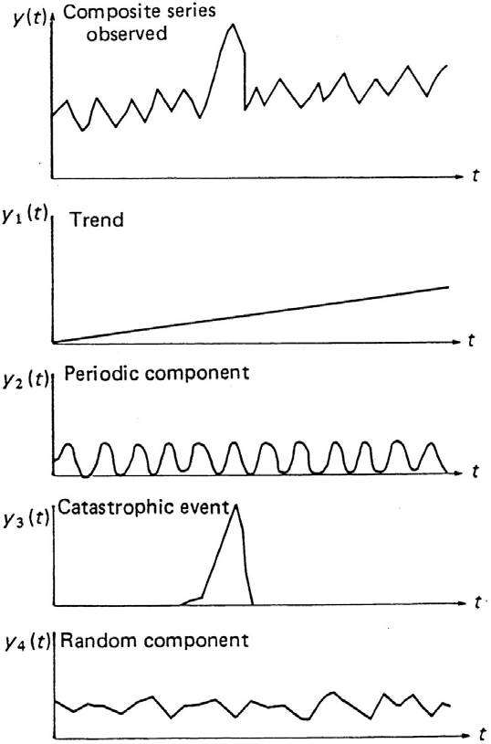
Figure 5.1: The time series components

PROPERTIES OF TIME SERIES

The purpose of a stochastic model is to represent important statistical properties of one or more time series. Indeed, different types of stochastic models are often studied in terms of the statistical properties of time series they generate. Examples of these properties include: trend, serial correlation, covariance, cross-correlation, etc. Therefore, before reviewing the different types of stochastic models used in hydrology, some distribution properties of stochastic processes need to be discussed. The following basic statistics are usually used for expressing the properties/characteristics of a time series.

_ n
Mean , μ = E( X ) = = 1 ∑ X

(5.2)

1 X n

t
t =1

Variance, σ 2 = S 2 = 1 n
∑
n − 1 t =1
−
( X t − X )
2
1 n− L − _
(5.3)

Co var iance, λ = Cov( X t , X t + L ) = ∑( X t − X )( X t + L − X )
n − L
t =1
(5.4)

Where L is the time lag.

Stationary time series:

If the statistics of the sample (mean, variance, covariance, etc.) as calculated by equations (5.2)-(5.4) are not functions of the timing or the length of the sample, then the time series is said to be stationary to the second order moment, weekly stationary, or stationary in the broad sense. Mathematically one can write as:
E( X 1 ) = μ
Var( X ) = σ 2
t
Cov( X t , X t + L ) = λL

In hydrology, moments of the third and higher orders are rarely considered because of the unreliability of their estimates. Second order stationarity, also called covariance stationarity, is usually sufficient in hydrology. A process is strictly stationary when the distribution of Xt does not depend on time and when all simultaneous distributions of the random variables of the process are only dependent on their mutual time-lag. In another words, a process is said to be strictly stationary if its n-th (n for any integers) order moments do not depend on time and are dependent only on their time lag.

Non-stationary time series:

If the values of the statistics of the sample (mean, variance, covariance, etc.) as calculated by equations (5.2)-(5.4) are dependent on the timing or the length of the sample, i.e. if a definite trend is discernible in the series, then it is a non- stationary series. Similarly, periodicity in a series means that it is non-stationary. Mathematically one can write as:
E( X1 ) = μt
Var( X t ) = σ t 2
Cov( X t , X t + L ) = λL,t

White noise time series:
For a stationary ties series, if the process is purely random and stochastically independent, the time series is called a white noise series. Mathematically one can write as:
E( X 1 ) = μ
Var( X t ) = σ 2
Cov( X t , X t + L ) = 0 for all L ≠ 0

Gaussian time series:
A Gaussian random process is a process (not necessarily stationary) of which all random variables are normally distributed, and of which all simultaneous distributions of random variables of the process are normal. When a Gaussian random process is weekly stationary, it is also strictly stationary, since the normal distribution is completely characterized by its first and second order moments.

ANALYSIS OF HYDROLOGIC TIME SERIES
Records of rainfall and river flow form suitable data sequences that can be studied by the methods of time series analysis. The tools of this specialized topic in mathematical statistics provide valuable assistance to engineers in solving problems involving the frequency of occurrences of major hydrological

events. In particular, when only a relatively short data record is available, the formulation of a time series model of those data can enable long sequences of comparable data to be generated to provide the basis for better estimates of hydrological behaviour. In addition, the time series analysis of rainfall, evaporation, runoff and other sequential records of hydrological variables can assist in the evaluation of any irregularities in those records. Cross-correlation of different hydrological time series may help in the understanding of hydrological processes.
Tasks of time series analysis include:
- Identification of the several components of a time series.
- Mathematical description (modelling) different components identified.
If a hydrological time series is represented by X₁, X₂, X_{3,} ..., X_{t}, ..., then symbolically, one can represent the structure of the X_{t} by:
X ⇔ [T_{t}, P_{t}, E_{t}]
Where T_{t} is the trend component, P_{t} is the periodic component and E_{t} is the stochastic component. The first two components are specific deterministic features and contain no element of randomness. The third, stochastic, component contains both random fluctuations and the self-correlated persistence within the data series. These three components form a basic model for time series analysis.
The aims of time series analysis include but not limited to:
- description and understanding of the mechanism,
- Monte-Carlo simulation,
- forecasting future evolution,
Basic to stochastic analysis is the assumption that the process is stationary. The modelling of a time series is much easier if it is stationary, so identification, quantification and removal of any non-stationary components in a data series is under-taken, leaving a stationary series to be modelled.

    - Trend component
This may be caused by long-term climatic change or, in river flow, by gradual changes in a catchment's response to rainfall owing to land use changes. Sometimes, the presence of a trend cannot be readily identified.

Methods of trend identification:

Different statistical methods, both nonparametric tests and parametric tests, for identifying trend in time-series are available in the literature. Two commonly used methods for identifying the trend are discussed briefly in this section.
- Mann-Kendall test
The test uses the raw (un-smoothed) hydrologic data to detect possible trends. The Kendall statistic was originally devised by Mann (1945) as a non-parametric test for trend. Later the exact distribution of the test statistic was derived by Kendall (1975).

The Mann-Kendall test is based on the test statistic S defined as follows:

n−1
∑
S =
i=1

n
∑sgn(x j − X i )
j =i+1
(5.5)

Where the X_{j} are the sequential data values, n is the length of the data set, and

⎧1if θ > 0

sgn(θ ) = ⎪ θ = 0
⎨0 if
(5.6)

⎪− 1if θ < 0
⎩
Mann (1945) and Kendall (1975) have documented that when, the statistic S is approximately normally distributed with the mean and the variance as follows:

E(S) =0 (5.7)
q
n(n −1)(2n + 5) − ∑tp (t p − 1)(2t p + 5)

V (S ) =
p=1
18
(5.8)

Where n = number of data
t_{p} = the number of ties for the p^{th} value (number of data in the p^{th} group) q = the number of tied values (number of groups with equal values/ties) The standardized Mann-Kendall test statistic ZMK is computed by

⎧
⎪
⎪
sgn(θ ) = ⎨0
⎪
⎪
⎪⎩
S − 1
Var(s)

S + 1
Var(s)
S > 0

S = 0
S < 0

(5.9)

The standardized MK statistic Z follows the standard normal distribution with mean of zero and variance of one.
The hypothesis that there has not trend will be rejected if

Zmk
> Z1−α / 2
(5.10)

Where Z1−α / 2 is the value read from a standard normal distribution table with α
being the significance level of the test.

- Linear regression method

Linear regression method can be used to identify if there exists a linear trend in a hydrologic time series. The procedure consists of two steps, fitting a linear regression equation with the time T as independent variable and the hydrologic data, Y as dependent variable, i.e.
Y = α + β.T (5.11)
and testing the statistical significance of the regression coefficient β.
Test of hypothesis concerning β can be made by noting that (β – β₀)/S_{β} has t distribution with n-2 degrees of freedom. Thus the hypothesis H₀: β = β₀ versus H₀: β ≠ β₀ is tested by computing

t = β − β0
Sβ
Where S_{β} is the standard deviation of the coefficient β with
(5.12)

S β =
∑
i=1
n
_
(T −T )
2
i
S
(5.13)

and

S = (5.14)
1 ∑
n
(Y − Yi )
^
2
n − 2
i
i=1

Where S is the standard error of the regression, Y_{i} and
^
Y are observed and

estimated hydrologic variable from the regression equation, respectively.

The hypothesis, i.e. no trend, is rejected if
Models for trend:
t > t1−α / 2 , n−2

The shape of the trend depends on the background of the phenomenon studied. Any smooth trend that is discernible may be quantified and then subtracted from the sample series. Common models for trend may take the following forms:
T_{t} = a + bt (a linear trend, as in Fig. 5.1) (5.15) or
T_{t} = a + bt + ct² + dt³ + ... (a non-linear trend) (5.16)
The coefficients a, b, c, d ... are usually evaluated by least-squares fitting. The number of terms required in a polynomial trend being primarily imposed by the interpretation of the studied phenomenon. The number of terms is usually based on statistical analysis, which determines the terms contributing significantly to the description and the interpretation of the time series. Restriction is made to the significant terms because of the principle of parsimony concerning the number of unknown parameters (constants) used in the model. One wishes to use as small a number of parameters as possible, because in most cases the addition of a complementary parameter decreases the accuracy of the other parameters. Also prediction- and control procedures are negatively influenced by an exaggerated number of parameters. This principle of parsimony is not only important with respect to the selection of the trend function but also with respect to other parts of the model.

Periodic component
In most annual series of data, there is no cyclical variation in the annual observations, but in the sequences of monthly data distinct periodic seasonal effects are at once apparent. The existence of periodic components may be investigated quantitatively by (1) Fourier analysis, (2) spectral analysis, and (3) autocorrelation analysis. Of which, the autocorrelation analysis method is widely used by hydrologists and will be discussed briefly in this section.

Identification of periodic component by autocorrelation analysis:
The procedure consists of two steps, calculating the autocorrelation coefficients and testing their statistical significance. For a series of data, X_{t}, the autocorrelation coefficient r_{L} between X_{t} and X_{t+L} are calculated and plotted against values of L (known as the lag), for all pairs of data L time units apart in the series:

r = 1 ∑n− L ( X
_
− )( X
− _ ) / 1 ∑n ( X
_
− )2
(5.17)

L n − L
_
t X
t =1
t + L X
t X
n t =1

Where X is the mean of the sample of n values of X_{t} and L is usually taken for values from zero up to n/4. A plot of r_{L} versus L forms the correlogram. The characteristics of a time series can be seen from the correlogram. Examples of
correlograms are given in Fig 54.2. Calculation of equation (5.17) for different L
gives the following cases:
      - If L = 0, r_{L} = 1. That is, the correlation of an observation with itself is one.

      - If r_{L} ≈ 0 for all L ≠ 0, the process is said to be a purely random process. This indicates that the observations are linearly independent of each other. The correlogram for such a complete random time series is shown in Fig 5.2(a).
      - If r_{L} ≠ 0 for some L ≠ 0, but after L > τ, then , the time series is still referred to as simply a random one (not purely random) since it has a ‘memory’

up to L = τ. When rτ
, the process is said to have no memory for what

occurred prior to time t-τ. The correlogram for such a non-independent stochastic process is shown in Fig 5.2(b). This is representative of an auto regressive process. Typically, such a correlogram could be produced from a series described by the Autoregressive model:
X_{t} = a₁X_{t-1} + a₂X_{t-2} +a₃X_{t-3} + … + ε_{t}
(4.18)
where a_{i} are related to the autocorrelation coefficients r_{i} and ε_{t} is a random independent element.
      - In the case of data containing a cyclic (deterministic) component, then r_{L} ≠ 0 for all L ≠ 0, the correlogram would appear as in Fig. 5.2(c). Where T is the period of the cycle.
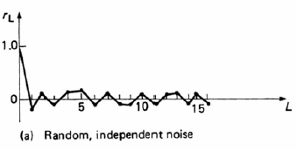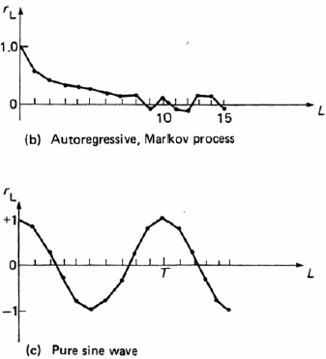

Figure 5.2 Examples of Correlograms

Modelling of periodic component:
A periodic function Pt is a function such that P_{t+T} = P_{t} for all t

The smallest value of T is called the period. The dimension of T is time, T thus being a number of time-units (years, months, days or hours, etc.) and we also have
P_{t+nT} = P_{t} for all t and for all integer n.

The frequency is defined as the number of periods per time-unit:

frequency =
1

period

Trigonometric functions are simple periodic functions. For example,
α sin (ωt + β)

has a period of 2π/ω, because
α sin [ω(t+2π/ω)+β] = α sin(ωt+2π+β) = α sin(ωt + β)

The pulsation or angular frequency is defined as
ω = 2π1 = 2π . frequency period

the constant α is termed the amplitude and β the phase (with respect to the origin) of the sine-function.

A simple model for the periodic component may be defined as (for more discussions refer to the literature of Time Series Analysis):
Pt = m + Csin(2 t/T) (5.19)

Where C is the amplitude of the sine wave about a level m and of wavelength T. The serial (auto) correlation coefficients for such a Pt are given by:
r_{L} = cos (2 L/T) (5.20)

The cosine curve repeats every T time units throughout the correlogram with rL
= 1 for L = 0, T, 2T, 3T,… Thus periodicities in a time series are exposed by regular cycles in the corresponding correlograms.

Once the significant periodicities, Pt, have been identified and quantified by µt (the means) and σt (the standard deviations) they can be removed from the original times series along with any trend, Tt, so that a new series of data, Et, is formed:

E = X t − Tt − mt

(5.21)

t
S
t
Simple models for periodic component in hydrology can be seen in the literature. For example, in many regions, typical monthly potential evapotranspiration variation during the year can be modelled more or less by a sinusoidal function, with a couple of parameters to tune the annual mean and the amplitude (Xu and Vandewiele, 1995).

This behavior leads to the idea to model by a truncated Fourier series: ep_{t} = {a + bsin[(2 /12)(t-c)]}+
where again t is time in month. The plus sign at the end is necessary for avoiding negative values of ep which otherwise may occur in rare cases. Again parameters a, b and c are characteristics of the basin.

Stochastic component
E_{t} represents the remaining stochastic component of the time series free from non-stationary trend and periodicity and usually taken to be sufficiently stationary for the next stage in simple time series analysis. This E_{t} component is analysed to explain and quantify any persistence (serial (auto) correlation) in the data and any residual independent randomness. It is first standardized by:
_

Z = Et − E
t S
(5.22)

E
_
Where E and s_{E} are the mean and standard deviation of the E_{t} series. The series, Z_{t}, then has zero mean and unit standard deviation. The autocorrelation coefficients of Z_{t} are calculated and the resultant correlogram is examined for evidence and recognition of a correlation and/or random structure.

For example, in Fig. 5.3a for a monthly flow, the correlogram of the Z_{t} stationary series (with the periodicities removed) has distinctive features that can be recognized. Comparing it with Fig. 5.2, the Z_{t} correlogram resembles that of an auto regressive (Markov) process. For a first order Markov model:

Zt = r1 Zt −1 + et
(5.23)

Where r₁ is the autocorrelation coefficient of lag 1 of the Z_{t} series and e_{t} is a random independent residual. A series of the residuals e_{t} may then be formed from the Z_{t} series and its known lag 1 autocorrelation coefficient, r₁:

et = Zt − r1 Zt −1
(5.24)

The correlogram of residuals is finally computed and drawn (Fig.5.3b). For this data this resembles the correlogram of 'white noise', i.e. independently distributed random values. If there are still signs of autoregression in the et correlogram, a second-order Markov model is tried, and the order is increased until a random et correlogram is obtained. The frequency distribution diagram of the first order et values (Fig. 5.3c) demonstrates an approximate approach to the normal (Gussian) distribution.

At this stage, the final definition of the recognizable components of the time series has been accomplished including the distribution of the random residuals. As part of the analysis, the fitted models should be tested by the accepted statistical methods applied to times series. Once the models have been formulated and quantified to satisfactory confidence limits, the total mathematical representation of the time series can be used for solving hydrological problems by synthesizing non-historic data series having the same statistical properties as the original data series.

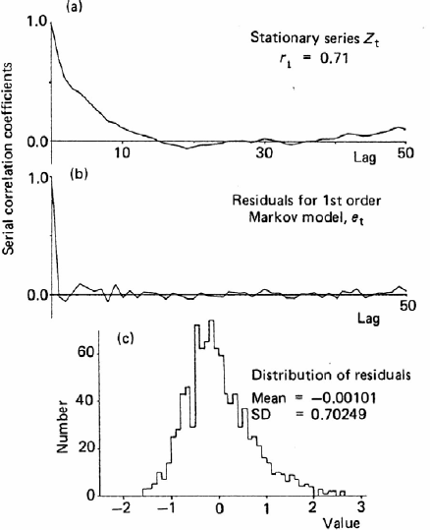
Figure 5.3 River Thames at Teddington Weirs ( 82 years of monthly flows, from Shaw, 1988)

TIME SERIES SYNTHESIS

The production of a synthetic data series simply reverses the procedure of the time series analysis. First, for as many data items as are required, a comparable sequence of random numbers, drawn from the et distribution, is generated using a standard computer package. Second, the corresponding synthetic Zt values are recursively calculated using equation 5.23 (starting the series with the last value of the historic Zt series as the Zt-1 value). Third, the Et series then derives from equation 5.22 in reverse:
_

Et = Zt SE + E
(5.25)

The periodic component Pt represented by mt and st for time period t is then added to the Et values to give:

X t = Tt + Et St + mt
(from equation 5.21) (5.26)

The incorporation of the trend component Tt then produces a synthetic series of Xt having similar statistical properties to the historic data series.

SOME STOCHASTIC MODELS
Ultimately design decisions must be based on a stochastic model or a combination of stochastic and deterministic models. This is because any system must be designed to operate in the future. Deterministic models are not available for generating future watershed inputs in the form of precipitation, solar radiation, etc., nor is it likely that deterministic models for these inputs will

be available in the near future. Stochastic models must be used for these inputs.

Purely random stochastic models
Possibly the simplest stochastic process to model is where the events can be assumed to occur at discrete times with the time between events constants, the events at any time are independent of the events at any other time, and the probability distribution of the event is known. Stochastic generation from a model of this type merely amounts to generating a sample of random observations from a univariate probability distribution. For example, random observations for any normal distribution can be generated from the relationship, y = σR_{N} + µ (5.27)

Where R_{N} is a standard random normal deviate (i.e. a random observation from a standard normal distribution) and µ and σ are the parameters of the desired normal distribution of y. Computer routines are available for generating standard random normal distribution.

Autoregressive models
Where persistence is present, synthetic sequences cannot be constructed by taking a succession of sample values from a probability distribution, since this will not take account of the relation between each number of sequences and those preceding it. Consider a second order stationary time series, such as an annual time series, made up of a deterministic part and a random part. The deterministic part is selected so as to reflect the persistence effect, while it is assumed that the random part has a zero mean and a constant variance. One of the models to simulate such a series is the Autoregressive model. The general form of an autoregressive model is:

( yt − μ) = β1 ( yt −1 − μ) + β 2 ( yt −2 − μ) + ... + β k ( yt −k − μ) + ε t
(5.28)

Where µ is mean value of the series, β is the regression coefficient, the {y1, y2,
…, yt,…} is the observed sequence and the random variables εt are usually assumed to be normally and independently distributed with zero mean and variance . In order to determining the order k of autoregression required to describe the persistence adequately, it is necessary to estimate k+2 parameters: β1, β2, …βk, µ and the variance of residuals . Efficient methods for estimating these parameters have been described by Kendall and Stuart (1968), Jenkins and Watts (1968).

The first order autoregression:
yt − μ = β1 ( yt −1 − μ) + ε t

(5.29)

has found particular application in hydrology. When equation (5.29) is used to model annual discharge series, the model states that the value of y in one time period is dependent only on the value of y in the preceding time period plus a random component. It is also assumed that εt is independent of yt.
Equation (5.29) is the well-known first order Markov Model in the literature. It has three parameters to be estimated: µ, β , and σ 2 .
1 E

For the moment method of parameter estimation, parameter µ can be computed from the time series as the arithmetic mean of the observed data.
As for β1, the Yule-Walker equation (Delleur, 1991) shows that:
P

ρk = ∑ β j ρk − j j =1

k >0
(5.30)

the above equation, written for k = 1, 2, …, yields a set of equations. Where ρk is the autocorrelation coefficient for time lag k. As the autocorrelation coefficients ρ1, ρ2, …, can be estimated from the data using equation (4.17), these equations can be solved for the autoregressive parameters β1, β2, …, βp. This is the estimation of parameters by the method of moments. For example, for the first order autoregressive model, AR(1), the Yule-Walker equations yield

ρ1 = β1.ρ0 = β1
sin ce ρ0 =1
(5.31)

Similarly we can derive the equations for computing β1 and β2 for the AR(2) model as

β = ρ1 (1 − ρ2 )
1 1 − ρ 2
1
(5.32)

It can be shown thatσ 2 . is related to (the variance of the y series) by:

E
ο 2 =σ 2 (1 − β 2 )
t
(5.33)

ε y 1

If the distribution of y is
N (μ y
,σ 2 )
then distribution of ε is N(0, σ 2 .). Random

values yt
1 − β
2
1
y
E
can now be generated by selecting εt
randomly from a N(0,
ο 2 .)

distribution. If z is N(0,1) then
E
Zσφ or Zσ y
is N (0,σ 2 . Thus, a model for

generating Y’s that are
ε
N (μ y
,σ 2 ) and follow the first order Markov model is

yt = μ y
y
+ β1 ( y
t −1
- μ y
) + Ztσ y
(5.34)

The procedure for generating a value for yt is:
1 − β
2
1
_

- estimate µy, σy, and β1 by
y , sx
and r₁(eq.5.17) respectively,

- select a zt at random from a N(0, 1) distribution, and
_

- calculate yt by eq. (5.34) based on
y , sx
and β1, and yt-1.

The first value of y , i.e. y , might be selected at random from a N(µ , σ 2 ).
t 1 y y
To eliminate the effect of y1 on the generated sequence, the first 50 or 100 generated values might be discarded.
Equation (5.34) has been widely used for generating annual runoff from watersheds

First order Markov process with periodicity: Thomas - Fiering model
The first order Markov model of the previous section assumes that the process is stationary in its first three moments. It is possible to generalise the model so that the periodicity in hydrologic data is accounted for to some extent. The main application of this generalisation has been in generating monthly streamflow where pronounced seasonality in the monthly flows exists. In its simplest form, the method consists of the use of twelve linear regression equations. If, say,

twelve years of record are available, the twelve January flows and the twelve December flows are abstracted and January flow is regressed upon December flow; similarly, February flow is regressed upon January flow, and so on for each month of the year.

_
q jan = q jan + b
_

jan
(qdect
_
_
- qdec ) + ε

jant

q feb = q feb + b feb (q jan − q jan ) + ε feb
……….
Fig.4.4 shows a regression analysis of q_{j+1} on q_{j}, pairs of successive monthly flows for the months (j+1) and j over the years of record where j = 1, 2, 3, ..., 12 (Jan, Feb, ... Dec) and when j = 12, j+1 = 1 = Jan (there would be 12 such regressions). If the regression coefficient of month j+1 on j is bj, then the
^

regression line values of a monthly flow,
previous months flow q_{j,} by the equation:
y j +1
, can be determined from the

^ _ _

q j +1 = q j +1 + b j (q j − q j )
(5.35)

To account for the variability in the plotted points about the regression line reflecting the variance of the measured data about the regression line, a further component is added:
(1− r 2 )
j
  - j + 1
where is the standard deviation of the flows in month j+1, r_{j} is the correlation coefficient between flows in months j+1 and j throughout the record, and Z = N(0, 1), a normally distributed random deviate with zero mean and unit standard deviation. The general form may written as
^ _ _
(1− r ² )
j

q j +
1 = q j +1+ b j (q j − q j ) + Z j +1.i .S j +1
(5.36)

Where b j = r j * S j +1 / S j , there are 36 parameters for the monthly model (q, for
each month). The subscript j refers to month. For monthly synthesis j varies from 1 to 12 throughout the year. The subscript i is a serial designation from year 1 to year n. Other symbols are the same as mentioned earlier.
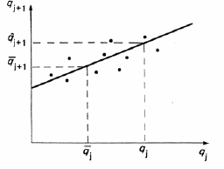
Fig.5.4: Thomas-Fiering model The procedure for using the model is as follows:
    - For each month, j = 1, 2, … 12, calculate

_
1
- The mean flow, q β = n

q j,i;
∑

(i = j,12 j,24 + j,...)

- The standard deviation, S j =
∑(q j,i − q j ) ²
n −1
_

- The correlation coefficient with flow in the preceding month,
_ _

r j =
∑
i
_
(q
j,i j
- q ) (q
2
∑
j +1,i
_
- q
2
j +1
)
i
∑(q j,i − q j )(q j +1,i − q j +1 )

- The slope of the regression equation relating the month’s flow to flow in the preceding month:

b j = r j
S j +1

S

j
    - The model is then set of twelve regression equations
where Z is a random Normal deviate N(0, 1).
    - To generate a synthetic flow sequence, calculate (generate) a random number sequence {Z1, Z2, … }, and substitute in the model.

Moving average models
The model form:
The moving average has frequently been used to smooth various types of hydrologic time series such as daily or weekly air temperature, evaporation rates, wind speed, etc. The moving average process used in the stochastic generation hydrologic data is somewhat different. In this use, the moving average process describes the deviations of a sequence of events from their mean value.
A process {x₁} defined as
x_{t} = e_{t} + Φ ₁e_{t-1} + Φ ₂e_{t-2} + ...+ Φ _{q}e_{t-q} (5.37) Where {x_{t}} is an uncorrelated stationary process, is called a moving average process of order q, denoted MA(q)-process.
It can also be written as
x_{t} = e_{t} - θ₁e_{t-1} - θ₂e_{t-2} - ...- θ_{q}e_{t-q} (5.38)
with Φ1 = -θ1, Φ 2 = -θ2, ..., Φ q = -θq.
The properties of the moving average process:
The autocovariance of the process is obtained by forming the product and taking the expectation:

For k = 0 we obtain the variance of the process
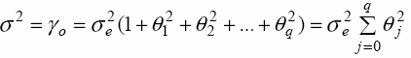
With the convention θo = -1
(5.39)

(5.40)

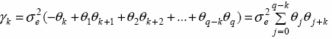The autocorrelation function is then
for k ≤ q (5.41) for k > q (5.42)

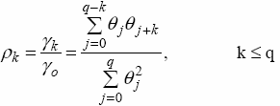(5.43)

Equations (5.40) and (5.41) can be used for the estimation of the parameters by method of moments. For this purpose they are rewritten as follows:

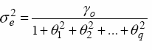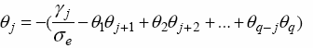(5.44)

(5.45)
Equ. (5.44) and (5.45) are used recursively. For example for the MA(1) model

x_{t} = e_{t} - θ₁e_{t-1} (5.46)
we have

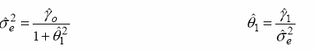(5.47)
Where are estimates of the auto-covariance and computed from the data.

ARMA models
Model form:
In stochastic hydrology ARMA models are known as Auto-Regressive Moving Average (ARMA) models. They combine any direct autocorrelation properties of a data series with the smoothing effects of an updated running mean through the series. The two components of the model for a data series x_{t,} e.g. annual river flows, are described by:
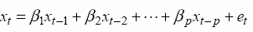
Auto-regression (AR(p))

(5.48)
Moving average (MA(q))
x_{t} = e_{t} - θ₁e_{t-1} - θ₂e_{t-2} - ...- θ_{q}e_{t-q} (5.49)
Where e_{t} are random numbers with zero mean and variance σ ² .
e
The Auto-regressive moving average (ARMA(p, q)) model is defined as:
(5.50)

One of the merits of the ARMA process is that, in general, it is possible to fit a model with a small number of parameters, i.e. p+q. This number is generally smaller than the number of parameters that would be necessary using either an AR model or a MA model. This principle is called the parsimony of parameters. The first order model ARMA(1, 1) is:

(5.51)
Properties of ARMA model:
Consider in the ARMA(1, 1) model which has been used extensively in hydrology:

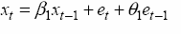
(5.52)
Multiplying both sides of (5.52) by X_{t-k}
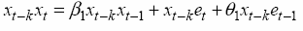
and taking the expectation of both sides we obtain the autocovariance
(5.53)
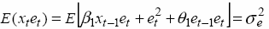
For k = 0, equ (5.53) becomes but
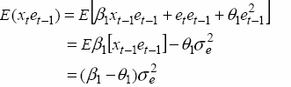
and

Thus
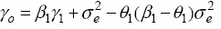
For k = 1 equ (5.53) becomes
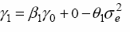
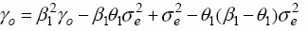
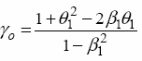
Combining with the previous equation or

and
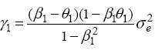
For k ≥ 2
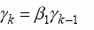
(5.54)

(5.55)

(5.56)

(5.57)

k ≥ 2 (5.58)

the autocorrelation function (ACF) is obtained by dividing (5.56), (5.57) and (5.58) by γ to obtain

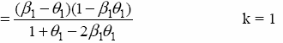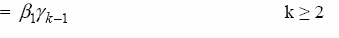(5.59a)

(5.59b)

(5.59c)
Observe that the MA parameter θ1 enters only in the expression for ρ1. For ρ2 and beyond the behaviour of the autocorrelation is identical to that of the AR(1) model.
Estimates of the parameters θ₁ and β₂ and can be obtained from equations (5.59b) and (5.59c), since the serial (auto) correlation coefficients ρ₁ and ρ₂ can be computed from data.
In general for an ARMA(p, q) model the autocovariance is

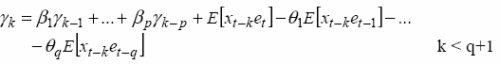(5.60a)

and the ACF is
(5.60b)

(5.61)

after lag q+1 the ACF tails off as for an AR(p) process. For the first q lags, the ACF depends on AR and MA parameters.
Hydrologic justification of ARMA models
A physical justification of ARMA models for annual streamflow simulation is as follows. Consider a watershed with annual precipitation Xt, infiltration aXt and evapotranspiration bXt. The surface runoff is (1-a-b)Xt = dXt. (See Fig 5.5).
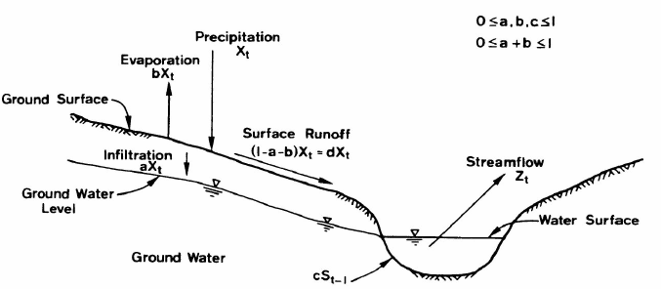
Fig.5.5 Conceptual representation of the precipitation-streamflow process after Salas and Smith (1980)
Let the groundwater contribution to the stream be cSt-1. Thus,
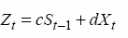 (5.62)

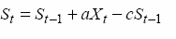
The conservation of mass for the groundwater storage is

or
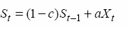
Rewriting (5.62)
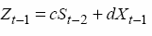
or
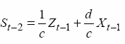
and rewriting (5.64) as
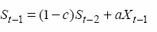
Combining (5.62), (5.66) and (5.65) we obtain
(5.63)

(5.64)

(5.65)

(5.66)

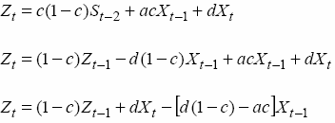
(5.67)
which has the form of an ARMA (1, 1), i.e. equation (5.52) model when the precipitation, Xt is an independent series and when (1-c) = β1, d = 1, and [d(1-c)- ac)] = θ1..

THE USES OF STOCHASTIC MODELS
- To make predictions of frequencies of extreme events
Stochastic models have been used to make predictions about the frequency of occurrence of certain extreme events of interest to the hydrologist. Models such as that given by equation (5.29) are selected, and the residual is taken to be random variable with probability distribution whose parameters are specified. The parameters are estimated from data; so-called "synthetic" sequence {y_{t}} can then be constructed, and the frequency with which the extreme event occurs in them can be taken as an estimate of the "true" frequency with which it would occur in the long run.

For the investigation of system operating rules
A further use for synthetic sequences generated by stochastic models is in reservoir operation, such as the investigation of the suitability of proposed operating rules for the release of water from complex systems of interconnected reservoirs. By using the generated sequence as inputs to the reservoir system operated according to the proposed rules, the frequency with which demands fail to be met can be estimated. This may lead to revision of the proposed release rules; the modified rules may be tested by a similar procedure.

To provide short-term forecasts
Stochastic models have been used to make forecasts. Given the values x_{t,} x_{t-1},

x_{t-2}, ...; y_{t}, y_{t-1}, y_{t-2}, ... assumed by the input and output variables up to time t, stochastic models have been constructed from this data for forecasting the output from the system at future times, t+1, t+2, ..., t+k, .... In statistical terminology, k is the lead-time of the forecast. Many stochastic models have a particular advantage for forecasting purposes in that they provide, as a by- product of the procedure for estimating model parameters, confidence limits for forecasts (i.e. a pair of values, one less than the forecast and one greater, such that there is a given probability P that these values will bracket the observed value of the variable at time t+k). Confidence limits therefore express the uncertainty in forecasts; the wider apart the confidence limits, the less reliable the forecast. Furthermore, the greater the lead-time k for which forecasts is required, the greater will be the width of the confidence interval, since the distant future is more uncertain than the immediate.

To "extend" records of short duration, by correlation
Stochastic models have been used to "extend" records of basin discharge where this record is short. For example, suppose that it is required to estimate the instantaneous peak discharge with a return period of T years (i.e. such that it would recur with frequency once in T years, in the long run). One approach to this problem is to examine the discharge record at the site for which the estimate is required, to abstract the maximum instantaneous discharge for each year of record, and to represent the distribution of annual maximum instantaneous discharge by a suitable probability density function. The abscissa, Yo, say, that is exceeded by a proportion 1/T of the distribution then estimates the T-year flood.
It, however, frequently happens that the length of discharge record available is short, say ten years or fewer. On the other hand, a much longer record of discharge may be available for another gauging site, such that the peak discharges at the two sites are correlated. In certain circumstances, it is then permissible to represent the relation between the annual maximum discharges at the two sites by a regression equation and to use this fitted equation to estimate the annual maximum instantaneous discharges for the site with short record.

To provide synthetic sequences of basin input
Suppose that the model has been developed for a system consisting of a basin with rainfall as input variable, streamflow as output variable. If a stochastic model were developed from which a synthetic sequence of rainfall could be generated having statistical properties resembling those of the historic rainfall sequence, the synthetic rainfall sequence could be used as input to the main model for transformation to the synthetic discharge sequence. The discharge so derived could then be examined for the frequency of extreme events.

This approach to the study of the frequency of extreme discharge events is essentially an alternative to that described in paragraph (1) above. In the latter, a synthetic sequence is derived from a stochastic model of the discharge alone; in the former, a synthetic discharge sequence is derived by using a model to convert a synthetic sequence of rainfall into discharge.

Reservoir Capacity Determination

The reservoir capacity is a term used to represent the reservoir storage capacity. Its determination is performed using historical inflow records in the stream at the proposed dam site. There are several methods to determine a reservoir storage capacity. The most common ones are presented below.

Mass curve (ripple's) method:
A mass curve (or mass inflow curve) is a plot of accumulated flow in a stream against time. As indicated below a mass curve can be prepared from the flow hydrograph of a stream for a large number of consecutive previous years. Figure 5.1 (a) shows a typical flow hydrograph of a stream for six consecutive years. The area under the hydrograph from the starting year (i.e., 1953) up to any time t_{I} (shown by hatching) represents the total quantity of water that has flown through the stream from 1953 up to time t₁ and hence it is equal to the ordinate of the mass curve at time t₁. The ordinates of mass curve corresponding to different times are thus determined and plotted at the respective times to obtain the mass curve as shown in fig. 5.1(b). A mass curve continuously rises as it shows accumulated flows. The slope of the curve at any point indicates the rate of flow at that particular time. If there is no flow during certain period the curve will be horizontal during that period.

Fig. 6.1: a) Mass curve b) flow hydrograph

A demand curve (or mass curve of demand) on the other hand is a plot between accumulated demand and time (Fig. 6.2). If the demand is at a constant rate then the demand curve is a straight line having its slope equal to the demand rate. However, if the demand is not constant then the demand will be curved indicating a variable rate of demand.

Figure 6.2: Demand curve

The demand and supply curves discussed above are thus the basis of the mass curve (or ripple's) method of reservoir capacity determination.

The reservoir capacity required for a specified yield or demand may be determined by using mass curve and demand curve using the following steps.

- A mass curve is prepared from the flow hydrograph for a number of consecutive years selected from the available stream flow record such that it includes the most critical or the driest period. Figure 6.3 shows a mass curve for a typical steam for a 6 years period;
- Corresponding to the given rate of demand, a demand curve is prepared. If the rate of demand is constant then the corresponding demand curve is a straight line as shown in figure 6.3
- Lines such as GH, FJ, etc are drawn parallel to the demand curve and tangential to the high points G, F etc, of the mass curve (or the points at the beginning of the dry periods);
- The maximum vertical intercepts X₁Y₁, X₂Y₂, etc between the tangential lines drawn in step 3 and the mass curves are measured. The vertical intercepts indicate the volume by which the total flow in the stream falls short of the demand and hence required to be provided from the reservoir storage. For example assuming the reservoir to be full at G, for a period corresponding to points G and Z₁ there is a total flow in the stream represented by Y₁Z₁and there is a total demand represented by X₁Z₁, leaving a gap of volume represented by X₁Y₁which must be met with from the reservoir storage;
- The largest of the maximum vertical intercepts X₁Y₁, X₂Y₂ etc, determined in step 4 represents the reservoir capacity required to satisfy the given demand. However, the requirement of storage so obtained would be the net storage that must be available for utilization and it must be increased by the amount of water lost by evaporation and seepage.

Figure 6.3: Use of a mass curve to determine the reservoir capacity required to produce a specified yield.
If the tangential lines drown (GH, FJ, etc) do not intersect the mass curve, the reservoir will not be filled again. Moreover, if the reservoir is very large the time interval between the points G and H, F and J, etc, may be several years. This graphical solution of the mass method can also be done in tabular calculation easily using computer spreadsheet programs.

Example 6.1: The following table gives the mean monthly flows in a river during certain year. Calculate the minimum storage required for maintaining a demand rate of 40m³/s: (a) using graphical solution (b) using tabular solution.

Month | Jan | Feb | Mar | Apr | May | June | Jul | Aug | Sept | Oct | Nov | Dec
Q(m³/s) | 60 | 45 | 35 | 25 | 15 | 22 | 50 | 80 | 105 | 90 | 80 | 70

Solution:-

Graphical solution:

Month | Mean flow (m³/s) | Monthly flow  volume (m³/s.day) | Accumulated  flow volume (m³/s.day)
Jan(31) | 60 | 1860 | 1860
Feb(28) | 45 | 1260 | 3120
Mar(31) | 35 | 1085 | 4205
Apr(30) | 25 | 750 | 4955
May(31) | 15 | 465 | 5420
Jun(30) | 22 | 660 | 6080
Jul(31) | 50 | 1550 | 7630
Aug(31) | 80 | 2480 | 10110
Sept(30) | 105 | 3150 | 13260
Oct(31) | 90 | 2790 | 16050
Nov(30) | 80 | 2400 | 18450
Dec(31) | 70 | 2170 | 20620

- Tabular calculation (sequent-peak algorithm)

Month | Volume in | Volume demand | Departure | Cumulative Departure | Storage
 | flow | (Cumec-day) | (2)-(3) | (cumec-day) | (Cumec-day)
 | (cumec-day) |  | (cumec-day)
(1) | (2) | (3) | (4) | (5) | (6)
Jan | 1860 | 1240 | 620 | 620
Feb | 1260 | 1120 | 140 | 760
Mar | 1085 | 1240 | -155 | 605 760-(-1160)
Apr | 750 | 1200 | -450 | 155 =1920
May | 465 | 1240 | -775 | -620 cumec-day
Jun | 660 | 1240 | -540 | -1160
Jul | 1550 | 1240 | 310 | -850
Aug | 2480 | 1240 | 1240 | 390
Sept | 3150 | 1200 | 1950 | 2340
Oct | 2790 | 1240 | 1550 | 3890
Nov | 2400 | 1200 | 1200 | 5090
Dec | 2170 | 1240 | 930 | 6020

As shown fig 6.4 if the end points of the mass curve are joined by a straight line AB, then its slope represents the average discharge of the stream over the total period for which the mass curve has been plotted. If a reservoir is to be constructed to permit continuous release of water at this average value of discharge for the period, then the capacity required for the reservoir is represented by the vertical intercept between the two straight lines A¹B¹ and A¹¹B¹¹ drawn parallel to AB and tangent to the mass curve at the lowest tangent point C and the highest tangent point D, respectively. If the reservoir having this capacity is assumed to contain a volume of water equal to AA¹ at the beginning of the period, then the reservoir would be full at D and it would be empty at C. However, if the reservoir was empty in the very beginning, then it would be empty again at point E and also during the period from F to K. On the other hand if the reservoir was full in the very beginning it would be full again at points F and K, and between points A and E' there will be spill of water from the reservoir.

In the earlier discussions the rate of demand has been assumed to be constant. However, the rate of demand may not be always constant, in which case the demand curve will be curve with its slope varying from point to point in accordance with the variable rate of demand at different times. In this case also the required capacity of the reservoir can be determined in the same way by super imposing the demand curve on the mass curve from the high points (or beginning of the dry period) till the two meet again. The largest vertical intercept between the two curves gives the reservoir capacity. It is however essential that the demand curve for the variable demand coincide chronologically with the mass curve of stream flow, i.e. June demand must coincide with June inflow and so on.

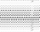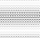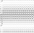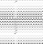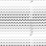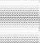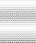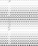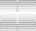
% Excee ded or Equalle d
0
126.6 107.1106.7
177.6 148.2 142.7 141 141
200
338.6
400
340.93
497
600
= Storage Required
800
964.7
1400

1200 1200

1000
Flow Duration Curve
Q (m3/s)

Figure 6.4: Use of a mass curve to determine the reservoir capacity required to produce yield equal to the average discharge of the stream.

Example 6.2: Reservoir Capacity determination by the use of flow duration curve
Determine the reservoir capacity required if a hydropower plant is designed to operate at an average flow.
Solution: The average flow is 340.93 m³/s.
- First option: Storage is same as the hatched area under flow duration curve.

Discharge (m3/s) | Descending Order | Rank | %Exceeded or Equaled
106.70 | 1200 | 1 | 8.33%
107.10 | 964.7 | 2 | 16.67%
148.20 | 497 | 3 | 25.00%
497.00 | 338.6 | 4 | 33.33%
1200.00 | 177.6 | 5 | 41.67%
964.70 | 148.2 | 6 | 50.00%
338.60 | 142.7 | 7 | 58.33%
177.60 | 141 | 8 | 66.67%
141.00 | 141 | 9 | 75.00%
141.00 | 126.6 | 10 | 83.33%
142.70 | 107.1 | 11 | 91.67%
126.60 | 106.7 | 12 | 100.00%

(1) | (2) | (3) | (1) -(3)
Ordinate of Flow Duration Curve (m3/s) | %Exceded or Equalled | Average Flow |  | Area
1200 | 8.33% | 340.93 | 0.00 | 0.00
964.7 | 16.67% | 340.93 | 0.00 | 0.00
497 | 25.00% | 340.93 | 0.00 | 0.00
338.6 | 33.33% | 340.93 | 2.33 | 6.90
177.6 | 41.67% | 340.93 | 163.33 | 14.84
148.2 | 50.00% | 340.93 | 192.73 | 16.29
142.7 | 58.33% | 340.93 | 198.23 | 16.59
141 | 66.67% | 340.93 | 199.93 | 16.66
141 | 75.00% | 340.93 | 199.93 | 17.26
126.6 | 83.33% | 340.93 | 214.33 | 18.67
107.1 | 91.67% | 340.93 | 233.83 | 19.50
106.7 | 100.00% | 340.93 | 234.23
 |  |  |  | 1013.73
 |  | Storage (Mm3) |  | 2662.61

- 2nd option (Mass Curve/Ripple's Diagram/Sequent Peak Algorithm.)

Month | Monthly Flow | Monthly Volume | Average Flow | Average Volume | Departure | Cumulative Departure
Jan | 106.70 | 280.25 | 340.93 | 895.47 | -615.22 | -615.22
Feb | 107.10 | 281.30 | 340.93 | 895.47 | -614.17 | -1229.39
Mar | 148.20 | 389.26 | 340.93 | 895.47 | -506.22 | -1735.60
Apr | 497.00 | 1305.40 | 340.93 | 895.47 | 409.93 | -1325.68
May | 1200.00 | 3151.87 | 340.93 | 895.47 | 2256.40 | 930.72
Jun | 964.70 | 2533.84 | 340.93 | 895.47 | 1638.37 | 2569.09
Jul | 338.60 | 889.35 | 340.93 | 895.47 | -6.12 | 2562.97
Aug | 177.60 | 466.48 | 340.93 | 895.47 | -429.00 | 2133.97
Sep | 141.00 | 370.34 | 340.93 | 895.47 | -525.13 | 1608.85
Oct | 141.00 | 370.34 | 340.93 | 895.47 | -525.13 | 1083.72
Nov | 142.70 | 374.81 | 340.93 | 895.47 | -520.66 | 563.06
Dec | 126.60 | 332.52 | 340.93 | 895.47 | -562.95 | 0.11
 |  |  |  |  | ANS (Mm3) | 2569.00

Reservoirs and sediments

A river entering a water reservoir will loose its capacity to transport sediments. The water velocity decreases, together with the shear stress on the bed. The sediments will therefore deposit in the reservoir and decrease its volume.

In the design of dam, it is important to assess the magnitude of sediment deposition in the reservoir. The problem can be divided I two parts:
    - How much sediments enter the reservoir
    - What is the trap efficiency of the reservoir

In a detailed study, the sediment size distributions also have to be determined for question 1. Question 2 may also involve determining the location of the deposits and the concentration and grain size distribution of the sediments entering the water intakes.

In general, there are two approaches to the sedimentation problem:

- The reservoir is constructed so large that it will take a very long time to fill. The economical value of the project will thereby be maintained.
- The reservoir is designed relatively small and the dam gates are constructed relatively large, so that it is possible to remove the sediments regularly by flushing. The gates are opened, lowering the water level in the reservoir, which increases the water velocity. The sediment transport capacity is increased, causing erosion of the deposits.

A medium sized reservoir will be the least beneficial. Then it will take relatively short time to fill the reservoir, and the size is so large that only a small part of the sediments are removed by flushing.

The flushing has to be done while the water discharge in to the reservoir is relatively high. The water will erode the deposits to a cross-stream magnitude similar to the normal width of the river. A long and narrow reservoir will therefore be more effectively flushed than a short and wide geometry. For the later, the sediment deposits may remain on the sides.

The flushing of a reservoir may be investigated by physical model studies.

Another question is the location of sediment deposits. Figure 5.5 shows a longitudinal profile of the reservoir. There is a dead storage below the lowest level the water can be withdrawn. This storage may be filled with sediments without affecting the operation of the reservoir.
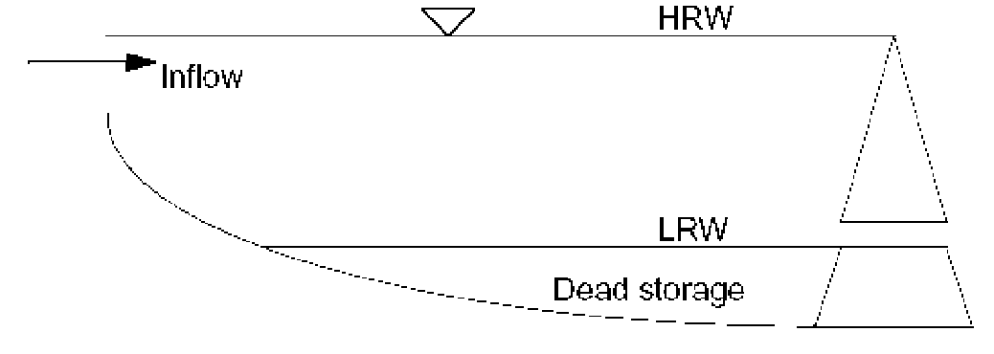
Figure 6.5: Longitudinal profile of a reservoir. HRW is the highest regulated water level. The reservoir volume below LRW is called the dead storage, as this can be used.

Sediment Load Prediction
Rough estimates of sediment load may be taken from regional data. Often the sediment yield in the area is known from neighboring catchments. It is then possible to assess the seriousness of the erosion in the present catchment and

estimate rough figures of sediment yield. The land use, slope and size of the catchment are important factors.

For a more detailed assessment, measurements of the sediment concentration in the river have to be used. Sediment concentrations are measured using standard sampling techniques, and water discharges are recorded simultaneously. The measurements are taken at varying water discharges. The values of water discharge and sediment concentrations are plotted on a graph, and a rating curve is made. This is often on the form:

Qs = a Q^{b}
w
(6.1)

Q_{s} is the sediment load, Q_{w} is the water discharge and a and b are constants, obtained by curve fitting

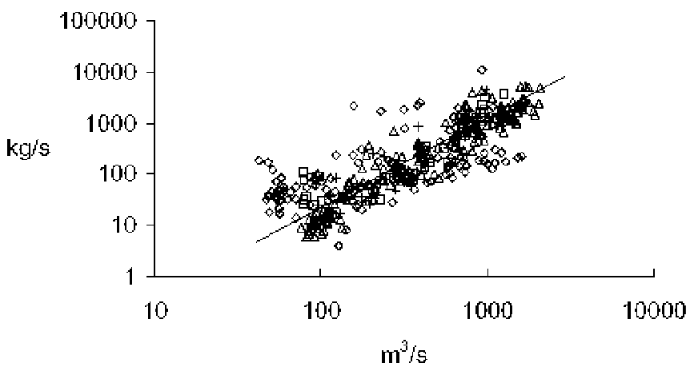

Figure 6.6: Example of sediment rating curve.

The annual average sediment transport is obtained by using a time series of the water discharge over the year together with equation 6.1.

- URBAN HYDROLOGY

Storm magnitudes and their frequency of occurrence are of greater importance than annual rainfall totals in urban hydrology.

Catchment Response Modifications
The changes made to a rural area by the construction of a concentration of building have a direct effect on its surface hydrology. The covering of the land surface by a large proportion of impervious materials means that a much larger proportion of any rainfall forms immediate runoff. In addition to extensive ground coverage by building in a city, the paved streets and car parks contribute large areas to the impervious surface. Any slope of the land also greatly enhances the runoff response of a paved area. In a defined catchment area, the effect on the stream discharge is dependent on the extent on the remaining pervious surfaces, where normal infiltration in to the soil and percolation in to the underlying strata can take place. Thus, after major urban development in a catchment, the following differences in the river flow from that of an equivalent rural catchment can be identified.

    - there is a higher proportion of rainfall appearing as surface runoff, and so the total volume of discharge is increased
    - for a specific rainfall event, the response of the catchment is accelerated, with a steeper rising limb of the flow hydrograph; the lag time and time to peak is reduced
    - flood peak magnitudes are increased, but for the very, but for the very extreme events (when the rural runoff coefficient > 50%) these increase in urban areas are diminished
    - in times of low flows, discharges are decreased since there is reduced contribution from the groundwater storage that has received less replenishment; and
    - water quality in streams and rivers draining urban area is degraded by effluent discharges, increased water temperature and danger from other forms of pollution

Many of these modifications are promoted by structural changes made to drainage channels. It is essential to remove rain water quickly from developed areas, and surface water drainage systems are included in modern town extensions.

The interaction of the artificial nature of urban catchments and the need to accommodate the changed hydrological characteristics is complex. The solving of one drainage problem may easily exacerbate another feature of the catchment runoff, e.g. rain events on the planned surface drainage of a new housing estate could produce higher peaks downstream than formerly, and these might cause flooding at previously safe points along the channel.

Due to urbanization effect, the runoff volume and time distribution of the runoff hydrograph is modified. The various hydrograph parameters such as peak discharge, Q_{p}, time to peak, t_{p} and lag time are usually related to catchment

characteristics including area of impervious surfaces or proportion of area urbanized, in order to obtain quantitative rainfall-runoff relationships.

Urban development planning
In the development of new urban centers, hydrological knowledge of the areas is required at two stages. The first is planning stage when the general layout of the new town is being decided. The second stage of hydrological involvement occurs at the detailing stage, the designing of storm water drainage channels and pipes to carry the surface water in to the rivers.

The principal objective at the planning stage is the determination of the size of flood, with its related return period, that the developing authority is prepared to accommodate. The design of the drainage system is dependent on a satisfactory assessment of the flood magnitude-return period relationship and the subsequent choice of a design flood.

Drainage design
Once the broad outline of the hydrological consequences of an urban development of an area have been determined at the planning stage and major remedial works considered, then the detailed design of the drainage systems is required. The engineering hydrologist is fully concerned with evaluating the runoff from sub areas to be drained in order to design the necessary storm water sewers. The peak runoff from the selected design storm determines the size sewer pipe which is dependent on the extent of each sub area to be drained. At the head of the catchment sub area, the required pipe size may e quite small, but downstream, as the sewer receives water from a growing are through a series of junctions, the pipe size gradually needs to be increased.

The problem of estimating the runoff from the storm rainfall is very much dependent on the character of the catchment surface. The degree of urbanization (extent of impervious area) greatly affects the volume of runoff obtained from a given rainfall. Retention of rainfall by initial wetting of surfaces and absorption by vegetation and pervious areas reduces the amount of storm runoff. These surface conditions also affect the time distribution of the runoff. Thus the computational method used to obtain the runoff from the rainfall should allow for the characteristics of the surface are to be drained.

7.3.1 Impervious areas
These comprises the roof areas and large expanses of paved surfaces of city centers and industrial sites, in which there is very little or even no part of the ground surface into which rainfall could infiltrate. The calculation of the runoff from these relatively small catchments is the most straight forward, since the area can be easily defined and measured. Over such limited areas, the storm rainfall can be assumed to be uniformly distributed with 100% runoff occurring. The response of the impervious surface is rapid, resulting in a short time of concentration of the flow in the drainage system. The rational formula can thus provide the peak drainage.
A(m ² )* i(mm / h)
Q(l / s) = (7.1)
3600

Looking the simple pipe design in the figure below, the computation of the required pipe size can be done as shown in the table.
A = 0.15 ha
1.0
A = 0.15 ha
A = 0.15 ha

1.1
2.0
A = 0.15 ha
1.2
Outfall

Figure 7.1: Simple Pipe Design
At the outset of the design procedure, the selected return period for a design storm will have been decided. Storm water sewers are usually designed for 1 in 1, 1 in 2 or 1 in 5 year storm return periods. The type of pipe will also have been chosen; the internal roughness governs the flow characteristics, and roughness coefficient. Velocities and discharges for standard sized pipes can be found from published tables, assuming full bore conditions, a hydraulic gradient equal to the pipe gradient and appropriate roughness coefficient. Design charts for the velocities and discharges are also available and provide for easier interpolation. Flows larger than those derived from the tables or charts would require hydraulic gradients greater than the pipe gradient, and these could only occur by ponding (or surcharging) of water in the manholes at the pipe junctions. The design objective is to avoid such surcharging.

Referring to figure 7.1, the design procedure begins with the choice of a trial pipe size for pipe 1.0, say 150 mm is chosen (the smallest used in practice) (Refer Table 7.1). From published tables and for k_{s} = 0.6 for a normal concrete pipe, the velocity and discharge for a gradient of 1 in 65 are noted, 1.26 m/s and
23.0 l/s, respectively. A flow greater than 23.0 l/s would result in surcharging.

The time of flow along the pipe is next calculated from the velocity and length of pipe and comes to 0.86 min. the time of concentration at the end of the first pipe is then 0.86 min plus an assumed allowance of 2 min, for the time of entry, which is assumed to cover the lag time between the beginning of the storm rainfall and the entry of the overland flow in to the leading manhole. With the time of concentration of the drainage to the end of the first pipe known, the design return period rainfall intensity (i) over this duration to give the peak flow an be obtained from intensity-duration-frequency data. The storm peak discharge is then calculated using equation 6.1 for comparison with the

unsurcharged full bore pipe flow. The first trial pipe of 150 mm diameter would clearly be surcharged, so the calculations are repeated with the next size pipe, diameter 225 mm. the calculated storm discharge, 28.8 l/s would be easily contained by larger pipe.

The calculations proceed for each pipe in turn, with the previous time of concentration being added to the new time of flow to give the combined times of concentration at the end of sequential pipes. The drainage areas are also accumulated. It will be noted that the 2.0 min time of entry is also added to the flow time of pipe 2.0 since it is at the start of a branch of pipeline. The time of concentration for the last pipe, is then the sum of the time of concentration of pipe 1.1 and the flow time of pipe 1.2. the extra contribution from the greatly increased area drained by the tributary pipe results in a much larger discharge requiring the next size larger pipe, 300 mm diameter.

Table 7.1: Rational method Drainage Design

Pipe No | Level Diff. (m) | Pipe Leng. (m) | Grad. (1 in ) | Trial Pipe  Dia (mm) | Pipe |  | Time of Flow  (min) | Time of Conc.  (min) | Rate of Rain (mm/h) | Imp. A  Cum. (ha) | Storm, Q  (l/s) | Comm.
 |  |  |  |  | v (m/s) | Q  (l/s)
1.0 | 1.00 | 65.00 | 65.00 | 150.00 | 1.26 | 23.00 | 0.86 | 2.86 | 67.50 | 0.15 | 28.13 | S
 |  |  |  | 225.00 | 1.64 | 67.50 | 0.66 | 2.66 | 69.20 |  | 28.83 | PF
1.1 | 0.90 | 70.00 | 78.00 | 225.00 | 1.50 | 61.70 | 0.78 | 3.44 | 63.20 | 0.25 | 43.89 | PF
2.0 | 1.50 | 60.00 | 40.00 | 150.00 | 1.61 | 29.40 | 0.62 | 2.62 | 69.50 | 0.20 | 38.61 | S
 |  |  |  | 225.00 | 2.10 | 86.00 | 0.48 | 2.48 | 70.70 |  | 39.28 | PF
1.2 | 0.90 | 50.00 | 56.00 | 225.00 | 1.77 | 72.80 | 0.47 | 3.91 | 60.20 | 0.53 | 88.63 | S
 |  |  |  | 300.00 | 2.13 | 156.00 | 0.39 | 3.83 | 60.70 |  | 89.36 | PF

7.4 The Transport and Road Research Laboratory (TRRL) Hydrograph Method (Watkins, 1962)
In the time-area method, the total catchment are is deemed to be contributing to the flow after the time of concentration, T_{c}, the time it takes for the rain on the furthest part of the catchment to reach the outfall. Thus in figure 7.2, for two drains receiving uniform rainfall from areas A₁ and A₂ with drain 2 joining the main channel, drain 1, a relationship of contributing area, A, versus time, T, is constructed. From the beginning of the flow in drain 1 at T=0 there is steady increase in area contributing until T = T₁ which is the value of T_{c} for area A₁. Drain 2 begins to contribute to the outfall flow T_{c} at time T = (T₂+T₃). Between times T₃ and T₁ both drains have been flowing and the joint contributing area (at
- at T = T₁ is given by:

A + (T1 − T3 ) .A
1

(7.2)

2
T
2
From T = (T₂+T₃), both areas are contributing fully. The time-area curve for the combined drains is composite line OBCD.
The principle of TRRL as outlined as in figure 6.2, a catchment are, divided into four sub areas, is drained by a single channel to the outfall where the hydrograph is required. Subarea 1 begins contributing to the flow first, to be

followed sequentially by the other three subareas. The composite time-area curve for the whole catchment is drawn by summing the subarea contributions at regular time intervals. The incremental contributing areas after each time interval are then read from the composite curve, a₁, a₂, a₃, etc. from the diagram, the time of concentration for the whole area is determined.

The effective rainfall intensity is computed for each of the chosen time unit intervals from gauge measurements. The discharge rates after each time unit interval are given by:
q₁ = i₁a₁
q₂ = i₂a₁ + i₁a₂
q₃ = i₃a₁ + i₂a₂ + i₁a₃ (7.3)
etc.
The peak flow is then considered as design flow.
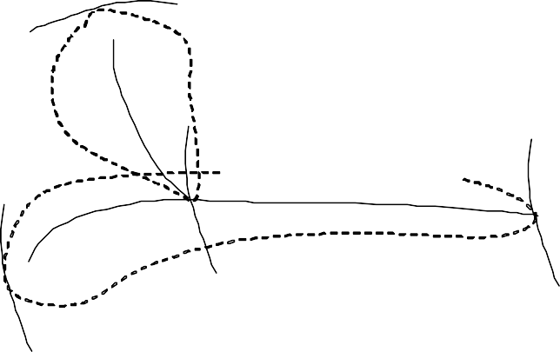T = T₃ +T₂l

A₂

T = T₁

Outfall

A₁ T = T₃

  - Time-area method
A

(A₁ + A₂ )
D Composite Curve

C

A1 Drain 1

Drain 2
B
A₂

O
T3 T1 (T₂ +T₃) T

T₂
  - Time-area diagram
Figure 7.2: Time-area method for sewer design

Example 7.1: The TRRL Hydrograph method

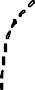Outfall
4
3
2
1

- Catchment boundary
9 10 11 12
8
7
6
Time Units
5
4
3
2
1
0
0
A4 A1
0.5
A3 A2
1
1.5
2
Composite A
2.5
Time Area Diagram

Time Units | Contributing Area (ha)
Time Units | a1 | a2 | a3 | a4 | Composite A
0.00 | 0 |  |  |  | 0
1.00 | 0.25 |  |  |  | 0.25
2.00 | 0.25 | 0 |  |  | 0.25
3.00 | 0.25 | 0.82 |  |  | 1.07
4.00 | 0.25 | 0.82 | 0.00 |  | 1.07
5.00 | 0.25 | 0.82 | 0.92 |  | 1.99
6.00 | 0.25 | 0.82 | 0.92 | 0.00 | 1.99
7.00 | 0.25 | 0.82 | 0.92 | 0.34 | 2.33
8.00 | 0.25 | 0.82 | 0.92 | 0.34 | 2.33
9.00 | 0.25 | 0.82 | 0.92 | 0.34 | 2.33
10.00 | 0.25 | 0.82 | 0.92 | 0.34 | 2.33
11.00 | 0.25 | 0.82 | 0.92 | 0.34 | 2.33
12.00 | 0.25 | 0.82 | 0.92 | 0.34 | 2.33

- Time-area diagram
Contributing A (ha)

Time Unit | Eff. RF(mm) | A  (ha) | A  (ha) | A  (ha) | A  (ha) | A  (ha) | A  (ha) | A  (ha) | A  (ha) | A  (ha) | A  (ha) | A  (ha)
1.0 | 8.8 | 0.25 | 0.25
2.0 | 57.6 | 0.82 | 0.82 | 0.25
3.0 | 38.0 | 0.92 | 0.92 | 0.82 | 0.25
4.0 | 11.7 | 0.34 | 0.34 | 0.92 | 0.82 | 0.25
5.0 | 10.8 |  |  | 0.34 | 0.92 | 0.82 | 0.25
6.0 | 8.8 |  |  |  | 0.34 | 0.92 | 0.82 | 0.25
7.0 | 3.4 |  |  |  |  | 0.34 | 0.92 | 0.82 | 0.25
8.0 | 3.3 |  |  |  |  |  | 0.34 | 0.92 | 0.82 | 0.25
9.0 | 3.9 |  |  |  |  |  |  | 0.34 | 0.92 | 0.82 | 0.25
10.0 | 2.9 |  |  |  |  |  |  |  | 0.34 | 0.92 | 0.82 | 0.25
11.0 |  |  |  |  |  |  |  |  |  | 0.34 | 0.92 | 0.82
12.0 |  |  |  |  |  |  |  |  |  |  | 0.34 | 0.92
13.0 |  |  |  |  |  |  |  |  |  |  |  | 0.34

Time Units | AiIi | AiIi | AiIi | AiIi | AiIi | AiIi | AiIi | AiIi | AiIi | AiIi | Total Q (l/s)
0 | 0.00 |  |  |  |  |  |  |  |  |  | 0.00
1 | 6.11 |  |  |  |  |  |  |  |  |  | 6.11
2 | 20.04 | 40.00 |  |  |  |  |  |  |  |  | 60.04
3 | 22.49 | 131.20 | 26.39 |  |  |  |  |  |  |  | 180.08
4 | 8.31 | 147.20 | 86.56 | 8.13 |  |  |  |  |  |  | 250.19
5 |  | 54.40 | 97.11 | 26.65 | 7.50 |  |  |  |  |  | 185.66
6 |  |  | 35.89 | 29.90 | 24.60 | 6.11 |  |  |  |  | 96.50
7 |  |  |  | 11.05 | 27.60 | 20.04 | 2.36 |  |  |  | 61.06
8 |  |  |  |  | 10.20 | 22.49 | 7.74 | 2.29 |  |  | 42.73
9 |  |  |  |  |  | 8.31 | 8.69 | 7.52 | 2.71 |  | 27.23
10 |  |  |  |  |  |  | 3.21 | 8.43 | 8.88 | 2.01 | 22.54
11 |  |  |  |  |  |  |  | 3.12 | 9.97 | 6.61 | 19.69
12 |  |  |  |  |  |  |  |  | 3.68 | 7.41 | 11.09
13 |  |  |  |  |  |  |  |  |  | 2.74 | 2.74

- Discharge hydrograph
9 10 11 12
8
7
6
Time Units
5
4
3
2
1
0
250.00

200.00

150.00

100.00

50.00

0.00
Total Q (l/s)

(4, 250.19)
300.00
Q (l/s)
The procedure of the TRRL method applies to one drainage unit, i.e. one pipe, in a system. The calculations have to be carried out for each pipe in a sewerage network.

